UI/UX DESIGN GUIDE
Vendor360
Visual design theme, component patterns, and screen-by-screen UX notes for the vendor mobile app
Vendor360 — AI-Powered Predictive Intelligence for India’s Local Vendors
Mini-Project · Phase I · Semester 3
Ajeenkya D Y Patil University, Pune — School of Engineering

1. Design Philosophy
Vendor360’s mobile experience is built for a first-time smartphone user standing behind a counter, often mid-transaction, in variable light and patchy connectivity. Every screen is optimised for one-handed, low-attention use: large touch targets, minimal text entry, voice as the default input, and immediate visual confirmation of every action.
- Voice-first — the microphone is always the primary, most prominent action on any data-entry screen; typing is a fallback, not the default.
- Glanceable — key numbers (stock levels, health score, today’s forecast) are readable in under two seconds, in bright sunlight, at arm’s length.
- Forgiving — every voice/OCR entry shows a confirm step before committing, since ASR and OCR are imperfect and trust must be earned.
- Warm, not corporate — the visual language uses warm saffron accents against a calm teal to feel approachable rather than clinical, deliberately distinct from generic blue enterprise software.

2. Colour Palette
The product palette is intentionally distinct from the university/academic report branding — it is meant to feel like a consumer product, not a research document.
Swatch | Name | Hex | Usage
█████ | Primary Teal | #0F7A6B | Primary actions, headers, active nav states
█████ | Teal Dark | #0A5A4F | Header text, high-emphasis labels
█████ | Amber / Saffron | #D98A0F | Voice mic button, key CTAs, highlights, festival alerts
█████ | Background | #FAF9F6 | App background — warm off-white, easier on the eyes than pure white
█████ | Text (ink) | #1A2E2A | Primary body and heading text
█████ | Muted grey-green | #5B6B67 | Secondary/meta text, timestamps, captions
█████ | Border | #D8E4E1 | Card borders, dividers
█████ | Danger / Alert | #E85D4C | Low-stock warnings, sync errors, expiry alerts

3. Typography
Style | Typeface | Usage
Display / Headings | Poppins SemiBold | Screen titles, key numbers, health score
Body | Poppins Regular | Body copy, list items, form labels
Numerals (data-heavy) | Poppins Medium, tabular figures | Prices, quantities, forecasts — aligned in tables/cards
Minimum size | 14sp body / 12sp caption | Never smaller, to remain legible for low-literacy and older users

4. Core Components

4.1 Phone shell & status bar
A consistent rounded phone frame with a light status bar establishes context across every mockup in this guide; production screens run edge-to-edge with safe-area padding.

4.2 Cards
Content is grouped into rounded white cards (12px radius, subtle border, soft shadow) on the warm background — this creates clear visual separation without heavy dividers or lines.

4.3 Pills & badges
Status indicators (in-stock, low-stock, synced, pending) use small rounded pill badges with a colour-coded fill: teal for healthy states, amber for attention, red for urgent/error states.

4.4 Bottom navigation
A fixed 4–5 item bottom nav bar (Home, Inventory, Voice, Forecast, Health Score) keeps primary destinations one tap away at all times.

4.5 Voice button
The microphone action is rendered as a large circular amber button, always in a fixed, thumb-reachable position, with a pulsing state to confirm active listening.

5. Screen-by-Screen UX Notes

5.1 Dashboard (Home)
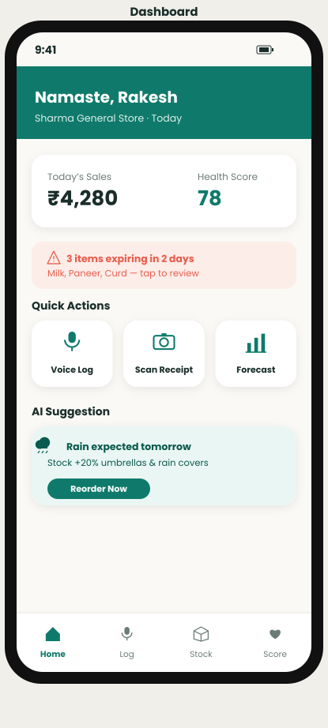
Home dashboard — today’s snapshot: sales, low-stock alerts, and forecast highlight.
- Purpose: give the vendor a two-second read on “how is my store doing right now.”
- Surfaces: today’s sales total, low-stock item count, and the top upcoming demand signal (e.g. a festival spike).
- The voice-entry button is reachable from the dashboard without navigating away, since logging a sale is the highest-frequency action.

5.2 Voice-to-Inventory Entry
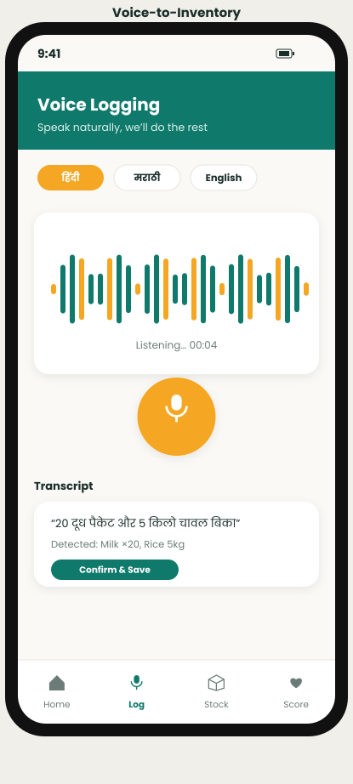
Voice entry — vendor speaks a stock update; live transcript shown for confirmation before committing.
- Purpose: log a sale or restock by speaking, in the vendor’s chosen language, without touching a keyboard.
- The live transcript is shown as it is captured so the vendor can visually confirm what was heard before it is applied to inventory.
- A single tap corrects a misheard word; the system never silently commits a low-confidence transcription.

5.3 OCR Receipt Scanning
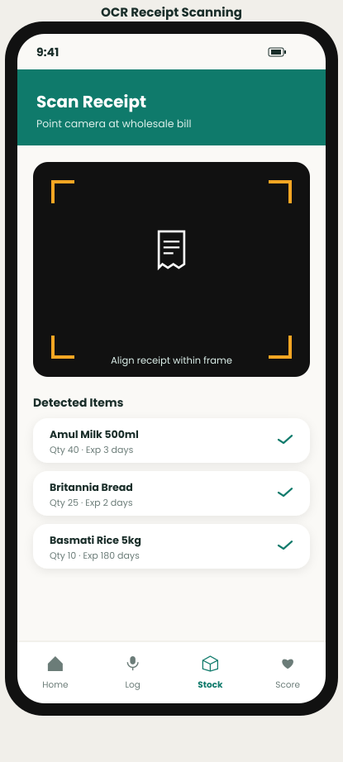
OCR capture — photographing a wholesale receipt auto-extracts line items and expiry.
- Purpose: eliminate manual re-typing of wholesale receipts into the inventory system.
- Extracted line items are shown with a confidence indicator; low-confidence rows are highlighted for a quick manual check rather than blocking the whole receipt.
- Expiry/shelf-life is computed automatically from the item category and today’s date.

5.4 Inventory List
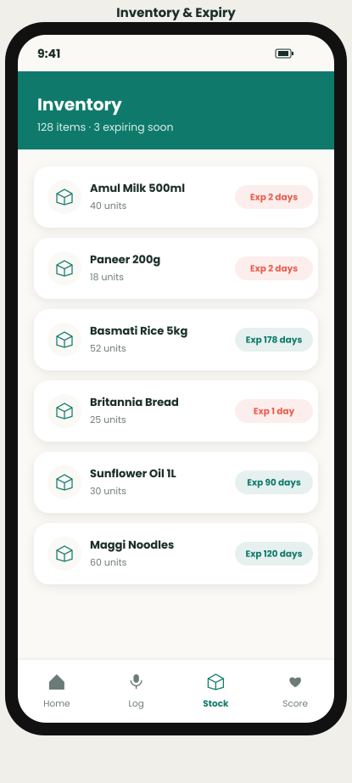
Inventory list — current stock levels with dynamic reorder-point indicators.
- Purpose: a scannable list of all SKUs with status pills (in-stock / low / reorder now).
- Reorder points are shown as a live threshold, not a static number, reflecting the dynamic safety-stock model.
- Tapping an item opens a quick-edit sheet; swipe gestures support fast restock logging.

5.5 Demand Forecast
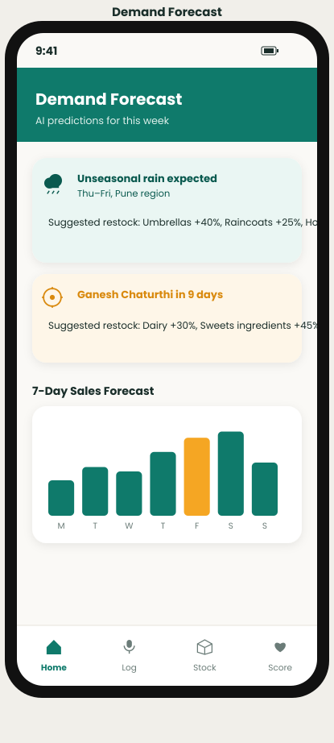
Forecast view — predicted demand for the coming days, annotated with weather/festival drivers.
- Purpose: turn the AI forecasting engine into a plain-language recommendation (“stock 20% more milk before Friday”).
- Each spike/dip is annotated with its driving signal (rain forecast, upcoming festival) so the recommendation is explainable, not a black box.

5.6 Micro-Credit Health Score
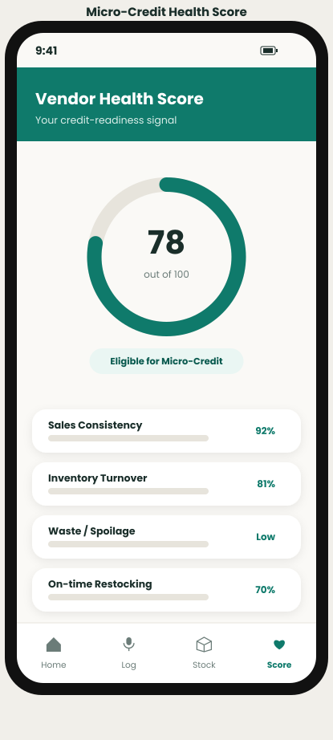
Health Score — a composite, explainable score built from sales consistency, turnover, and waste.
- Purpose: give the vendor (and, with consent, a lender) a single trustworthy number representing business health.
- The score breakdown is always visible — consistency, turnover, and waste contribution — so it never feels like an opaque black-box judgment.
- An explicit consent toggle controls whether the score is shared with a connected lender.

6. Accessibility & Localisation Notes
- All primary flows are available in Hindi, Marathi, and English; language is selected once at onboarding and affects both voice and on-screen text.
- Colour is never the sole status signal — pills combine colour with an icon or short label for colour-blind users.
- Touch targets are a minimum of 44×44dp to accommodate imprecise taps in a busy, one-handed retail environment.
- Critical alerts (low stock, sync failure) use both a visual badge and, where enabled, a short spoken notification.

