Implementation of a Transaction Manager
Aman Hogan-Bailey
2238-CSE-5331-002, Professor Ashraf Aboulnaga
The University of Texas at Arlington
October 25th, 2023

Contents
Overall Status 3
Difficulties Encountered 4
File Descriptions 5
List of Files 5
Zgt_tm.C 6
Zgt_tx.C 8
Division of Labor 10
Logical Errors 11
Using the number of waiting transactions: 11
Placement of the zgt_v() sempharore: 11
Placement of freelocks(): 12
References 13

Overall Status
The overall status of the project is, for all intents and purposes, complete. Readtx(), writetx(), committx(), and aborttx(), have been implemented, and most of the output logs look mostly correct, form my current understanding of the S2PL protocol. There was one issue of note, however: I could not run the tmtest script successfully. I installed some dependencies and updated my Ubuntu, but I still could not get it to run. So, I had to manually run the test cases several times and log the amount of times they hung and successfully ran. I input this information into the test-robustness excel sheet. Below is the step-by-step process of how the project components were completed and implemented:
- Reviewed documentation on how to implement S2PL in java.
- Reviewed the project help page and project description; then read implementation details for the zgt_tm and zgt_tm
- Implemented abort, commit, read, and write in the zgt_tm and made sure it ran correctly.
- Implemented abort, commit, read, and write, process_read_write, do_commit_abort, and set_lock in the zgt_tx.
- Ran through tests of each of the test files.
- Corrected and modified code along the way when getting erroneous output.

Difficulties Encountered
Conceptually, the semaphore and thread logic were understandable, but the implementation logic itself was rather difficult to understand. For example, the p and v semaphores seemed to work at random times, and not work in other times. It could be because I was placing them in thread safe areas.
zgt_p(0);
// …
zgt_v(0);
When to free the locks was also difficult to understand, and I eventually reached the conclusion through trial and error.
// Free locks
txptr->free_locks();
zgt_v(txptr->tid);

File Descriptions

List of Files
Below is a comprehensive list of modified or newly created files as a part of the transaction manager project:
src
┣ Multi_ROTxs.log
┣ RW_disjoint.log
┣ RW_pot_ddlk.log
┣ ddlk_2Tx.log
┣ ddlk_3Tx.log
┣ disj_multi_accesses.log
┣ interleaved_RW.log
┣ multiple_aborts.log
┣ no_conflicts_2Txs.log
┣ unlikely_ddlk.log
┣ zgt_tm.C
┗ zgt_tx.C

Zgt_tm.C
Here is an overview of the major functions and data structures modified or created in the zgt_tm.C.
- Data Structures
  - threadid: An array of pthread_t structures to hold thread IDs.
  - mutexpool: An array of pthread_mutex_t structures used for thread synchronization.
  - condpool: An array of pthread_cond_t structures used for thread condition variables.
  - condset: An array of integers used to track if a condition variable is set.
  - SEQNUM: An array to track the sequence numbers for transactions.
  - optime: An array to store random sleep times for threads.
  - ZGT_Nsema: An integer representing the number of semaphores.
- Main Functions
  - zgt_tm::BeginTx(long tid, int thrNum, char type): Creates a new thread to start a transaction. It takes a transaction ID, thread number, and transaction type (Read or Write) as arguments.
  - zgt_tm::TxRead(long tid, long obno, int thrNum): Creates a new thread to perform a read operation within a transaction. It takes the transaction ID, object number, and thread number as arguments.
  - zgt_tm::TxWrite(long tid, long obno, int thrNum): Creates a new thread to perform a write operation within a transaction. It takes the transaction ID, object number, and thread number as arguments.
  - zgt_tm::CommitTx(long tid, int thrNum): Creates a new thread to commit a transaction. It takes the transaction ID and thread number as arguments.
  - zgt_tm::AbortTx(long tid, int thrNum): Creates a new thread to abort a transaction. It takes the transaction ID and thread number as arguments.
  - zgt_tm::endTm(int thrNum): Ends the transaction manager, waits for all threads to complete, and releases resources like mutexes, condition variables, and semaphores.

Zgt_tx.C
Here is an overview of the major functions and data structures created in the zgt_tm.C
- Data Structures
  - Lastr: Linked list of transactions
  - Zgt_tx – class containing information about transactions
  - Zgt_tx* - pointer to a class containing information about transactions
  - Zgt_hlink – structure that linkes nodes hashes, and nodes of the same transaction
- Main Functions
  - begintx(void* arg): This function is used for initiating a new transaction. It creates a new transaction node, initializes its data members, and adds it to the transaction list.
  - readtx(void* arg): This function is for reading an object within a transaction. It acquires a lock for the object if it's not already present in the hash table or if the same transaction already holds a lock on it.
  - writetx(void* arg): This function is similar to readtx, but for writing an object within a transaction.
  - aborttx(void* arg): This function is used to abort a transaction, setting its status to 'A' (abort).
  - committx(void* arg): This function is used to commit a transaction, setting its status to 'E' (commit in progress).
  - do_commit_abort(long t, char status): A helper function called from aborttx and committx to perform the actual abort or commit operations on the transaction. It also releases locks and handles transactions waiting on semaphores.
  - zgt_tx::set_lock(long tid1, long sgno1, long obno1, int count, char lockmode1): A method within the zgt_tx class that sets a lock on an object within a transaction. It handles different lock modes, objects held by other transactions, and waiting transactions on semaphores.

Division of Labor
I worked alone so there was no division of labor. In total, the assignment took about 42 hours to complete, with at least 40% of that time comprising of researching or debugging.

Logical Errors
Below are points that detail experiences and challenges encountered during the implementation and debugging of the transaction manager:
Using the number of waiting transactions: For the first half of the project, in the set_lock function, I was manually trying to find the number of waiting tractations, until I figured out, zgt_nwait() was a built in function defined in the project. Using this resolved the logical transaction output errors received.
// If no object is being held by a transaction
else
{
// Get number of transactions waiting on semaphore
int zgt_wait = zgt_nwait(hash_txptr->tid);
// Exclusive Lock
if(…){ … }
// Shared Lock
else{ … }
}

Placement of the zgt_v() sempharore: From my understanding, I thought every p semphaore needed a corresponding v semaphore, but when I did that for this function, my program kept hanging. I did eventual trial and error and figured out that the z semaphore was the only thing that worked in this case.
int index = 0;
for(index = 0; index <= tx_count; index++)
{
zgt_v(semno);
}

Placement of freelocks(): Im still not sure why the I needed to free the lcoks before the z semaphore. Before, I sued the z semaphore then freed the locks of the transaction pointer, but it was not working.
// Free locks
txptr->free_locks();
zgt_v(txptr->tid);

References
Input Texts
no_conflict_2Txs.txt | // serializable history  // 2 transactions (no conflicts)  // same object accessed  // multiple times  Log no_conflicts_2Txs.log  BeginTx 1 R  Read 1 1  Read 1 2  BeginTx 2 W  Read 2 8  Read 2 7  Write 2 6  Write 2 5  Commit 2  read 1 3  read 1 4  Commit 1  end all
interleaved_RW.txt | log interleaved_RW.log  BeginTx 1 W  Read 1 1  Write 1 2  Read 1 3  Write 1 4  BeginTx 2 W  Write 2 8  Write 2 2  Read 2 1  BeginTx 3 W  Write 3 1  Write 3 2  Write 3 9  Read 3 8  Commit 1  commit 2  Commit 3  end all
Multi_ROTxs.txt | // Multiple RO Txs test case  // read only transactions  log Multi_ROTxs.log  // op Tx# type  // op Tx# Obj  BeginTx 1 R  Read 1 1  Read 1 2  Read 1 3  Read 1 8  BeginTx 2 R  Read 2 1  Read 2 8  Read 2 5  BeginTx 3 R  Read 3 1  Read 3 5  Read 3 3  read 3 7  Commit 2  commit 3  Commit 1  end all
disj_multi_accesses.txt | // serial history  // 2 transactions  // same disjoint objects accessed  // multiple times  Log disj_multi_accesses.log  BeginTx 1 W  Read 1 1  Read 1 2  Write 1 3  Write 1 4  read 1 1  write 1 2  write 1 4  write 1 4  commit 1  begintx 2 W  read 2 5  write 2 5  write 2 6  read 2 6  commit 2  end all
ddlk_3Txs.txt | // possible deadlock test case  // Two write transactions  log ddlk_3Tx.log  // op Tx# type  BeginTx 1 W  // op Tx# Obj  Read 1 1  Write 1 2  Read 1 6  BeginTx 2 W  Read 2 2  Write 2 1  Read 2 7  commit 2  Commit 1  begintx 3 R  read 3 2  write 3 1  read 3 2  end all
ddlk_2Txs.txt | // 2 transactions  // classic deadlock  // will hang w/o deadlock resolution  Log ddlk_2Tx.log  BeginTx 1 W  BeginTx 2 W  Read 1 1  Read 2 2  Write 1 2  Write 2 1  Commit 1  commit 2  end all
test_abort.txt | // simple deadlock test case  // Two write transactions  log test_abort.log  // op Tx# type  // op Tx# Obj  BeginTx 1 W  read 1 6  write 1 7  write 1 7  read 1 6  begintx 2 W  read 2 8  write 2 7  abort 2  begintx 3 R  read 3 4  write 3 5  read 3 9  commit 3  commit 1  end all
RW_disjoint.txt | // Multiple RW Txs test case with no deadlock  log RW_disjoint.log  // op Tx# type  // op Tx# Obj  BeginTx 1 W  Read 1 1  Write 1 2  Read 1 3  BeginTx 2 W  Write 2 4  Write 2 5  BeginTx 3 W  Write 3 6  Write 3 7  read 3 8  Commit 3  commit 2  Commit 1  begintx 5 R  read 5 9  read 5 10  read 5 11  read 5 12  read 5 13  read 5 1  commit 5  end all
RW_pot_ddlk.txt | // Multiple RW Txs test case with no deadlock  log RW_pot_ddlk.log  // op Tx# type  // op Tx# Obj  BeginTx 1 W  Read 1 1  Write 1 2  Read 1 3  Write 1 8  BeginTx 2 W  Write 2 4  Write 2 5  BeginTx 3 W  Write 3 6  Write 3 7  Read 3 9  Commit 3  commit 2  Commit 1  begintx 5 R  read 5 1  read 5 2  read 5 3  read 5 8  read 5 6  read 5 7  commit 5  end all
unlikely_ddlk.txt | // serializable history  // ddlk unlikely  log unlikely_ddlk.log  BeginTx 1 W  Read 1 3  Read 1 2  BeginTx 2 W  Read 2 1  Write 2 3  Write 1 3  Write 1 2  Write 2 2  Commit 1  commit 2  end all
multiple_aborts.txt | // Multiple RW Txs test case with no deadlock  // 23 operations  log multiple_aborts.log  // op Tx# type  // op Tx# Obj  BeginTx 1 W  Read 1 1  Write 1 2  Read 1 3  Write 1 8  BeginTx 2 W  Write 2 4  Write 2 5  BeginTx 3 W  Write 3 6  Write 3 7  Read 3 9  abort 3  commit 2  abort 1  begintx 5 R  read 5 1  read 5 2  read 5 3  read 5 8  read 5 6  read 5 7  abort 5  end all

Output Logs
no_conflict_2Txs.txt | 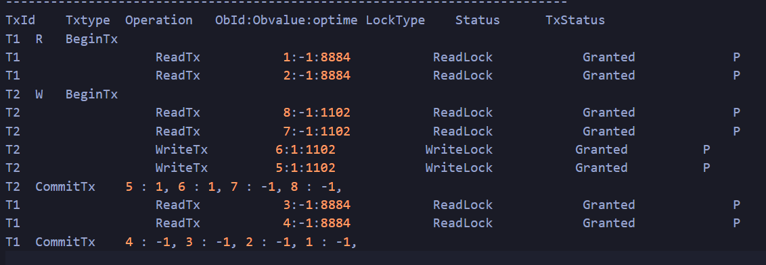
interleaved_RW.txt | 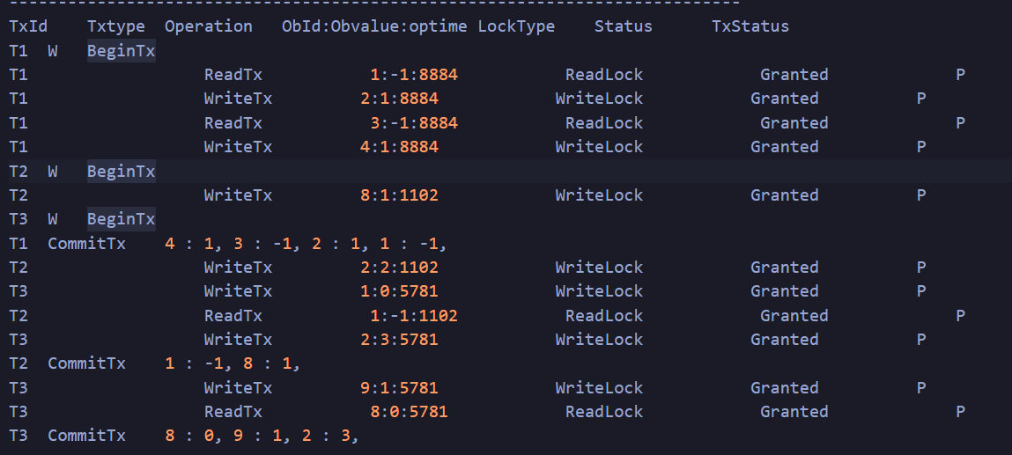
Multi_ROTxs.txt | 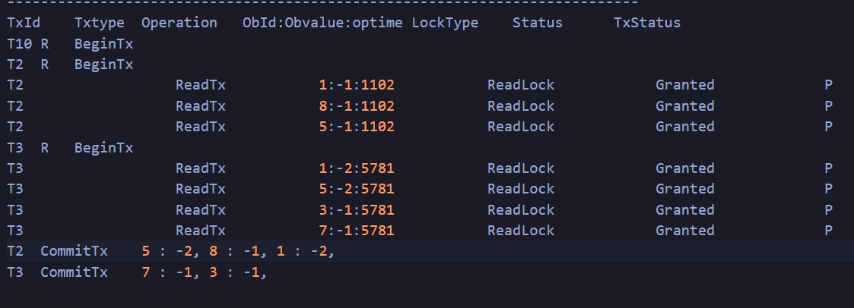
disj_multi_accesses.txt | 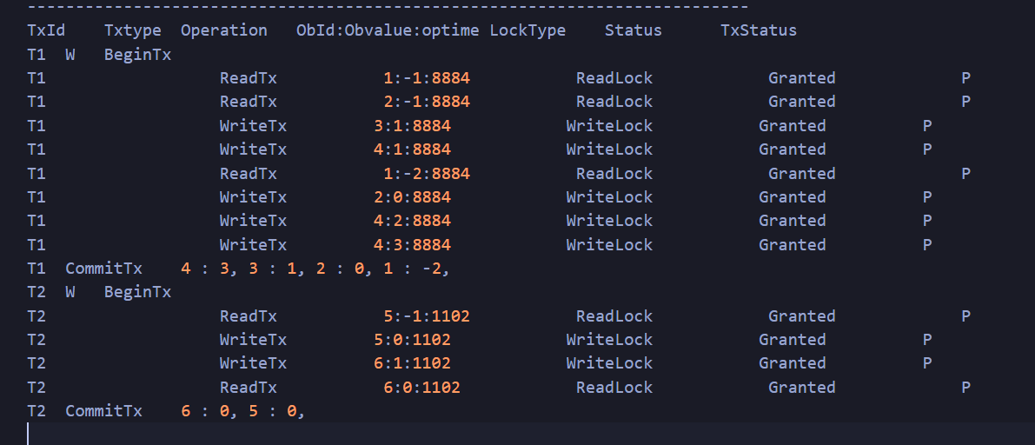
ddlk_3Txs.txt | 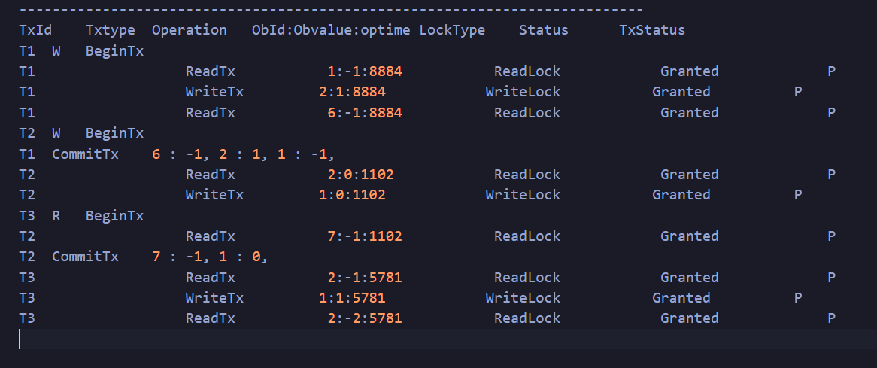
ddlk_2Txs.txt | 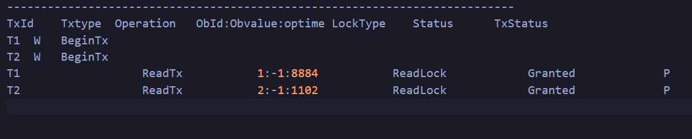
test_abort.txt | 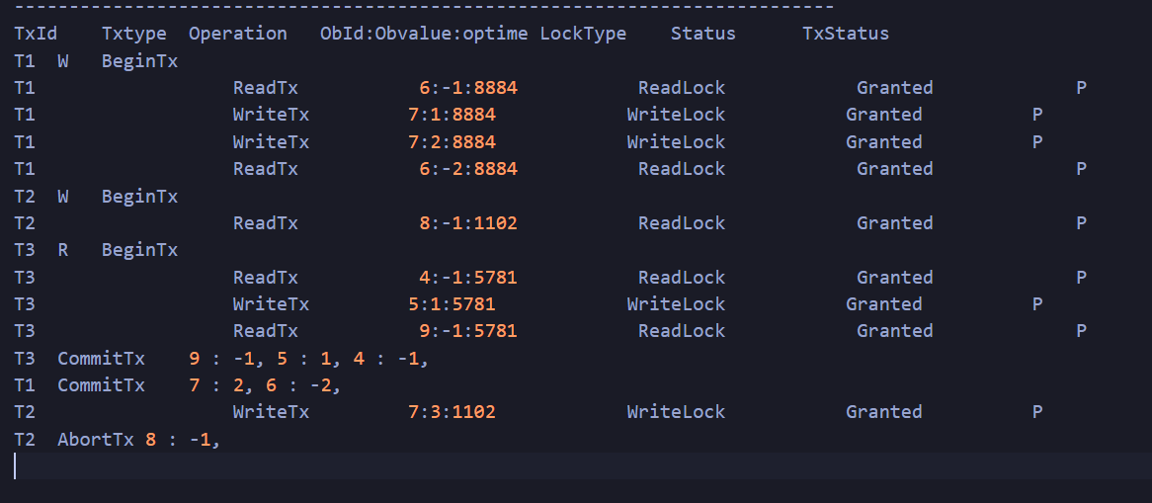
RW_disjoint.txt | 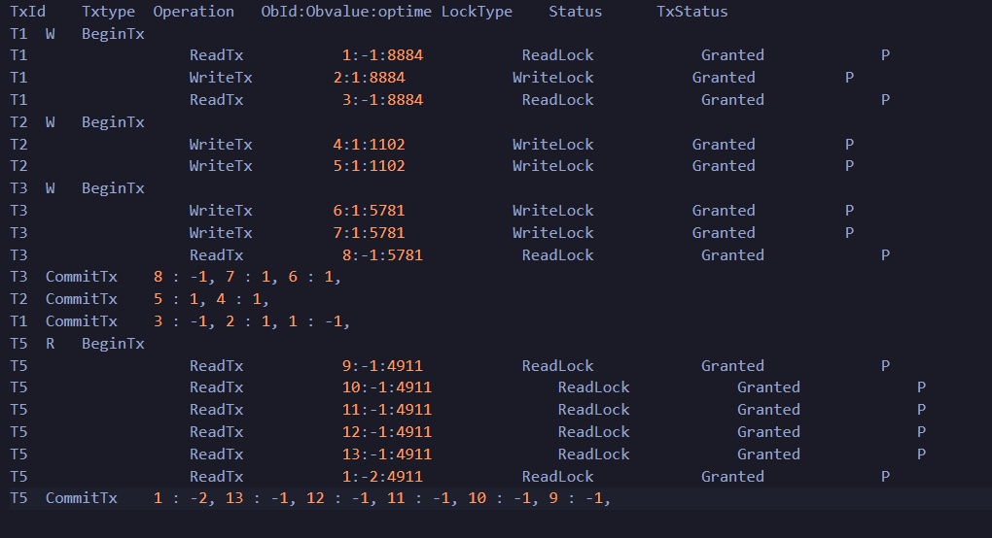
RW_pot_ddlk.txt | 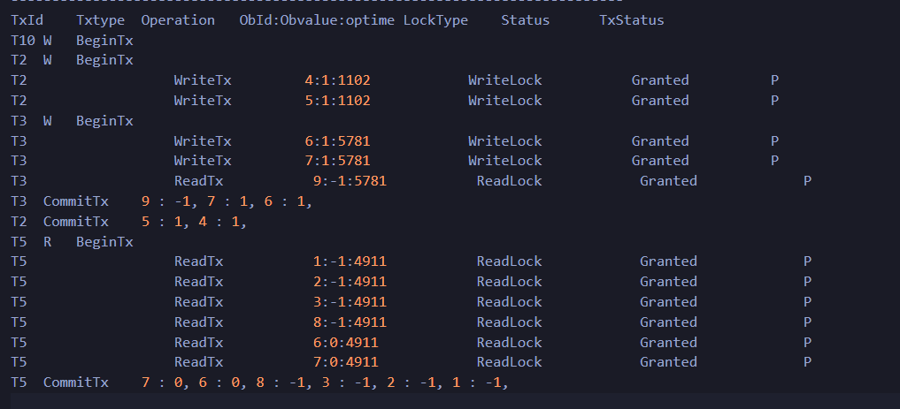
unlikely_ddlk.txt | 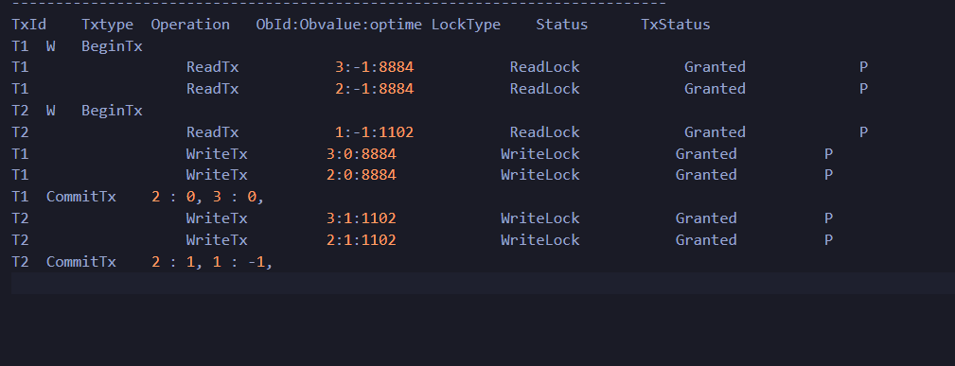
multiple_aborts.txt | 