This app is a full stack mini clone of Tinder, where one can left or right swap the users.

Deployed link: <https://datemenow.netlify.app/>

Please wait for the cards to show up (speed might vary on different networks)

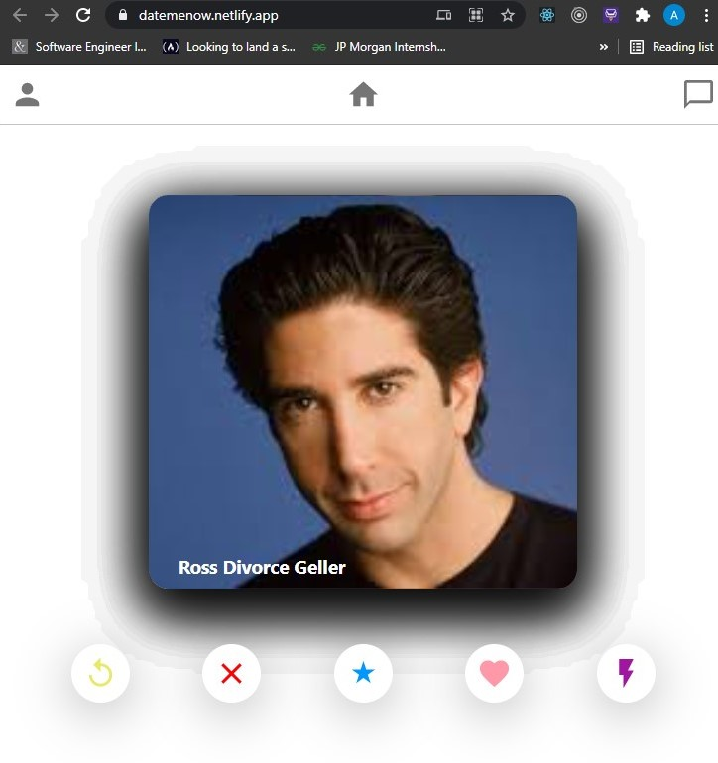

**Tech Stack used:** MongoDB, Express, Node.js, React.js, React-tinder-cards, POSTMAN

When the app is opened it makes a request to MongoDB server which returns an array with details of different users to display on the card.

The backend is designed to add the details of card to MONGO DB, which can be done using POSTMAN.