SET 1 : (121 ,139,182,164)

1. Write the python program to add two lists of input [1,2,3,4,5,6] and [4,6,12,3,2,1] using map and lambda and then perform multiplication for the resultant value off add with the input list [4,2,8,3,2,1]
2. Get the List of strings as input and list of strings individually as character using map () function using python program.
3. Write the python program the calculate cube of a number by using def () and lambda () function.
4. Write the python program to calculate Fahrenheit and Celsius using map () function and print the temperature in Fahrenheit and Celsius.
5. Write the python program to calculate the sequence of the first 11 Fibonacci numbers and filter out first the odd and then the even elements from the sequence of the first 11 Fibonacci numbers.

SET 2 (124, 138 , 167, 177)

Lab 2 – Procedural Programming

1. Write a function pyramid that gets the number of lines as argument and prints the below pyramid

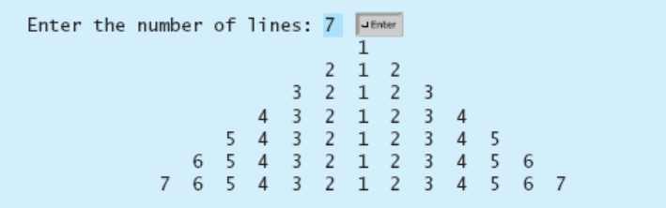

2. You are given a list of tuples with each tuple having three elements of the format (a,b,c) where a,b and c are positive integers. Create a lambda function that takes three arguments a, b and c and returns the output (a+b)2 + c. Use this lambda function on the list of tuples with the Python built in map function to generate a new list of answers of lambda expression.

3. Check if parantheses (),{} or [] in an expression is balanced.

Example: (2+4*[89-5(78+16)]-6) is balanced whereas

(5+8-[56-{12/3})] is unbalanced

Hint: Use stack concepts with lists

4. Get a list of non-empty tuples from the user. You can use any end of sequence representation e.g “end” or “quit” for tuples and list input entry. Write a function sort_tuple(). Input to the function is the list of tuples entered by the user. Output from the function is a sorted list according to the condition - sorted in increasing order by the last element in each tuple.

e.g. [(1, 7), (1, 3), (3, 4, 5), (2, 2)] yields

[(2, 2), (1, 3), (3, 4, 5), (1, 7)]

5. Create a function that takes an integer between 0 and 999 as its only parameter, and returns a string containing the English words for that number. For example, if the parameter to the function is 142 then your function should return “one hundred forty two”. Use one or more dictionaries to implement

SET 3 (122, 137, 150, 180)

**18CSC207J ADVANCED PROGRAMMING PRACTICE**

**(Lab experiment for the week 1-02-2021 to 05-02-2021)**

1. Create a function for finding average of N numbers (where N=95,98,95,98,99) using python Programming (Define the function name as avg)
2. Develop a python code to double the given number using lambda function.
3. Create a subroutine called tables and print the tables by passing the parameter 3600 .
4. Develop a python code to display the items with duplicate elements and print the number of items in the tuple.
5. Create a python code to display the processor, number of cores and year of release of an new AMD processor using Dictionary with above key and give the values for it.

SET 4 (123, 144, 155, 181)

1.Write a Python function to Find Factorial of Number using Recursion. The function accepts the number as an argument.

# 2. Write a Python function to Display Fibonacci Sequence using Recursion

# 3. Write a Python function to check whether a number is in a given range.

# 4. Write a Python function that prints out the first n rows of Pascal's triangle.

5. Write a Python function that takes a list and returns a new list with unique elements of the first list

Example

Sample List : [1,2,3,3,3,3,4,5]  
Unique List : [1, 2, 3, 4, 5]

Set 5: (125, 142, 157, 178)

### Consider a list of all the computer languages ['CPP', 'C', 'Python', 'CPP', 'Java', 'Java']. There are some languages repeated in the list. Write a Code in Python to display the unique elements from List.

### Assume we have the following list which contains the name of some all-time greatest cricket players: player = ['Kohli', 'Tendulkar', 'Lara', 'Ponting', 'Kallis']. Write a function “select()”in Python which takes a list as parameter. Your task is to write a code in the function that selects one player randomly and display it.

### Given an array A containing n integers. The task is to check whether the array is Monotonic or not. An array is monotonic if it is either monotone increasing or monotone decreasing. An array A is monotone increasing if for all i <= j, A[i] <= A[j]. An array A is monotone decreasing if for all i <= j, A[i] >= A[j]. Your task is to write a function - “CheckMonotonic()”)” that takes the input array as input. Return “True” if the given array A is monotonic else return “False”.

(a) Input : 6 5 4 4

Output: True

(b) Input : 5 12 10 15

Output: False

1. In the COVID 19 pandemic, the districts were categorized as red, green and yellow zone, depending on the number of cases recorded. Write a subroutine “zone()” in python for this application. The task is to get the name of the district and number of cases recorded per week. The subroutine takes the number of cases as parameter and returns the zone of the district.

|  |  |
| --- | --- |
| Cases recorded per week. | Zone |
| >=10,000 | Red |
| >=2000 and <10,000 | Yellow |
| <2,000 | Green |

Input:

District: Kancheepuram

Number of cases: 7000

Output:

Yellow

5. A set of lottery ticket numbers are in the range [1, 10]. You have purchased a ticket numbered N. The official drawing is done by randomly choosing a number in [0, 10]. If the drawn number matches with your ticket number, then you are the jackpot winner. Write a python function Winner() for choosing the winner of the lottery system. The function should return the lucky number using the random module.

Set 6: (129, 148, 162, 176)

1. Write a python code for creating a password for E-Aadhar card. The details used are the first 4 letters of your name, date and month of your birth. The task is to generate a password with the lambda function and display it.

Input:

Name: Rajeev

Date of Birth: 04-12-1990

Output: raje0412

**2.** Given an array of names of candidates in an election. A candidate name in the array represents a vote cast to the candidate. Print the name of candidates received Max vote. If there is tie, print a lexicographically smaller name.

Input : votes[] = {"John", "Johnny", "Jackie", "Johnny", "John", "Jackie", "Jamie", "Jamie", "John", "Johnny", "Jamie", "Johnny", "john"}

Output : John

Explanation: We have four Candidates with name as 'John', ‘Johnny’, 'Jamie', 'Jackie'. The candidates John and Johnny get maximum votes. Since John is alphabetically smaller, we print it.

3.A web application is developed for a bank. The first page gets the user id and password. Write a python application to check the credentials of the user. The task is to enter 5 pairs of user id and password in a dictionary and perform the following.

Credentials: {Ramesh: 12345, Seetha: abcde, Abhishek: pqrst, Ramya: 98765, Priya: xyzab}

1. Input:

User id: Ramesh

Password: 12345

Output: Dear Ramesh, you are welcome to our bank

1. Input:

User id: Abhsk

Password: 1245

Output: ‘Your details does not match with our records’

**4.** Develop an application called Quiz. Store 7 pairs of questions and answers in a dictionary. The task is to ask 5 questions. The user enters the answers. For every correct answer 1 mark is awarded. Finally, display the total score of the user.

### 5. Captchas are tools you can use to differentiate between real users and automated users, such as bots. Create a tuple of 5 captcha in python. Your task is to randomly display a captcha from the tuple. Then enter the captcha. If the same captcha was entered, then display “You are not a robot”, else display “You are a robot”

### (a) Enter 5 captcha:

### Rh7yA, ju97g, gP0h3, mn0Gl, Ril98

### Enter the following captcha to check if you are a robot: ju97g

### Ju97g

### You are not a robot

### (b) Enter 5 captcha:

### Rh7yA, ju97g, gP0h3, mn0Gl, Ril98

### Enter the following captcha to check if you are a robot: gP0h3

### Xh564

### You are a robot

Set 7: (126, 137, 151, 175)

1. Data protection has become one of the most crucial task in the internet. An application uses Caesar cipher for this purpose, which works as following:

The encryption can be represented using [modular arithmetic](https://en.wikipedia.org/wiki/Modular_arithmetic) by first transforming the letters into numbers, according to the scheme, A → 0, B → 1, ..., Z → 25. Encryption of a letter x by a shift n can be described mathematically as,



Write a subroutine “encrypt(msg, n)” that takes ‘msg’ and ‘n’ as parameters and returns encrypted text using Caesar cipher.

Text : ATTACKATONCE

Shift: 4

Cipher: EXXEGOEXSRGI

2**.** Develop an application called “Feedback analyzer”. The application has sets of words for the feedback –‘Positive’, ‘Negative’.

Positive – (good, excellent, super, great, fantastic)

Negative – (bad, worse, worst, pathetic, poor)

Your task is to store the bag of words in a tuple. Given a feedback sentence, find out if it is a positive or negative feedback.

(a) Input: The watch is good

Output: Positive

(b) Input: The watch is pathetic

Output: Negative

3. Image encryption plays a major role in the transmission of multimedia data. The greyscale value of a pixel is in the ranges of [0,255]. The following method is used for encrypting a pixel value for a given key, which is in the range [0,255] too.

temp_pixel = pixel (xor) ((key+5)%256)

Write a lambda function in python to perform the above task. For increasing the strength of the cipher the encryption must be repeated 5 times.

4**.** Write 2 lambda functions in python to calculate the volume and area of a sphere using the formulas.

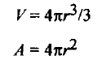

### 5. An application has to be created for storing the register number and Xth board exam marks of the students. Your task is to create a dictionary in python to store the pair {register_no: marks} for 5 students. For a given, register number, display the corresponding marks.

Set 8: (128, 147, 160, 174)

**Subroutines**

1. Use incremental development to write a function called hypotenuse that returns the length of the hypotenuse of a right triangle given the lengths of the two legs as arguments. Record each stage of the development process as you go.

**Lambda Functions**

1. Find the Number Occurring Odd Number of Times using Lambda expression and reduce function

Given an array of positive integers. All numbers occur even number of times except one number which occurs odd number of times. Find the number in O(n) time & constant space.

Examples:

Input : [1, 2, 3, 2, 3, 1, 3]

Output : 3

**Functions**

1. Write a Python program to find number of days between two given dates. Given two dates, Write a Python program to find the total number of days between them.

Examples:

Input : dt1 = 13/12/2018, dt2 = 25/2/2019

Output : 74 days

Input : dt1 = 01/01/2004, dt2 = 01/01/2005

Output : 365 days

**Tuples and List**

1. A) Write a python code to remove tuples from list of tuples if greater than n. Given a list of a tuple, the task is to remove all the tuples from list, if it’s greater than n (say 100).

Example:

intial_list [(‘b’, 100), (‘c’, 200), (‘c’, 45), (‘d’, 876), (‘e’, 75)]

Resultant tuple list: [(‘b’, 100), (‘c’, 45), (‘e’, 75)]

4) b) Given a list of tuples, write a Python program to remove all the duplicated tuples from the given list.

Example:

Input : [(1, 2), (5, 7), (3, 6), (1, 2)]

Output : [(1, 2), (5, 7), (3, 6)]

Input : [('a', 'z'), ('a', 'x'), ('z', 'x'), ('a', 'x'), ('z', 'x')]

Output : [('a', 'z'), ('a', 'x'), ('z', 'x')]

**Dictionary**

5.Given a sequence of strings, the task is to find out the second most repeated (or frequent) string in the given sequence. (Considering no two words are the second most repeated, there will be always a single word).

Examples:

Input : {"aaa", "bbb", "ccc", "bbb",

"aaa", "aaa"}

Output : bbb

#### Set 9 -18CSC207J-Advance Programming Practice - Week 2 Programs (127, 149, 159, 172)

#### Create a function showEmployee() in such a way that it should accept employee name, and it’s salary and display both, and if the salary is missing in function call it should show it as 9000

1. Write a Python program to create a lambda function that adds 15 to a given number passed in as an argument, also create a lambda function that multiplies argument x with argument y and print the result.
2. Write a Python program to count the number of strings where the string length is 2 or more and the first and last character are same from a given list of strings.
3. Write a Python program to convert a tuple of string values to a tuple of integer values.

Original tuple values:  
(('333', '33'), ('1416', '55'))  
New tuple values:  
((333, 33), (1416, 55))

1. Write a Python program to print all unique values in a dictionary.

Sample Data : [{"V":"S001"}, {"V": "S002"}, {"VI": "S001"}, {"VI": "S005"}, {"VII":"S005"}, {"V":"S009"},{"VIII":"S007"}]  
Expected Output : Unique Values: {'S005', 'S002', 'S007', 'S001', 'S009'}

Set 10 (130, 141, 156, 171)

1. Write a Python function that accepts a string and calculate the number of upper case letters and lower case letters.

Sample String : 'The quick Brow Fox'  
Expected Output :  
No. of Upper case characters : 3  
No. of Lower case Characters : 12

1. Write a Python program to create a lambda function that takes one argument, and that argument will be multiplied with an unknown given number.
2. Write a Python program to generate and print a list of first and last 5 elements where the values are square of numbers between 1 and 30 (both included).
3. Write a Python program to compute the sum of all the elements of each tuple stored inside a list of tuples.

Original list of tuples:  
[(1, 2), (2, 3), (3, 4)]  
Sum of all the elements of each tuple stored inside the said list of tuples:  
[3, 5, 7]  
Original list of tuples:  
[(1, 2, 6), (2, 3, -6), (3, 4), (2, 2, 2, 2)]  
Sum of all the elements of each tuple stored inside the said list of tuples:  
[9, -1, 7, 8]

1. Write a Python program to create and display all combinations of letters, selecting each letter from a different key in a dictionary.

Sample data : {'1':['a','b'], '2':['c','d']}  
Expected Output:  
ac  
ad  
bc  
bd

Set 11 (158 170 146 131)

**Week 2**

1. **Functions**

Write a Python program that accepts a hyphen-separated sequence of words as input and prints the words in a hyphen-separated sequence after sorting them alphabetically.   
Sample Items : green-red-yellow-black-white  
Expected Result : black-green-red-white-yellow

1. Lambda Functions

Implement a python program with Lambda function to execute the filter () to determine the odd numbers and even numbers separately from a list of given 10 numbers

Sample input : my_list=[1,2,3,4,11]

Sample output :

Odd

[1,3,11]

Even

[2,4]

1. Subroutines

Implement a subroutine sequence in python to carry out binary serach and linear serach for a sample set of 5 inputs.

1. List and Tuples

Implement a python program for a given a list of tuples, the task is to remove all tuples having duplicate first values from the given list of tuples.

Sample Input: [(12.121, 'Tuple1'), (12.121, 'Tuple2'),

(12.121, 'Tuple3'), (923232.2323, 'Tuple4')]

Sample Output: [(12.121, 'Tuple1'), (923232.2323, 'Tuple4')]

1. Dictionary

Implement a python program Given Dictionary with value lists, the task is to write a Python program to assign each key with an index of the maximum value in the value list.

Sample Input : test_dict = {“gfg” : [5, 3, 6, 3], “is” : [1, 7, 5, 3], “best” : [9, 1, 3, 5]}

Sample Output : {‘gfg’: 2, ‘is’: 1, ‘best’: 0}

(Hint : Max element in “gfg”‘s value is 6 at 2nd index, hence assigned 2)

Set 12 (155, 169, 132, 145)

**Week2: Procedure oriented Programming, MAP, Lambda, List**

1.A Discrete Mathematics professor has a class of students. Frustrated with their lack of discipline, he decides to cancel class if fewer than some number of students are present when class starts. Arrival times go from on time (arrivalTime<=0) to arrived late (arrivalTime>0).

Given the arrival time of each student and a threshhold number of attendees, determine if the class is canceled.

Sample Input

2

4 3

-1 -3 4 2

4 2

0 -1 2 1

Sample Output

YES

NO

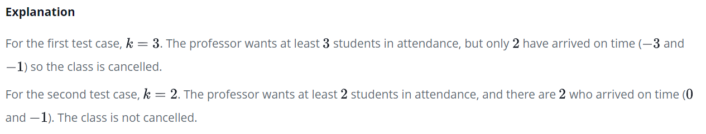

2. Anna and Brian are sharing a meal at a restaurant and they agree to split the bill equally. Brian wants to order something that Anna is allergic to though, and they agree that Anna won't pay for that item. Brian gets the check and calculates Anna's portion. You must determine if his calculation is correct.

For example, assume the bill has the following prices:bill =[2,4,6]. Anna declines to eat item k= bill[2] which costs 6. If Brian calculates the bill correctly, Anna will pay (2+4)/2 =3 . If he includes the cost of bill[2], he will calculate (2+4+6)/2=6 . In the second case, he should refund 3 to Anna.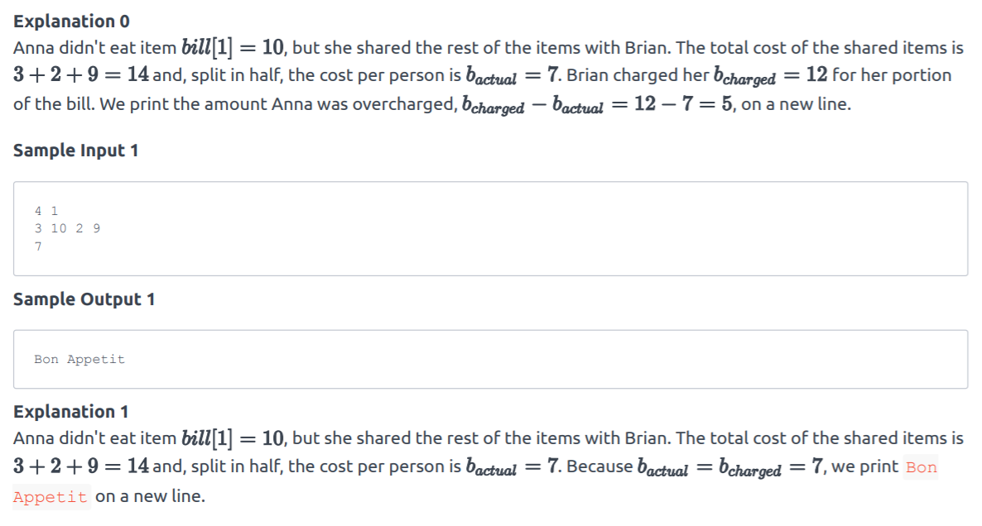

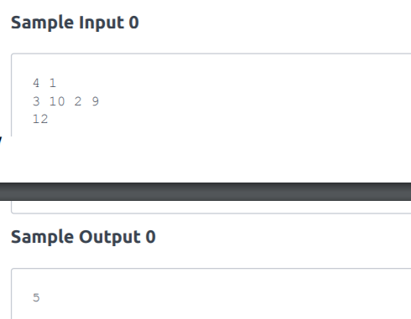

1. Below are the two lists convert it into the dictionary keys = ['Ten', 'Twenty', 'Thirty'] values = [10, 20, 30] Expected output: {'Ten': 10, 'Twenty': 20, 'Thirty': 30}
2. A list on a single line containing the cubes of the first  N Fibonacci numbers using lambda function.

Sample Input

5

Sample output

[0, 1, 1, 8, 27]

1. Use map and lambda function to display Fahrenheit

C = [39.2, 36.5, 37.3, 38, 37.8]

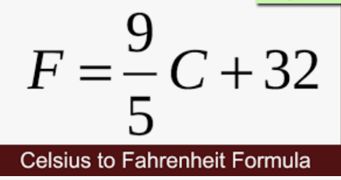

SET 13 (154, 168, 133, 143)

1. Implement a Python program to sort a list of dictionaries using Lambda.

Original list of dictionaries :  
[{'make': 'Nokia', 'model': 216, 'color': 'Black'}, {'make': 'Mi Max', 'model': '2', 'color': 'Gold'}, {'make': 'Samsung', 'model': 7, 'color': 'Blue'}]  
Sorting the List of dictionaries :  
[{'make': 'Nokia', 'model': 216, 'color': 'Black'}, {'make': 'Samsung', 'model': 7, 'color': 'Blue'}, {'make': 'Mi Max', 'model': '2', 'color': 'Gold'}]

1. Create a Python function that accepts a string and calculate the number of upper case letters and lower case letters.    
   Sample String : 'The quick Brow Fox'  
   Expected Output :  
   No. of Upper case characters : 3  
   No. of Lower case Characters : 12
2. Write a Python program to move all zero digits to end of a given list of numbers.    
   Expected output:  
   Original list:  
   [3, 4, 0, 0, 0, 6, 2, 0, 6, 7, 6, 0, 0, 0, 9, 10, 7, 4, 4, 5, 3, 0, 0, 2, 9, 7, 1]  
   Move all zero digits to end of the said list of numbers:  
   [3, 4, 6, 2, 6, 7, 6, 9, 10, 7, 4, 4, 5, 3, 2, 9, 7, 1, 0, 0, 0, 0, 0, 0, 0, 0, 0]
3. Create a Python script to print a dictionary where the keys are numbers between 1 and 15 (both included) and the values are square of keys.    
   Sample Dictionary  
   {1: 1, 2: 4, 3: 9, 4: 16, 5: 25, 6: 36, 7: 49, 8: 64, 9: 81, 10: 100, 11: 121, 12: 144, 13: 169, 14: 196, 15: 225}
4. Write a Python program to find the numbers of a given string and store them in a list, display the numbers which are bigger than the length of the list in sorted form. Use lambda function to solve the problem.    
   Original string: sdf 23 safs8 5 sdfsd8 sdfs 56 21sfs 20 5  
   Numbers in sorted form:  
   20 23 56

SET 14 (152, 166 , 134, 163)

**Week -2 Procedure Programming Paradigm Using Python**

1. Develop a checker program using functions in python, which checks for the occurrence of all the characters from the alphabets that exist atleast once, in the given sentence

2. Develop a Numeric adder- classifier using lambda functions in python that could classify the non-negative values and negative values of the given 10 elements that are presented in the tuple. The adder implements the addition that could be done separately for the negative and non-negative elements.

3. Develop a redundancy remover using functions in python, where the redundancy remover takes the elements of the list and returns the elements of the list with the redundant element removed.

4. Develop an arithmetic encoder using functions in python which can generate element-wise average of the given tuple

Tuple

(1, 2, 3, 4)  
(3, 5, 2, 1)  
(2, 2, 3, 1)

5. Develop a NLP application using functions in python, where the word analyzer needs to count the characters of the word that are presented in the given gazetteers.

Gazetteers

{1:’Apple’, 2:’Oracle’,3:’Advanced Programming Practice’,4:’Software Project Management’, 5:’Fundamentals of mathematics’}

SET 15 (136, 165)

# 1. Write a Python function to check whether a number is in a given range.

# 2. Write a Python function that prints out the first n rows of Pascal's triangle.

# 3. Write a Python program to compute the sum of all the elements of each tuple stored inside a list of tuples.

Original list of tuples:  
[(1, 2), (2, 3), (3, 4)]  
Sum of all the elements of each tuple stored inside the said list of tuples:  
[3, 5, 7]  
Original list of tuples:  
[(1, 2, 6), (2, 3, -6), (3, 4), (2, 2, 2, 2)]  
Sum of all the elements of each tuple stored inside the said list of tuples:  
[9, -1, 7, 8]

4. Write a Python program to create and display all combinations of letters, selecting each letter from a different key in a dictionary.

Sample data : {'1':['a','b'], '2':['c','d']}  
Expected Output:  
ac  
ad  
bc  
bd

5**.** Write 2 lambda functions in python to calculate the volume and area of a sphere using the formulas.



SET 16 (68,74,100,105)

1. Write a Python Program to Convert octal to binary, binary to decimal.

2. Write a Python function that prints out the first n rows of Pascal's triangle.

3. Write a Python program to execute a string containing Python code.

4. Write a Python program to create a dictionary of keys x, y, and z where each key has as value a list from 11-20, 21-30, and 31-40 respectively. Access the fifth value of each key from the dictionary.

{'x': [11, 12, 13, 14, 15, 16, 17, 18, 19],  
'y': [21, 22, 23, 24, 25, 26, 27, 28, 29],  
'z': [31, 32, 33, 34, 35, 36, 37, 38, 39]}  
15  
25  
35  
x has value [11, 12, 13, 14, 15, 16, 17, 18, 19]  
y has value [21, 22, 23, 24, 25, 26, 27, 28, 29]  
z has value [31, 32, 33, 34, 35, 36, 37, 38, 39]

5.Write a Python program to create a dictionary from two lists without losing duplicate values.