1 :

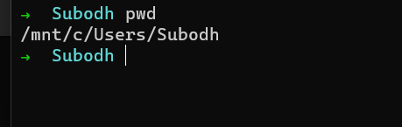

2 :

Absolute path :

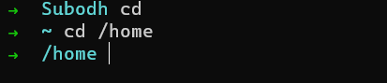

Root directory :

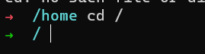

Current directory :

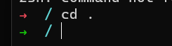

Parent directory :

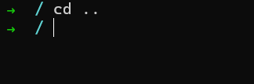

3 (LS) :

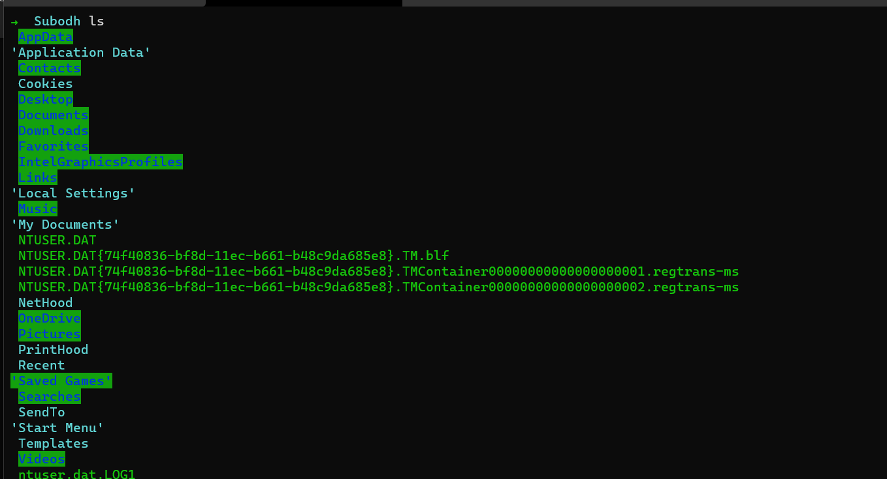

Hidden files :

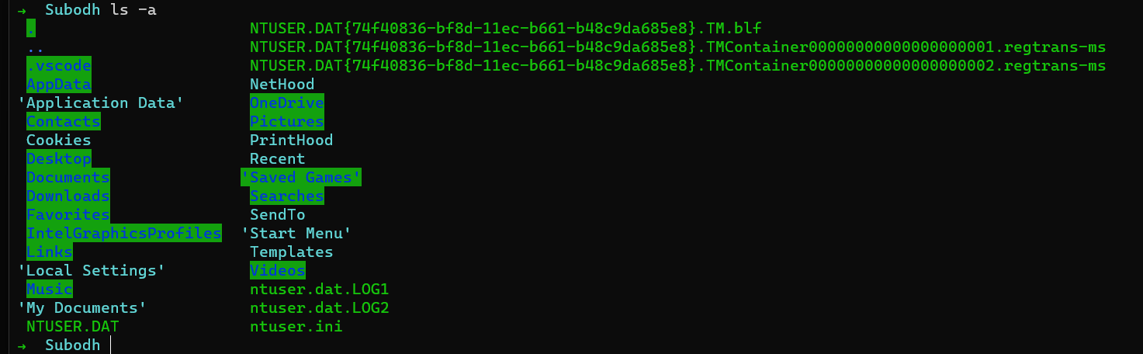

Long list format :

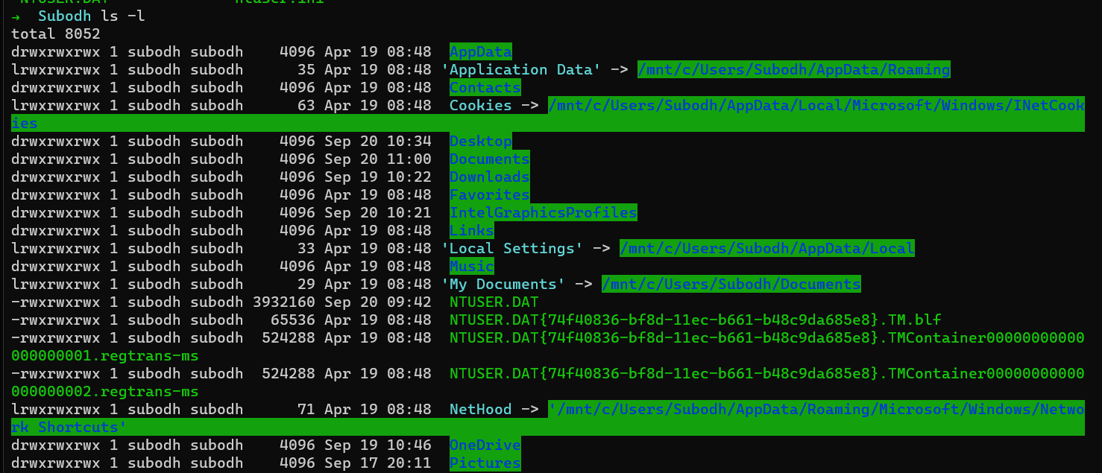

-R to display content of sub directories

4 : (mkdir) :

Mkdir <dirname>

For multiple – mkdir <dirname1> <dirname2> ..





5 : rmdir :



rm -r <dirname> (to remove dir along with subdirectories)

6 : touch :

To create empty files



7 : rm :

To remove files



8 : cp -r :

Cp to copy a file or a directory.

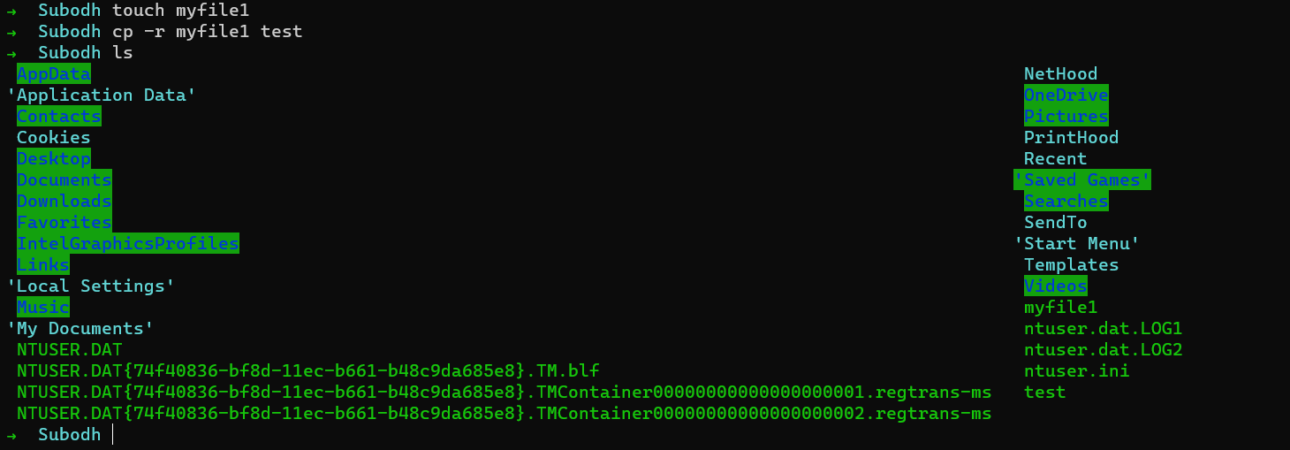

9 : mv

Mv command to move a existing file or a directory from one location to another.

10 : Head

Displays content of a file. It displays 10 lines of any files.

-n displays a specified number of lines.

Syntax : Head -n 15 <filename>

11: tail

Displays the last lines of a file. Main purpose is to read the error message

-n to display the specific number of lines.

Syntax : tail <filename>

12 : cat

Displays the content of a file

Cat <filename>

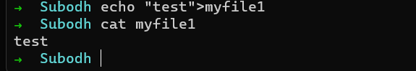

13 : echo

Writes messages in file



14 : tac

It’ll display the content of the file in reverse order.