**Arithmetic Operator**

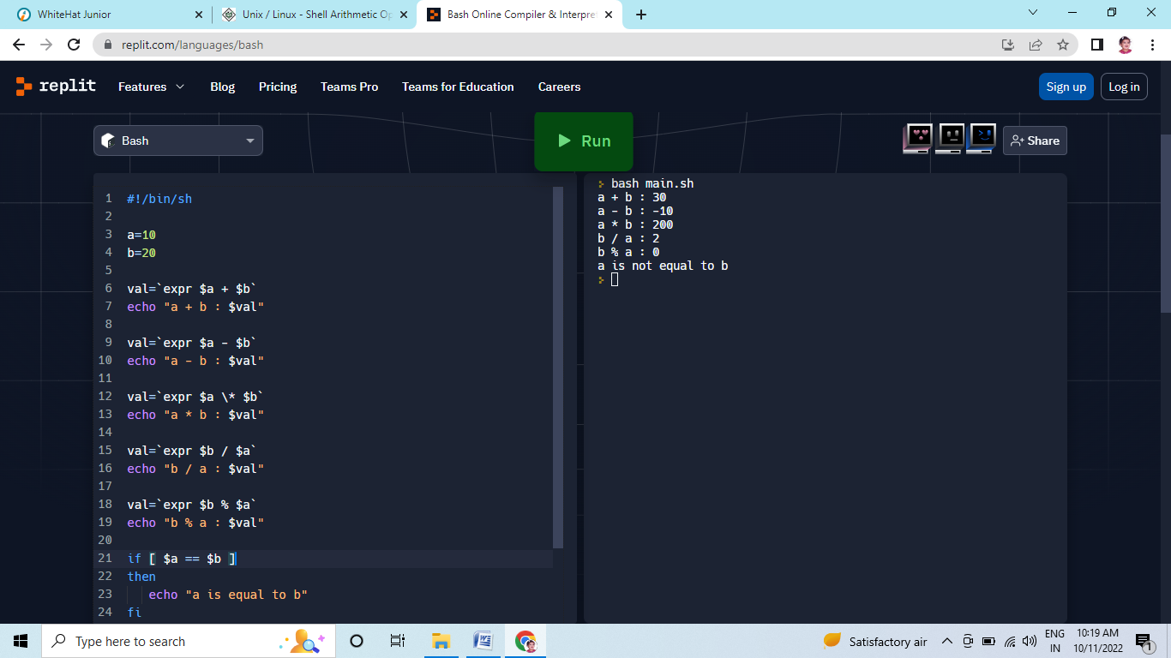

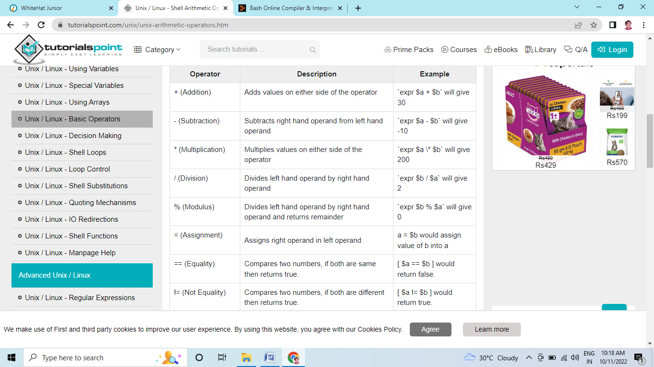

#!/bin/bash

read -p 'Enter a : ' a

read -p 'Enter b : ' b

sum=` expr $a + $b `

echo Addition of a and b are $sum

sub=` expr $a - $b `

echo Subtraction of a and b are $sub

mul=` expr $a \* $b `

echo Multiplication of a and b are $mul

div=` expr $a / $b `

echo Division of a and b are $div

mod=` expr $a % $b`

echo Modulus of a and b are $mod

((++a))

echo After increment the value of a is $a

((--b))

echo After decrement the value of b is $b

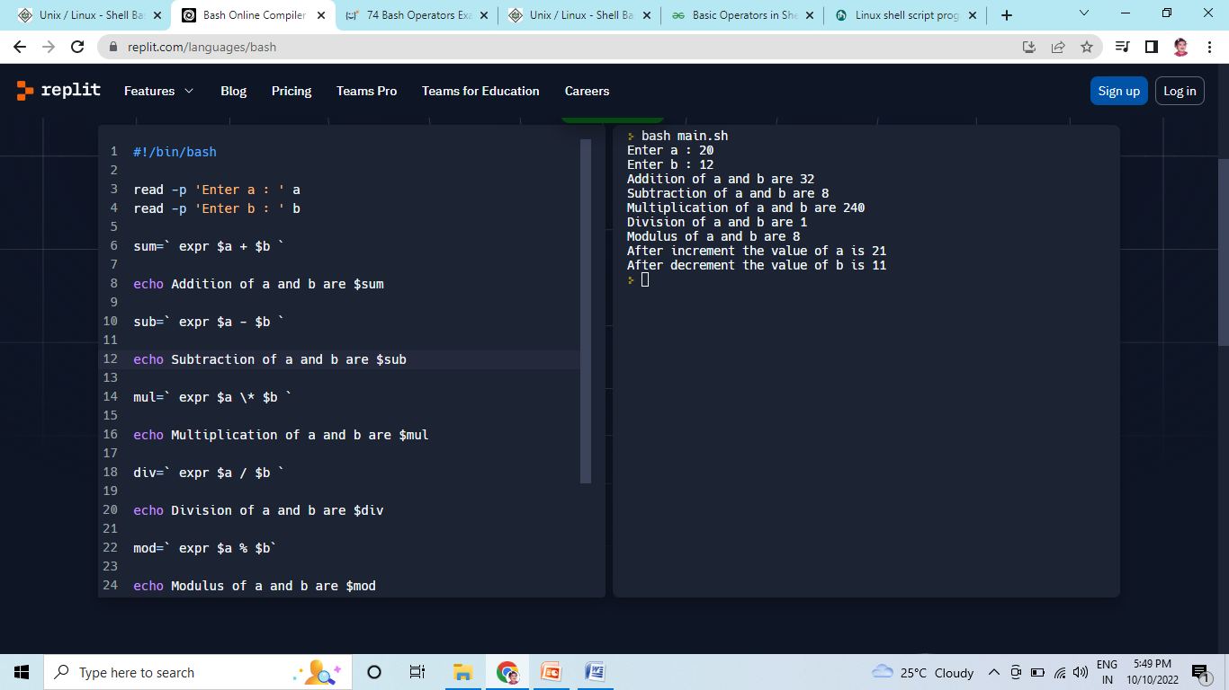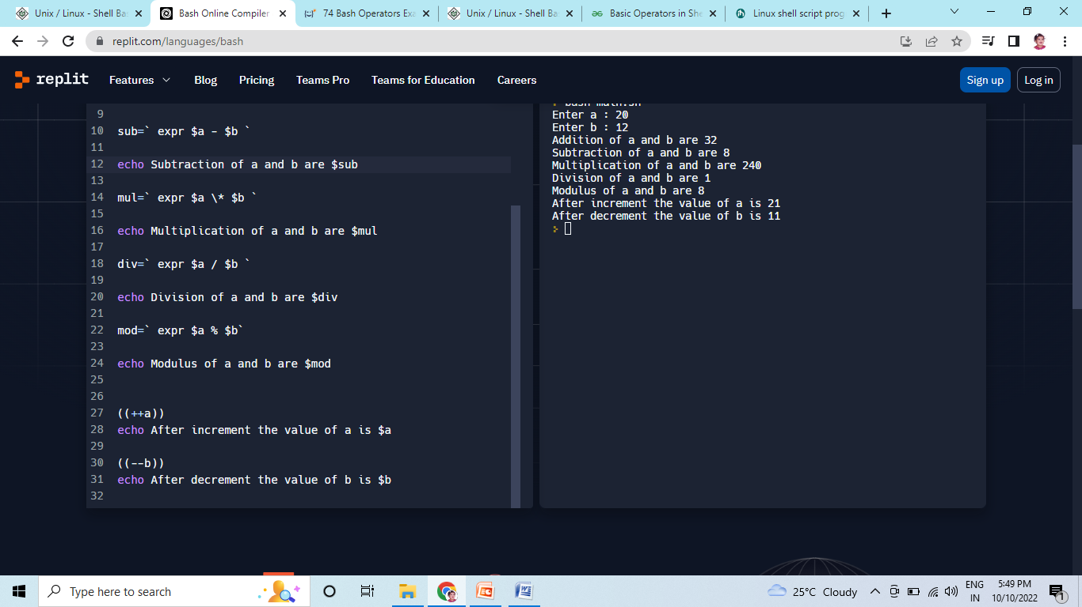

**Relational Operator**

**#!/bin/bash**

**#reading data from the user**

**read -p 'Enter a : ' a**

**read -p 'Enter b : ' b**

**if(( $a==$b ))**

**then**

**echo a is equal to b.**

**else**

**echo a is not equal to b.**

**fi**

**if(( $a!=$b ))**

**then**

**echo a is not equal to b.**

**else**

**echo a is equal to b.**

**fi**

**if(( $a<$b ))**

**then**

**echo a is less than b.**

**else**

**echo a is not less than b.**

**fi**

**if(( $a<=$b ))**

**then**

**echo a is less than or equal to b.**

**else**

**echo a is not less than or equal to b.**

**fi**

**if(( $a>$b ))**

**then**

**echo a is greater than b.**

**else**

**echo a is not greater than b.**

**fi**

**if(( $a>=$b ))**

**then**

**echo a is greater than or equal to b.**

**else**

**echo a is not greater than or equal to b.**

**fi**

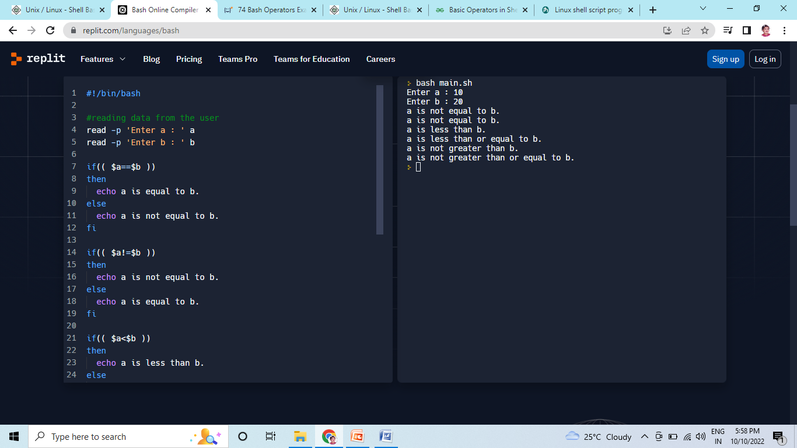

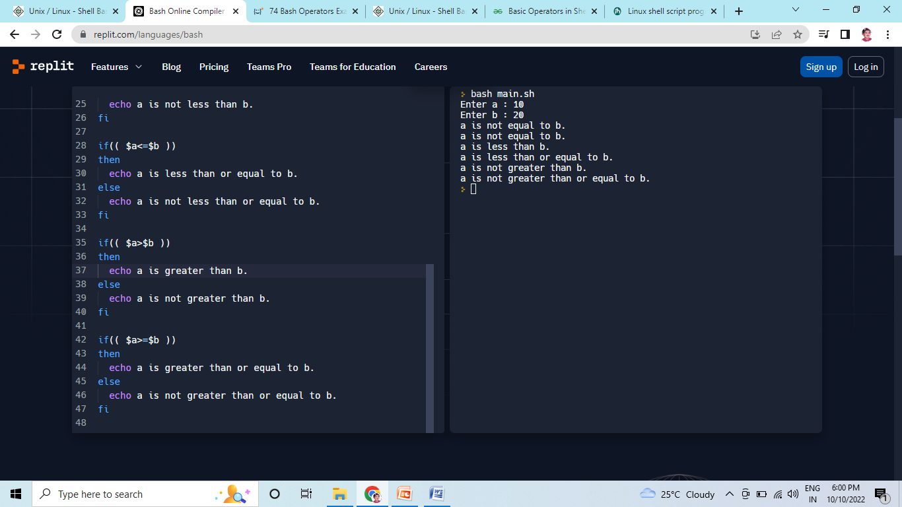

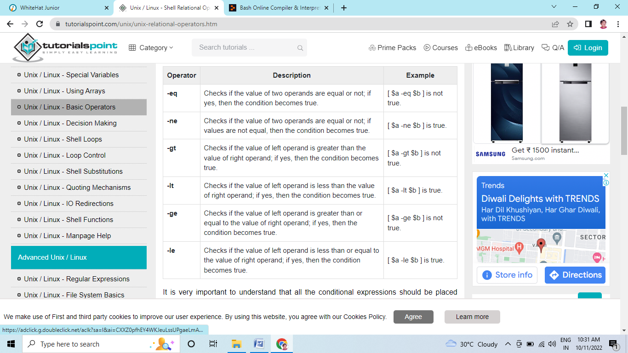

It is very important to understand that all the conditional expressions should be placed inside square braces with spaces around them. For example, **[ $a <= $b ]** is correct whereas, **[$a <= $b]** is incorrect.

#!/bin/sh

a=10

b=20

if [ $a -eq $b ]

then

echo "$a -eq $b : a is equal to b"

else

echo "$a -eq $b: a is not equal to b"

fi

if [ $a -ne $b ]

then

echo "$a -ne $b: a is not equal to b"

else

echo "$a -ne $b : a is equal to b"

fi

if [ $a -gt $b ]

then

echo "$a -gt $b: a is greater than b"

else

echo "$a -gt $b: a is not greater than b"

fi

if [ $a -lt $b ]

then

echo "$a -lt $b: a is less than b"

else

echo "$a -lt $b: a is not less than b"

fi

if [ $a -ge $b ]

then

echo "$a -ge $b: a is greater or equal to b"

else

echo "$a -ge $b: a is not greater or equal to b"

fi

if [ $a -le $b ]

then

echo "$a -le $b: a is less or equal to b"

else

echo "$a -le $b: a is not less or equal to b"

fi

