|  |
| --- |
| **SOCIAL NFT MARKETPLACE**  **A Project Report**  **Submitted**  **In Partial Fulfillment of the Requirements**   **For the Degree of**    **Bachelor of Technology (B.Tech)**  **in**  **Computer Science & Engineering (AI & ML)**  **by**    **Aman Kumar**  **2001331530027**      **Under the Supervision of**  **Ms. Neelam**      **NOIDA INSTITUTE OF ENGINEERING AND TECHNOLOGY**  **GREATER NOIDA**    **DR. A P J ABDUL KALAM TECHNICAL UNIVERSITY,**  **UTTAR PRADESH, LUCKNOW** |

# Declaration

We hereby declare that the project work presented in this report entitled **“SOCIAL NFT**

**MARKETPLACE”*,*** in partial fulfilment of the requirement for the award of the degree of

Bachelor of Technology in Computer Science & Engineering AI& ML, submitted to **NOIDA INSTITUTE OF ENGINEERING AND TECHNOLOGY** , is based on our own work carried out at Department of Computer Science & Engineering AI & ML. The work contained in the report is true and original to the best of our knowledge and project work reported in this report has not been submitted by us for award of any other degree or diploma.

Signature:

Name: Aman Kumar

Roll No: 2001331530027

Date:

Place: Greater Noida

# Certificate

This is to certify that the Project report entitled **“SOCIAL NFT MARKETPLACE” done by**

**Aman Kumar (2001331530027)** is an original work carried out by them in Department of Computer Science & Engineering AI & ML , **NOIDA INSTITUTE OF ENGINEERING AND TECHNOLOGY**, Greater Noida under my guidance. The matter embodied in this project work has not been submitted earlier for the award of any degree or diploma to the best of my knowledge and belief.

Date:

**Ms. Neelam Bidhuri** **Mr. Shubhas Chandra**

**Signature of the Supervisor**   **Head of Department**

# Acknowledgement

The merciful guidance bestowed to us by the almighty made us stick out this project to a successful end. We humbly pray with sincere heart for his guidance to continue forever.

We pay thanks to our project guide **Ms. Neelam Bidhuri** who has given guidance and light to us during this project. His/her versatile knowledge has helped us in the critical times during the span of this project.

We pay special thanks to our Head of Department **Mr. Shubhas Chandra** who has been always present as a support and help us in all possible way during this project.

We also take this opportunity to express our gratitude to all those people who have been directly and indirectly with us during the completion of the project.

We want to thank our friends who have always encouraged us during this project.

At the finally thanks to all the faculty of CSE (AI & ML) department who provided valuable suggestions during the period of project.

# Abstract

Social Media plays an important role in our day today’s life. Social media has opened the door of opportunity to socialize with the people around or anywhere in the world. This paper analyzed how a normal photo sharing social media website can be converted into a social NFT Marketplace. The research aims to provide a theoretical contribution in creating a website in web 3 that is not only involved in photo sharing but also converting it into NFT sale and purchase business. The Study discusses the user’s social media behavior with an NFT market. Paper also identifies the making of a NFT marketplace in such an environment so that sale and purchases of NFT become the part of daily life of people implementing them in social media and ultimately increase the whole market value and revenue.

## TABLE OF CONTENT

Declaration ………….................................................................................................. (ii)

Certificate ................................................................................................................. (iii)

Acknowledgement …………............................................................................................................ (iv)

Abstract ................................................................................................................. (v)

Table of Content.............................................................................................................. (vi)

List of Figures ………………………………………………………………………… (viii)

**Chapter 1. Introduction..........................................................................................** 1

1.1 Background & Motivation...................................................................... 2

1.2 Objective………………………............................................................. 2

1.3 Delimitation of research….……………………………….................... 3

1.4 Benefits of research….………………………………………………... 4

**Chapter 2.** **Literature Survey................................................................................** 5

2.1 Introduction …………………………………………………………. 6

2.2 Key Takeaways.................................................................................... 7

2.3 How does a blockchain work………………………………………... 8

2.4 Attributes of Cryptocurrency…….………………………………… 8

2.5 How blockchain is revolutionizing………………………………… 9

2.6 Literature review…………………………………………………… 9

**Chapter 3. Problem Formulation and Proposed Work……………………….** 12

3.1 Introduction …………………………………………………………. 13

3.2 Problem Statement …………………………………………………… 14

3.3 Proposed Work ………………………………………………………. 16

**Chapter 4. System Analysis & Design …............................................................** 17

4.1 NFT………………………………….……………………………… 18

4.2 Data Flow Diagram…………………………………………………. 20

4.3 System Architecture………………………………………………… 21

**Chapter 5. Methodology…........................................................................................** 22

5.1 Initialization of front-end………………………………………….…. 22

5.2 Routing/Navigation in your app………………………………………. 25

5.3 Next.js data fetching…………………………………………………... 27

**Chapter 6. Result & Analysis ………………………..........................................** 28

6.1 Initialization of hardhat………………………………………… 29

6.2 Writing and compiling smart contract…………………………... 30

6.3 Compiling contracts……………………………………………... 31

6.4 Deploying to remote network…………………………………...

32

**Chapter 7. Conclusion & Future Scope.……………………….............................** 34

7.1 Inferences………………………………………………. 35

7.2 Future scope……………………………………………. 36

**References …………………………………………………………………….....** 38

**Appendix I** Plagiarism Report of Project Report**………………………………...** 39

**Appendix II** Research Paper based on**………………………………….………...** 43

**Appendix III** Plagiarism Report of Research Paper**………………………………** 48

**Figure No. Description Page No.**

**Figure 2.2.1** Blockchain a shared database…………………….. 7

**Figure 2.4.1** Attributes of cryptocurrency……………………… 8

**Figure 4.1** Metamask wallet………………………………….. 17

**Figure 4.2** Polygon network…………………………………. 18

**Figure 4.1.1** NFT Token……………………………………….. 19

**Figure 4.2.1** Data flow diagram………………………………… 20

**Figure 4.3.1** System Architecture………………………………. 21

**Figure 5.1.1** Initialization of front end…………………………. 22

**Figure 5.1.2** Initialization of next.js……………………………. 23

**Figure 5.1.3** Next.js folders…………………………………….. 23

**Figure 5.1.4** Index.js app……………………………………….. 24

**Figure 5.2.1** Navigation/Routing in app………………………... 25

**Figure 5.2.2** Linking home page……………………………….. 26

**Figure 5.3.1** Retrieving data with next.js ……………………… 27

**Figure 6.1** NPX Hardhat …………………………….............. 28

**Figure 6.1.1** Hardhat config.js…………………………………. 29

**Figure 6.2.1** Smart Contract……………………………………. 30

**Figure 6.3.1** Contract Compilation…………………………….. 31

**Figure 6.3.2** Deploying contract……………………………….. 32

**Figure 6.4.1** Deploying to Alchemy…………………………… 32

**LIST OF FIGURES**

# Chapter 1

## Introduction

NFT Marketplace is an internet based commercial center where craftsmen sell their multifaceted craftsmanship and where purchasers can get to it utilizing digital currency, like Bitcoin. Many business sectors additionally charge exchange expenses and require a record also (normally free).

Currently, the utilization of virtual entertainment has turned into an everyday need.

Web-based entertainment is frequently used to speak with the general population and access data and data, as well as simply decide. It is a significant specialized device with others locally and around the world, as well as sharing, making, and scattering data. Virtual entertainment can impact customer buying choices through audits, promoting procedures and publicizing. As a matter of fact, virtual entertainment colossally affects our capacity to convey, construct connections, access and disperse data, and pursue better choices.

Studies have shown that a disturbing number of individuals invest 25% of their energy via virtual entertainment, further demonstrating how significant and well known online entertainment are as of late. So, the inquiry emerges, "why placed an NFT thing via virtual entertainment?” One of those interests comes from individuals who appreciate supporting crafted by autonomous makers by buying their works," said Artsy CEO Mike Steib.

The most recent NFTs cost records appear to be generally determined by recently given crypto moguls and billions hoping to seize their bitcoin property, etc. Interest in the crypto biological system. “So the thing we are doing here is simply uniting these two stages in a single spot so making the NFT commercial center so expandable and everyday work among its clients. The consideration of an NFT commercial center via online entertainment can carry dynamic change

xi

to both the PC and business designing divisions by establishing a one-of-a-kind climate for communicating with individuals locally and simultaneously leading the business through them.

xii

### 1.1 Background & Motivation

Blockchain is a conveyed site that is divided among PC network hubs. As a data set, blockchain stores data electronically in a computerized design. Blockchain is most popular for its significant job in digital currency frameworks, like Bitcoin, for keeping a safe and special exchange record. The new plan of the blockchain guarantees and carries out the uprightness and security of the information records and makes trust with no contribution of outsiders.

One significant contrast between a standard site and a blockchain is how information is organized. Blockchain gathers data together in gatherings, known as blocks, that catch data sets. Blocks have a specific stockpiling limit and, once finished, are shut and associated with a pre-filled block, shaping a progression of information known as the blockchain. Everything new data following a recently introduced block is added to the recently constructed block which will be added to the series once finished.

A site typically sorts out its information into tables, while a blockchain, as its name suggests, coordinates its information into pieces (blocks) gathered. This information structure normally makes an irreversible course of events of information when utilized in an alternate setting. At the point when the block is filled, it is put on a stone and turns out to be essential for this course of events. Each block in the series is given a timestamp when it is added to the series.

### 1.2 Objective

The main objective of the project is to not limit social media to influencer marketing, social interaction, business promotion and many more but to also include a web 3 component in social media to make a new marketplace for the NFT marketplace.

It will be as simple as for users to use this application: - A.

They simply have to login into their account. B. Upload their favorite pic to the server.

1. The code will convert their pic into NFT.
2. It will be further published in the feed of the people who follow the particular person.
3. From their onwards, followers can easily like the NFT.
4. And if they want, they can make a buyout to the NFT as simple as that.

Studies have shown that a significant number of people spend 25% of their time on social networking platforms, which shows how relevant and popular social media platforms have become in recent times. So this encourages us to revolutionize social media viewing with a broader NFT marketplace.

As it may be guessed, this objective will be helpful to artists and common people to get a new platform to make the sale and purchase of their NFT by being in continuous contact with their social media, users will get to explore a new world of NFT marketplace in web3.

### 1.3 Delimitation of research

Delimitations of research refer to the specific boundaries or limitations that the researcher sets on the scope of their study. In the context of a research project on NFT marketplaces, some possible delimitations could include:

1. Geographic delimitation: The study could be limited to specific regions or countries where NFT marketplaces are more prevalent, such as the United States, Europe, or Asia.
2. Time delimitation: The study could focus on a specific time period, such as the past year, to analyse trends and developments in the NFT marketplace.
3. Platform delimitation: The study could focus on specific NFT marketplaces, such as OpenSea, Rarible, or Super Rare, to analyse their features, operations, and impact.
4. User delimitation: The study could focus on specific groups of users, such as artists, collectors, investors, or developers, to analyse their behaviour, motivations, and experiences in the NFT marketplace.
5. Topic delimitation: The study could focus on specific topics related to NFT marketplaces, such as legal issues, technical challenges, or economic implications, to provide a more focused and in-depth analysis.

The delimitations of research in NFT marketplaces should be based on the research questions, objectives, and methodology of the study, as well as the availability of data and resources. It is important to clearly define the delimitations to ensure that the study is feasible, relevant, and meaningful.

### 1.4 Benefits of research

Research in the NFT marketplace can provide several benefits, such as:

1. Improving understanding of the NFT ecosystem: Research can help to develop a better understanding of the various stakeholders, trends, challenges, and opportunities in the NFT marketplace. This can help investors, artists, collectors, and other stakeholders to make more informed decisions and strategies.

1. Identifying potential areas for innovation and growth: Research can identify potential areas for innovation and growth in the NFT marketplace, such as new types of digital assets, new use cases, or new market segments. This can help to stimulate innovation and competitiveness in the NFT ecosystem.

1. Providing insights into user behaviour and preferences: Research can provide insights into the behaviour and preferences of NFT users, such as their motivations for buying and selling NFTs, their perception of NFT authenticity and value, or their preferred platforms and features. This can help NFT marketplaces to improve their services and user experience.

1. Informing policy and regulation: Research can inform policy and regulation related to NFTs, such as intellectual property rights, taxation, anti-money laundering, or consumer protection.

This can help to ensure a more stable and sustainable NFT ecosystem.

1. Enhancing academic and professional knowledge: Research can contribute to the academic and professional knowledge of NFTs, blockchain technology, digital art, and other related fields.

This can help to advance the understanding and application of these emerging fields.

Research in the NFT marketplace can provide valuable insights and knowledge that can benefit various stakeholders and contribute to the development of the NFT ecosystem.

# Chapter 2

## Literature Survey

NFT Marketplace is an internet based commercial center where craftsmen sell their multifaceted craftsmanship and where purchasers can get to it utilizing digital currency, like Bitcoin. Many business sectors additionally charge exchange expenses and require a record also (normally free). In this day and age, the utilization of virtual entertainment has turned into an everyday need. Webbased entertainment is frequently used to speak with the general population and access data and data, as well as simply decide. It is a significant specialized device with others locally and around the world, as well as sharing, making, and scattering data. Virtual entertainment can impact customer buying choices through audits, promoting procedures and publicizing. As a matter of fact, virtual entertainment colossally affects our capacity to convey, construct connections, access and disperse data, and pursue better choices.

Studies have shown that a disturbing number of individuals invest 25% of their energy via virtual entertainment, further demonstrating how significant and well-known online entertainment are as of late. So the inquiry emerges, "why placed an NFT thing via virtual entertainment? “One of those interests comes from individuals who appreciate supporting crafted by autonomous makers by buying their works," said Artsy CEO Mike Stein. "Some are dazzled by taking computerized resources anybody can duplicate and guarantee responsibility for. The most recent NFTs cost records appear to be generally determined by recently given crypto moguls and billions hoping to seize their bitcoin property, etc. Interest in the crypto biological system."

So, the thing we are doing here is simply uniting these two stages in a single spot so making the NFT commercial center so expandable and everyday work among its clients. The consideration of an NFT commercial center via online entertainment can carry dynamic change to both the PC and business designing divisions by establishing a one-of-a-kind climate for communicating with individuals locally and simultaneously leading the business through them.

### 2.1 Introduction

The introduction of a literature survey on NFT marketplaces should provide an overview of the topic and explain the importance of studying NFT marketplaces. It should also introduce the research questions and objectives of the literature survey. Here is an example of an introduction: Non-Fungible Tokens (NFTs) have emerged as a new asset class, with the potential to revolutionize the way we create, own, and trade digital assets. NFTs are unique digital assets that are stored on a blockchain, providing immutable ownership and authenticity verification. NFTs can represent a wide range of digital assets, such as art, music, videos, games, and collectibles. NFTs have gained significant attention and popularity in recent years, with high-profile sales and celebrity endorsements. The NFT marketplace has grown rapidly, with a variety of platforms and marketplaces emerging to facilitate NFT trading and investment. However, the NFT marketplace is still in its early stages, and there are many questions and challenges to be addressed.

Therefore, studying NFT marketplaces is important to understand the nature and potential of this new asset class. This literature survey aims to provide a comprehensive overview of the existing literature on NFT marketplaces, with a focus on market analysis, user behavior and preferences, legal and regulatory issues, technical challenges and solutions, and future directions and opportunities. The research questions guiding this literature survey are:

1. What is the current state of the NFT marketplace, in terms of market size, trends, and competition?
2. What are the motivations and behaviors of NFT buyers and sellers, and how do they influence pricing and valuation?
3. What are the key legal and regulatory issues in NFT transactions, and how are they being addressed?
4. What are the technical challenges and solutions in NFT marketplaces, and how do they affect user experience and adoption?
5. What are the emerging trends and future opportunities in NFTs and NFT marketplaces, and how can they be leveraged for economic and social benefits?

### 2.2 Key Takeaways

* A blockchain is a type of shared database that differs from a general website in the way it stores information; blockchains store data in blocks and are then linked together via Cryptography. ● As new data enters, it is added to the new block. Once a block is filled with data, it is tied to the previous block, causing the data to be grouped together in chronological order.
* Different types of information can be stored in the blockchain, but the most common use to date has been as a transaction book.
* In the case of Bitcoin, the blockchain is used in isolation so that no one person or group has the power to control it — instead, all users, in general, retain control.

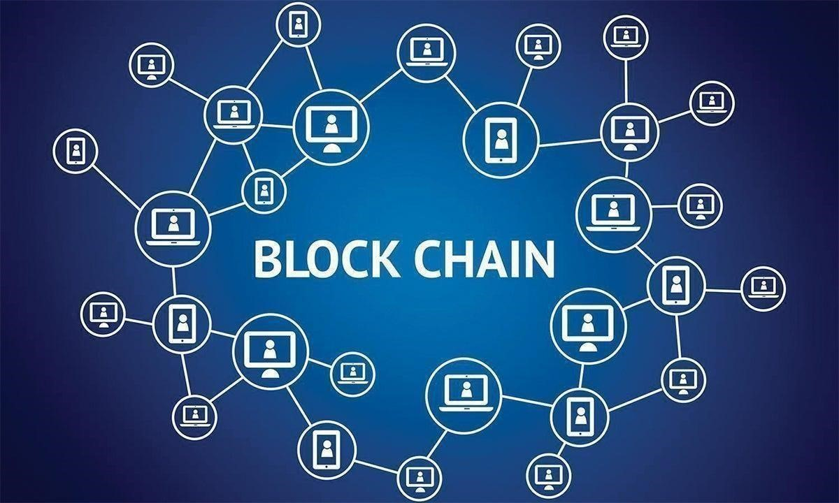

**Figure 2.2.1: Blockchain a shared Database**

### 2.3 How does a blockchain work

The aim of the blockchain is to implement digital information to be saved and distributed, but not to be edited. That is why blockchains are also known as ledger technology (DLT) technology. First proposed as a research project in 1991, the concept of blockchain preceded its first widely used use: Bitcoin, in 2009. In the years since, the use of blockchains has popularized with the creation of enormous cryptocurrencies, financial applications (Defi), non-affiliate tokens (NFTs), and smart contracts.

### 2.4 Attributes of cryptocurrency

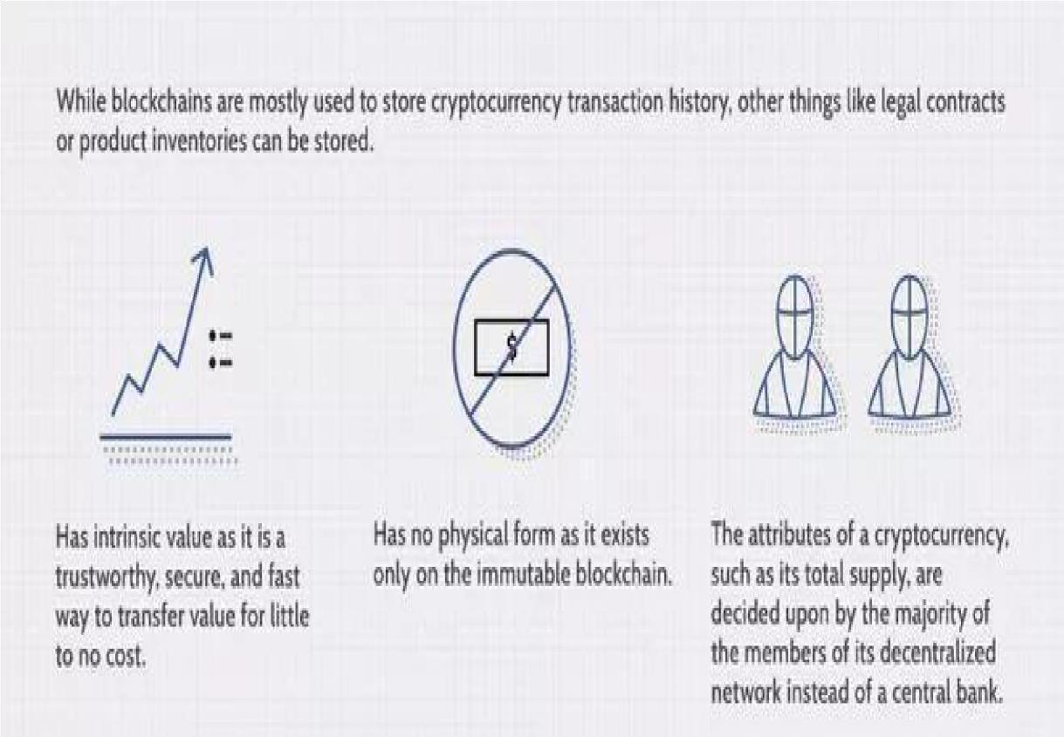

#### Figure 2.2.2: Transaction process

**2.5 How blockchain is revolutionizing content distribution.**

The blockchain technology revolution began with cryptocurrency sets like bitcoin but has grown beyond the financial world and banks. With a host of new businesses and applications built on technology, these industries now represent a major division that will soon affect the world. Blockchain helps spread the cost of running the platform to its various participants but rewards them equally.

This set model is already suitable for blockchain-based solutions such as cloud storage, payment processing, and cybersecurity security. Increasingly, however, technology is also playing an important role in the distribution of content.

For many, this is a better deal than the old-fashioned way, which has seen control and profit remain in the hands of content management companies rather than the content creators themselves. Blockchain can greatly undermine the current state of inequality and seek to restore power to the hands of those people who create and consume content on a great amount.

### 2.6 Literature Review

A literature review on NFT marketplaces is a critical analysis of the existing research and scholarly work on the topic of NFTs and their associated marketplaces. A literature review aims to identify the current state of knowledge on a particular topic, highlight the key findings and gaps in the literature, and provide a critical analysis of the methods and theories used in the studies reviewed.

Here are some examples of literature review on NFT marketplaces:

Example 1: Market Analysis

The NFT marketplace has experienced explosive growth in recent years, with sales volume increasing from $12 million in 2018 to $2.5 billion in the first half of 2021 (NonFungible.com, 2021). The market is dominated by a few major platforms, such as OpenSea, Rarible, and SuperRare, which account for over 80% of the market share (DappRadar, 2021). However, there are also many smaller platforms and marketplaces that cater to specific niches and audiences. The NFT marketplace can be segmented based on several criteria, such as type of asset, genre, platform, and user profile. For example, the most popular NFT categories are art, sports, and collectibles, with art NFTs accounting for over 50% of the market share (NonFungible.com, 2021). Within each category, there are various sub-genres and styles, such as digital art, music, gaming, and memes.

The user profile of NFT buyers and sellers is diverse and dynamic, ranging from individual collectors and investors to celebrities and institutions. Many NFT buyers and sellers are early adopters of blockchain technology and cryptocurrency enthusiasts, but there is also a growing interest from mainstream users and investors. The motivations and behaviors of NFT buyers and sellers vary widely, depending on their goals, preferences, and values.

The competitive landscape of NFT marketplaces is characterized by intense competition, innovation, and consolidation. Many new platforms and marketplaces are entering the market, offering unique features and services to attract users and creators. However, the market is also facing challenges such as high fees, scalability issues, and regulatory uncertainty. The key success factors in the NFT marketplace include user experience, trust, liquidity, and community engagement.

Example 2: User Behavior and Preferences

The NFT marketplace is a complex and dynamic ecosystem that involves a wide range of actors and factors. Understanding the motivations and behaviors of NFT buyers and sellers is crucial to predicting and shaping the future of the NFT marketplace. Several studies have examined the factors that influence NFT pricing and valuation, including aesthetics, rarity, history, and social proof (Kokkinaki et al., 2021; Kogan et al., 2021).

NFT buyers and sellers have different goals and preferences, depending on their background, values, and context. Some buyers are primarily interested in collecting and investing in NFTs as a speculative asset, while others are motivated by the artistic or cultural value of NFTs. Similarly, some sellers are driven by financial gains, while others see NFTs as a new form of creative expression and engagement.

User satisfaction and loyalty in NFT marketplaces depend on various factors, such as ease of use, quality of content, social interaction, and transparency. Many NFT marketplaces offer features such as curation, ratings, and reputation systems to enhance user trust and engagement. However, there are also concerns about fake or low-quality NFTs, scams, and market manipulation, which can undermine user confidence and loyalty.

The adoption and diffusion of NFTs depend on various factors, such as network effects, technology readiness, regulatory support, and social norms. While NFTs have gained significant attention and traction in recent years, there are also challenges and barriers to adoption, such as lack of awareness, complexity, and interoperability issues. To foster the mainstream adoption of NFTs, it is essential to address these challenges and promote the benefits and value of NFTs to different stakeholders.

However, the study also identified some challenges and concerns among NFT buyers and sellers, such as the lack of transparency and liquidity in the marketplace, the high fees and gas costs associated with NFT transactions, and the potential for fraud and scams. These issues can undermine trust and confidence in the NFT marketplace and hinder its growth and adoption.

To address these issues, NFT marketplaces need to focus on improving user experience, transparency, and security, by leveraging technological innovations, such as decentralized finance (DeFi) and smart contracts, and by collaborating with regulators and industry stakeholders to establish best practices and standards. By doing so, NFT marketplaces can unlock the full potential of NFTs as a new asset class, and create value for creators, buyers, and society as a whole.

# Chapter 3

## Problem Formulation and proposed work

Problem formulation and proposed work on NFT marketplace is a research area that focuses on identifying the key challenges and opportunities in the emerging market for non-fungible tokens (NFTs) and designing and developing effective and user-friendly NFT marketplaces. NFTs are unique digital assets that enable creators, investors, and collectors to create, own, and exchange unique digital assets.

The lack of reliable and user-friendly NFT marketplaces is a major obstacle to the wider adoption and use of NFTs. The proposed work aims to address these challenges by conducting a comprehensive research plan that includes a literature review, market analysis, user behavior analysis, technical analysis, design and development, and evaluation of an NFT marketplace. The research plan aims to identify best practices and solutions for developing effective and userfriendly NFT marketplaces that provide a seamless experience for all stakeholders.

The proposed work in the area of problem formulation and proposed work on NFT marketplace is expected to contribute to the emerging field of NFT marketplaces and provide insights into the challenges and opportunities in this market. The study will also provide insights into the potential of NFTs and their impact on various industries, such as art, music, and gaming. Ultimately, the proposed work aims to design and develop effective and user-friendly NFT marketplaces that can overcome the challenges and provide a seamless experience for all stakeholders.

### 3.1 Introduction

As the world becomes more digitized and decentralized, non-fungible tokens (NFTs) have emerged as a new asset class that enables the creation, ownership, and exchange of unique digital assets. NFTs are gaining traction in various industries, including art, music, and gaming, and are becoming increasingly popular among creators, investors, and collectors. However, despite the potential of NFTs, the lack of reliable and user-friendly NFT marketplaces is a major obstacle to their wider adoption and use.

The problem statement for a study on NFT marketplaces revolves around the need to understand the key challenges and opportunities in the emerging market for NFTs. Existing NFT marketplaces often face issues such as high transaction fees, limited functionality, and technical challenges, which can hinder the growth and adoption of NFTs. To address these challenges and maximize the potential of NFTs, there is a need to design and develop effective and user-friendly NFT marketplaces that can provide a seamless experience for all stakeholders.

This proposed work aims to tackle these issues and develop a comprehensive research plan to understand the challenges and opportunities in the NFT marketplace. By conducting a literature review, market analysis, user behavior analysis, technical analysis, design and development, and evaluation of an NFT marketplace, this study aims to design and develop a prototype NFT marketplace that addresses key challenges and provides a seamless experience for users. This work is expected to contribute to the emerging field of NFT marketplaces and provide insights into best practices and solutions for developing effective and user-friendly NFT marketplaces.

Problem formulation involves identifying the specific research question or problem that your study seeks to address. For a study on NFT marketplaces, the problem formulation could be something like:

What are the key challenges and opportunities in the emerging market for NFTs, and how can NFT marketplaces be designed to maximize their potential for creators, investors, and users? Based on the problem formulation, the proposed work would involve a research plan that outlines the methods and approaches that will be used to address the research question. Here are some possible components of a proposed work plan for a study on NFT marketplaces:

1. Literature review: Conduct a comprehensive literature review on NFT marketplaces, including academic articles, industry reports, and news articles. Analyse and synthesize the findings of the studies reviewed and identify key themes and trends in the literature.
2. Market analysis: Conduct a market analysis of the NFT marketplace, including an analysis of market size, growth trends, and competitive landscape. Identify key players in the NFT marketplace and their business models.
3. User behavior analysis: Analyze user behavior and preferences in the NFT marketplace, including factors that influence pricing and purchasing decisions. Identify user needs and pain points in the NFT marketplace.
4. Technical analysis: Conduct a technical analysis of the NFT marketplace, including an analysis of technical challenges and solutions related to NFT transactions, such as gas fees, scalability, and interoperability. Identify promising technical solutions for addressing these challenges.
5. Design and development: Based on the findings of the research, design and develop a prototype NFT marketplace that incorporates best practices and addresses key challenges and opportunities in the NFT marketplace. Conduct user testing and feedback to refine the design and functionality of the marketplace.
6. Evaluation: Evaluate the effectiveness of the proposed NFT marketplace in addressing key challenges and opportunities in the NFT marketplace. Compare the performance of the proposed marketplace to existing NFT marketplaces and identify areas for improvement.

The proposed work plan should be comprehensive and methodologically sound, incorporating both qualitative and quantitative research methods as appropriate. The plan should also be feasible within the timeframe and resources available for the study

### 3.2 Problem Statement

As the use of non-fungible tokens (NFTs) continues to gain popularity in various industries, including art, music, and gaming, there is a need to understand the key challenges and opportunities in the emerging market for NFTs. One of the main challenges is the lack of reliable and userfriendly NFT marketplaces that can facilitate the buying, selling, and trading of NFTs. Existing NFT marketplaces are often plagued by issues such as high transaction fees, limited functionality, and technical challenges, which can hinder the growth and adoption of NFTs. To address these challenges and maximize the potential of NFTs for creators, investors, and users, there is a need to design and develop effective and user-friendly NFT marketplaces that can overcome these challenges and provide a seamless experience for all stakeholders.

The proposed work for the study aims to address this problem statement by conducting a comprehensive research plan that involves a literature review, market analysis, user behavior analysis, technical analysis, design and development, and evaluation of an NFT marketplace. The ultimate goal is to develop a prototype NFT marketplace that incorporates best practices and addresses key challenges and opportunities in the NFT marketplace, and to evaluate its effectiveness in comparison to existing NFT marketplaces.

Here are some possible problem statements for a study on NFT marketplaces:

While NFTs have gained significant popularity and attention in recent years, there is still a lack of understanding and consensus on the key challenges and opportunities in the emerging market for NFTs. This study seeks to identify these challenges and opportunities and propose solutions for designing effective NFT marketplaces.

While NFTs have been hailed as a new frontier in digital art and collectibles, there are concerns about the sustainability and scalability of the NFT marketplace, particularly with regards to technical challenges such as gas fees and scalability. This study seeks to evaluate these challenges and propose technical solutions for addressing them.

While NFTs have the potential to revolutionize the way we think about ownership and value in the digital world, there is a lack of understanding about user behavior and preferences in the NFT marketplace. This study seeks to analyze user behavior and preferences and propose design solutions that meet the needs of NFT marketplace users.

While there are many NFT marketplaces in existence, there is still room for innovation and improvement in the design and functionality of these marketplaces. This study seeks to design and develop a prototype NFT marketplace that incorporates best practices and addresses key challenges and opportunities in the NFT marketplace and evaluate its effectiveness in comparison to existing marketplaces.

While NFTs have the potential to democratize access to ownership and value in the digital world, there are concerns about issues such as copyright infringement and fraud in the NFT marketplace. This study seeks to identify these issues and propose solutions for ensuring the authenticity and legality of NFT transactions.

### 3.3 Proposed Work

The proposed work for a study on NFT marketplaces includes the following steps:

1. Literature Review: A comprehensive literature review will be conducted on NFT marketplaces, including academic articles, industry reports, and news articles. The literature review will analyze and synthesize the findings of the studies reviewed and identify key themes and trends in the literature.
2. Market Analysis: A market analysis will be conducted on the NFT marketplace, including an analysis of market size, growth trends, and competitive landscape. Key players in the NFT marketplace and their business models will be identified, and their strengths and weaknesses will be analyzed.
3. User Behavior Analysis: User behavior and preferences in the NFT marketplace will be analyzed, including factors that influence pricing and purchasing decisions. User needs and pain points in the NFT marketplace will be identified, and potential solutions will be explored.
4. Technical Analysis: A technical analysis will be conducted on the NFT marketplace, including an analysis of technical challenges and solutions related to NFT transactions, such as gas fees, scalability, and interoperability. Promising technical solutions for addressing these challenges will be identified and evaluated.
5. Design and Development: Based on the findings of the research, a prototype NFT marketplace will be designed and developed that incorporates best practices and addresses key challenges and opportunities in the NFT marketplace. The design and functionality of the marketplace will be user-tested and refined.
6. Evaluation: The effectiveness of the proposed NFT marketplace in addressing key challenges and opportunities in the NFT marketplace will be evaluated. The performance of the proposed marketplace will be compared to existing NFT marketplaces, and areas for improvement will be identified.

The proposed work plan aims to provide a comprehensive and methodologically sound approach to understanding the challenges and opportunities in the NFT marketplace and designing and developing effective and user-friendly NFT marketplaces that can overcome these challenges and provide a seamless experience for all stakeholders.

# Chapter 4

## System Analysis & Design

**NFT (Non-Fungible Token):**

A non-fungible token (NFT) is a novel and non-compatible unit of information put away on a blockchain, a type of computerized ledger. NFTs can be related with reproducible computerized records, for example, photographs, recordings, and sound. NFTs utilize a computerized record to give a public testament of genuineness or verification of proprietorship, yet don't confine the sharing or duplicating of the hidden computerized documents. The absence of compatibility (fungibility) recognizes NFTs from blockchain cryptographic forms of money, like Bitcoin.

**BLOCKCHAIN WALLET (MetaMask):**

MetaMask is a digital money programming wallet used to interface with the Ethereum blockchain. It permits clients to get to their Ethereum wallet by means of a program expansion or versatile application, which can then be utilized to collaborate with decentralized applications. MetaMask is created by ConsenSys Software Inc., a blockchain programming organization zeroed in on Ethereum-based devices and foundation.



### Figure 4.1: Metamask Wallet

**POLYGON/ETHEREUM NETWORK:**

Polygon is the framework and foundation for building and connecting Ethereum-compatible blockchain networks. Aggregating scalable solutions of Ethereum support a multi-chain Ethereum ecosystem.

Polygon integrates the best of Ethereum and sovereign blockchains into a single combination of multiple strings.

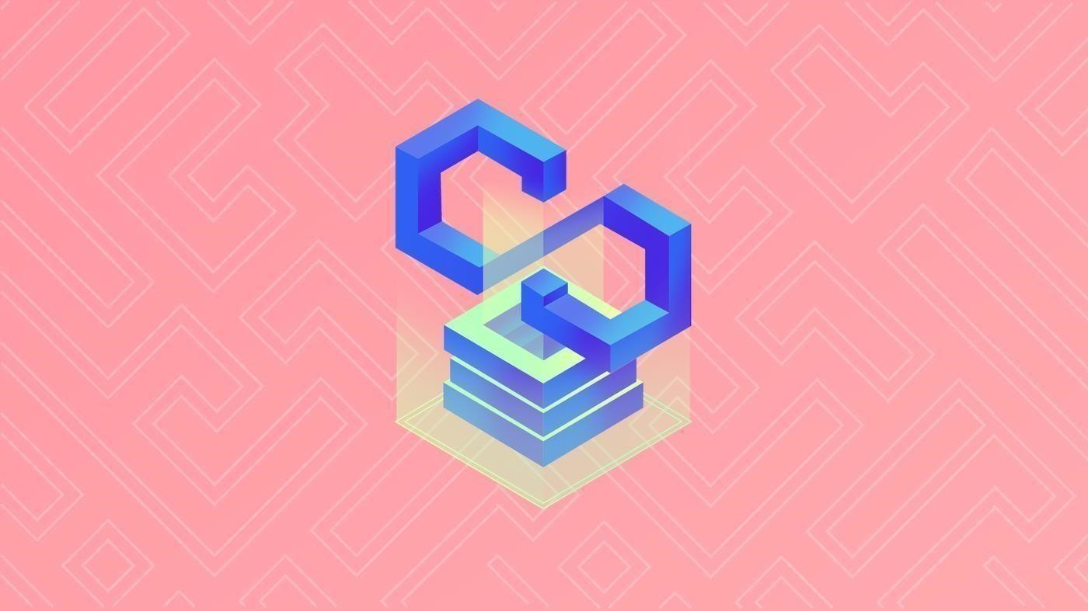

**Figure 4.2: Polygon Network**

### 4.1 Non Fungible Token (NFT)

The NFT is a unit of information put away in a computerized record, called a blockchain that can be sold and exchanged. An NFT might be related to a particular computerized or actual gadget (like a record or actual item) and a permit to involve the gadget for a particular reason. An NFT (and a permit to utilize, duplicate, or show the fundamental gadget) can be exchanged and sold in computerized markets. The unlawful idea of NDP exchanging, as a rule, brings about a casual trade of responsibility for resources that has no legitimate reason for requirement and frequently accommodates utilize just as a superficial point of interest.

A non-fungible token (NFT) is a novel and non-compatible unit of information put away on a blockchain, a type of computerized ledger. NFTs can be related with reproducible computerized records, for example, photographs, recordings, and sound. NFTs utilize a computerized record to give a public testament of genuineness or verification of proprietorship, yet don't confine the sharing or duplicating of the hidden computerized documents. The absence of compatibility (fungibility) recognizes NFTs from blockchain cryptographic forms of money, like Bitcoin.

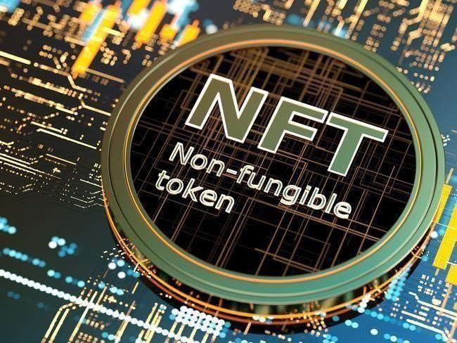

**Figure 4.1.1: NFT Token**

### 4.2 Data flow diagram

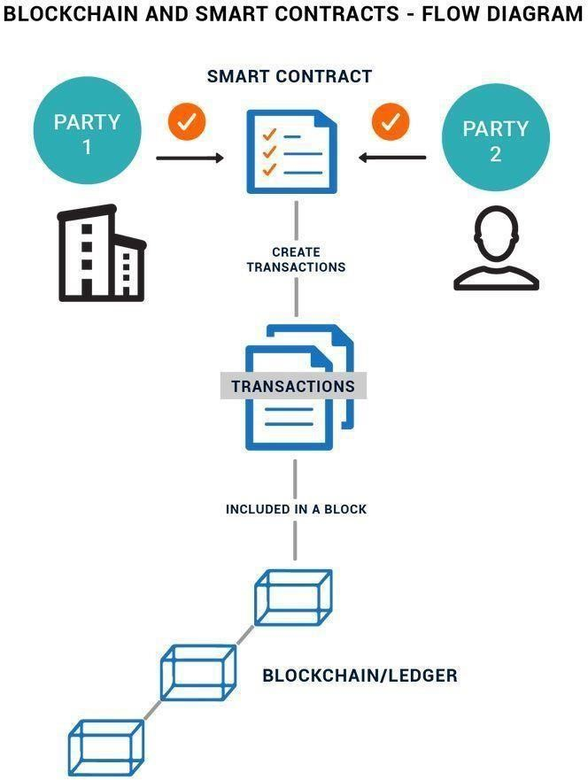

**Figure 4.2.1: Data flow diagram**

### 4.3 System Architecture



**Figure 4.3.1**



**:**



**System architecture**

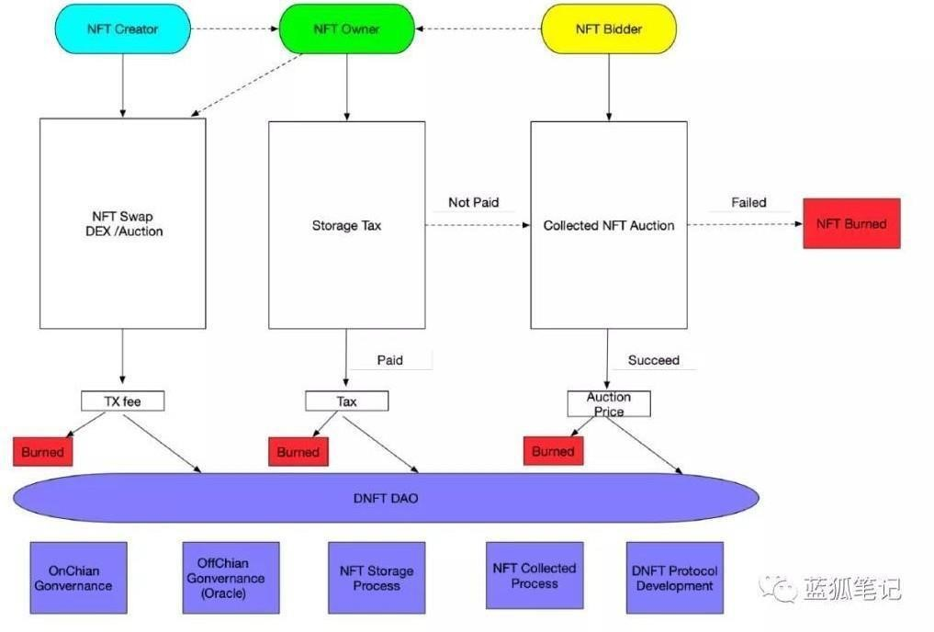

# Chapter 5

## Methodology

**5.1 Initialization of front-end**

Open the terminal in your desired folder and write the following: **npx create-next-app – example with-tailwinds app-name.**

Now the terminal will look like this.

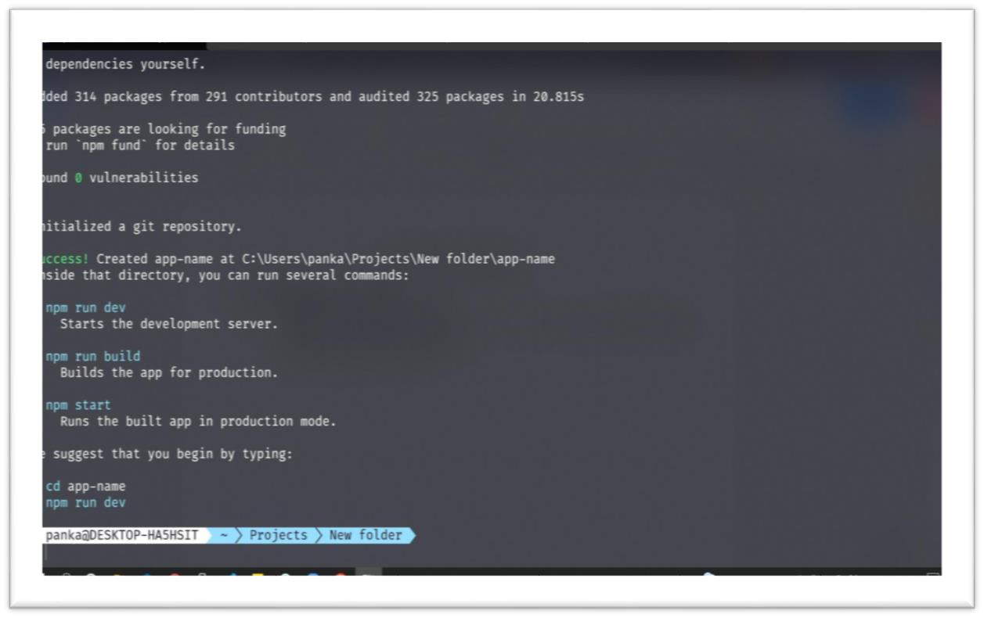

### Figure 5.1.1: Initialization of frontend

**After the installation is complete:**

1. Run npm run dev or yarn dev to start the development server on http://localhost:3000.
2. Visit http://localhost:3000 to view your application.
3. Edit pages/index.js and see the updated result in your browser.

Now at the initial stage the application will be shown as below.

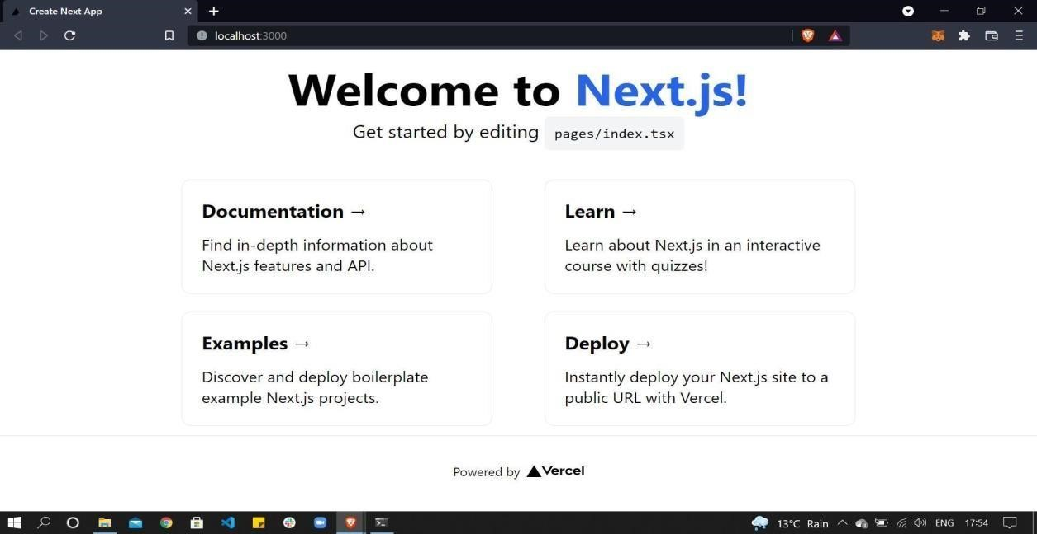

**Figure 5.1.2: Initialization of Next.js**

Now go back to the terminal and write **code.** It will open the VS code and the directory structure is shown below.

Next.js Folder Structures:

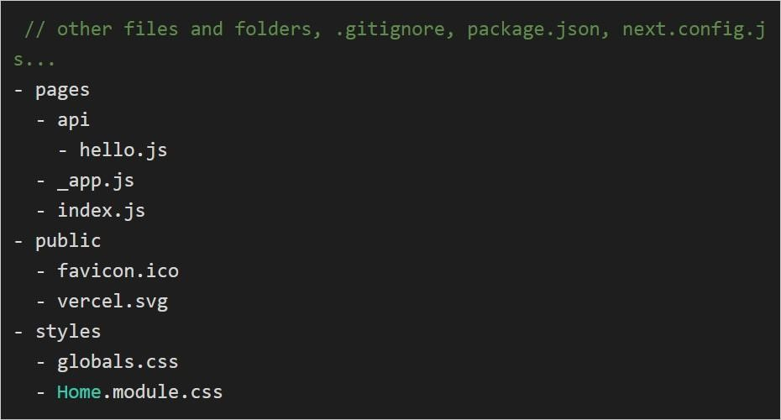

### Figure 5.1.3: Next.js folder

The index.js file for this project's single page has the following format:

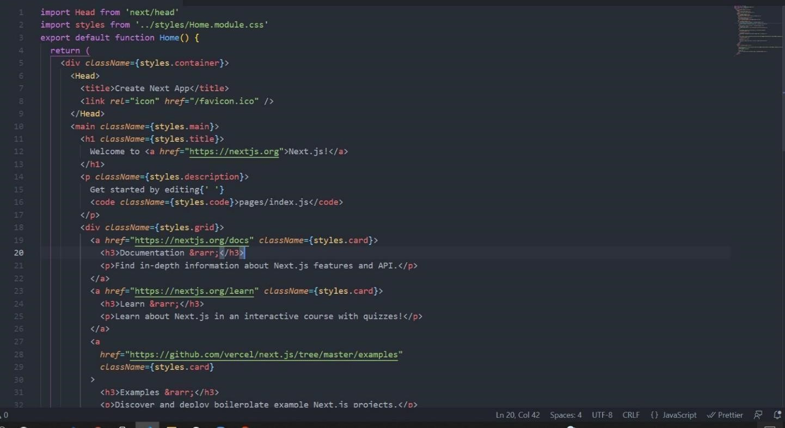

### Figure 5.1.4: Next.js app

1. **Page:**

Your page records are in the pages envelope. With a unique course created from the document name, each page record is a React component. The Next.js page hello.js, for instance, can be viewed in pages/hello.js. Some pages, like _app.js above, include a highlight prefix in their name to identify them as bespoke sections. Next.js makes use of these sections to interact with various parts. For instance, each page starts with _app.js, which isn't used the same way as claim page.2.

1. **Public:**

Because these records are static and must be referred to, this organizer is intended for serving them. This package often includes any images or symbols that the website uses, as well as internal information like Google Site Verification vercel. Which displays the stage organization's insignia, and favicon.ico, a small symbol to use on program tabs, are both included in our public envelope.

1. **Styles:**

These CSS templates, which determine which page elements are present, are contained in this envelope. All pages used in the project will adhere to the general standard provided by the globals.css document. Using module documents with the post fix "component Name," you can also add part-unambiguous styling module.css.

**5.2 Navigation/routing in your application:**

Route alludes to the ways in which your site's Next.js users can browse. The two main methods for describing a site route are courses and links.

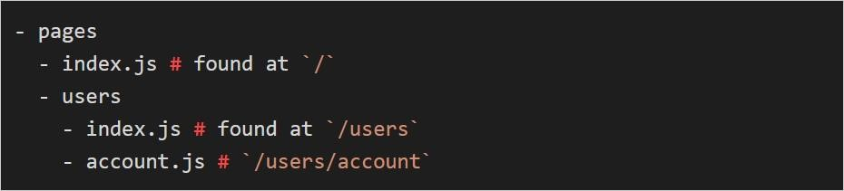

### Figure 5.2.1: Navigation/Routing in app

Courses in Next.js are receptive because of the underlying course meanings of every part. To streamline your application steering, it's essential to figure out the record, settled, and dynamic courses.

1. **Index:**

Instead of/file, record files like index.js are directed to the application's beginning. You can utilize this for your potential benefit by making numerous record documents that go about as the greeting well-known gin point of various route ways inside your site.

For instance, if no more course is added, the site's landing page is the index.js page found under the pages section. The clients way's welcome page is located in the second index.js file under clients. which came to by entering <siteName>/clients.

1. **Nested:**

Settled courses are courses that are just open through a common parent course, for example, clients/accounts. You might think have settled courses like settled documents on your computer, where you must navigate through all higher portions to get to the settled part.

1. **Dynamic Routes:**

In order to account for different ways of acting, we can also recall the rules for our courses. Square portions are a hallmark of dynamic pages. We can essentially send data to a page using this element just like we would a capacity.

For example, we may redesign the client section to allow each client to have their own records page.

Instead of staring at customers, clients may now rapidly access their record data page by entering their record name in the URL. I could input my record name, /clients/educative, to access a specific page that populates with information corresponding to the record name entered. The account.js record has to have constraining statements that direct it depending on what boundary.

1. **Linking:**

Moreover, you can offer client-side navigation links so that users can browse the website without using the URL bar. The connecting method in Next.js is the Link React component. The Link component uses a href argument filled with the document path from the goal component. By doing so, a link will be established between the current page and the page from the selected course. For instance, if you include Link href= "/clients/"> in hello.js, a link will be established to the clients' greeting.

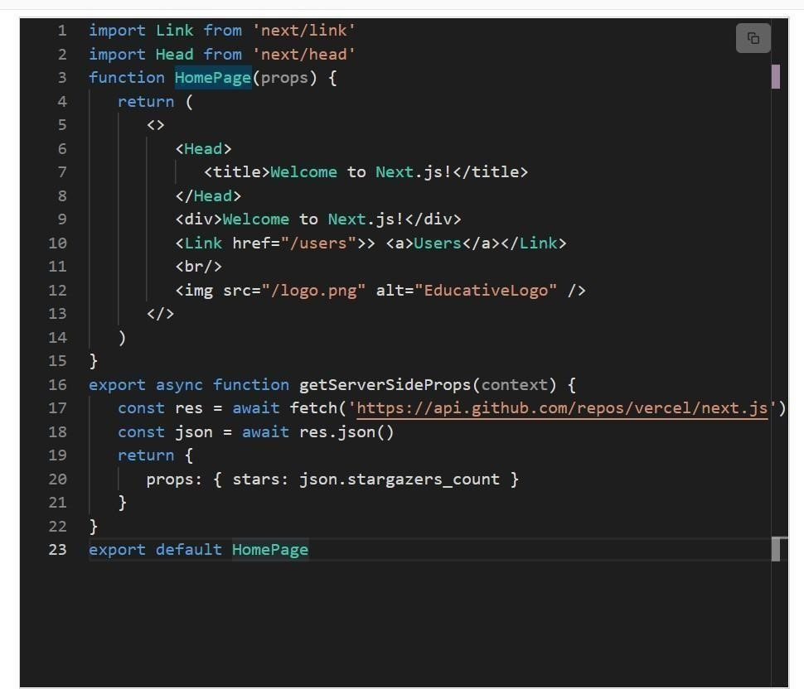

**Figure 5.2.2: Linking**

**5.3 Retrieving Data with Next.js:**

Getting information is next. To create a page, JavaScript requests data from a server. Making apps that are simple to comprehend requires choosing the appropriate pre-render techniques and obtain capabilities. The page can be created using either static age, which retains a previous render of the page so that it tends to be conveyed immediately, or SSR, which instructs the server to render the whole page after receiving the request.

1. **SSR:** Better for pages that are extremely interactive and can not be generated statically.
2. **SG:** The static render will always satisfy the user's needs, making it better for text-only or static pages.
3. Either the bringing approach or the crossover structure can be used. Next. Js provides three sync information-gathering features that work as focused alternatives to the traditional React approach. These abilities include:

GetStaticProps is a tool that SG uses to fetch page content from outside sources.

Get page paths from external data using SG and getStaticPaths. to pull per-rendered pages at build, use get Server Side Props with SSR

.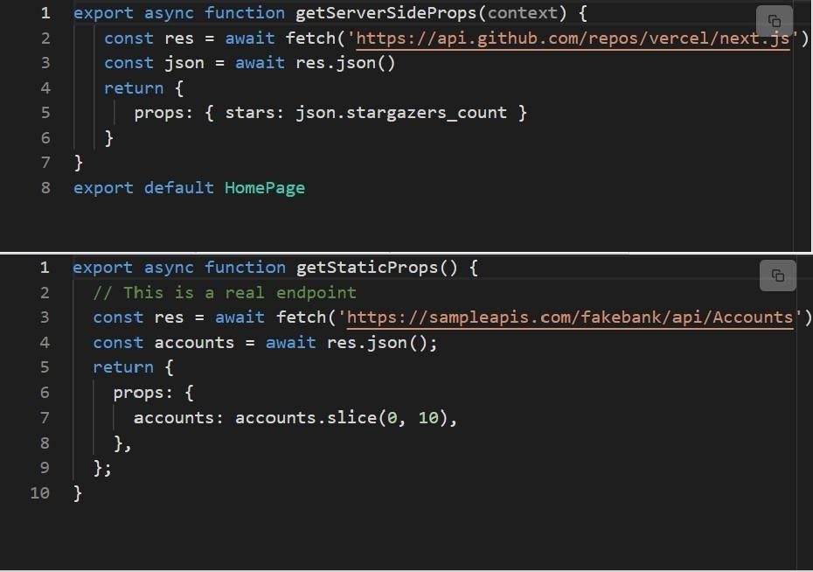

Figure 5.3.1: Retrieving Next.js

# Chapter 6

## Result and Analysis

Web 3's initialization: Open a terminal and type the command npm install -save-dev.

Run Hardhat in the same registry where you introduced it. Again open the terminal and compose this **npx hardhat.** Presently the terminal will be look like this:

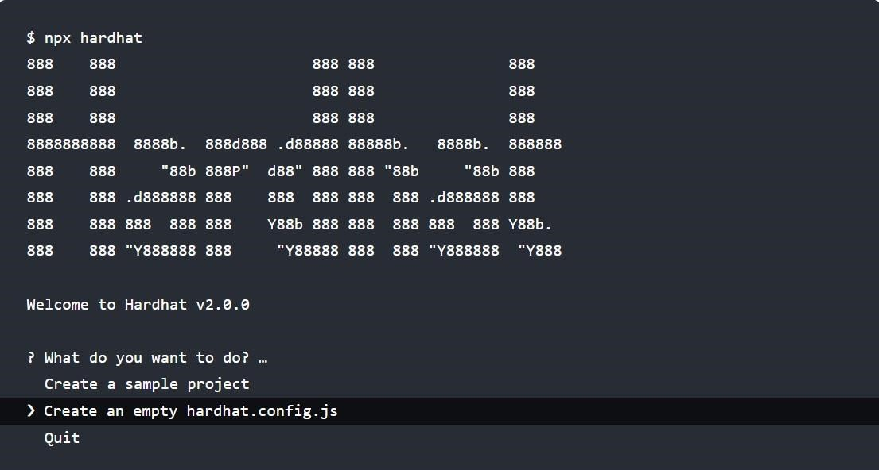

### Figure 6.1: NPX hardhat

**6.1 Initialization of Hardhat:**

When Hardhat is launched, it searches the active working registry for the closest hardhat.config.js record. Normally, this file resides in your project's foundation, and Hardhat can function with just a void hardhat.config.js file. This paper contains the whole terms of your agreement.

The organization of Hardhat:

The ideas of tasks and plugins are central to the design of Hardhat. The majority of Hardhat's functionality is provided by plugins, which developers are free to utilize as they see fit.

1. **Task:**

You are performing an errand each time you run Hardhat from the CLI. The organise assignment, for instance, is being handled by npx hardhat include. Run npx hardhat to see the projects that are currently available in your project. Go ahead and investigate any assignment by running npx hardhat help [task].

1. **Plugins:**

Hardhat is unopinionated as far as what devices you wind up utilizing, yet it accompanies a few inherent defaults. Which can all be overridden. More often than not the method for utilizing a given device is by consuming a module that incorporates it into Hardhat.

For this instructional exercise we will utilize the Ethers.js and Waffle modules. You can connect to Ethereum using them and test your agreements. Later on, we'll explain how they're used. Run the following in your task list to introduce them:

Bitcoin waffle chain

Add the following line to your hardhat.config.js so that it seems to be as follows:

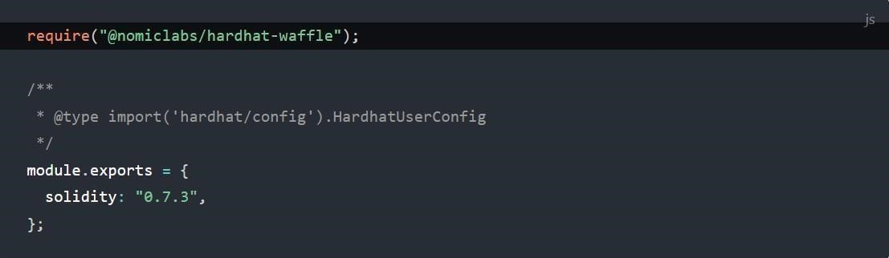

**Figure 6.1.1: Hardhat config.js**

**6.2 Writing and compiling smart contracts:**

We're going to implement a transferable token in a straightforward smart contract. The most popular use of token contracts is to trade or hold value. Although we won't go into great detail about the contract's Solidity code in this lesson, there is certain reasoning we used that you should be aware of:

There is an unchangeable fixed supply of tokens, and the full supply is allocated to the address used to launch the contract.

Everyone can send and receive tokens, as long as they have at least one. The token cannot be divided. 1, 2, 3, or 37 tokens can be transferred, but not 2.5.

Create a document inside the registry named NFT. Sol and then create a new index called agreements. Attach the code below to the document and give it some time to read. It is simple and filled with comments that explain the fundamentals of Solidity.

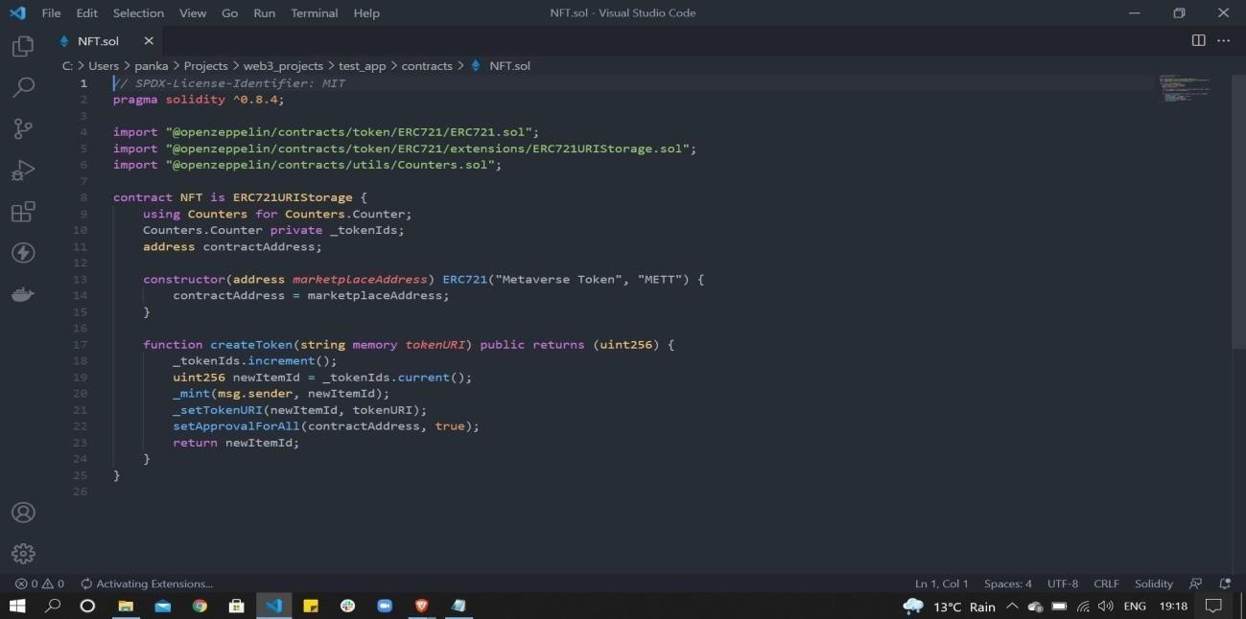

**Figure 6.2.1: Compiling smart contract**

**6.3 Contracts Compilation:**

Run npx hardhat compile in your terminal to compile the contract. One of the built-in tasks is the compile task.

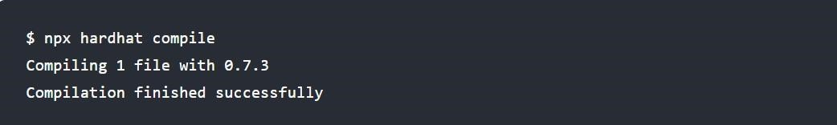

### Figure 6.3.1: Contract compilation

Everything has been effectively assembled and is now time to employ the contract. When you're prepared to share your App with people, the best thing you can do is present it in a live gathering. In this manner, anybody can access an event that isn't taking place locally on your computer. The Ethereum network, also known as the "mainnet," operates with real money. In addition, there are other living associations that don't regulate real money but imitate this realworld scenario capability and can be used by others as a standard organising environment. Ethereum features a number of these designated "testnets," including Ropsten, Kovan, Rinkeby, and Goerli. You should transfer your settlements to the Ropsten testnet, per our advice.

Shipping an item to the testnet is the same as passing it to the mainnet at the item level. The network you partner with makes a big difference. Could you look into what the code looks like to send your arrangements using ethers.js? The key concepts, which we discovered back in the testing section, are Signer, ContractFactory, and Contract. When testing is viewed differently, there is business as usual that should be carried out, keeping in mind that while you are putting your plans to the test, you are actually connecting to your development association. Because of this, the code is fundamentally extremely similar to or identical. The project root's file should be modified to accommodate new library scripts, and the going with should be pasted into a deploy.js record:

While doing any activities, you can use the — network parameter to tell Hardhat to connect to a certain Ethereum network. such as:

The sending actually gets lost after Hardhat finishes the most typical manner of running in this situation because running it without the - - network limit would cause the code to clash with an embedded instance of Hardhat Network, but it is now convenient to test that our plan code is functional:

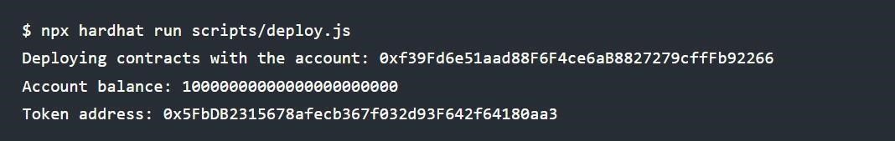

### Figure 6.3.2: Deploying contract

**6.4 Deploying to remote network:**

You must add an association section to your hardhat.config.js record in order to transfer to a remote association, such as the mainnet or any testnet. For this model, we'll use Ropsten, but you can substitute any other association instead:

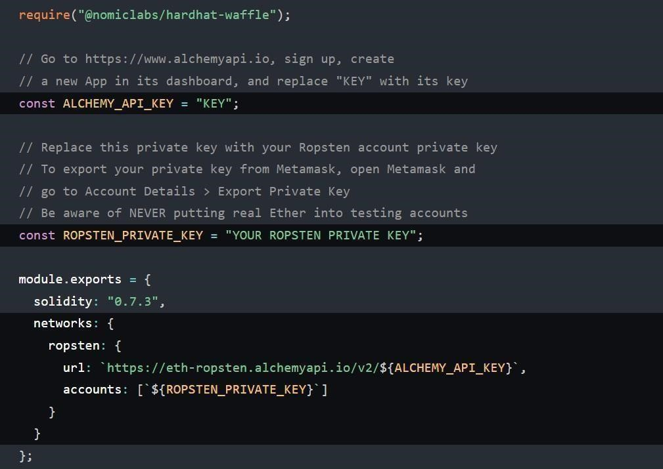

### Figure 6.4.1: Deploy to Alchemy

Although the URL might point to any Ethereum hub or entrance, we're utilising Alchemy (opens new window). Go get your ALCHEMY API KEY, then come back. In order to transmit Ropsten, you must send ropsten-ETH to the location where the plan will be created. A nozzle, which offers aid by dispersing testing-ETH for free, can be used to obtain some ETH for testnets. You must first update Metamask's association with Ropsten before executing this one for Ropsten (opens new window).

Finally, run:

You ought to see the deployed contract address if all went correctly.

# Chapter 7

## Conclusion and future scope

The academic impact of this research should benefit society, technology, market, and economic changes in order to contextualize the study from a socio-technical standpoint. It has been tried to fill in the gaps in end-user perceptions of the concept of value through NFT ownership because the existing knowledge of NFTs and blockchain is quite specialized, at least most likely in terms of the speculative or fake character of value production. Academics, public and commercial block chain firms seeking to build products around NFTs, students, tech enthusiasts, and anybody else interested in advancing knowledge from a meta viewpoint and comprehending the value of NFTs would be the contributors and research stakeholders. In instance, NFTs are a tool to better define ownership arrangements, and other Trans disciplinary block chain breakthroughs have social and economic ramifications. From a technological standpoint, the study emphasizes the enhancement of existing goods and procedures, enabling block chain developers and business owners to carefully choose and construct use cases that actually add value to NFTs. This study enables businesses to get an edge by adjusting to new conceptions of ownership and how they can create value, while being a "value machine" with unique ownership. As refuted in the study, it is clear that the legal foundation for NFTs is still unstructured, thus policymakers and legal experts can also benefit from this research to improve the tokenization's legal ramifications. As more people purchase digital goods and give in to their appetites for virtual fetishism, digital advancements have prepared the road for digital media to contribute to modern consuming habits in today's society. 2011: McAllister The fundamental character of things is concealed beneath capitalism's emphasis on mass manufacturing. An object created without a practical use, however, frequently causes confusion and challenges new definitions. Jhally, in this sense, a commodity has numerous meanings and is shared in consuming contexts rather than production contexts, yet it is reified in the eyes of the consumer and contradicts the nuanced process of production. NFTs have a similar reality in that they can be significant to some people even though they have little use or exchange value.

### 7.1 Inferences

Research topics were connected to empirical results through the literature that already exists in the fields of block chain, non-fungible tokens, and the ideas of ownership, ownership, community development, and traditional economic theories. Some intriguing conclusions came from this study after a thorough analysis of the interview data that was gathered. The goal was to apply the interpretation paradigm to identify the concepts of the questioned respondents and extract knowledge from the research questions because the study started with a deep interest in understanding people's views on the ideals supporting NFT:

1. How do users view the worth of NFTs?
2. How do exclusive NFT structures benefit users?
3. How does the value of NFT impact how users perceive control and ownership?
4. What kind of value perception must exist for users to consider NFTs to be valuable assets?

A preliminary examination of the literature was done to map existing situations in an effort to advance knowledge, but because the topic is still developing, few works were discovered that directly address important themes of societal immutability. An empirical study that problematical situations in the landscape of the existing level of knowledge in block chain technology was undertaken as part of this research. Nine interviews were conducted in an unstructured format, nine data points were analysed using the thematic analysis methodology 58, and six main themes of the research questions were discovered: making money with NFTs, community building information, information on the concepts of ownership or the sense of ownership, information about power and control over goods, about the loss of the aesthetics of real beings, and information about the fetish for digital products. Our study revealed that the majority of users saw NFT business activities as a way to make extra money. Additionally, they saw that immutability offered a superior means of enabling private structures to empower individuals.

The NFT firm could only implement improved use cases, though, if smart contracts were used in conjunction with the appropriate utility factors. Commercialization and tradable derivatives, utilizing cooperative and community-based business models like BAYC, also contributed to the value creation process. Most NFT trading by users has been seen as a way to increase profits by removing them from the labor-intensive production process. Despite getting all of their usage value from the NFTs in their bitcoin wallets, consumers were obligated to participate in this process by nature. Also, it was observed that the concept of value in traditional art has adopted the form of digitization to contextualize this viewpoint; value in art no longer appears to be a contextual process, but rather a transitory dimension influenced by ongoing digital innovation. Although the power and ownership paradigms still had trade-offs at the time due to the lack of legal structure, owners seemed to do so by possessing something valuable or unworthy, but in reality, they had less utility or exchange value. This is the problem that block chain is trying to solve by eliminating the need for third-party verification and authority. The ability to govern these assets has little to no benefit, in contrast to how NFTs redefined owner ships by inking credentials on a block chain, as explained by NFT traders. Although the interviewees' views to technical prospects were generally positive, the NFT trading tactics now felt coercive. The essence of identity and co-creation is of significant value for the individuals, but they had certain rational motives that meant they could sell their assets to another buyer if necessary. To further contextualize this, many people felt they needed to belong to a community. Exclusive identity was seen as a commonality in their responses. They also believed that NFTs were a way to create digital identities and collaborate towards value creation. A growing need for digitalization was also highlighted, as well as a desire to be known in the digital age and a possibility that community development within a Gesellschafts structure is occurring in a more digital setting. The study began by analysing the ongoing NFT phenomenon via the prism of classical economics, therefore this looks more suited to a capitalistic cure than to addressing a genuine issue. Users viewed profit maximization through Marxist eyes, which led them to lose organic social links. Even the exclusive nature of communities under a collaborative business model tended to be profitable. Though still in its infancy, more structured reforms are required for this wholesome transition towards a better society. It is noteworthy to note that blockchain is a means towards better forms of governance, eliminating central authority, making the world more libertarian, and it could aid in mitigating several problems in the society.

### 7.2 Future projects

In this study, the ethnographer attempted to illustrate how individuals perceive value by combining it with conventional ideas and tying it to the whole block chain infrastructure, especially the NFT space. Yet, other aspects of the NFT scenario, such as the adoption rates, remain unexplored. Furthermore, the use of block chain oracles to link on-chain and off-chain data structures is still in its infancy. Technical obstacles still exist in this area, but future work on NFT use cases and linking oracles can move forward. A comprehensive grasp of non-fungibility from the general population through quantitative analysis is also a way to go forward. In this research, the sampling was done taking into account the knowledge of those who have fundamental knowledge in the domain and are participating in the NFT business. Also, there are usability issues with utilizing crypto wallets; not many people are comfortable with the transactions of digital wallets, thus this is a challenging area that may limit widespread adoption. Users are frequently biased and look for opportunities to make money in NFT-based businesses due to fear of missing out, according to some practical recommendations from the study. Further research on this fear of missing out can be done to determine why people engage in such behavior despite the risk of financial loss. Evidence for the development of communities through NFTs is encouraging and can be explored through a more qualitative examination based on the concepts of exclusivity and individuality. In the end, studies on community formation are important areas to look at. Are organic societies devolving into smaller and smaller communities of like-minded people, and if so, why and how are NFTs responsible for this? Community formation was not anticipated as a theme in the research but turned out to be an interesting insight. The current research's model was qualitative, making it impossible to replicate, although a quantitative approach might be used to carry out a similar format. A certain bias is developed here in terms of generalizing the scenario of value creation because the research's chosen samples were individuals connected to, knowledgeable about, or involved in the NFT trading circle. Despite mass adoption, however, it is currently challenging to sample the general population. By extending the theoretical framework or by building the same study situation from a classical economics perspective and offering more evidence on the same, future studies can revisit a similar challenge. There aren't many unresolved issues because this research is grounded in traditional lenses from a meta perspective, allowing for precise boundaries to be established for particular themes that can then be further examined separately. Evaluation of NFT use cases in the current market is another area that could be the subject of research.

## References

1. C. Usman W, "Non-Fungible Tokens: Blockchains, Scarcity, and Value," Critical Blockchain Research Initiative (CBRI) Working Papers, p. 14, 2021.
2. S. a. G. G. Adhami, "Initial coin offerings: Tokens as innovative financial assets," in Contributions to Economics, Germany, Springer, 2019, pp. 61-81.
3. L. a. D. D. Baele, "Could cryptocurrencies contribute to a well-diversified portfolio for European investors?.," 2017.
4. A. e. a. Gervais, "On the security and performance of proof of work blockchains.," in ACM SIGSAC conference on computer and communications security, 2016.
5. J. K. A. L. N. Garay, "The bitcoin backbone protocol with chains," in Lecture Notes in Computer Science, Springer, Cham, 2017, pp. 291-323.
6. G. Wood, Ethereum: A secure decentralised generalised transaction ledger, 2014, pp. 1-32.
7. N. Szabo, "Smart contracts: building blocks for digital markets," Journal of Transhumanist Thought,, 1996. [8] D. J. B. T. S. Jacques, "Erc-777 token standard," 20 11 2017. [Online].

Available: [https://eips.ethereum.org/EIPS/eip-777.](https://eips.ethereum.org/EIPS/eip-777)

1. S. Nakamoto, "Bitcoin: A peer-to-peer electronic cash system," Manubot, 2019.
2. C. T. Z. M. G. S. R. G. P. Ba, "The Effect of Cryptocurrency Price on a Blockchain-Based Social Network," in Studies in Computational Intelligence, 2020, pp. 581-592.
3. V. V. B. Fabian, "Erc-20 token standard," 19 11 2015. [Online]. Available: [https://eips.ethereum.org/EIPS/eip-20.](https://eips.ethereum.org/EIPS/eip-20)
4. R. e. a. Witek, "EIP-1155: Multi Token Standard," 17 06 2018. [Online]. Available: [https://eips.ethereum.org/EIPS/eip-1155.](https://eips.ethereum.org/EIPS/eip-1155)
5. V. e. a. Buterin, "A next-generation smart contract and decentralized application," 2014. [14] E. D. S. J. E. N. S. William, "EIP-721: NonFungible Token Standard," 24 1 2018. [Online]. Available: https://eips.ethereum.org/EIPS/eip721. [15] W. e. a. Cai, "Decentralized Applications:

The Blockchain-Empowered Software System," in IEEE, 2018.

## Appendix I

### Plagiarism Report of Project Report

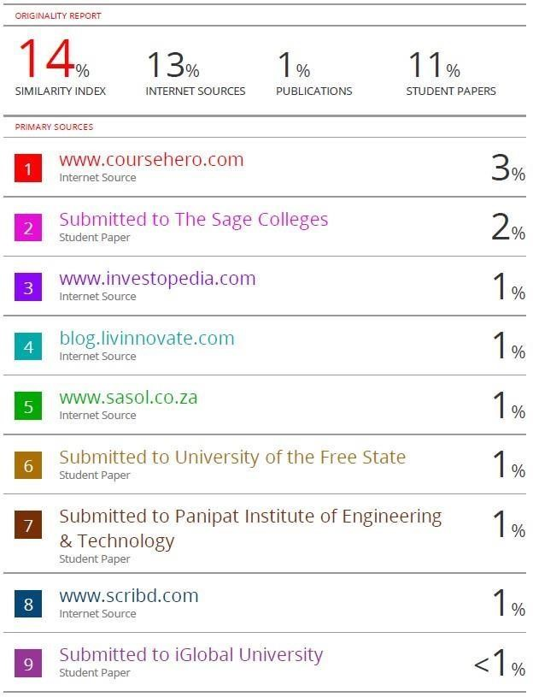

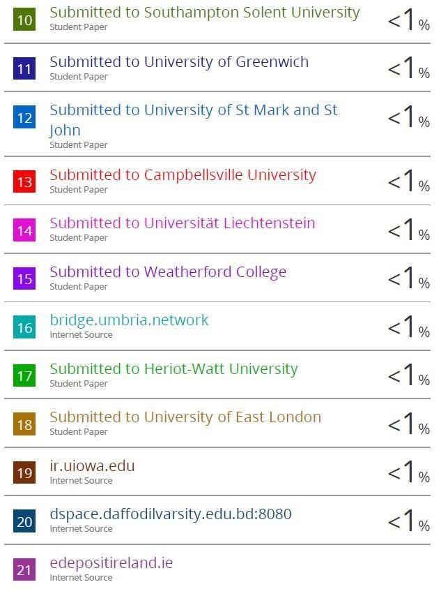

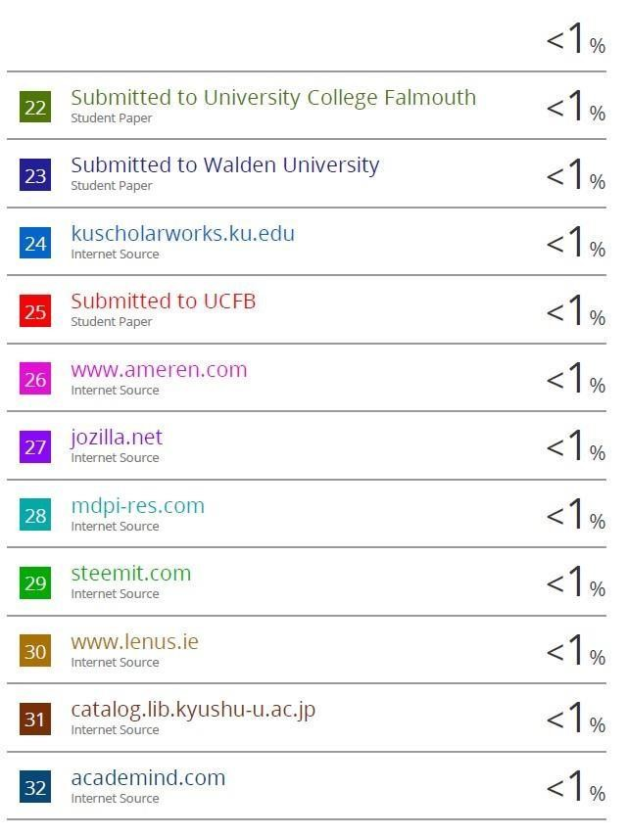

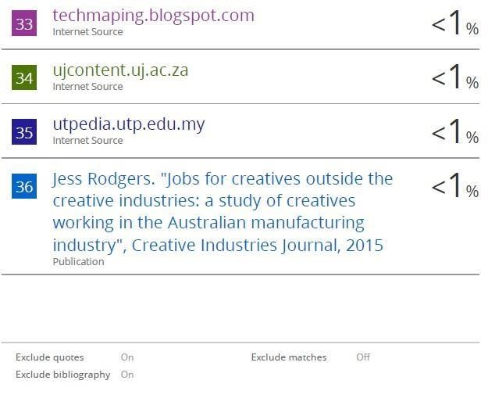

# Appendix II

**Research Paper based on Project.**

## A Social NFT Marketplace

Department of CSE AI & ML,

**NOIDA INSTITUTE OF ENGINEERING AND TECHNOLOGY**, Greater Noida,

India Author to whom correspondence should be addressed: Ms.Neelam

**ABSTRACT:** Social Media plays an important role in our modern lives. Social media has opened the door to the opportunity to meet people close to anywhere in the world. This paper has analyzed how a standard photo sharing website for social media can be converted into a public NFT Marketplace. The research aims to provide a theoretical contribution to website creation on web3 which is not only involved in image sharing but also converts it into an NFT marketing and purchasing business. The study discusses user behavior of the platform for communication and the NFT market. The paper also identifies the creation of an NFT marketplace in such an environment so that the sale and purchase of NFT becomes part of the daily lives of people who use it on social media and ultimately increase the total market value and revenue. The inclusion of an NFT market place on social media can bring dynamic change to both the computer and business engineering department by creating a unique social network and at the same time conducting business through it.

Keywords– NFT, Blockchain, Marketplace, Social Media, Web 3

### 1. Introduction

NFT Marketplace is an online marketplace where artisans offer their varied craftsmanship and where customers can pay for it with cryptocurrencies like Bitcoin. Many commercial sectors also charge transaction fees and need a record, which is typically free.

Utilizing virtual entertainment has become a daily requirement in the modern world. Webbased entertainment is widely used to interact with the public, obtain data, and make simple decisions. It is a significant specialized tool for exchanging, creating, and dispersing data among people locally and globally. Through audits, advertising techniques, and public relations, virtual entertainment can influence consumer purchasing decisions.

In actuality, virtual entertainment has a profound impact on our ability to communicate, form connections, acquire and disseminate information, and make smarter decisions. Studies have revealed that a concerning number of people spend 25% of their time engaging in virtual entertainment, underscoring the importance and popularity of online entertainment in recent years. The question,

"Why placed an NFT thing via virtual entertainment?" therefore arises. According to Artsy CEO Mike Steib, "one of those interests comes from people who appreciate supporting autonomous makers by purchasing their works." "Some are mesmerized by using computerized resources that anyone may reproduce and take ownership over. The most recent NFTs price records seem to be largely influenced by newly minted crypto billionaires trying to take their bitcoins, etc. Thus, what we are doing is only combining these two stages in a single location to make the NFT commercial center more extensible and useful to its clients on a daily basis. By creating a special environment for connecting with people locally and simultaneously guiding the business via them, the concept of an NFT commercial center via online entertainment can bring dynamic change to both the PC and business designing divisions.

#### 1.1 About blockchain

A transmitted site that is divided up across computer network hubs is called blockchain. Blockchain holds data electronically in a computerized architecture as a data set. Most people know about blockchain for its important role in establishing a secure and unique exchange record in digital currency systems like Bitcoin. The new blockchain strategy ensures and implements the integrity and security of the data records and establishes trust without the assistance of other parties. The way information is organized on a conventional website vs a blockchain is one notable difference. Data is gathered by blockchain in groups called blocks that include data sets. The blockchain is a flow of information made up of blocks, each of which has a set amount of data it may hold before being closed and linked to another block that has already been filled up. A website typically organizes its information into tables, whereas a blockchain, as its name implies, coordinates its information into pieces (blocks) gathered together. This information structure typically makes an irreversible course of events of information when used in an alternative setting. At the point when the block is created, all new data after a recently introduced block is added to the recently constructed block, which will be added to the series once finished.

#### 1.2 How does blockchain Work

|  |
| --- |
| 44 |

The blockchain is a technology that enables digital information to be disseminated and stored, but not altered. Blockchains also go by the name ledger technology (DLT) for this reason. The idea of a blockchain was initially put up as a research project in 1991, before it was first extensively applied in 2009 with the creation of Bitcoin. Since then, massive cryptocurrencies, financial applications (Defi), non-affiliate tokens (NFTs), and smart contracts have all been developed, increasing the popularity of blockchain technology. **1.3 Transaction Process**

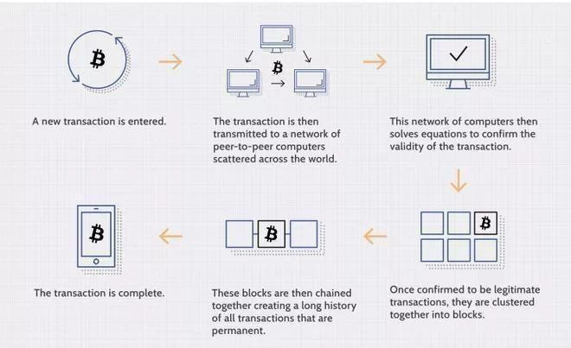

**Figure 1.3.1: Transaction process**

**1.4 The main ideas**

1. Blockchain technology was initially used to power digital currency,
2. But it has now been applied to a variety of projects and industries, including content delivery.
3. Flixxo is an example of a content distribution service where users can earn cryptocurrency tokens by distributing videos around the platform.
4. The traditional model of content distribution would typically favor merchants over creators; blockchain innovation can eventually level the playing field.

**2. Methodology**  Web 3 initialization:

Open a terminal and type the command npm install

-save-dev. Run in the same registry where you first Installed Hardhat. Open the terminal once more and type this npx hardhat.

The terminal will currently look like this:

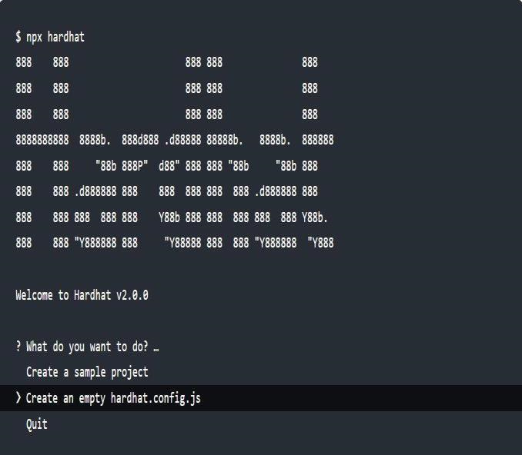

**Figure 2.1 : Initialization of hardhat**

**Structure of hardhat:**

Tasks and plugins are important to the way Hardhat is organised. The majority of Hardhat's functionality is provided by plugins, which developers are free to utilize as they see fit.

**Tasks:**

Every time you run Hardhat through the CLI, you are completing a task. For instance, the organise duty is being carried out by npx hardhat include. Run npx hardhat to see the currently available projects in your venture. You can look into any assignment by using the npx hardhat help [task] command.

**Plugins:**

Regarding the devices you choose to use, Hardhat is agnostic, however it comes with several builtin settings. They are all overridable. The Ethers.js and Waffle modules will be used for this educational activity. You can connect to

45

Ethereum using them and test your agreements. Later, we'll make sense of how they're used. Run the following in your task list to introduce them: Write the following sentence in your terminal: npm introduce - - save dev ethereum-waffle chai

@nomiclabs/hardhat-ethers

@nomiclabs/hardhatwaffle

Add the following line to your hardhat.config.js so that it seems to be as follows:

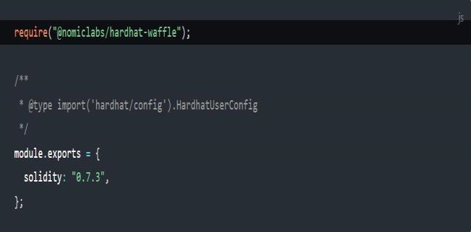

**Figure 2.2: Hardhat.config.js Smart contract code:**

Compiling Contracts:

.Run npx hardhat compile in your terminal to compile the contract. One of the built-in tasks is the compile task.



**Figure 2.3: Item addressing Ethereum** The item that addresses an Ethereum account is known as a Signer in the ethers.js library.

Sending exchanges to contracts and different accounts is utilized. Here we're getting a rundown of the records in the hub we're associated with, which for this situation is Hardhat Network, and just keeping the first.

The ethers variable is accessible in the worldwide extension. Assuming you like your code continuously being unequivocal, you can add this line at the top:

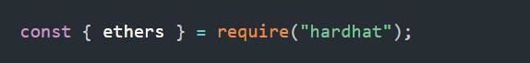

**Figure 2.4: Ethers require hardhat**

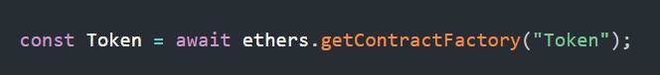

**Figure 2.5: Ethers require token**

Token serves as a processing facility for instances of our symbolic agreement, just as a Contract Factory in ethers.js is a deliberation utilized to send new brilliant agreements.

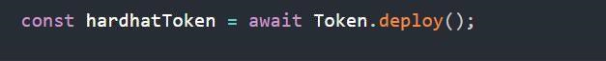

**Figure 2.6: Hardhat token initialization**

Calling deploy () on a ContractFactory will begin the organization, and return a Promise that sets out to a Contract. This is the item that has a strategy for every one of your shrewd agreement capacities.

We may call our agreement methods on the hardhat Token when the agreement is transmitted and then utilise them to acquire the owner account's balance by calling balanceOf

().

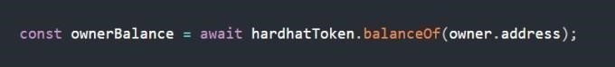

**Figure 2.7: Setting owners address**

|  |
| --- |
| 46 |

Recall that the proprietor of the symbolic who gets the whole inventory is the record that makes the arrangement, and while utilizing the hardhatethers module ContractFactory and Contract occurrences are associated with the primary underwriter of course. This implies

that the record in the proprietor variable executed the arrangement, and balance Of () ought to return the whole stock sum.

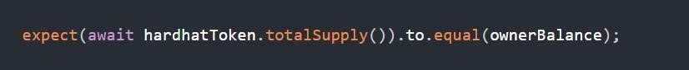

**Figure 2.8: Checking balance is sufficient**

Here, we are once more using the Contract example to call a great agreement work in our Solidity code. The symbolic's inventory total is returned by totalSupply (), and we check to make sure it is, as it should be, equal to owner Balance. To do this we're utilizing Chai (opens new window) which is an attestations library. These attesting capacities are designated "matchers", and the ones we're utilizing here really come from Waffle (opens new window). For this reason we're utilizing the hardhat-waffle module, which makes it more straightforward to affirm values from Ethereum. Look at this part (opens new window) in Waffle's documentation for the whole rundown of Ethereum-explicit matchers.

1. **Results**  Social NFT market place has been successfully developed and now the ownership of creators will be in revolution.

1. **Conclusion**

Finally, with the aid of web 3 and web 2 technologies, we were able to develop a social nft market place that goes beyond only limiting social media to photo sharing applications to also serve as a marketplace for non-fungible tokens between creators and buyers.

47

For users, using this application will be as straightforward as possible:-

* + 1. They simply have to login into their account.
    2. Upload a copy of their preferred image to t he server.
    3. The code will convert their pic into NFT.
    4. It will be further published in the feed of the people who follow the particular person.
    5. From their onwards followers can easily like the NFT.
    6. And if they want they can make a buyout to the NFT as simple as that.

According to studies, quite a few people spend about 25% of their time on social networking sites. This further demonstrates how relevant and wellliked social media platforms have grown in recent years. So, with a large NFT market, we came to the conclusion that it was up to us to bring about a revolutionary transformation in how people view social media.

As it may be guessed, this product will be helpful to artists and common people to get a new platform to make the sale and purchase of their NFT by being in continuous contact with their social media, users will get to explore a new world of NFT market place in web3.

1. **Reference**

* 1. <https://en.wikipedia.org/wiki/Blockchain>

* 1. <https://polygon.technology/>
  2. <https://metamask.io/>

* 1. https://web3js.readthedocs.io/en/v1.5.2

# Appendix III

## Plagiarism Report of Research Paper

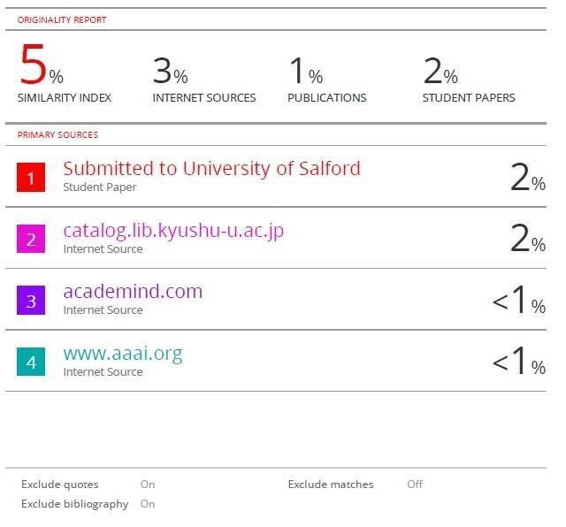

48

49