INTERNSHIP PROJECT REPORT
AI-Powered Generative Content
& Document Intelligence Platform
Notebook-Centered Implementation, Validation & Evaluation
Student Name | Aman Kumar
Registered Email | apk355194@gmail.com
Primary Deliverable | Executed Jupyter Notebook with clear outputs
Supporting Source | GitHub repository
Report Date | 8 September 2026
GitHub: AmanKumar-St/Doc-IntelligentSys

Table of Contents
1. Abstract
2. Introduction
3. Objectives
4. Literature Review / Existing System
5. Methodology
6. Code
7. Output Snapshots
8. Results & Analysis
9. Conclusion
References

Project Deliverable Focus
This report is deliberately centered on the executed demonstration notebook because the notebook is the primary evidence of implementation: it shows the system being initialized, documents being parsed, chunks being created, embeddings and retrieval being executed, five task modes being demonstrated, multi-turn context being resolved, outputs being validated, and an evaluation benchmark being run. The GitHub repository is the supporting source for the complete production-oriented implementation, tests, configuration, backend, frontend, and evaluation assets.

1. Abstract
The project implements an AI-powered document intelligence platform that combines document ingestion, retrieval-augmented generation (RAG), specialized generative task routing, multi-turn query rewriting, deterministic citation validation, factuality checking, and automated evaluation. The primary demonstration artifact is an executed Jupyter notebook that provides visible evidence of the complete workflow.
The notebook demonstrates ingestion of DOCX, PDF, and Markdown sources through Microsoft MarkItDown, followed by Markdown-aware hierarchical chunking. The resulting chunks are embedded using a hosted embedding model and indexed for semantic retrieval. Retrieval is implemented as a two-stage process: dense vector search followed by reranking. Retrieved chunks receive deterministic citation identifiers such as [C1], [C2], and are supplied to task-specific prompts.
Five generative modes are demonstrated: question answering, summarization, structured extraction, classification, and content generation. The notebook also demonstrates context-dependent follow-up questions, where the query rewriter uses conversation history to resolve references such as 'How much can be carried over into the next year?'. A validation layer checks structure, citations, and factual grounding before the result is returned.
In the executed notebook benchmark shown in the supplied output snapshots, 10 test cases were evaluated. The reported overall benchmark pass rate was 90.0%, with 100.0% retrieval relevance, 90.0% answer relevance, 100.0% factuality, 100.0% consistency, 100.0% citation validity, and an average turn latency of 8.43 seconds.

2. Introduction

2.1 Problem Context
Organizations increasingly store useful knowledge in heterogeneous documents such as employee handbooks, technical API guides, financial reports, PDFs, DOCX files, and Markdown notes. Traditional document search can locate matching terms but does not naturally provide a conversational interface, structured extraction, summaries, classifications, or source-grounded content generation. General-purpose language models can generate fluent responses, but without retrieval and validation they can produce unsupported statements.

2.2 Proposed System
The proposed system addresses these limitations by connecting document processing and language generation through a modular RAG pipeline. Source files are converted into structured Markdown, divided into semantic chunks, embedded, stored for vector search, reranked, and then passed to a task-specific generation layer. The output is subsequently checked by deterministic validators. This makes the notebook not only a demonstration of LLM generation, but a demonstration of an end-to-end document intelligence workflow.

2.3 Technology Stack
Layer | Technology | Purpose
Document parsing | Microsoft MarkItDown | Converts supported document formats to Markdown while retaining document structure.
Language/runtime | Python 3.12 | Notebook and backend implementation.
Embeddings | OpenRouter text-embedding-3-small | 1536-dimensional embeddings shown in the notebook output.
Vector storage | In-memory cosine similarity for demo; Qdrant for production | Supports the notebook demonstration and production-oriented backend.
Generation | OpenRouter / meta-llama/llama-3.3-70b-instruct | Hosted generation provider shown in the executed notebook.
Backend | FastAPI | Production REST API supporting the same core services.
Frontend | React + TypeScript + Vite | Web interface included in the repository.
Evaluation | Notebook benchmark + repository evaluation suite | Measures retrieval, relevance, factuality, citation validity, consistency and latency.

3.Objectives
- Build a modular retrieval-augmented document intelligence pipeline.
- Support ingestion of multiple document formats through Microsoft MarkItDown.
- Preserve document hierarchy during Markdown-aware chunking so that retrieved content retains section context.
- Generate semantic embeddings and perform dense retrieval followed by reranking.
- Demonstrate five task modes: QA, summarization, extraction, classification, and content generation.
- Implement context-aware multi-turn query rewriting for follow-up questions.
- Attach deterministic inline citation identifiers to retrieved evidence and validate those citations.
- Validate structured output and perform factuality/numerical grounding checks.
- Evaluate the system using repeatable test cases and report measurable results.
- Provide a reproducible executed notebook as the main submission artifact while maintaining a complete GitHub implementation.

4. Literature Review / Existing System

4.1 Retrieval-Augmented Generation
Retrieval-Augmented Generation (RAG) combines information retrieval with text generation. Instead of requiring a model to rely only on information encoded in its parameters, relevant external passages are retrieved and provided as context for generation. This project follows that general architecture but extends it with document-format normalization, hierarchical chunking, reranking, deterministic citations, validation, and multiple task modes.

4.2 Dense Retrieval and Reranking
Dense retrieval represents queries and documents in vector space, allowing semantically related text to be retrieved even when exact wording differs. A second-stage reranker can then improve precision among the retrieved candidates. The project demonstrates this pattern explicitly: the notebook output shows 20 initial dense candidates reduced to 6 after reranking.

4.3 Existing System Comparison
System Type | Typical Approach | Limitation | Project Response
Keyword search | Exact or lexical matching | Weak semantic matching; no generation | Semantic retrieval + reranking
Standalone LLM | Direct prompt → generation | May lack source grounding | Retrieved evidence supplied to generation
Basic RAG | Retrieve → generate | Often limited task control and validation | Five task modes + validation
Generic chat assistant | Conversation + generation | Follow-up references may be ambiguous | Explicit multi-turn query rewriting
Document intelligence platform | Documents + AI tasks | Quality depends on ingestion, retrieval and controls | MarkItDown + hierarchical chunks + citations + evaluation

4.4 References to Established Work
- Lewis, P. et al. (2020). Retrieval-Augmented Generation for Knowledge-Intensive NLP Tasks. NeurIPS 2020.
- Karpukhin, V. et al. (2020). Dense Passage Retrieval for Open-Domain Question Answering. EMNLP 2020.
- Microsoft MarkItDown project documentation — document-to-Markdown conversion.
- Qdrant documentation — vector similarity search and vector database concepts.

5. Methodology
The methodology is presented in the same order in which the executed notebook exposes the system. This makes the report directly traceable to the submitted notebook outputs.

Phase 1 — Environment & Models
The notebook confirms Python 3.12.12, required libraries, and live hosted inference through OpenRouter. The displayed provider is meta-llama/llama-3.3-70b-instruct.

Phase 2 — Demonstration Documents
Synthetic demonstration sources are prepared: an employee handbook, a cloud API guide, and a Q3 financial report. These sources provide heterogeneous content for testing HR, technical, and financial questions.

Phase 3 — Document Ingestion
Microsoft MarkItDown parses the DOCX, PDF, and Markdown inputs into Markdown. The notebook shows successful parsing and previews of the resulting heading hierarchy.

Phase 4 — Markdown-Aware Chunking
Documents are split using heading-aware logic. The implementation keeps section names, heading paths, character offsets, and context prefixes. The notebook reports 8 chunks for the employee handbook, 11 for the API guide, and 6 for the financial report.

Phase 5 — Embedding & Indexing
The notebook embeds 25 chunks with a 1536-dimensional embedding model and indexes them for cosine-similarity retrieval. The production architecture uses Qdrant, with a local embedded option.

Phase 6 — Retrieval & Reranking
A normalized query is embedded, 20 dense candidates are retrieved, and a second-stage reranker reduces them to the top 6 precision chunks. Retrieved chunks receive deterministic citation IDs.

Phase 7 — Task Routing
The task router selects the appropriate prompt path for QA, summarization, extraction, classification, or generation. The same retrieval context can therefore support multiple user intents.

Phase 8 — Multi-Turn Query Rewriting
When a follow-up contains contextual triggers or pronouns, the router combines the current instruction with the most recent relevant user turn before retrieval.

Phase 9 — Validation
The validation service checks structure for JSON-based tasks, maps citations to retrieved chunks, filters unsupported citation tags, and evaluates factual grounding.

Phase 10 — Evaluation
The executed notebook reports a 10-case benchmark. The displayed aggregate results provide measurable evidence of retrieval, relevance, factuality, citation validity, consistency, and latency.

5.1 End-to-End Data Flow
Multi-format files
↓
MarkItDown → Markdown
↓
Hierarchical Markdown chunking
↓
Embedding provider → vector representations
↓
Dense retrieval → reranking
↓
Task router + multi-turn query rewriting
↓
Five task-specific generation modes
↓
Citation + structure + factuality validation
↓
Validated answer + citations + structured data

5.2 Notebook-to-Repository Mapping
Function | Repository Location | Role
Notebook demonstration | notebooks/Document_Intelligence_Demo.ipynb | Primary executed evidence and reproducible walkthrough.
Ingestion | backend/app/ingestion/service.py | MarkItDown parsing and ingestion service.
Chunking | backend/app/ingestion/chunker.py | Hierarchical Markdown-aware chunking.
Retrieval | backend/app/retrieval/service.py | Dense retrieval, reranking and citation IDs.
Task routing | backend/app/generation/tasks/router.py | Five task modes and multi-turn resolution.
Validation | backend/app/generation/validation/ | Citation, structure and factuality validation.
Evaluation | scripts/evaluate_system.py + data/evaluation/ | Repository-level benchmark and result artifact.

6. Code
The notebook is the primary demonstrator, while the GitHub repository contains the modular implementation used by the production-oriented system. The following representative excerpts show the core logic without turning the report into a full source-code listing.

6.1 Markdown-aware chunking
class MarkdownChunker:
def __init__(self, chunk_size=1000, chunk_overlap=150):
self.chunk_size = chunk_size
self.chunk_overlap = chunk_overlap
header_pattern = re.compile(r"^(#{1,6})\s+(.+)$")
# Heading hierarchy is maintained while blocks are built.
# Large blocks are split with overlap and heading context.
The complete implementation and supporting modules are available in the project repository; these excerpts are included to explain the architectural logic relevant to the notebook.

6.2 Dense retrieval + reranking
query_vectors = await self.embedding_provider.embed([normalized])
query_vector = query_vectors[0]
candidate_chunks = self.qdrant.search(
query_vector=query_vector,
top_k=search_k,
document_id=document_id,
)
reranked_chunks = await self.reranker.rerank(
query=normalized,
chunks=candidate_chunks,
top_k=target_k,
)
for idx, chunk in enumerate(reranked_chunks, start=1):
chunk.citation_id = f"C{idx}"
The complete implementation and supporting modules are available in the project repository; these excerpts are included to explain the architectural logic relevant to the notebook.

6.3 Multi-turn query resolution
pronoun_triggers = [
r"\b(it|this|that|they|them|these|those)\b",
r"\b(how much|how many|what about|and what|what else)\b",
r"\b(carry over|carried over|reimbursement|allowance)\b",
]
# If context is required, bind the current instruction to the
# most recent user topic before retrieval.
The complete implementation and supporting modules are available in the project repository; these excerpts are included to explain the architectural logic relevant to the notebook.

6.4 Task routing
if request.task_type == TaskType.QA:
messages = build_qa_messages(...)
elif request.task_type == TaskType.SUMMARIZATION:
messages = build_summarization_messages(...)
elif request.task_type == TaskType.EXTRACTION:
messages = build_extraction_messages(...)
elif request.task_type == TaskType.CLASSIFICATION:
messages = build_classification_messages(...)
elif request.task_type == TaskType.GENERATION:
messages = build_content_generation_messages(...)
The complete implementation and supporting modules are available in the project repository; these excerpts are included to explain the architectural logic relevant to the notebook.

6.5 Validation pipeline
cleaned_text, citations, cit_status = (
CitationValidator.validate_and_map_citations(
answer_text=raw_output,
context_chunks=context_chunks,
strict=False,
)
)
fact_status, fact_score, fact_warns = (
FactualityValidator.check_factuality(
answer_text=cleaned_text,
context_chunks=context_chunks,
)
)
The complete implementation and supporting modules are available in the project repository; these excerpts are included to explain the architectural logic relevant to the notebook.

7. Output Snapshots
The following figures reproduce the supplied executed-notebook outputs. They are included as execution evidence and follow the notebook workflow from environment setup through evaluation.
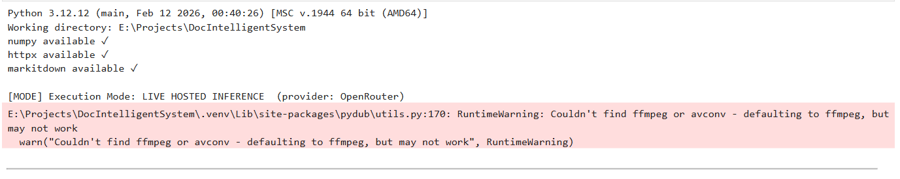
Figure 1. Notebook environment and execution mode: Python 3.12.12, required libraries, and live hosted inference.
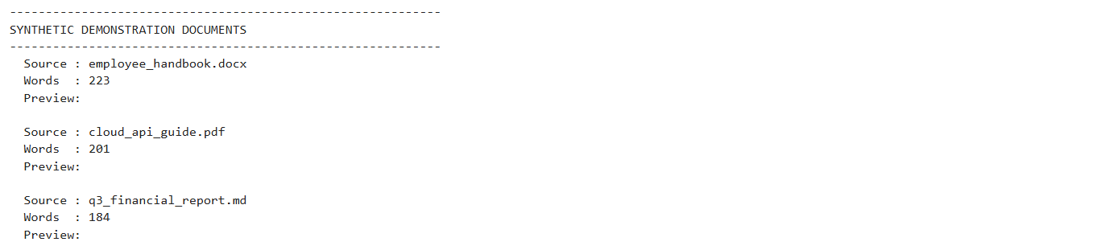
Figure 2. Synthetic demonstration documents used for the notebook evaluation.

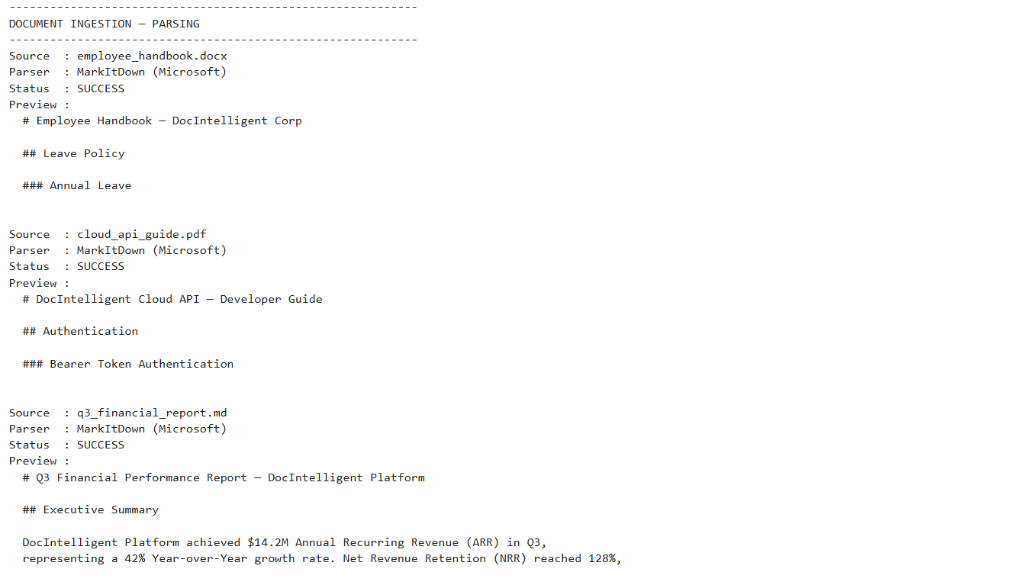
Figure 3. Document ingestion through Microsoft MarkItDown with successful parsing previews.
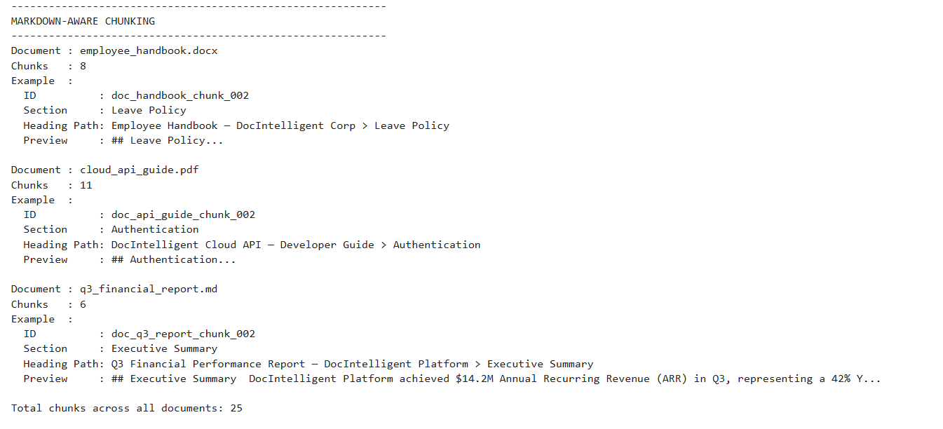
Figure 4. Markdown-aware hierarchical chunking with document sections and heading paths.
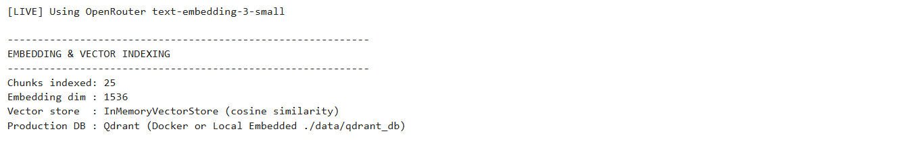
Figure 5. Embedding and vector indexing: 25 chunks and 1536-dimensional embeddings.
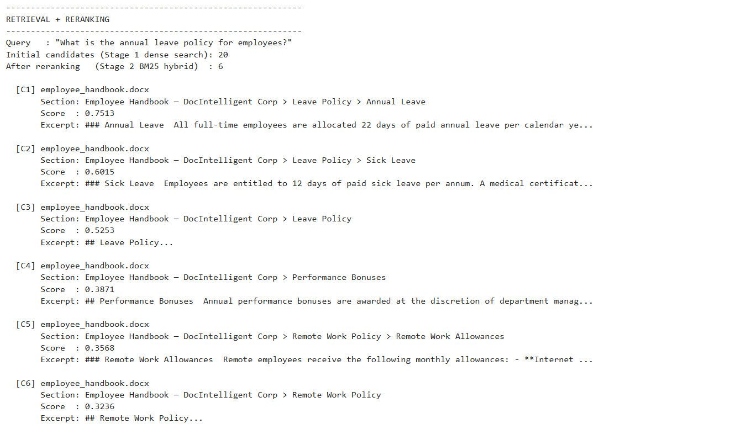
Figure 6. Two-stage retrieval and reranking: 20 dense candidates reduced to 6 precision chunks.
Figure 7. Live generation provider initialization using OpenRouter and the selected generation model.
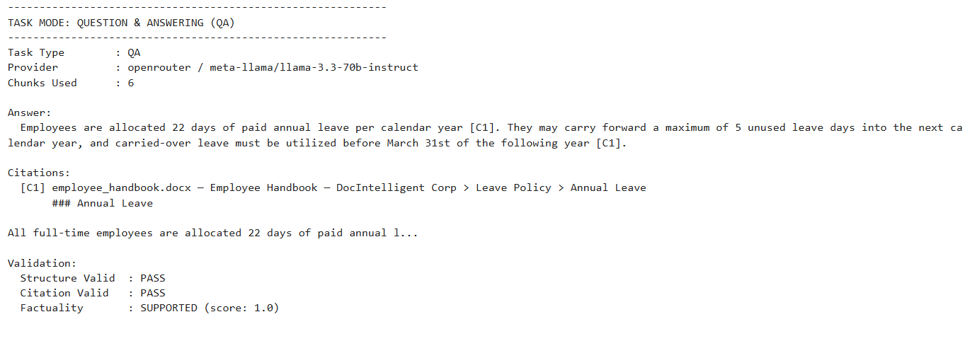
Figure 8. Question-answering task with inline citation and validation status.
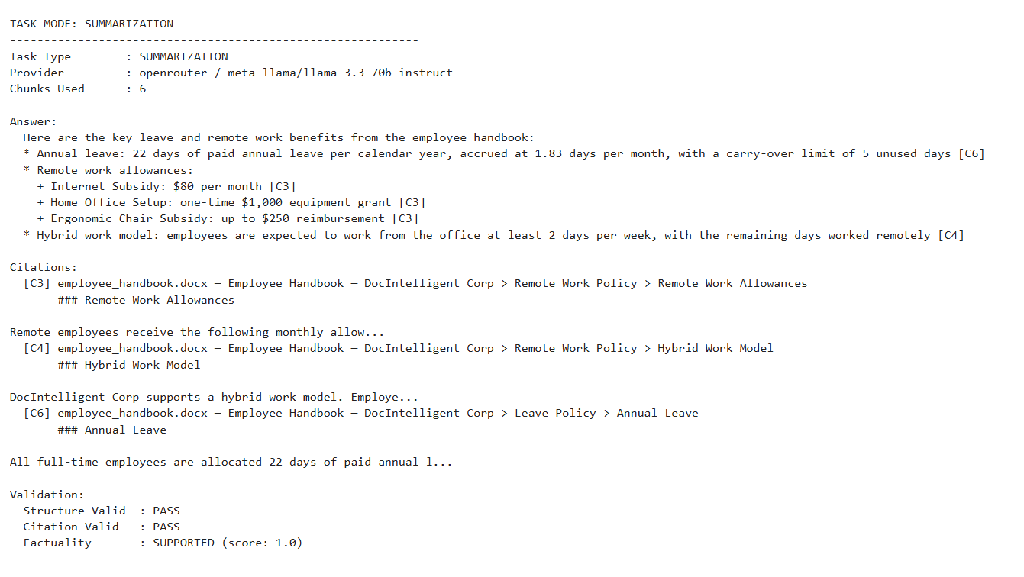
Figure 9. Summarization task with leave and remote-work benefits and citations.
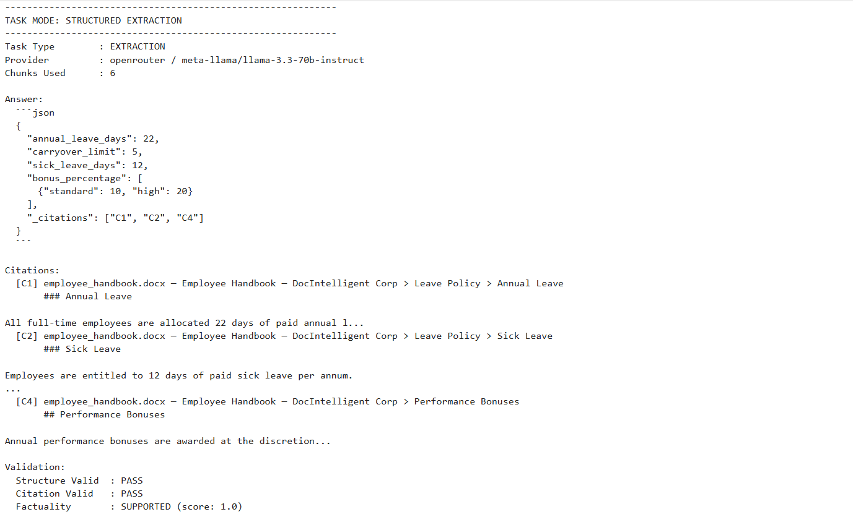
Figure 10. Structured extraction task returning JSON fields with citations.
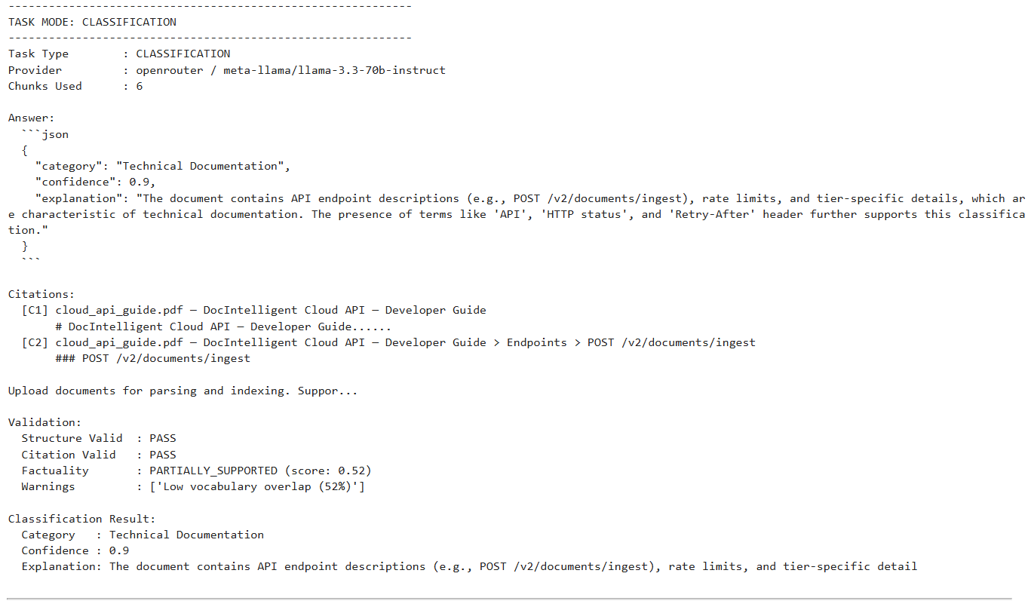
Figure 11. Classification task returning category, confidence, explanation and validation information.
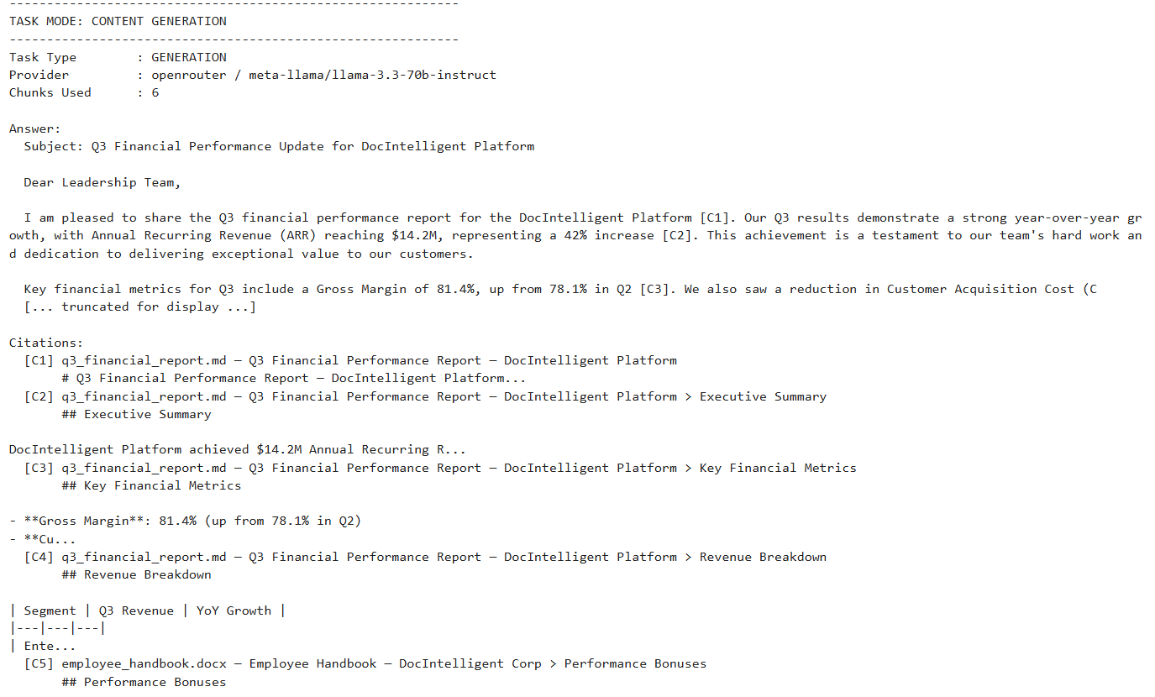
Figure 12. Content-generation task producing a grounded executive financial update with citations.
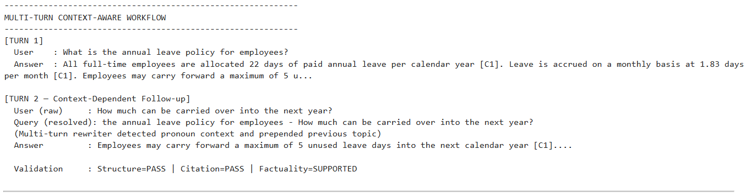
Figure 13. Multi-turn context-aware workflow resolving a follow-up carryover question.
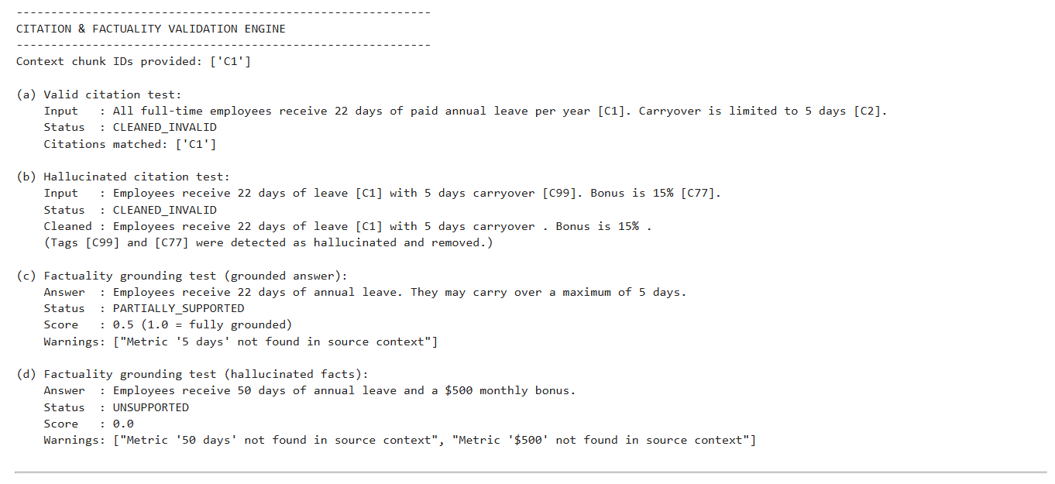
Figure 14. Citation and factuality validation tests, including hallucinated citation/metric detection.
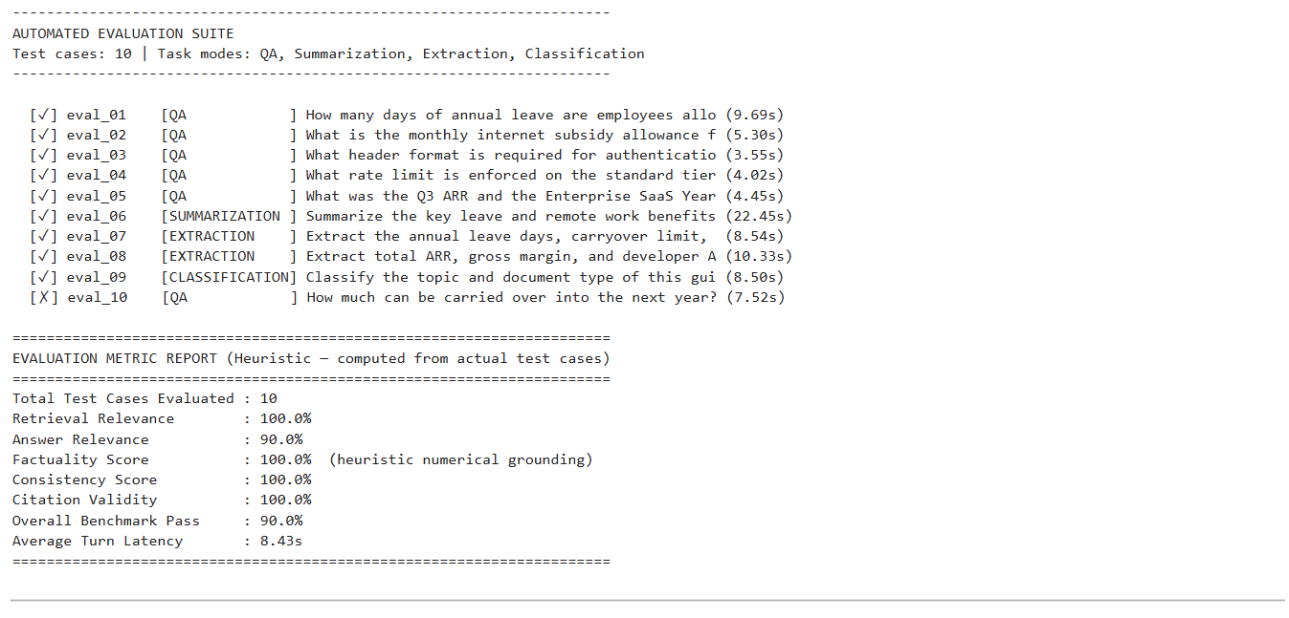
Figure 15. Automated notebook evaluation suite: 10 cases, 90% overall benchmark pass, and 8.43 s average turn latency.

8. Results & Analysis

8.1 Notebook Benchmark Results
Metric | Notebook Result
Total test cases | 10
Retrieval relevance | 100.0%
Answer relevance | 90.0%
Factuality score | 100.0%
Consistency score | 100.0%
Citation validity | 100.0%
Overall benchmark pass | 90.0%
Average turn latency | 8.43 s

8.2 Task-Level Observations
- QA: The notebook demonstrates source-grounded answers with [C1]-style citations and explicit validation status.
- Summarization: The system combines multiple retrieved sections into concise, cited summaries.
- Extraction: Structured JSON output is produced for requested fields such as annual leave, carryover, sick leave, and bonus ranges.
- Classification: The model returns an allowed category, confidence and explanation, followed by structural/citation/factuality checks.
- Generation: The model can create an executive-style update while retaining source citations for financial claims.
- Multi-turn reasoning: The follow-up 'How much can be carried over into the next year?' is rewritten using the prior annual-leave topic before retrieval.
- Validation: The supplied output demonstrates removal of unsupported citation tags and detection of unsupported numerical facts.

8.3 Interpretation of the 90% Benchmark
A 90.0% overall pass rate means 9 of the 10 notebook test cases satisfied the benchmark's overall pass condition. The displayed report simultaneously records 100.0% retrieval relevance, factuality, consistency, and citation validity, while answer relevance is 90.0%. Therefore, the principal gap in the notebook benchmark is answer relevance rather than retrieval or citation validity.
The latency figure of 8.43 seconds is an average across the displayed test cases and includes hosted inference. Latency is therefore influenced by the external generation/embedding provider and network conditions, not only by local Python execution.

8.4 Validation Analysis
The validation output demonstrates that the system does not simply trust generated text. A test containing unsupported citation identifiers such as [C99] and [C77] is marked CLEANED_INVALID, while a fabricated statement containing unsupported numerical values receives an UNSUPPORTED factuality status. A partially grounded answer is also distinguishable from a fully supported answer.

8.5 Notebook vs. Repository Benchmark
The notebook snapshot and the repository also contain different benchmark artifacts. The submitted notebook visibly reports 10 test cases and a 90.0% overall pass rate. The current repository evaluation_results.json separately records a 13-case benchmark with 84.6% overall pass rate and 11.6 s average latency. These figures should not be merged into one metric because they represent different evaluation runs/configurations. The 90.0% result is the appropriate headline metric for this notebook-centered report.

8.6 Limitations
- The notebook's evaluation metrics are automated heuristics rather than a human-annotated benchmark.
- Hosted inference introduces variable latency and external service dependence.
- The notebook demonstrates an in-memory cosine-similarity vector store, while the production-oriented backend supports Qdrant.
- Factuality checks are grounding checks against retrieved context; they do not replace human review for high-stakes decisions.
- The quality of retrieval and generation remains dependent on chunk quality, embedding quality, reranking quality, and the selected generation model.

9. Conclusion
The project successfully demonstrates a complete document intelligence workflow rather than a standalone language-model demo. The executed notebook provides direct evidence of multi-format ingestion, hierarchical chunking, semantic embeddings, two-stage retrieval, five generative task modes, context-aware query rewriting, deterministic citation validation, factuality grounding, and automated evaluation.
The notebook-centered design is especially suitable as the primary internship submission artifact because the evaluator can inspect the execution sequence and outputs directly. The GitHub repository complements the notebook by providing the modular FastAPI backend, React frontend, Qdrant storage integration, provider abstractions, validation modules, tests, and evaluation scripts. Together, the notebook and repository demonstrate both reproducibility and software-engineering structure.
The executed notebook achieved a reported 90.0% overall benchmark pass rate across 10 test cases, with perfect displayed scores for retrieval relevance, factuality, consistency, and citation validity. The validation demonstrations further show that unsupported citations and unsupported numerical claims can be detected instead of being silently presented as reliable answers. The project therefore meets the intended goal of combining RAG-based document understanding with controlled generative tasks and measurable output validation.

References
- Project repository — https://github.com/AmanKumar-St/Doc-IntelligentSys
- Lewis et al. (2020), Retrieval-Augmented Generation for Knowledge-Intensive NLP Tasks — https://arxiv.org/abs/2005.11401
- Karpukhin et al. (2020), Dense Passage Retrieval for Open-Domain Question Answering — https://aclanthology.org/2020.emnlp-main.550/
- Microsoft MarkItDown — https://github.com/microsoft/markitdown
- Qdrant documentation — https://qdrant.tech/documentation/
- FastAPI documentation — https://fastapi.tiangolo.com/
- React documentation — https://react.dev/
End of Report

