**Git:** Git is used to manage individual’s code, we can manage and share our code and we can also mark checkpoints in our code. It is used to track changes in code over time. Git operates locally means all the changes will be saved in our computer.

**GitHub:** GitHub is used when we have many people and we want to merge everybody’s code into a single file without sharing the code with other tools.

1. Downloading:
   1. Download [Git](https://git-scm.com/downloads) from here.
2. Setup Git locally:
   1. git config –global user.name “Aman” - **This is the username everybody will see**
   2. git config –global user.email “[aman@gmail.com](mailto:aman@gmail.com)” – **This is the email address displayed to everyone**
   3. git config –global core.autocrlf “input” – **This is used when code will not work**
   4. git config –global core.editor “code –wait” – **If code is not correct then VS Code or any other code editor will open**
3. Making Git available:
   1. To make git available in our project then click on **Source Control** from the left side on third number and then click on **initialize repository**.
4. Stages:
   1. U – Untracked 🡪 Not tracked by GitHub.
   2. A – Added or staged 🡪 Managed by GitHub.
   3. C – Committed 🡪 Added to GitHub repository.
   4. M – Modified 🡪 Added new content to the file.
5. Checkpoint:
   1. Create a file of any type you want.
   2. Click on source control tab and click on staged changed and click on “+” to add into staged changes.
   3. Then type any type of message related to work you did till now and click on commit.
   4. This will add a checkpoint to your code and now you can do your further work.
   5. Then again you can do the same thing to mark another checkpoint into you file.
   6. **To see the checkpoints of your file: use this command 🡪 git log –oneline**
      1. The checkpoints will have unique ID, this can be used to manage the checkpoints.
6. Git Ignore:
   1. Git ignore is used when we want to keep that file but don’t want GitHub to keep the track of the file.
   2. To do this we create a file by name 🡪 **.gitignore**
   3. Then we write the name of those file which we want to ignore into the gitignore file.
7. Going back to the saved checkpoints:
   1. To go back and delete all the data of previously done work.
   2. Use this command: **git reset --hard HEAD~1**
   3. **1 means how many stages we want to go back**.
   4. For example: we have created a gitignore file and added test.txt into it and committed it.
   5. After running this command - git reset --hard HEAD~1 🡪 our created file gitignore will be deleted and we are now 1 stage/step back.
8. Some more commands:
   1. To check status of our code folder 🡪 **git status –v** 🡪 This will list all the stages of all the files, like – U, A, M, etc.
9. Branching:
   1. Branching means not adding new code directly into the main file/code, instead of this we create a new branch and provide the main and then changes are made into that branch and then finally we merge the both and our new main branch is ready.
   2. 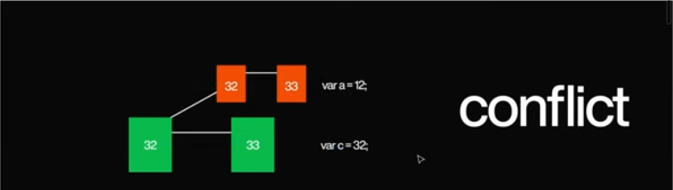In branching if we add a new line of code in main and another line of code in other branch and but some line of code is different in both of them then we will get a **conflict error** means git is now confused which he has to take.
   3. After conflict it will give 3 options while merging the code:
      1. Accept the code form the other branch.
      2. Accept the code from the main branch.
      3. Accept both code.