**Custom React**

* We can also create our personal react app.
* First we have created a div in HTML file and then select it in JS file.
* Create an element using object

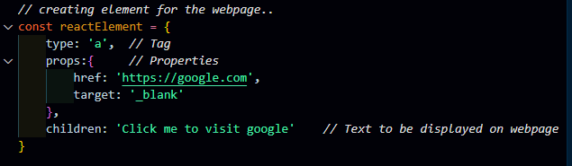

* There are two ways to this element on the webpage-
  + Manually
  + Loop
* In **manual way**, we set each attribute manually, but this is very time consuming for more tags which have many attributes.

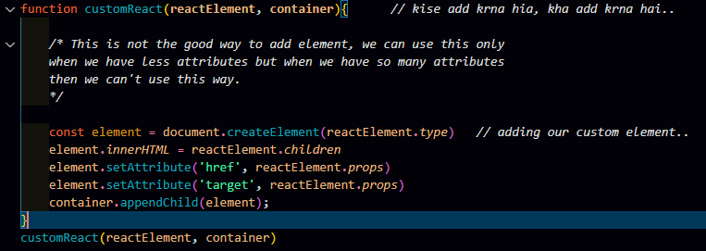

* By **using loop**, we iterate over the property key and then all the attributes add automatically.

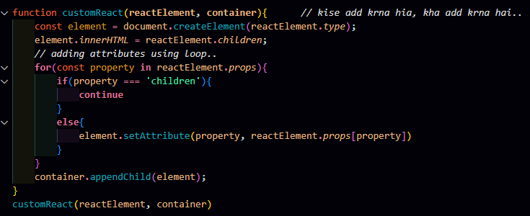

**In the above we have created the element the JS file but we can also create elements directly in the main.jsx file.**

For creating elements we have discussed the **3 ways:**

1. **Way:**

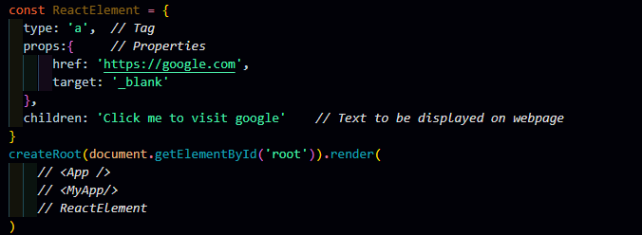

But creating elements by using this way will **NOT WORK** because the keys: type, props, children are made by us and these are **not pre-defined keywords that’s way it is not going to work.**

1. **Way:**

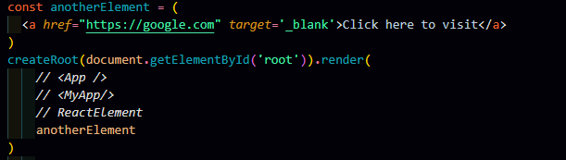

Creating elements in this way **will work**.

1. **Way:**

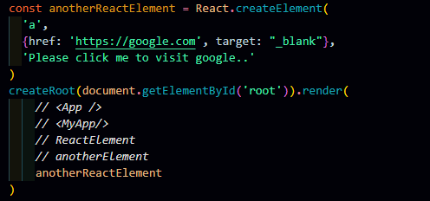

This method **will also work.**

**Adding variables in the React**

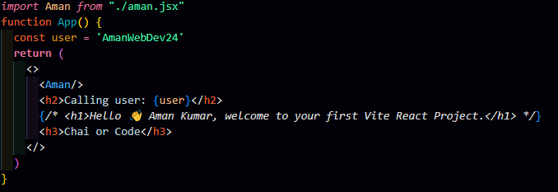

To use any variable we use {}.

This is called the evaluated expression. It means final expression.