**Props and Tailwind**

**Tailwind**

* Create a folder.
* Install all the necessary files and folders as we have discusses already.
* Then, go to tailwind official website and click on install tailwind CSS with vite or you can use any other also.
* Then use this command-

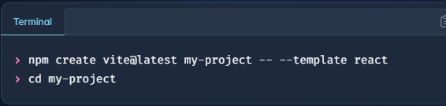

* 2nd Step-

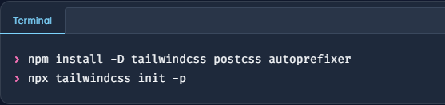

* 3rd Step-

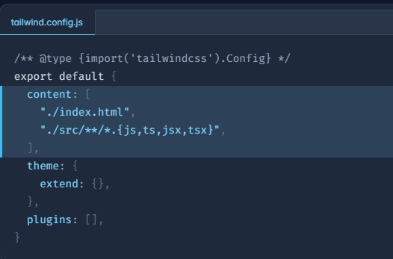

* 4th Step-

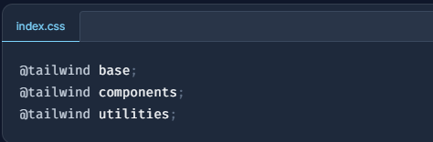

* After all these steps, you are all set and now you can run your file.
* **Example:**

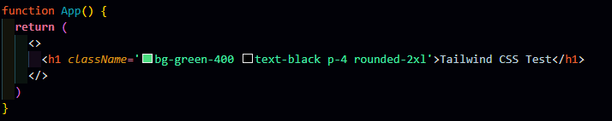

* We have to use className and then we can use any Tailwind CSS Class.

**Props**

* Props makes the component reusable, means we can use that code again and again.
* It is short form of properties.
* Image tag must be a closing tag in React JS.
* To use props in our code we have the pass the variable in the function name while creating the component.

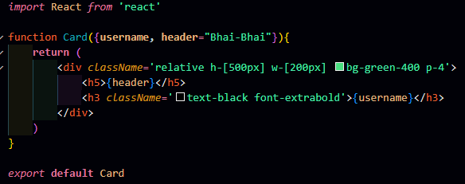

Default value of props, if user doesn’t enter anything.

**Props**

* Using props in the code.

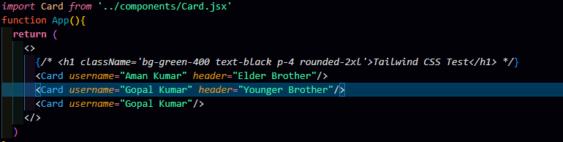

Here we have not used header prop, it means it will add the default value that we have passed in the function.

‘Username’ is the prop and ‘Aman Kumar’ is the value to be displayed.

‘Username’ is the prop and ‘Aman Kumar’ is the value to be displayed.