1. Installing some dependencies for our blog app:
   1. **@reduxjs/toolkit ✔**
   2. **react-redux ✔**
   3. **react-router-dom ✔**
   4. **appwrite ✔**
   5. **@tinymce/tinymce-react ✔**
   6. **html-react-parser ✔**
   7. **react-hook-form ✔**

**Creating Environment Variables**

1. Always keep in mind while creating environment variables that they should be in the **root directory of the project**.
2. Create file using **.env**.
3. We **never push .env file** to **GitHub**, for this we have **add** our **.env file in the git-ignore** file (from the source control).
4. For testing our env files:
   1. **Using vite:** 
      1. We use vite only when we create our app using **vite**.
   2. **Using react:**



* + 1. We use react only when we create our app using **create-react-app**.

1. In most of the cases we have to **restart our server, whenever any changes made in the env file**.
2. Accessing the file:
   1. **Using react:**
      1. We use **process.env.file-name.**



* 1. **Using vite:**
     1. We use **import.meta.env.file-name.**



1. Sometimes accessing the env file becomes so difficult to solve this we will **create a folder inside the src and in which we will create a js file. Inside this js file we will create an object with all the important appwrite things and we export it.**

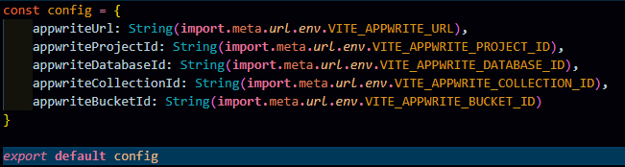

**Appwrite**

1. We will make account on Appwrite and create our project.
2. **Important steps to add in our vite app:**
   1. Appwrite url (endpoint), paste it in appwrite-url
   2. Project ID, paste it in project-id
   3. Create database and copy its id, paste it in database-id
   4. Create collection (tables) in database section and copy its id, paste it in collection-id
      1. Then go to settings inside the **collection (articles)** and give the permission who can **access the collection** and then select what user can do.
      2. Inside the articles, we will add **attributes** like title, content, etc.
   5. Then we will go to **storage section** (buckets) in which we will **add our all images**, and copy the bucket id, paste it in bucket-id. In last give the permission like who can edit, and what can be edit.