**Custom Hooks**

* To create custom hooks, create a folder in the src
* Hooks are special types of function..
* Create a custom hooks file with the .JS extension because in majority cases custom hooks return the JS only.
* Basic structure of custom hook-



* Never store any data in any variable, it won’t update the UI.
* To create a custom hooks we use these steps:  
  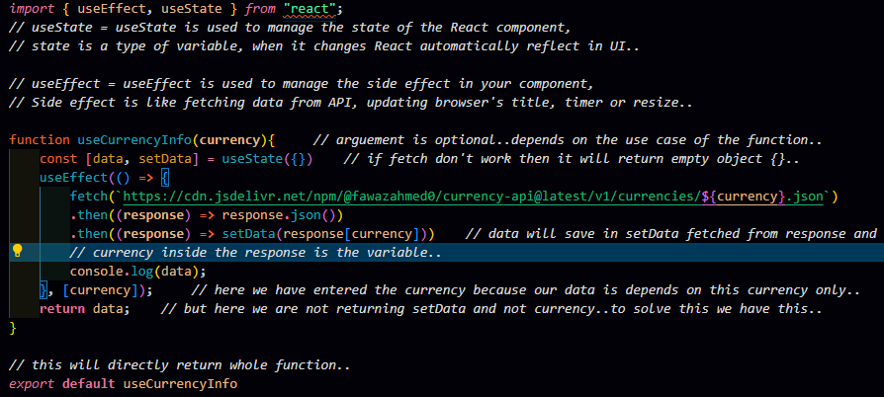
* Here we have used useState and return an empty object.
* Then we have fetched the url and store the response in setData method.
* In dependency array we have passed the currency because function depends on currency change.
* In last we are returning the data but not setData and currency so, to solve this we directly return the whole function.

Custom Hooks is ENDED here!!