Selfie verification must
Proper (must) Photo
Proper (must) Photo
Proper Photo

Photo
Own video with music & love quote

- Aadhar or Govt photo id or international photo id ( Passport) (with filter option) verification must
- Gender Male / Female with filter option
- Education with filter option
- Name show on profile
- Age as per govt id ( Must be adult)
- Height, Weight, Body orientation with filter option
- Marital status with filter option
- Residing locations with filter options ( India, Nepal, Myanmar, Sri Lanka, Singapore, Japan, South Korea, Russia, Australia)
- City name with filter option
- Fitness with filter option
- Languages known with filter options
- Drinking & Smoking habits with filter option
- Share your interests with filter option

Features
- Chatting, Messages
- Audio Call
- Phone number option ( Share through user’s request )
- Attachment photos, stickers, emoji’s
- Dating & chatting locations choice able with filter option
- Languages with filter options
- Send messages request for future dating
- Daily quotes
- Zodiac Sign as per DOB
- Astro match

Settings 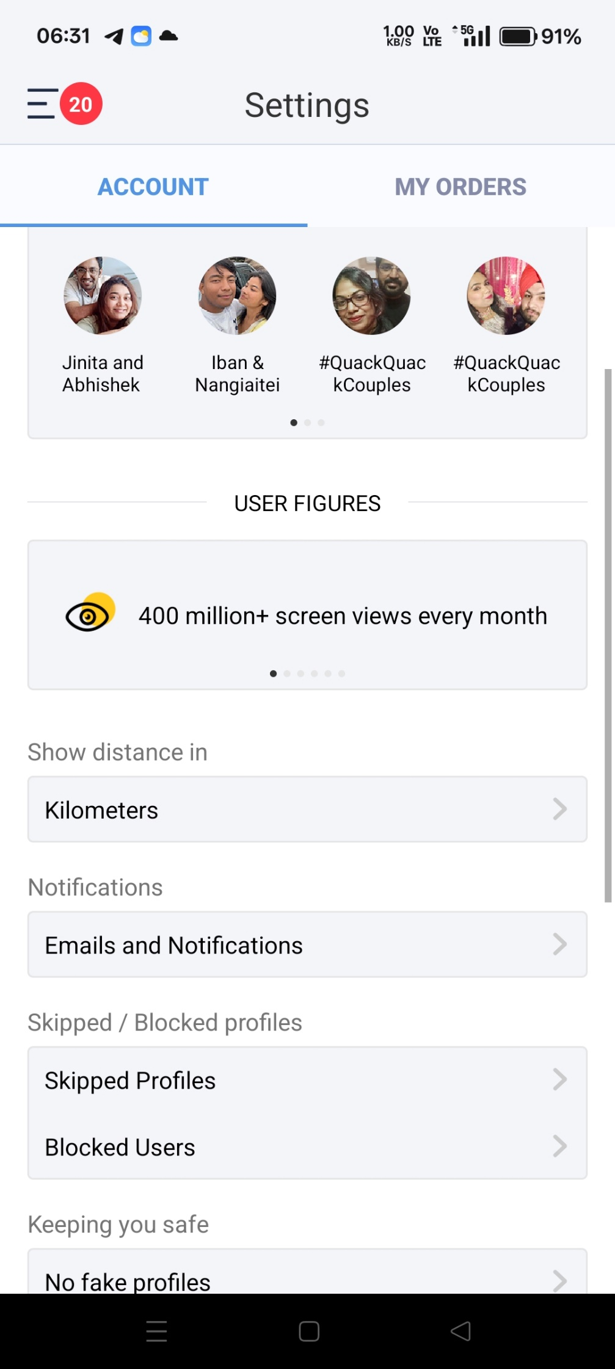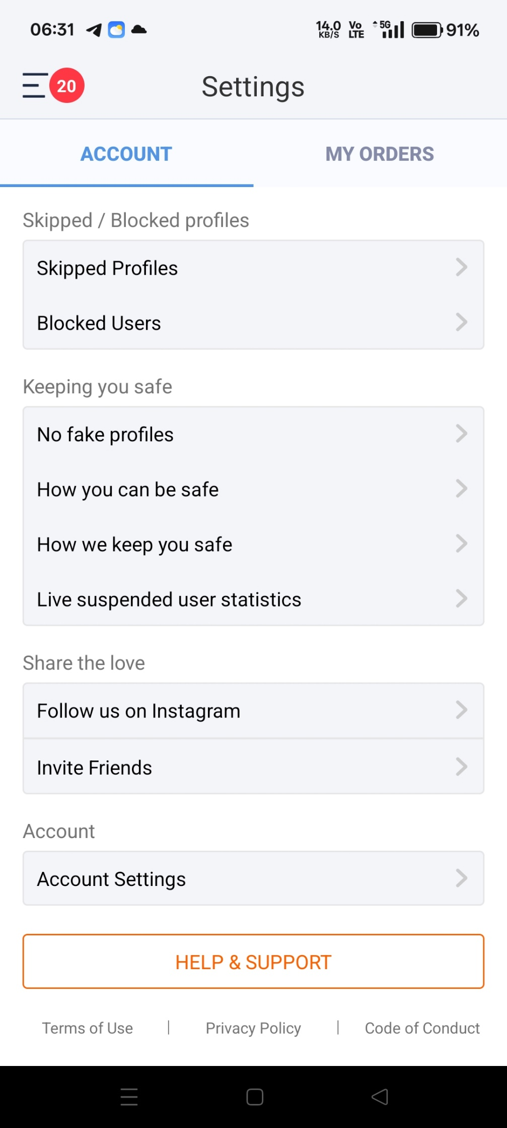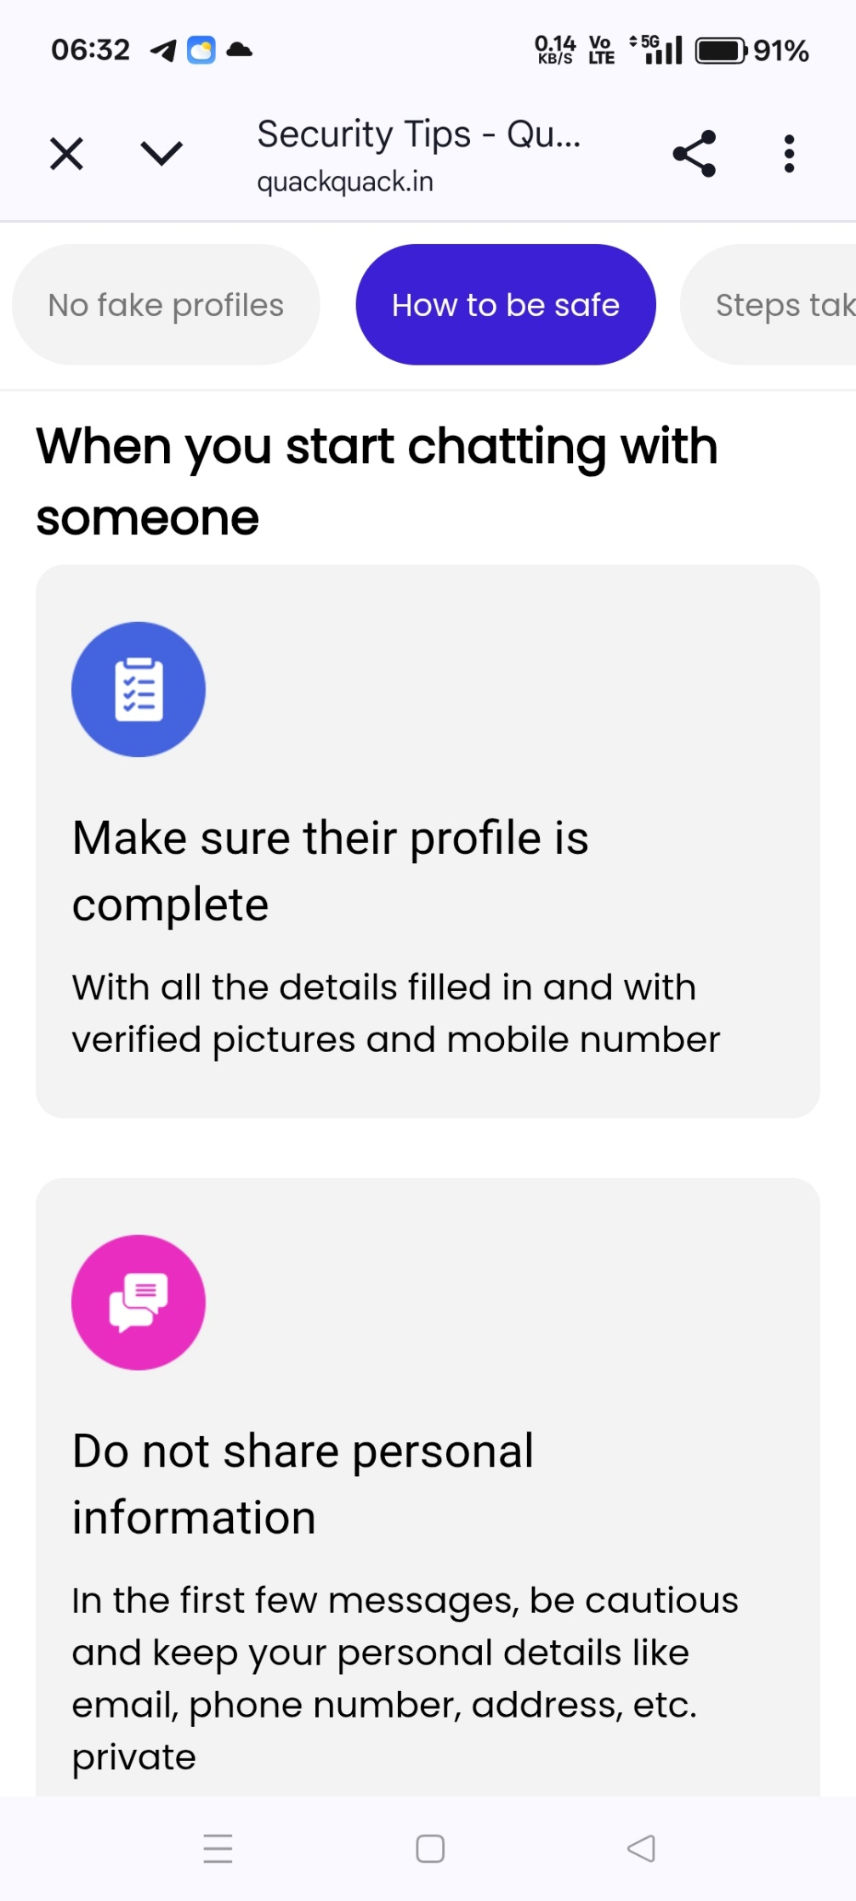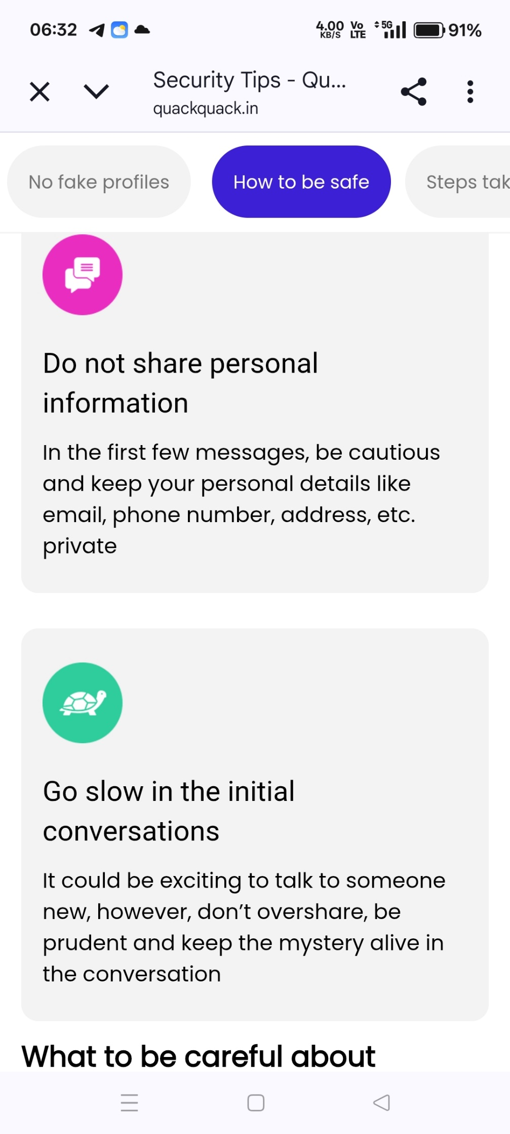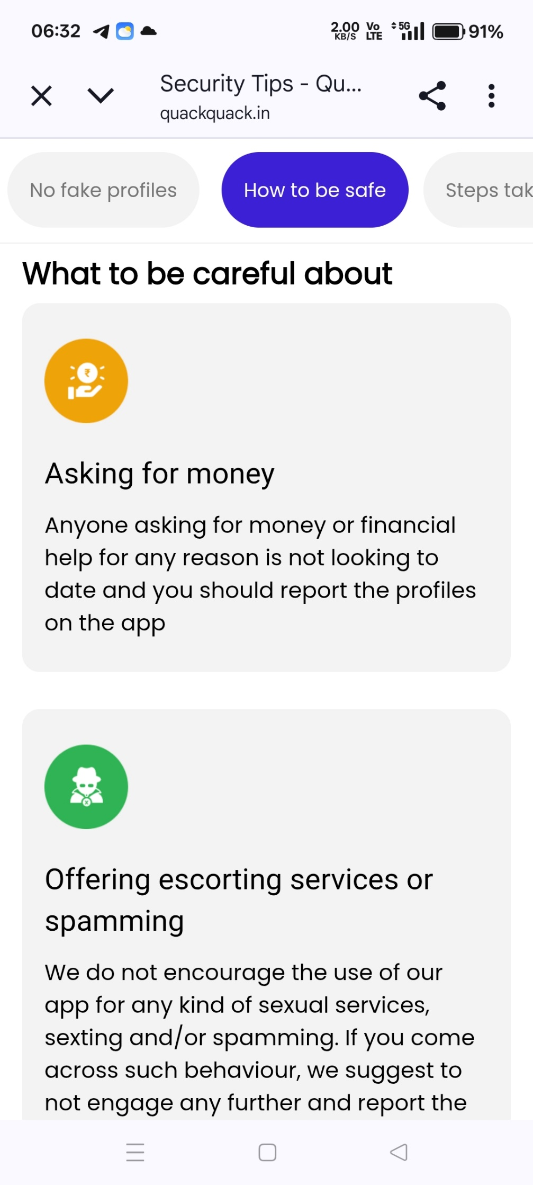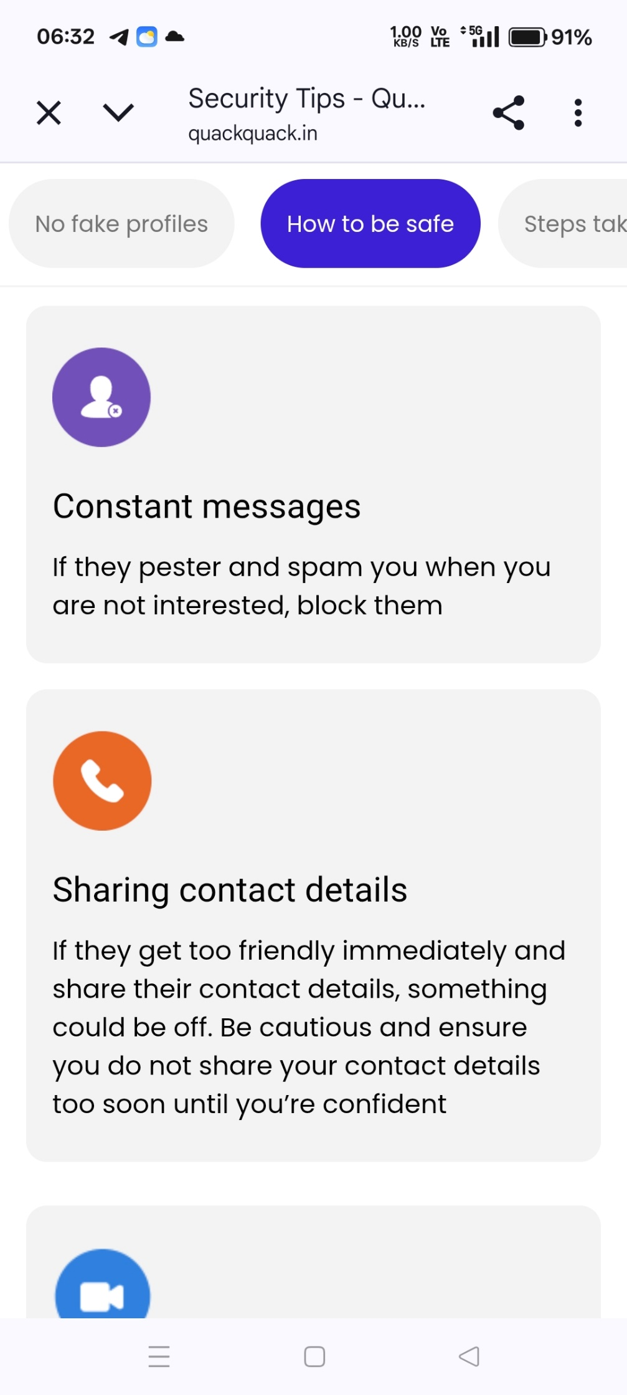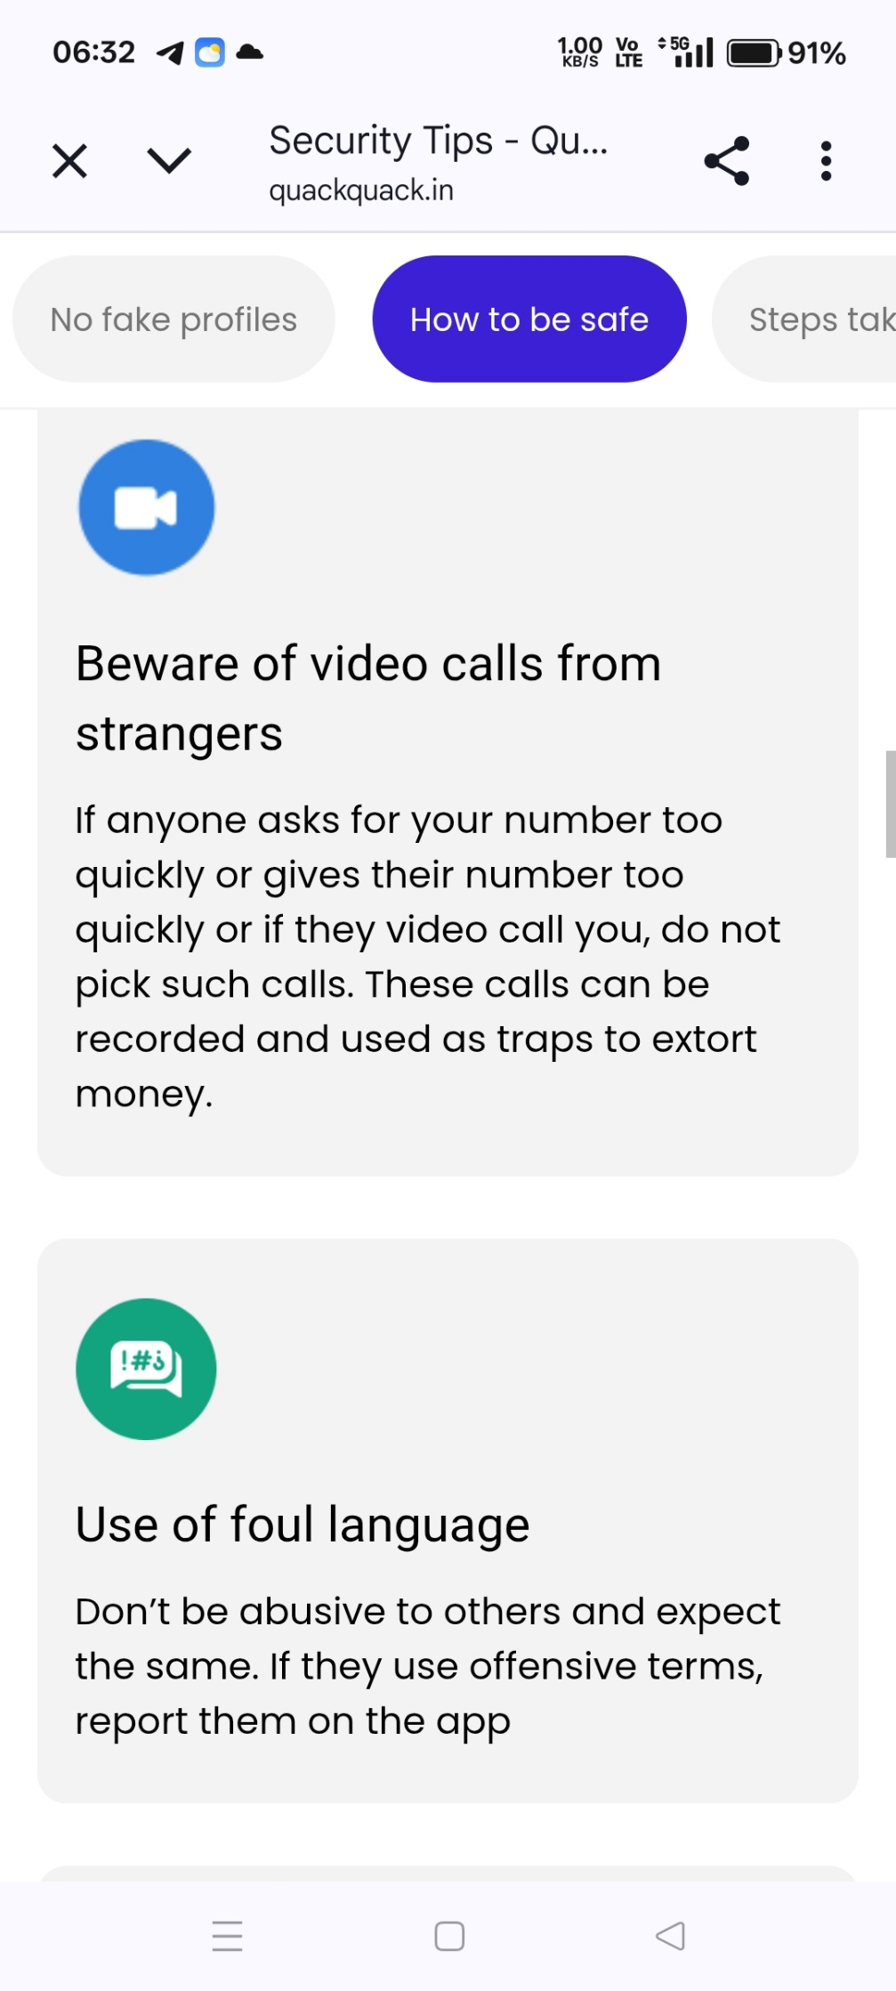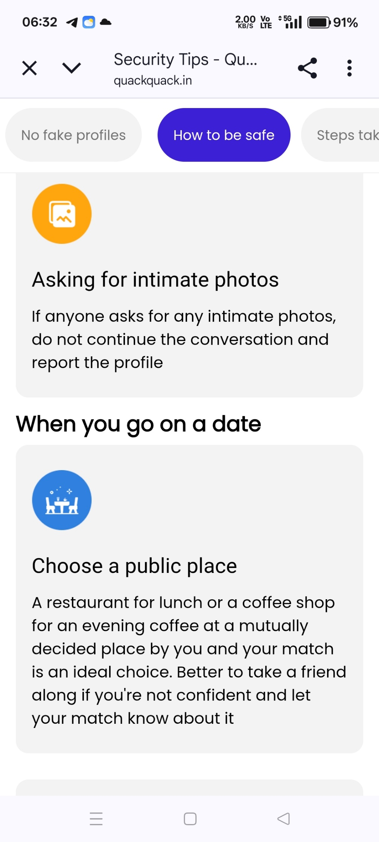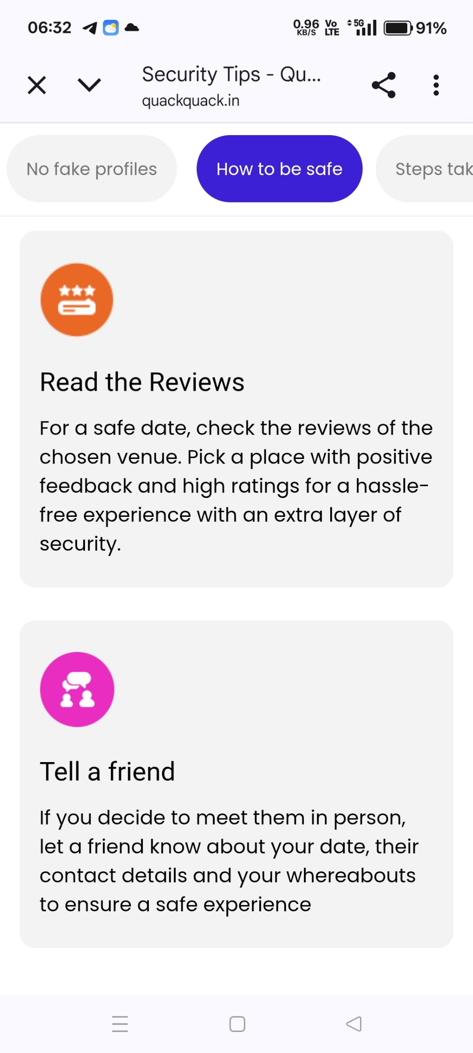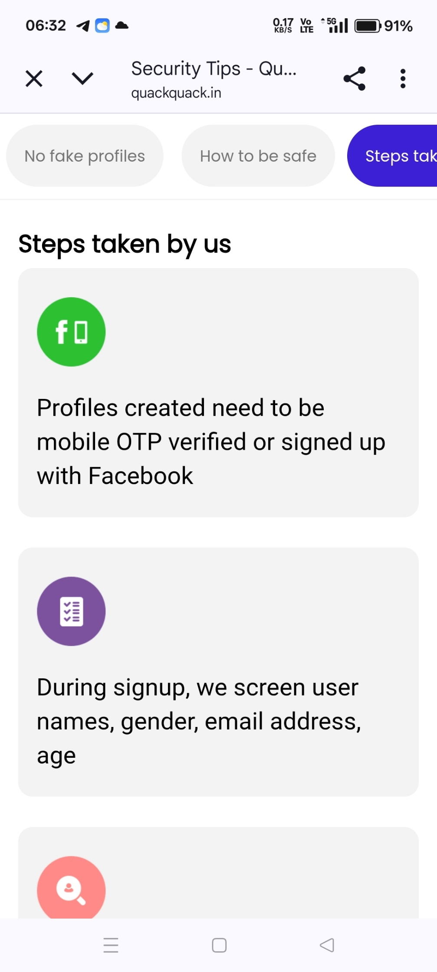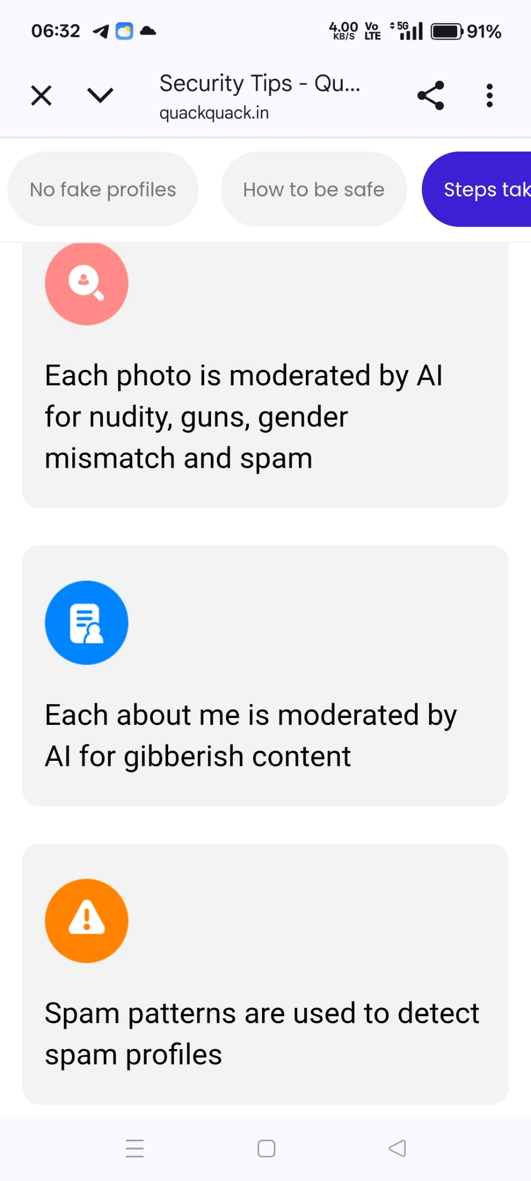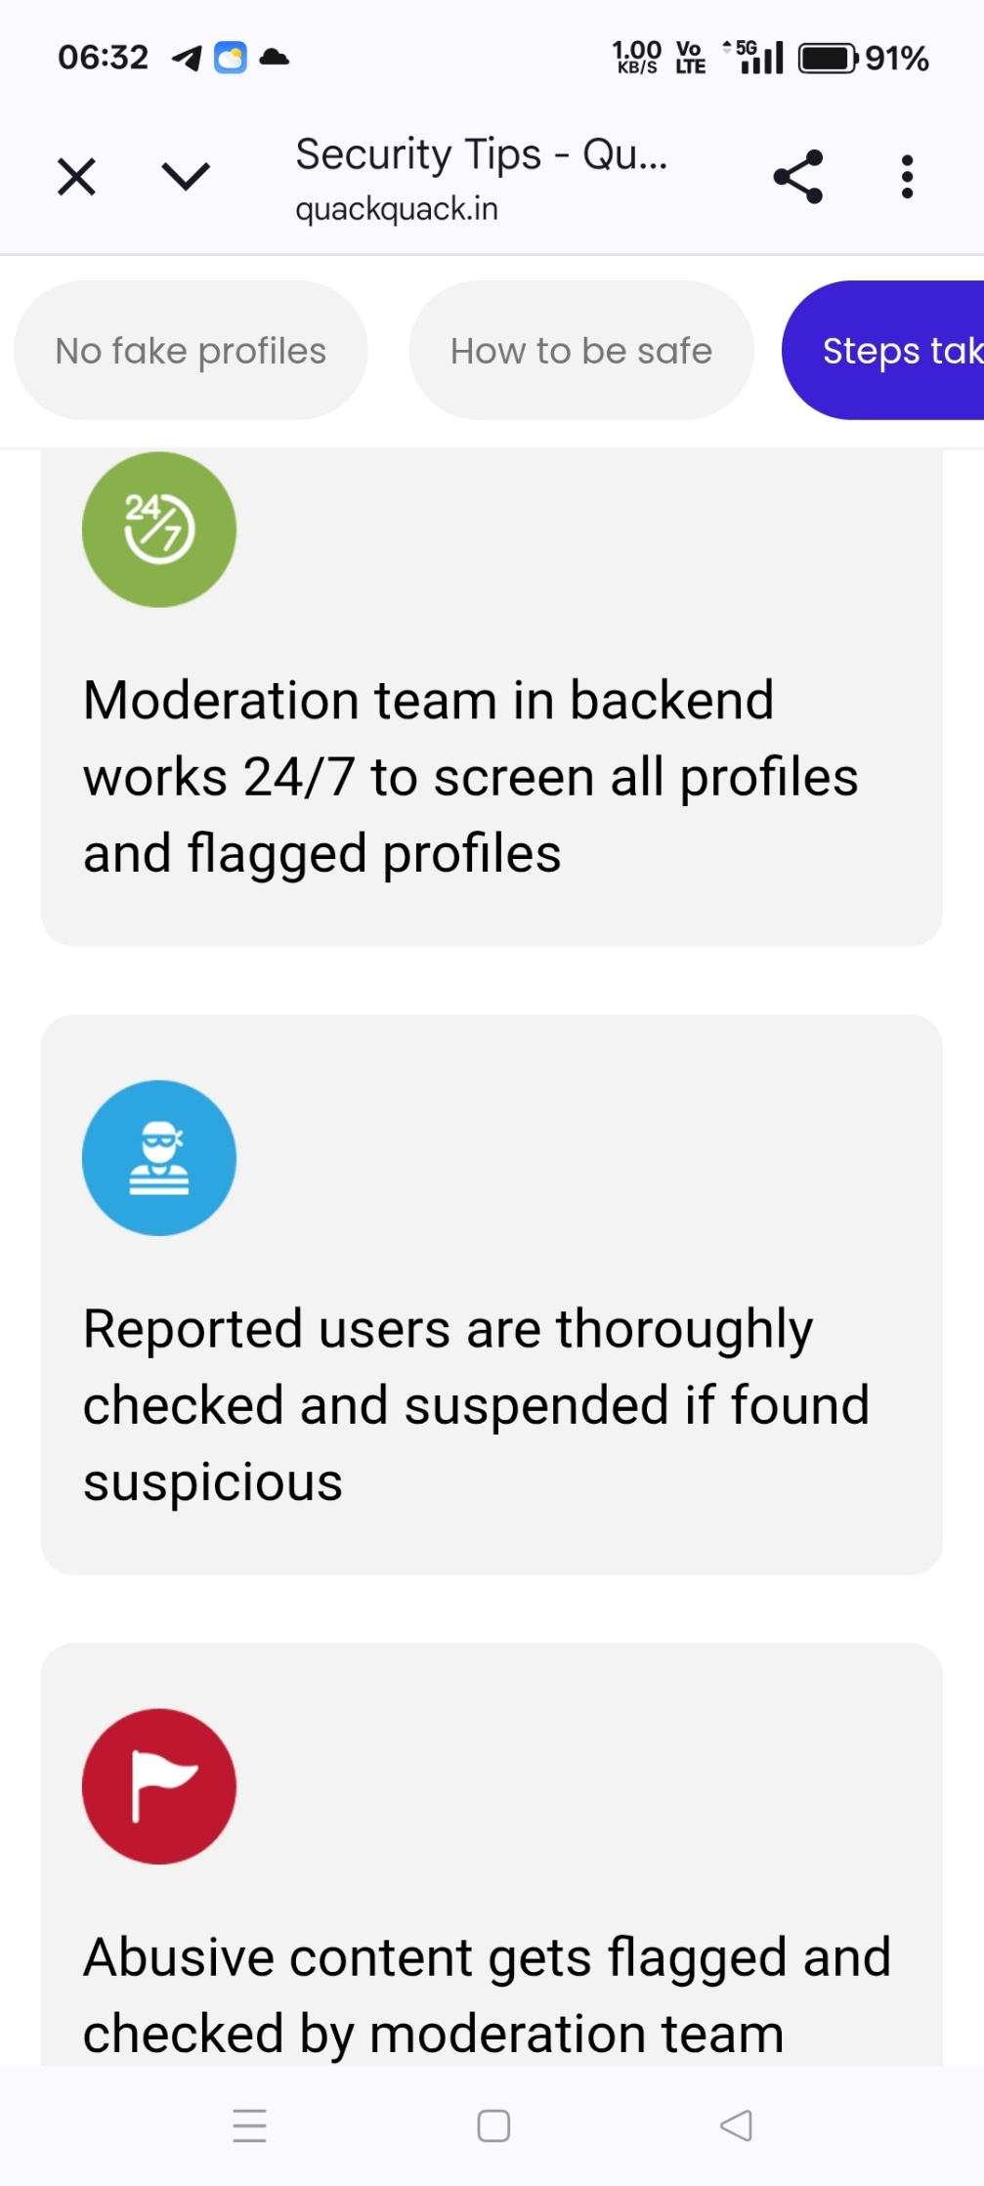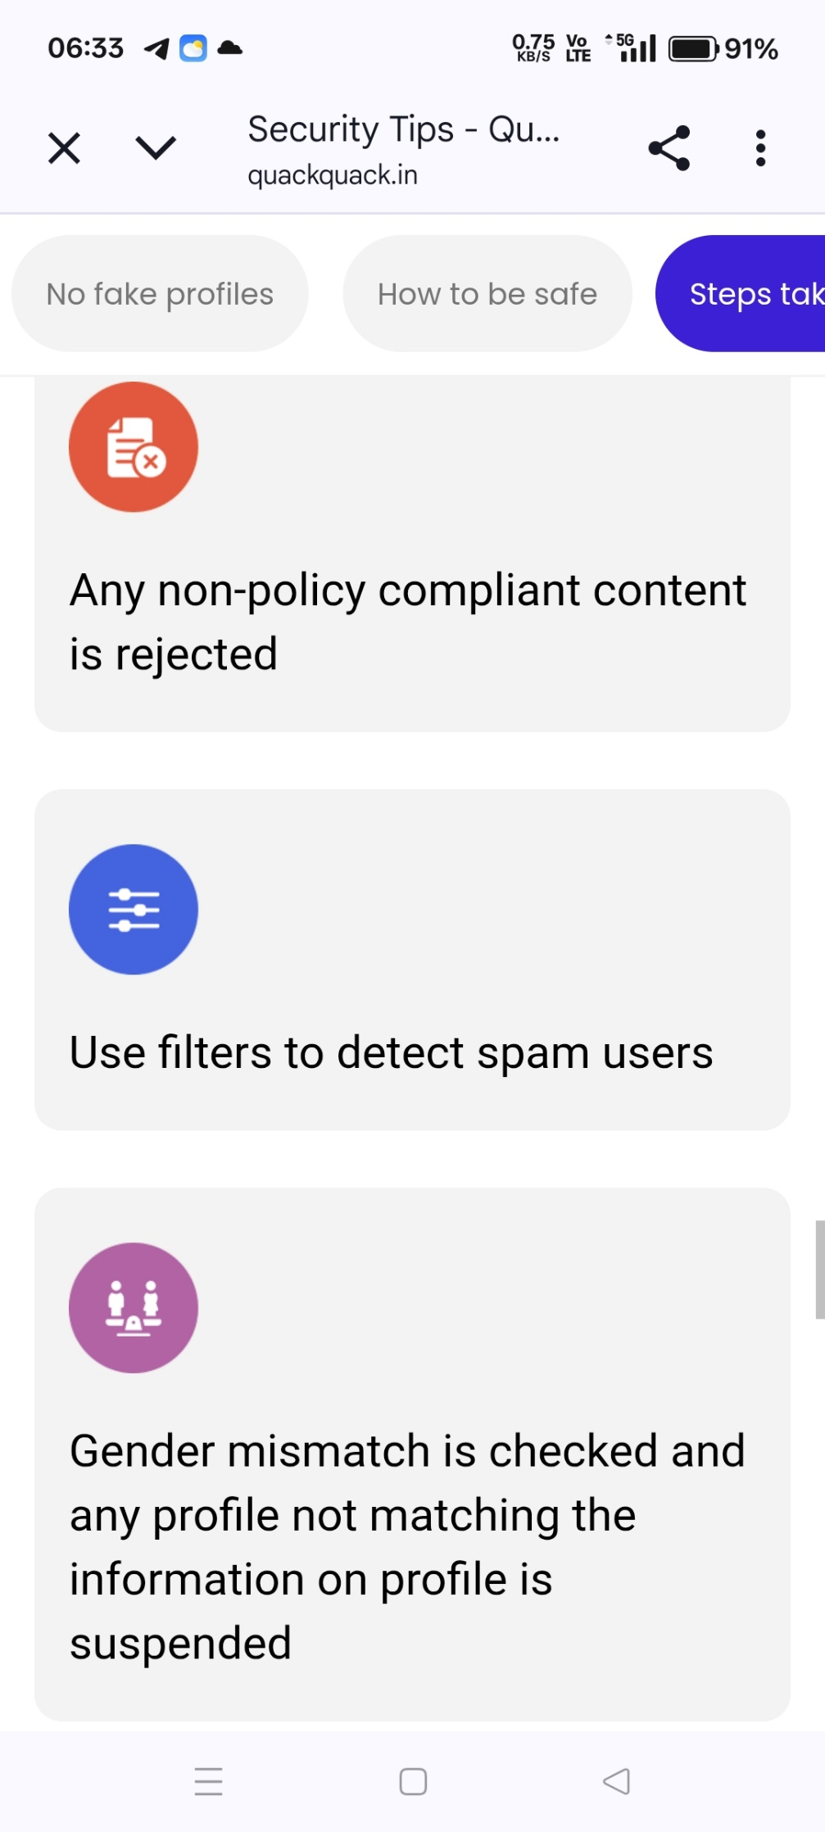

Subscription
Silver
* Unlimited Likes
* 50 Super Likes
*15 love quote
* 20messages
*50 see who likes
* 20 dating request

Rs. 399 per week
Rs. 699 /1 month
Rs. 1399/3 months
Rs. 2099/ 6 months

Free
*15 likes count
* 2 Super Likes
*No love quote
* No messages
*No see who likes
* No dating request

Gold
* Unlimited Likes
*Unlimited Super Likes
*100 love quote
* 100messages
* Unlimited see who likes
* 60 dating request

Rs. 899 per week
Rs. 1399 /1 month
Rs. 2099/3 months
Rs. 3099/ 6 months

Plus
*Unlimited Likes
* 20 Super likes
*5 love quote
* 3 messages
*3 see who likes
*3 dating request

Rs. 199 per week
Rs. 499 /1 month
Rs. 899/ 3 months
Rs. 1499/ 6 months

