Week 3: Advanced Data Analysis and Visualization
Logistics Data Analytics Internship Project

1. Introduction
This report presents advanced exploratory data analysis and visualizations of logistics and supply-chain data. The analysis examines delivery risk, shipping performance, sales trends, customer segments, markets, and shipping modes.

2. Objectives
- Analyze late-delivery risk across shipping modes and markets.
- Compare actual shipping time with scheduled shipping time.
- Examine sales across markets, customer segments, and shipping modes.
- Identify monthly and quarterly sales and delivery-risk trends.
- Save analysis results and visualizations for reporting.

3. Analysis Results

Shipping Mode Analysis
Shipping Mode | Total_Shipments | Late_Deliveries | Late_Delivery_Rate
First Class | 27814 | 26513 | 95.32
Second Class | 35216 | 26987 | 76.63
Same Day | 9737 | 4454 | 45.74
Standard Class | 107752 | 41023 | 38.07

Customer Segment Analysis
Customer Segment | Total_Orders | Late_Deliveries | Late_Delivery_Rate
Home Office | 32226 | 17747 | 55.07
Consumer | 93504 | 51248 | 54.81
Corporate | 54789 | 29982 | 54.72

Market Analysis
Market | Total_Orders | Late_Deliveries | Late_Delivery_Rate
Europe | 50252 | 27743 | 55.21
Pacific Asia | 41260 | 22712 | 55.05
Usca | 25799 | 14138 | 54.80
Africa | 11614 | 6340 | 54.59
Latam | 51594 | 28044 | 54.36

Shipping Time Analysis
Shipping Mode | Avg_Actual_Days | Avg_Scheduled_Days | Average_Delay_Days
First Class | 2.00 | 1.00 | 1.00
Same Day | 0.48 | 0.00 | 0.48
Second Class | 3.99 | 2.00 | 1.99
Standard Class | 4.00 | 4.00 | -0.00

Quantity and Delivery Analysis
Order Item Quantity | Total_Orders | Late_Deliveries | Late_Delivery_Rate
1.00 | 99134.00 | 54405.00 | 54.88
2.00 | 20315.00 | 11039.00 | 54.34
3.00 | 20350.00 | 11216.00 | 55.12
4.00 | 20335.00 | 11147.00 | 54.82
5.00 | 20385.00 | 11170.00 | 54.80

Sales by Market
Market | Total_Sales | Average_Sales | Total_Records
Europe | 10872396.80 | 216.36 | 50252
Latam | 10277612.84 | 199.20 | 51594
Pacific Asia | 8273743.74 | 200.53 | 41260
Usca | 5066528.71 | 196.38 | 25799
Africa | 2294452.93 | 197.56 | 11614

Sales by Customer Segment
Customer Segment | Total_Sales | Average_Sales | Total_Records
Consumer | 19095790.16 | 204.22 | 93504
Corporate | 11168406.84 | 203.84 | 54789
Home Office | 6520538.02 | 202.34 | 32226

Sales by Shipping Mode
Shipping Mode | Total_Sales | Average_Sales | Total_Records
Standard Class | 22022391.88 | 204.38 | 107752
Second Class | 7145444.82 | 202.90 | 35216
First Class | 5674369.76 | 204.01 | 27814
Same Day | 1942528.56 | 199.50 | 9737

Monthly Sales Analysis
Month | Total_Sales | Total_Records
2015-01 | 1051590.08 | 5322
2015-02 | 927009.90 | 4729
2015-03 | 1051253.69 | 5362
2015-04 | 1014463.28 | 5126
2015-05 | 1050478.44 | 5357
2015-06 | 1024006.17 | 5134
2015-07 | 1038081.19 | 5299
2015-08 | 1029494.69 | 5273
2015-09 | 1018338.60 | 5140
2015-10 | 1049154.27 | 5302
2015-11 | 1029120.24 | 5235
2015-12 | 1057840.88 | 5371
2016-01 | 1046308.25 | 5317
2016-02 | 968542.85 | 4894
2016-03 | 1025853.12 | 5210
2016-04 | 1001211.58 | 5097
2016-05 | 1029400.20 | 5302
2016-06 | 1003059.55 | 5054
2016-07 | 1045715.62 | 5305
2016-08 | 1048200.25 | 5334
Only the first 20 rows are displayed in this report. Refer to the exported CSV file for the complete results.

Monthly Delivery Risk
Month | Total_Records | Late_Deliveries | Late_Delivery_Rate
2015-01 | 5322 | 2880 | 54.11
2015-02 | 4729 | 2594 | 54.85
2015-03 | 5362 | 2936 | 54.76
2015-04 | 5126 | 2760 | 53.84
2015-05 | 5357 | 2951 | 55.09
2015-06 | 5134 | 2778 | 54.11
2015-07 | 5299 | 2939 | 55.46
2015-08 | 5273 | 2936 | 55.68
2015-09 | 5140 | 2914 | 56.69
2015-10 | 5302 | 2906 | 54.81
2015-11 | 5235 | 2841 | 54.27
2015-12 | 5371 | 2937 | 54.68
2016-01 | 5317 | 2955 | 55.58
2016-02 | 4894 | 2650 | 54.15
2016-03 | 5210 | 2905 | 55.76
2016-04 | 5097 | 2815 | 55.23
2016-05 | 5302 | 2951 | 55.66
2016-06 | 5054 | 2873 | 56.85
2016-07 | 5305 | 2755 | 51.93
2016-08 | 5334 | 2948 | 55.27
Only the first 20 rows are displayed in this report. Refer to the exported CSV file for the complete results.

Quarterly Sales Analysis
Quarter | Total_Sales | Average_Sales | Total_Records
2015Q1 | 3029853.67 | 196.58 | 15413
2015Q2 | 3088947.89 | 197.79 | 15617
2015Q3 | 3085914.48 | 196.40 | 15712
2015Q4 | 3136115.39 | 197.14 | 15908
2016Q1 | 3040704.22 | 197.18 | 15421
2016Q2 | 3033671.33 | 196.32 | 15453
2016Q3 | 3096312.91 | 195.98 | 15799
2016Q4 | 3133128.86 | 197.34 | 15877
2017Q1 | 3070237.70 | 198.46 | 15470
2017Q2 | 3175893.43 | 205.16 | 15480
2017Q3 | 3357485.64 | 212.34 | 15812
2017Q4 | 2204819.37 | 342.68 | 6434
2018Q1 | 331650.12 | 156.22 | 2123

Quarterly Delivery Risk
Quarter | Total_Records | Late_Deliveries | Late_Delivery_Rate
2015Q1 | 15413 | 8410 | 54.56
2015Q2 | 15617 | 8489 | 54.36
2015Q3 | 15712 | 8789 | 55.94
2015Q4 | 15908 | 8684 | 54.59
2016Q1 | 15421 | 8510 | 55.18
2016Q2 | 15453 | 8639 | 55.91
2016Q3 | 15799 | 8540 | 54.05
2016Q4 | 15877 | 8757 | 55.16
2017Q1 | 15470 | 8434 | 54.52
2017Q2 | 15480 | 8295 | 53.59
2017Q3 | 15812 | 8721 | 55.15
2017Q4 | 6434 | 3514 | 54.62
2018Q1 | 2123 | 1195 | 56.29

4. Visualizations
Week3 Late Delivery By Shipping Mode
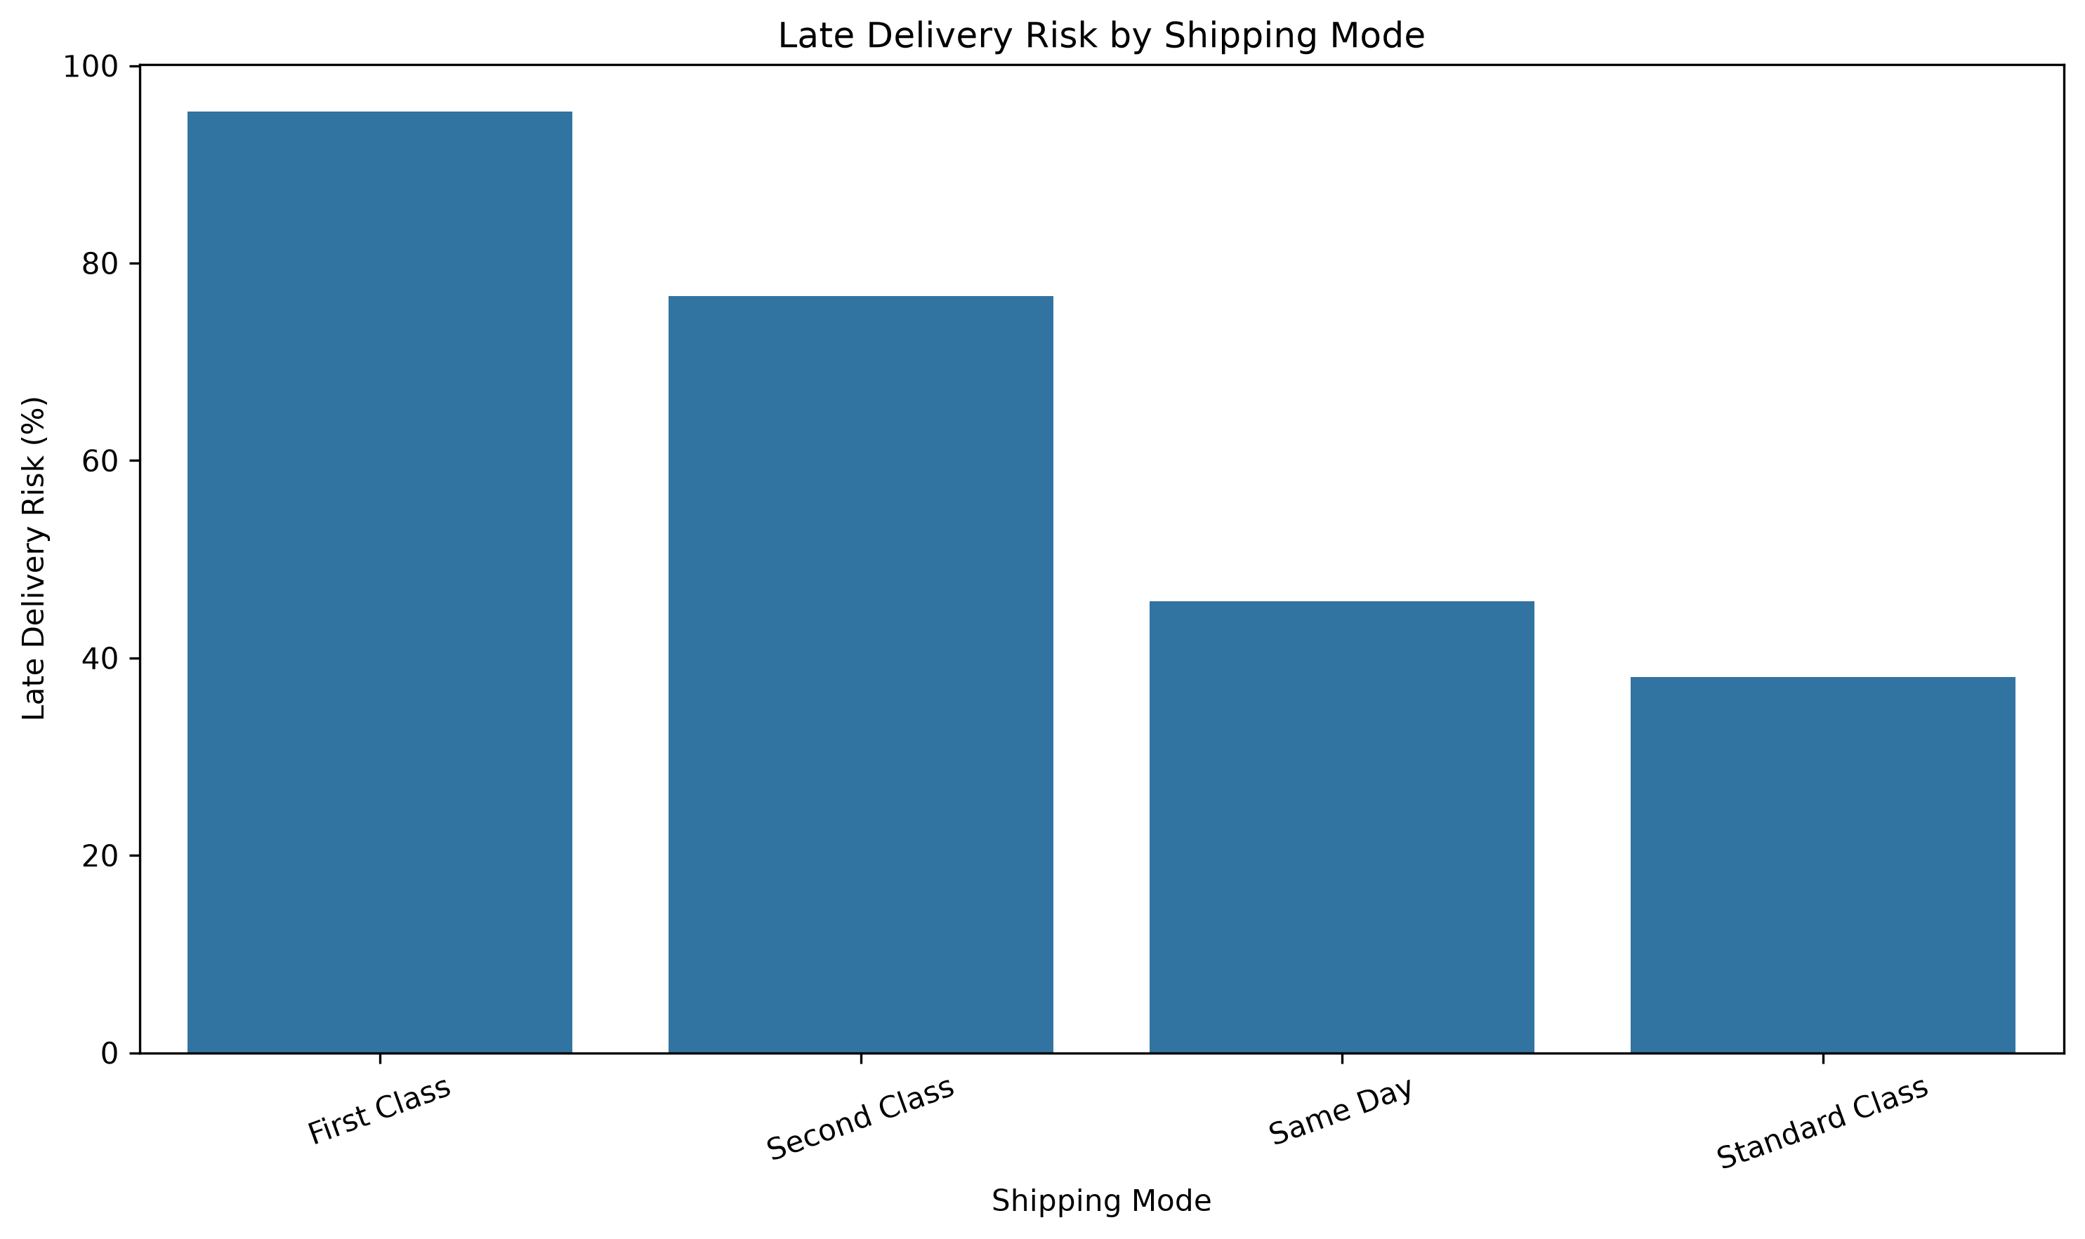
Week3 Late Delivery By Customer Segment
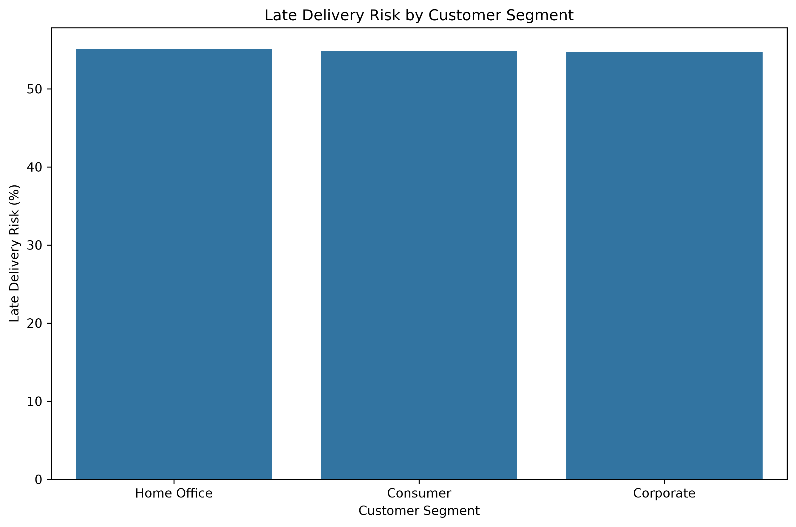
Week3 Late Delivery By Market
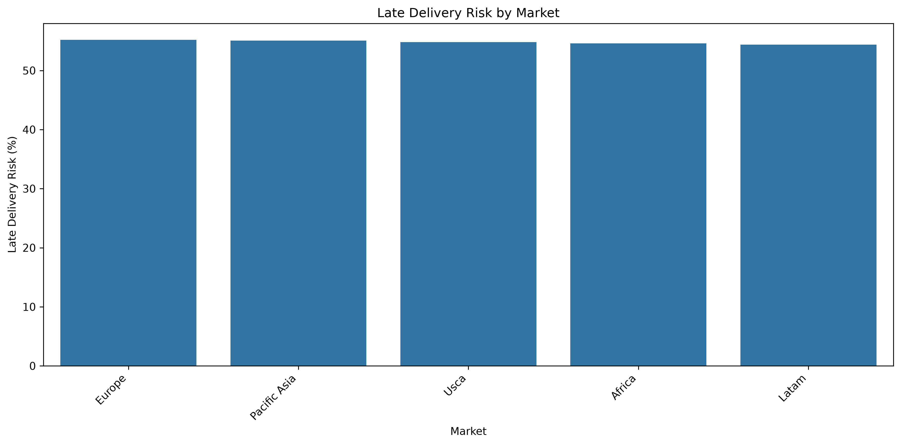
Week3 Actual Vs Scheduled Shipping
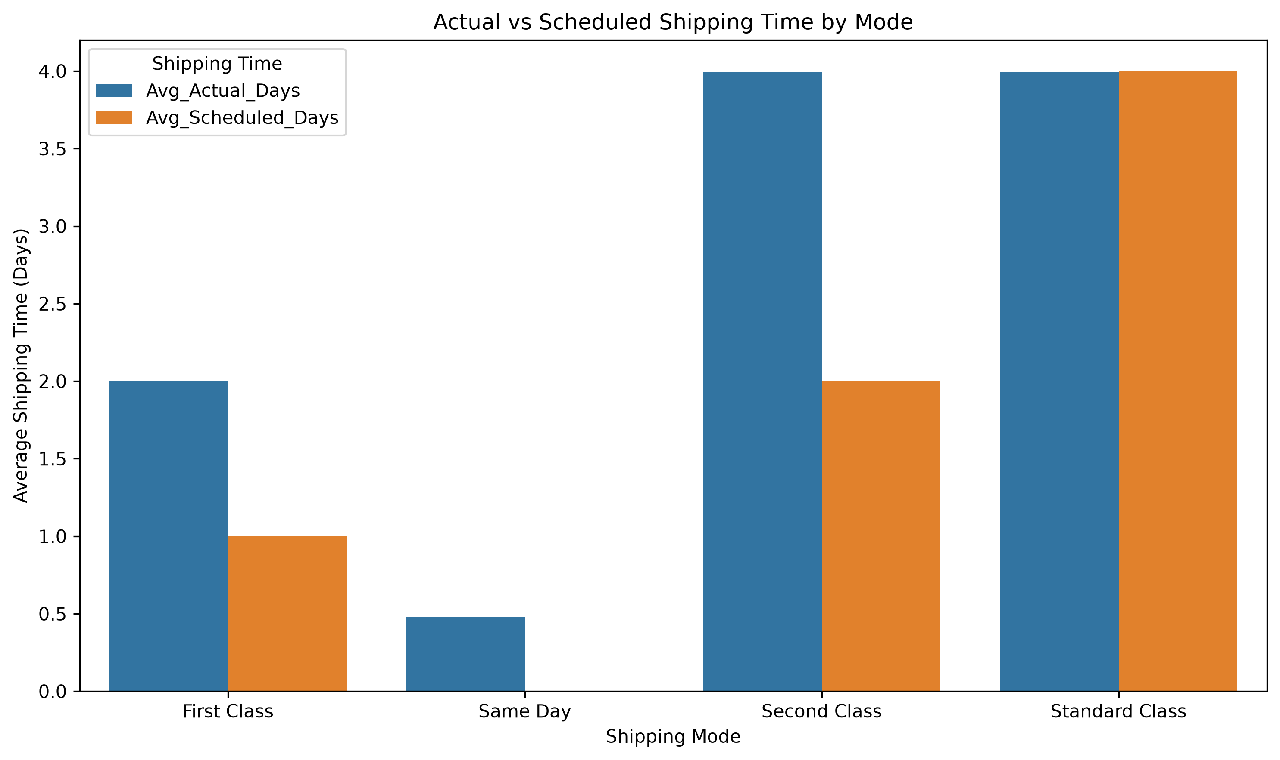
Week3 Late Delivery By Quantity
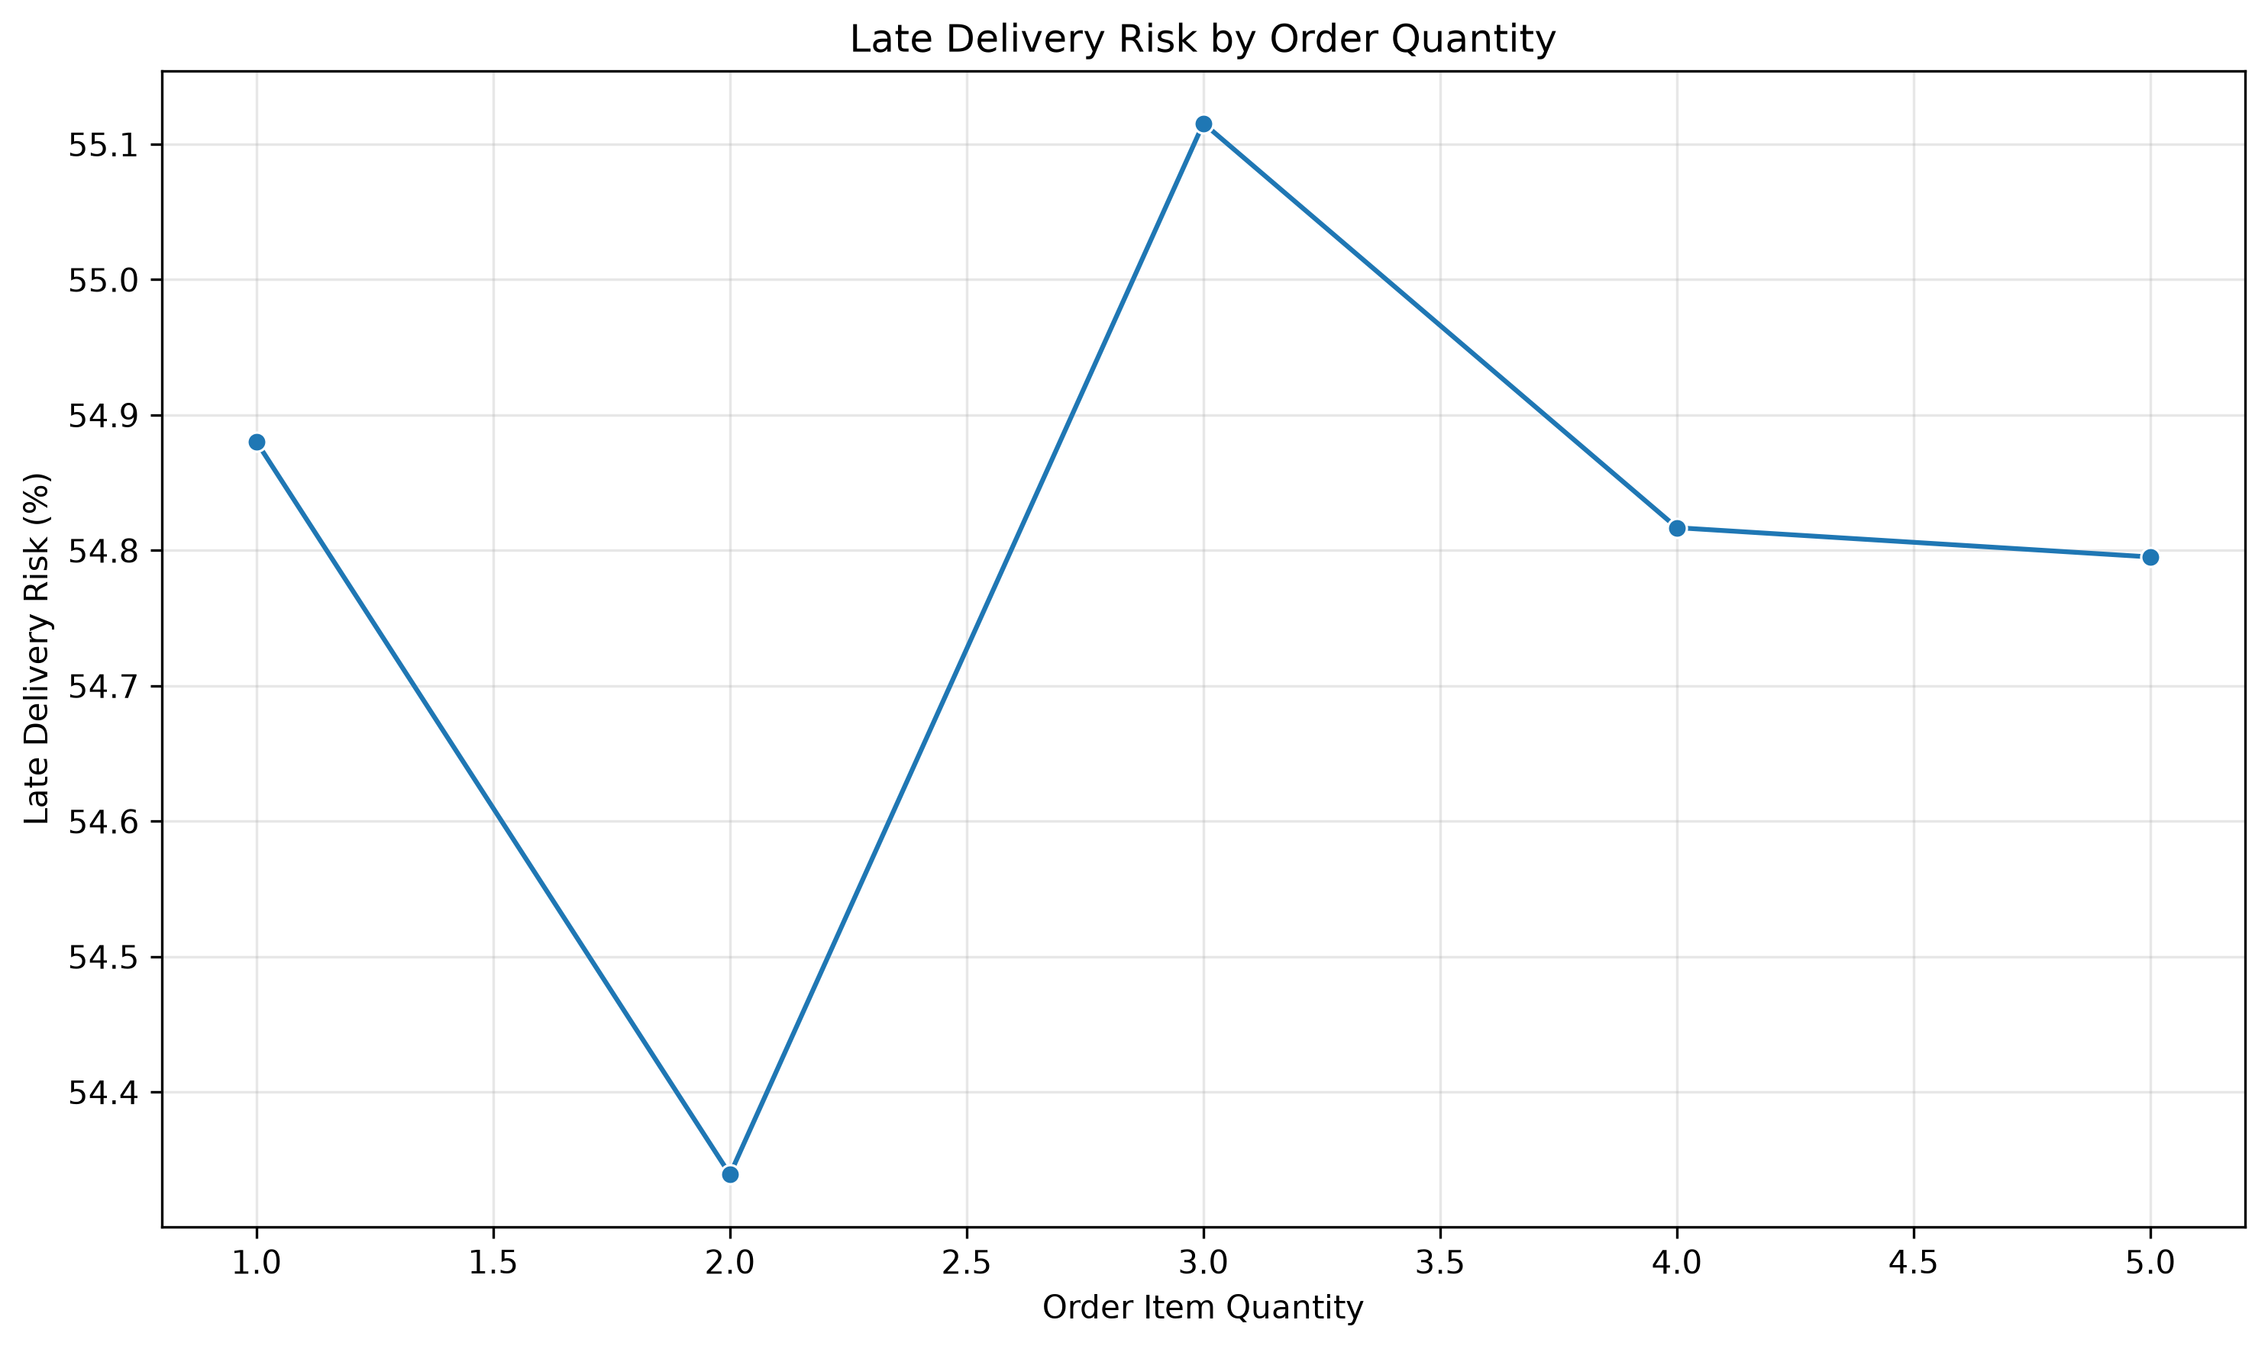
Week3 Total Sales By Market
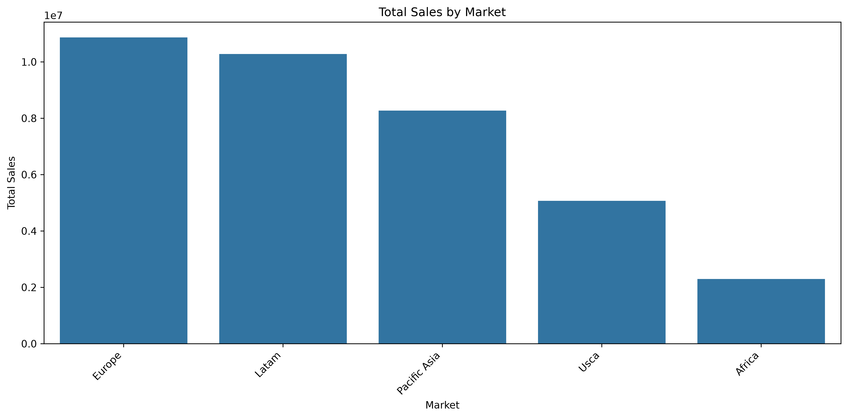
Week3 Total Sales By Customer Segment
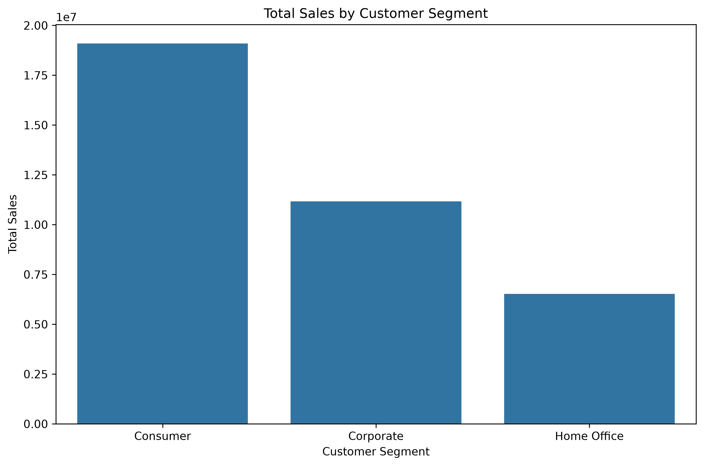
Week3 Total Sales By Shipping Mode
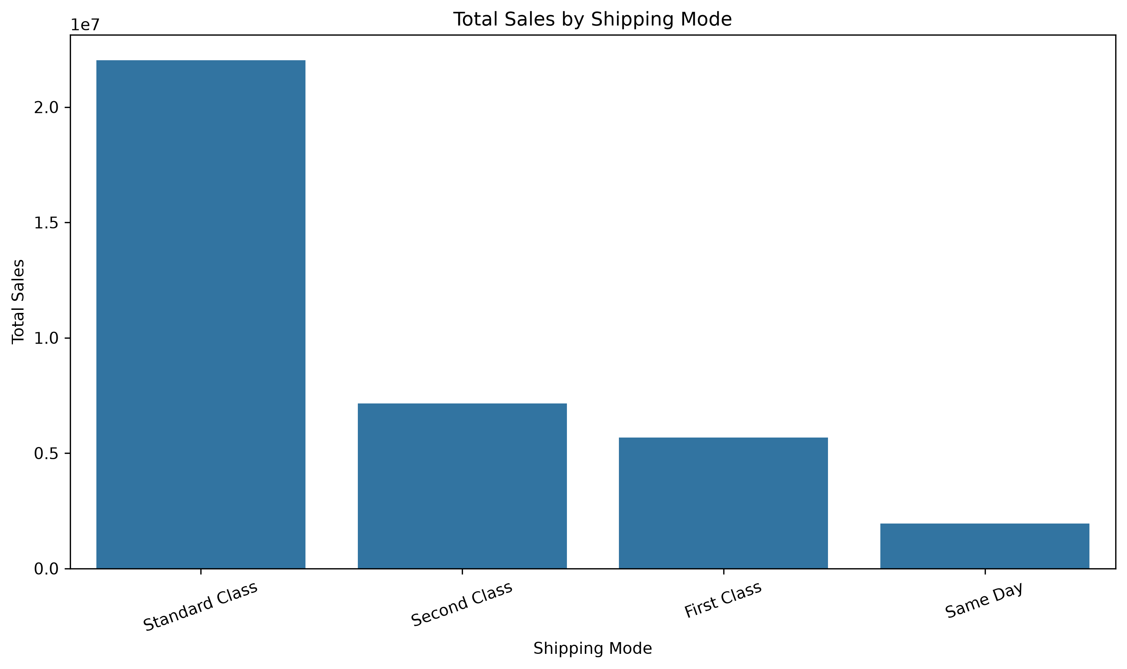
Week3 Monthly Sales Trend
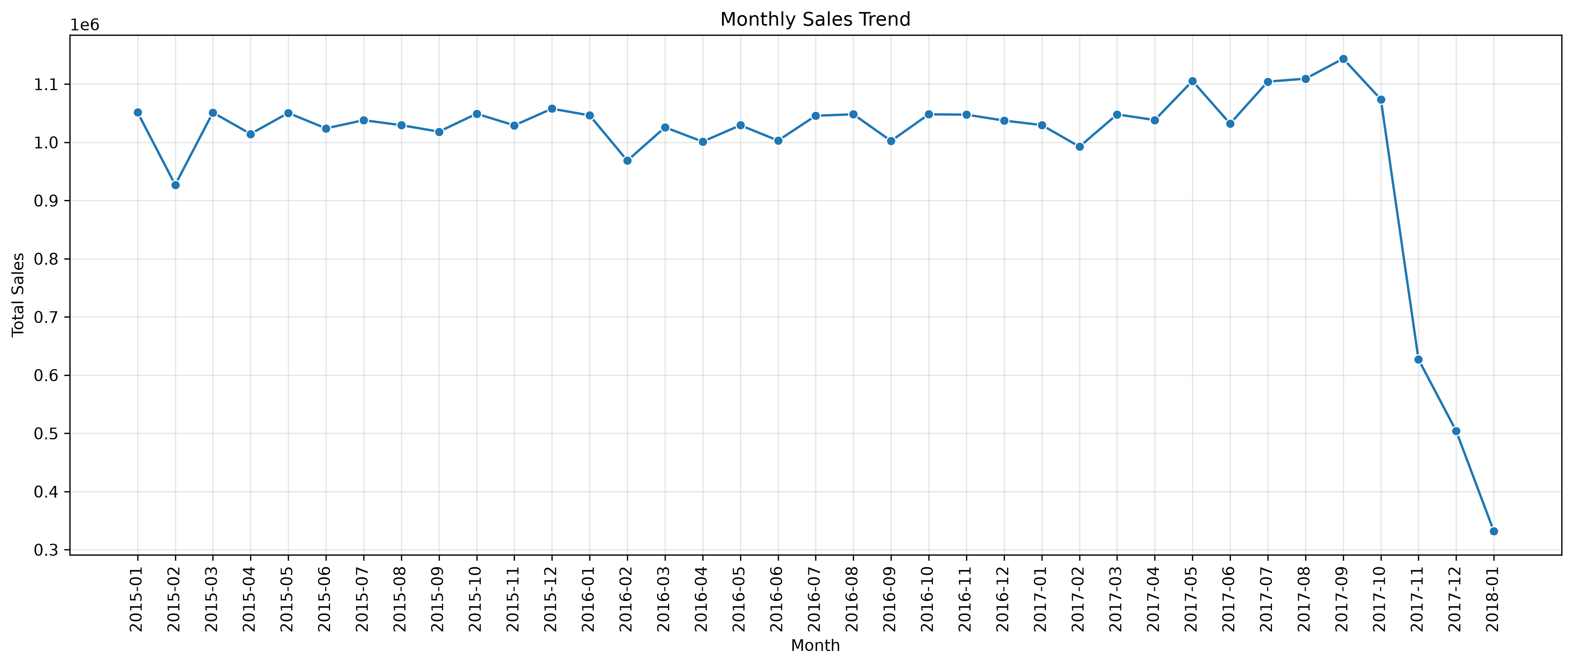
Week3 Monthly Late Delivery Risk
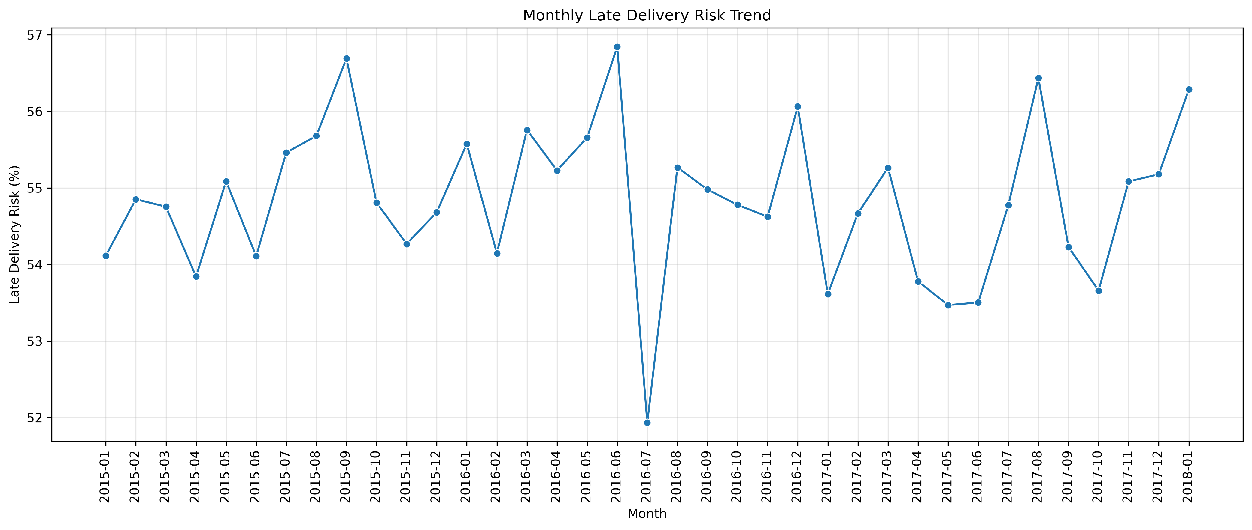
Week3 Quarterly Sales Trend
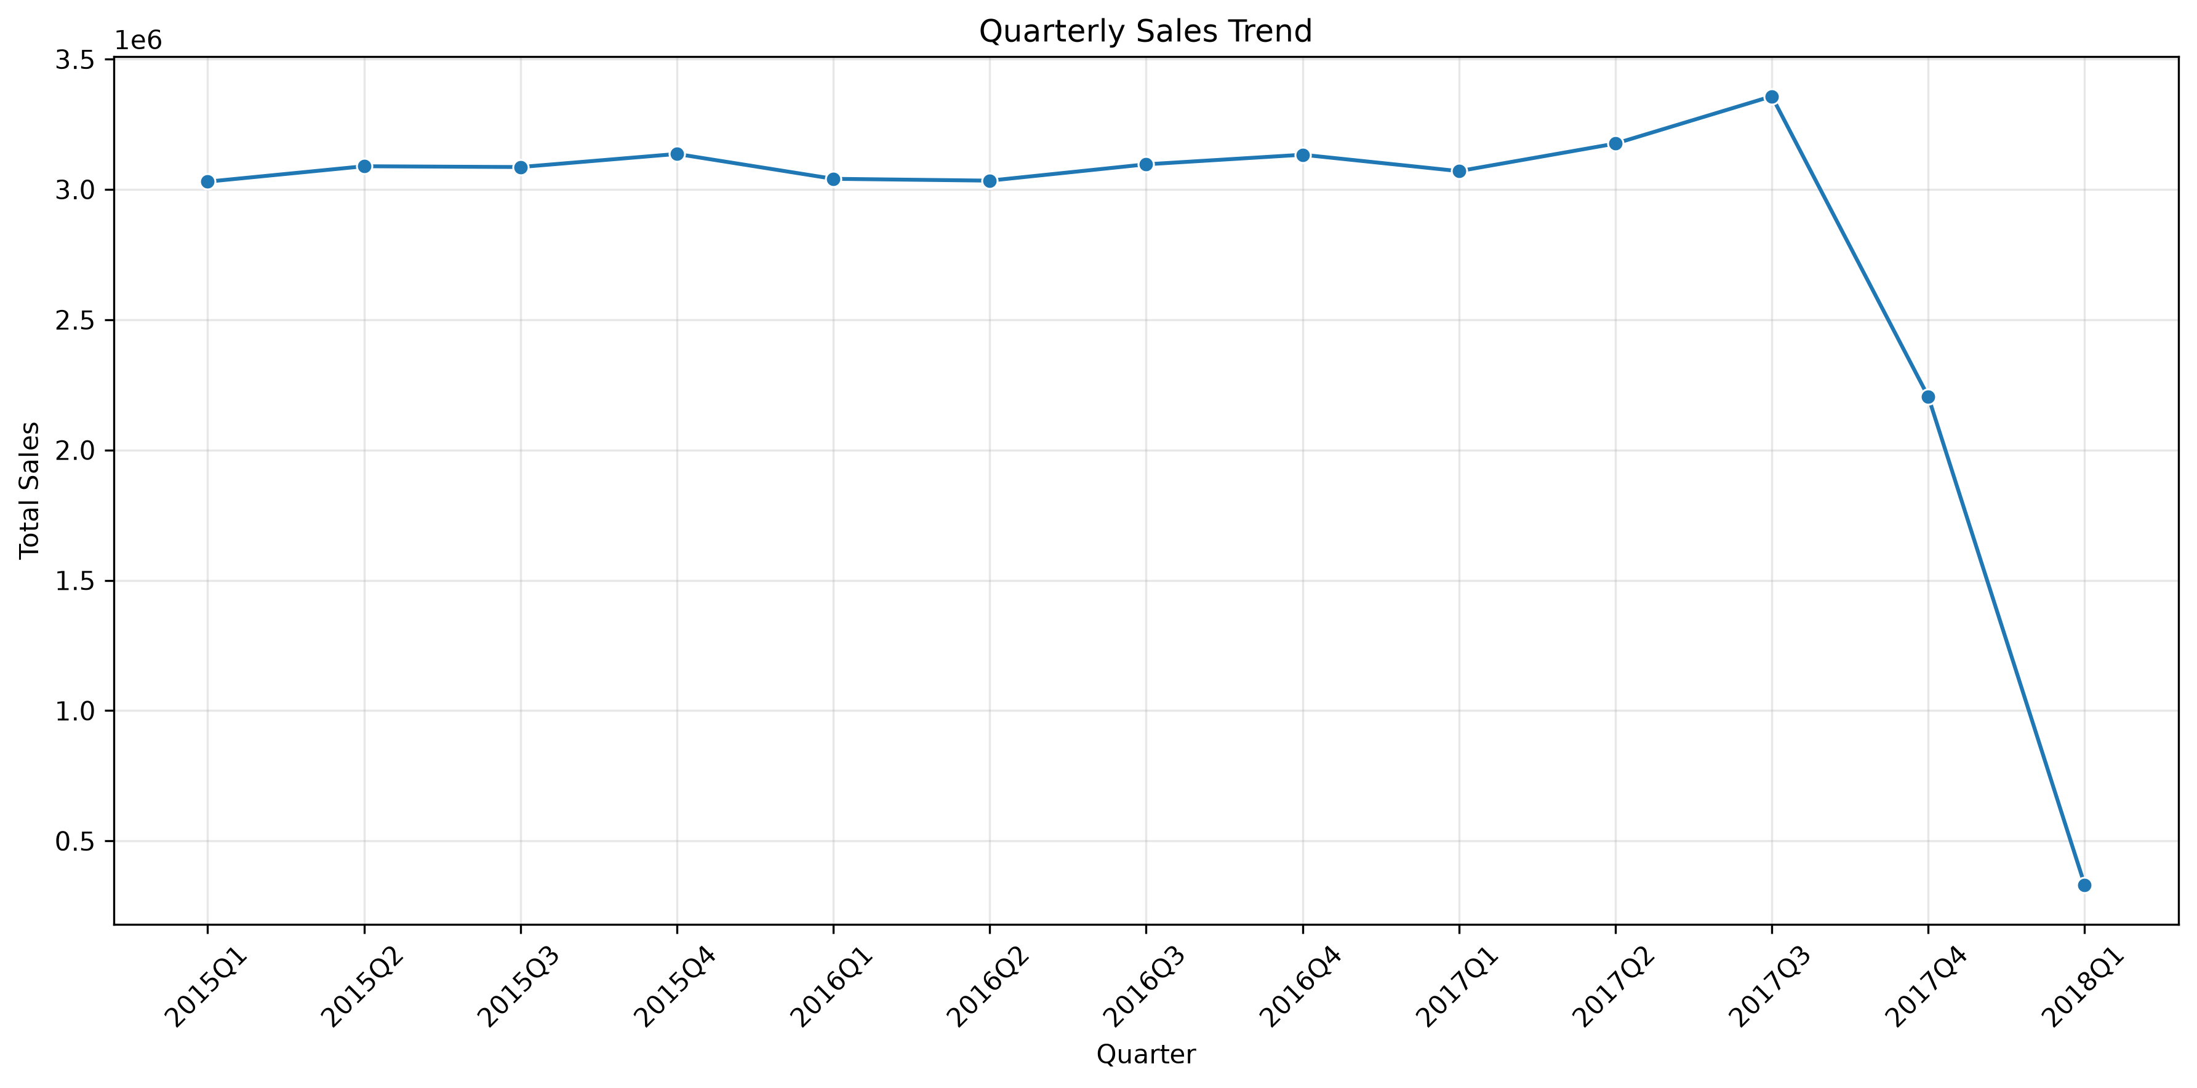
Week3 Quarterly Delivery Risk
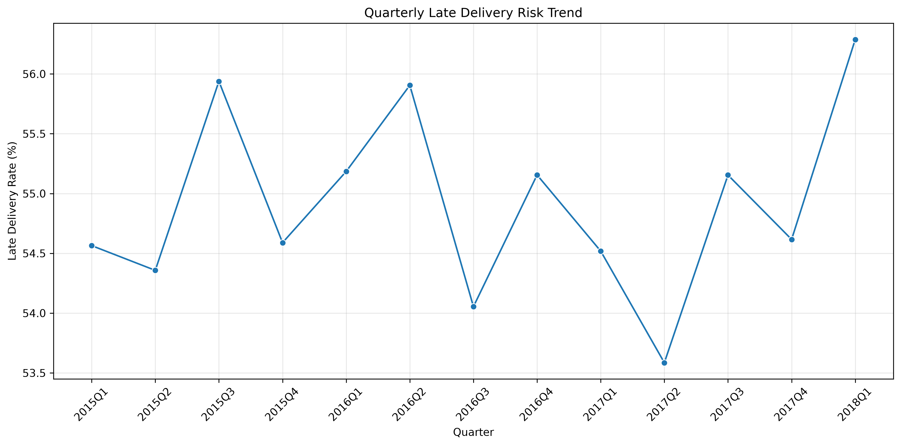

5. Conclusion
The analysis provides a comparative view of logistics delivery performance and sales patterns. The tables and charts can help identify areas requiring further investigation. Conclusions about specific trends should be based on the observed values in the analysis tables and visualizations.

6. Output Files
Supporting charts, CSV analysis tables, and the text summary are stored in the project's Output folder.

