RESUME

Name : Aman Mishra

Present Address |  | Contact Details |  |  | 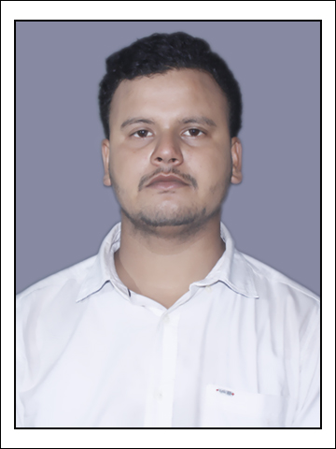
Vill+Post-Jamalpur,Mirzapur,U.P. |  | Mobile: | 9557589160
 |  | Land Line No.
 |  | E-Mail: | aman231302@gmail.com
Career Objective: |  | Looking for a challenging role in a reputable organization to utilize my technical and management skills for the growth of the organization as well as to enhance my knowledge about new things.
Educational Qualifications:
Exam | Year | College & Board | Main Subjects | Marks% | Remarks
10th | 2013 | SMT Deokali Inter College Jamalpur,Mirzapur | PCM | 68.33 | Passed
12th | 2015 | SMT Deokali Inter College Jamalpur,Mirzapur | PCM | 65 | Passed
B.Tech | 2020 | R.B.S Engineering Technical Campus Bichpuri Agra. | Computer Science & Engineering. | 60.30 | Passed

Technical Skills: | JAVA , HTML,MYSQL,ECLIPSE.
EXTRA CURICULLAR ACTIVITES
Cricket , Events Participation

CERTIFICATION:
Java Certification
Participation Certification in ICDIS-2019

INDUSTRIAL TRAINING:

Image Infosystems Pvt. Ltd.( 17 th June 2019 to 17 th july 2019 )

Projects: | DEFECT TRACKING SYSTEM
Additional Information /Achievement |  |  | Teamwork and Interpersonal skills.  Java Certification  Participation Certification in ICDIS-2019
Personal Details |  |  |  | Permanent Address / Contact Details
Father's Name: |  | Mr.Sandeep Kumar Mishra |  | JAMALPUR,MIRZAPUR,U.P
D.O.B: |  | 15/03/1998

Language Proficiency: | English,Hindi,BhojPuri | Father’s Phone No. 9598278467
Marital Status: | Single | Father’s Phone No. 9598278467
Signature
Aman Mishra

