IT2020 – Software Engineering

**Year 2, Semester I, 2024 Group Assignment**

**<<Online Transport System >>**

**Group Details**

**Campus: Malabe**

**SE/OOP Group Number: SE/OOP/2024/S1/MLB/WD/G135**

|  |  |  |
| --- | --- | --- |
|  | **Student Registration Number** | **Student Name** |
| **1** | **IT22172396** | **K. S. M. Samarasekara** |
| **2** | **IT22276278** | **T. D. P. Randeniya** |
| **3** | **IT22278012** | **T. T. Thilakerathne** |
| **4** | **IT22548146** | **R. J. M. P. M. Bandara** |

INTRODUCTION 3

Common Use Case Diagram 4

IT22172396 – K. S. M. Samarasekara 5

Use Case Scenario 5

Sequence Diagram 6

Communication Diagram 7

IT22276278 – T. D. P. Randeniya 8

Use Case Scenario 8

Registered User login SD (reference) 9

Sequence Diagram 10

Communication Diagram 11

IT22278012 – T. T. Thilakerathne 12

Use Case Scenario 12

Sequence Diagram 14

Communication Diagram 15

IT22548146 – R. J. M. P. M. Bandara 16

Use Case Scenario 16

Sequence Diagram 17

Communication Diagram 18

“Way To Go” is a website that provides incredible service and makes booking cars, vans, three-wheelers, motorcycles for your ride to simple. You can use “Way to go” to plan you travel itinerary and access a variety of other helpful features. Customers can use the app to check prices for their chosen desires after enrolling to the website. Users must select their package according to the Kilo Meters and days, pick up and drop off points, and the type of vehicle they need, as they arrange their vehicle booking. The website allows customers to register themselves as Customers. To register in the system customer must sign up to the website creating a username and a password. Also, E-mail, NIC, Phone number, Address, Gender likewise data must save in their private profile. After that process Customer can login to the website using their login credentials. This web site is not only for the customers, but we are also enrolling the drivers through the website and the app. Driver user must register on the website as a Driver, in the registering process they must upload their CV to system. After considering Age, Experiences, and other qualifications, selected drivers will notify from an email.

Credit cards, Debit cards, Bank deposits are acceptable. Customers must pay full or half payment when they are booking the ride, other half can be paid after the ride. A customer that frequently uses this system will be given offers as free rides or discounts on prices.

The drivers will be received the confirmed booked rides list. And the company will assign drivers on each booked ride. Drivers will paid by a monthly salary. All the vehicle costs will be handled by the company, excluding driver fault accidents.

Customers are able to cancel an incomplete booked ride, and also they can edit their profile details. Drivers are able to accept or decline booking rides, and also they can edit their profile details. If any user needs help with any thing of the services, they can contact the receptionist and solve their problems. The service is rated by both drivers and the customers. “Way To Go” offers all the users a good service that makes their life simple.

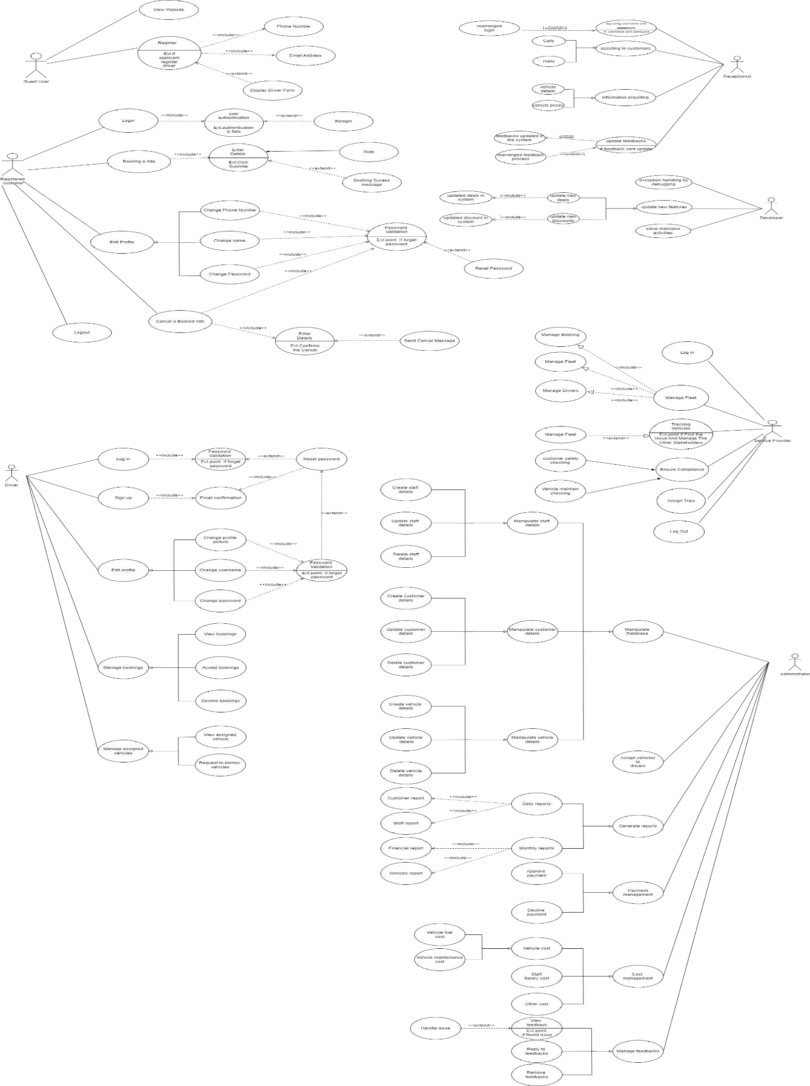

## Use Case Scenario

|  |  |  |
| --- | --- | --- |
| Use Case ID | 004 | |
| Use Case Name | Payment Management | |
| Summary | Handle all payments | |
| Priority | 3 | |
| Precondition | * The Administrator must logged into the online transport system with their login credentials. | |
| Postcondition | * Payment database updated. * Generate financial reports. | |
| Primary Actor | Administrator | |
| Main Success Scenario | **Step** | **Action** |
|  | 1 | Administrator login to the system with their username and password. |
|  | 2 | System verifies the username and password. |
|  | 3 | Administrator selects the ‘’payment Management” option from main menu. |
|  | 4 | The system retrieves a list of pending payments from completed trips, including customer fees, fuel chargers, vehicle  maintenance chargers. |
|  | 5 | The administrator reviews the list of all payments, ensuring accuracy. |
|  | 6 | For each payment, the administrator selects the appropriate action. |
|  | 7 | Once all payments have been reviewed and approved, the Administrator confirms the payment batch. |
|  | 8 | Administrator Update the payment database, marking the payments as completed. |
|  | 9 | The Administrator generates financial reports. |
| Extension | **Step** | **Branching Action** |
|  | 1a | The system notifies entered login details valid or invalid. |
|  | 1b | If invalid details, the system will send an error massage and ask to re- enter correct data |
|  | 1c | The system terminates after the three unsuccessful attempts |
|  | 1d | The system displays the “forget password” to recover the password. |
|  | 6a | If the payment is correct, the Administrator approves it and will upload that payment to the payment batch. |
|  | 6b | If there is a problem with a payment, the Administrator will deal with it and then approve and uploads to the payment batch. |

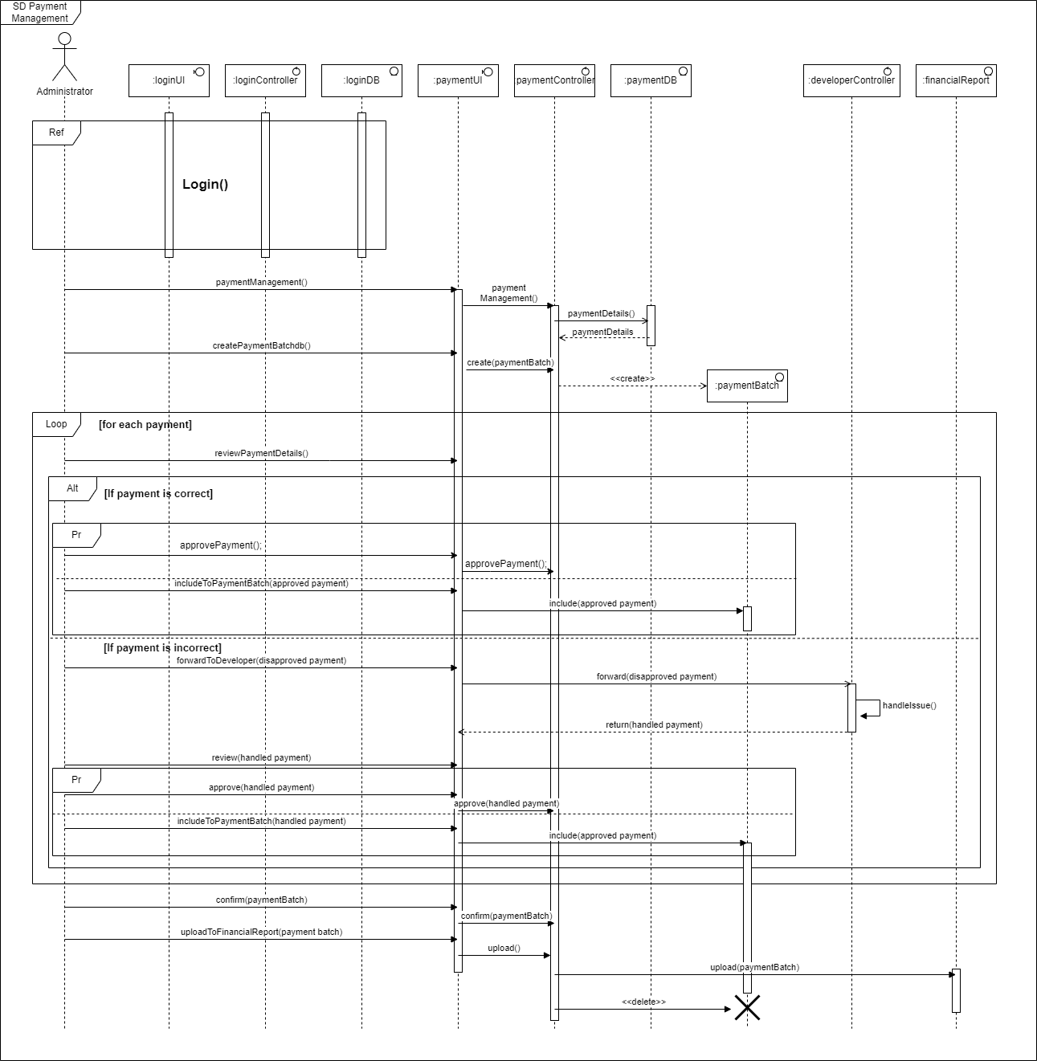

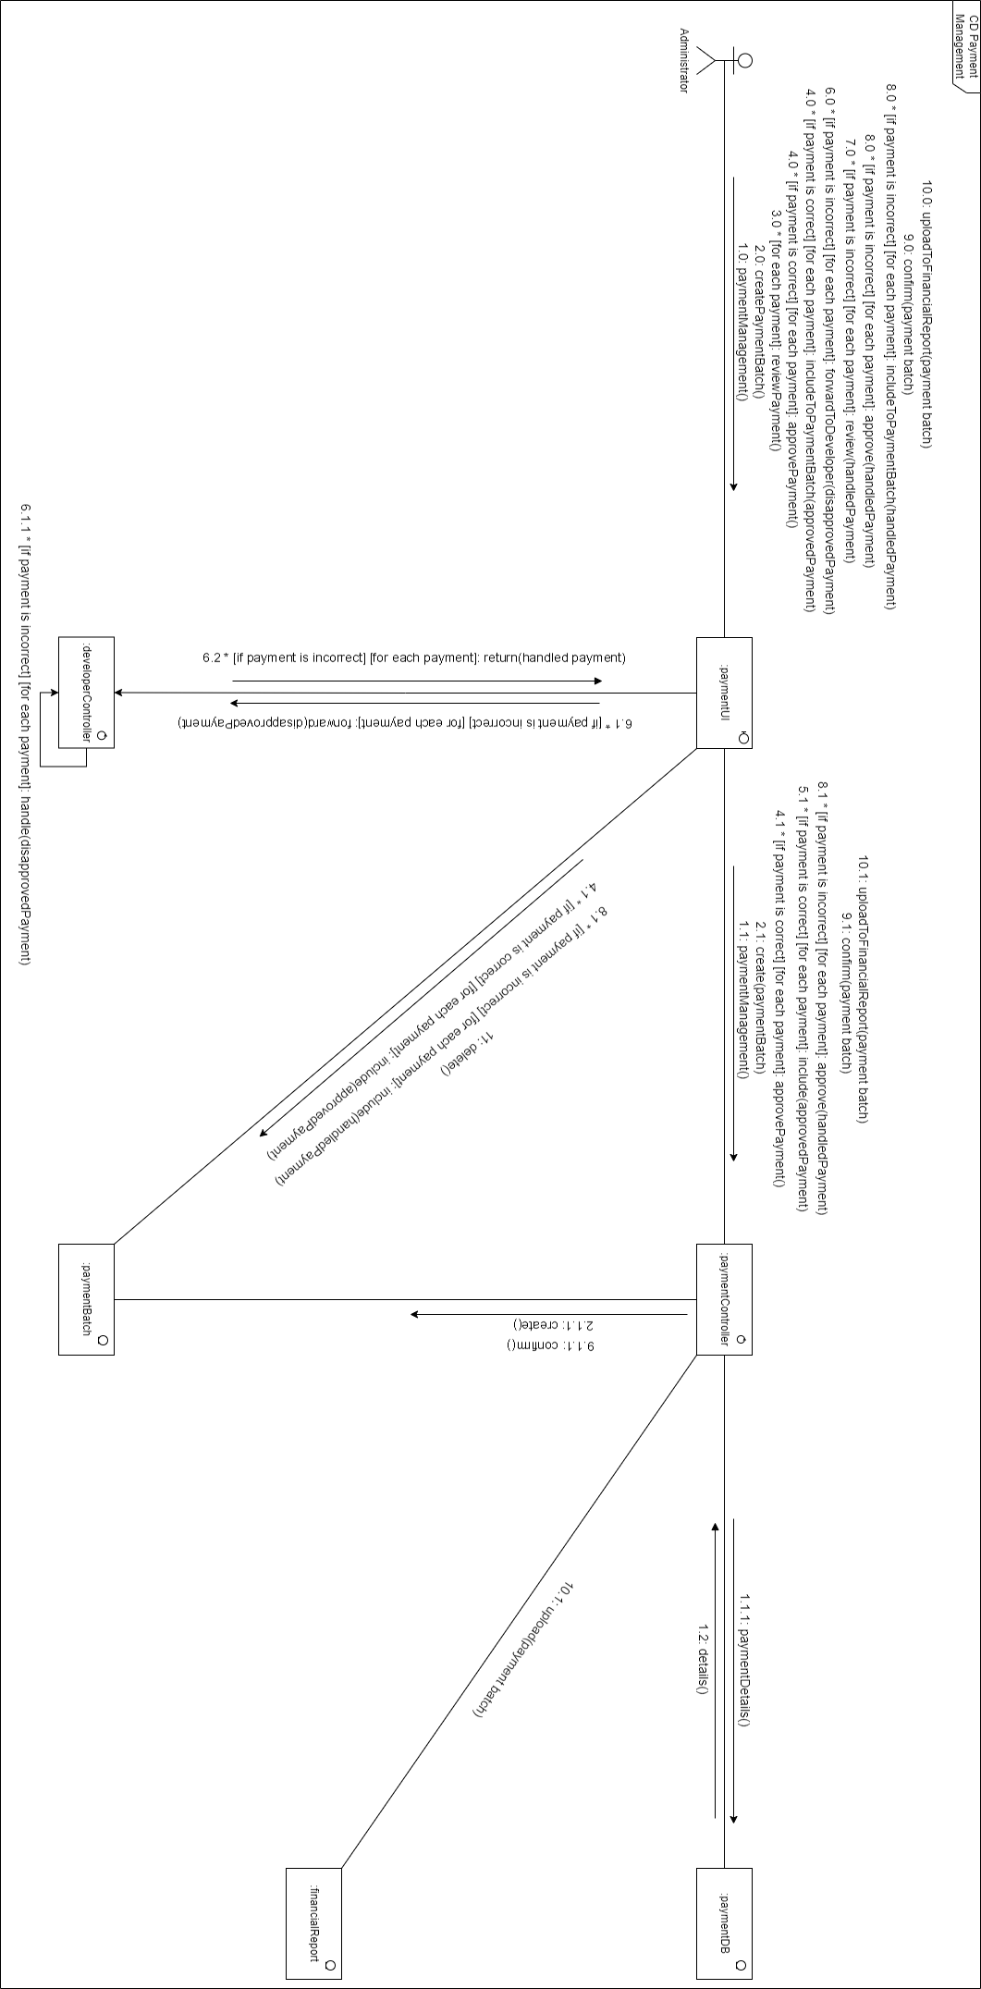

# IT22276278 – T. D. P. Randeniya

## Use Case Scenario

|  |  |  |
| --- | --- | --- |
| Use Case ID | 002 | |
| Use Case Name | Edit Profile | |
| Summary | Registered users edit their profiles | |
| Priority | 2 | |
| Precondition | * User must register to the System. * Registered user must login to the system. | |
| Postcondition | * Registered users were changed their profile details. | |
| Primary Actor | Registered User | |
| Main Success Scenario | **Step** | **Action** |
|  | 1 | Registered user login to system using their login credentials. |
|  | 2 | User navigates to the edit profile. |
|  | 3 | System shows personal details of the registered user. |
|  | 4 | User edits the profile details |
|  | 5 | System validates the details according to data types. |
|  | 6 | User validates their login credentials again to confirm the change of the details. |
|  | 7 | System generates a successful message and redirecting the user to home page. |
| Extension | **Step** | **Branching Action** |
|  | 1a | If the login credentials are not valid system will another 2 attempts to try. |
|  | 5a | If user editing the phone number system will check if the phone number has 10 numbers. |
|  | 5b | If user editing the name system will check if the name is including only string characters. |
|  | 5c | If user editing the profile picture system will check if the uploaded picture is in .jpg /.heic / .jpeg formats. |
|  | 5d | If user editing the password system will check if the password is including an uppercase letter, a lowercase letter, a special  character, and all the sum of characters are 15. |
|  | 6a | If the user credentials are not valid, system will give another 2 more attempts to try again |
|  | 6b | If entered user credentials are valid, System will generate a successful message while user redirecting to the home page. |

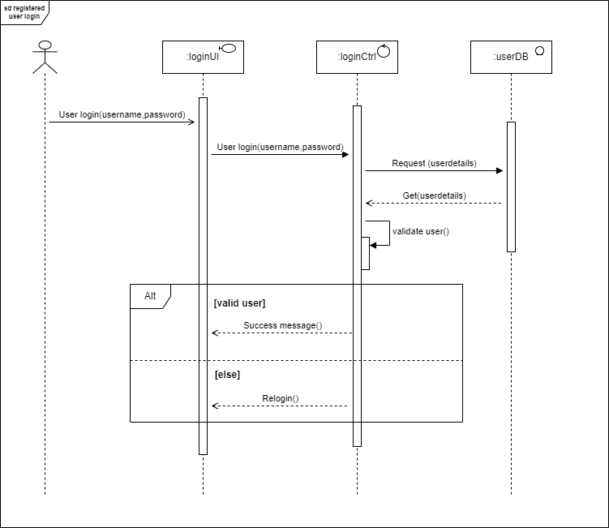

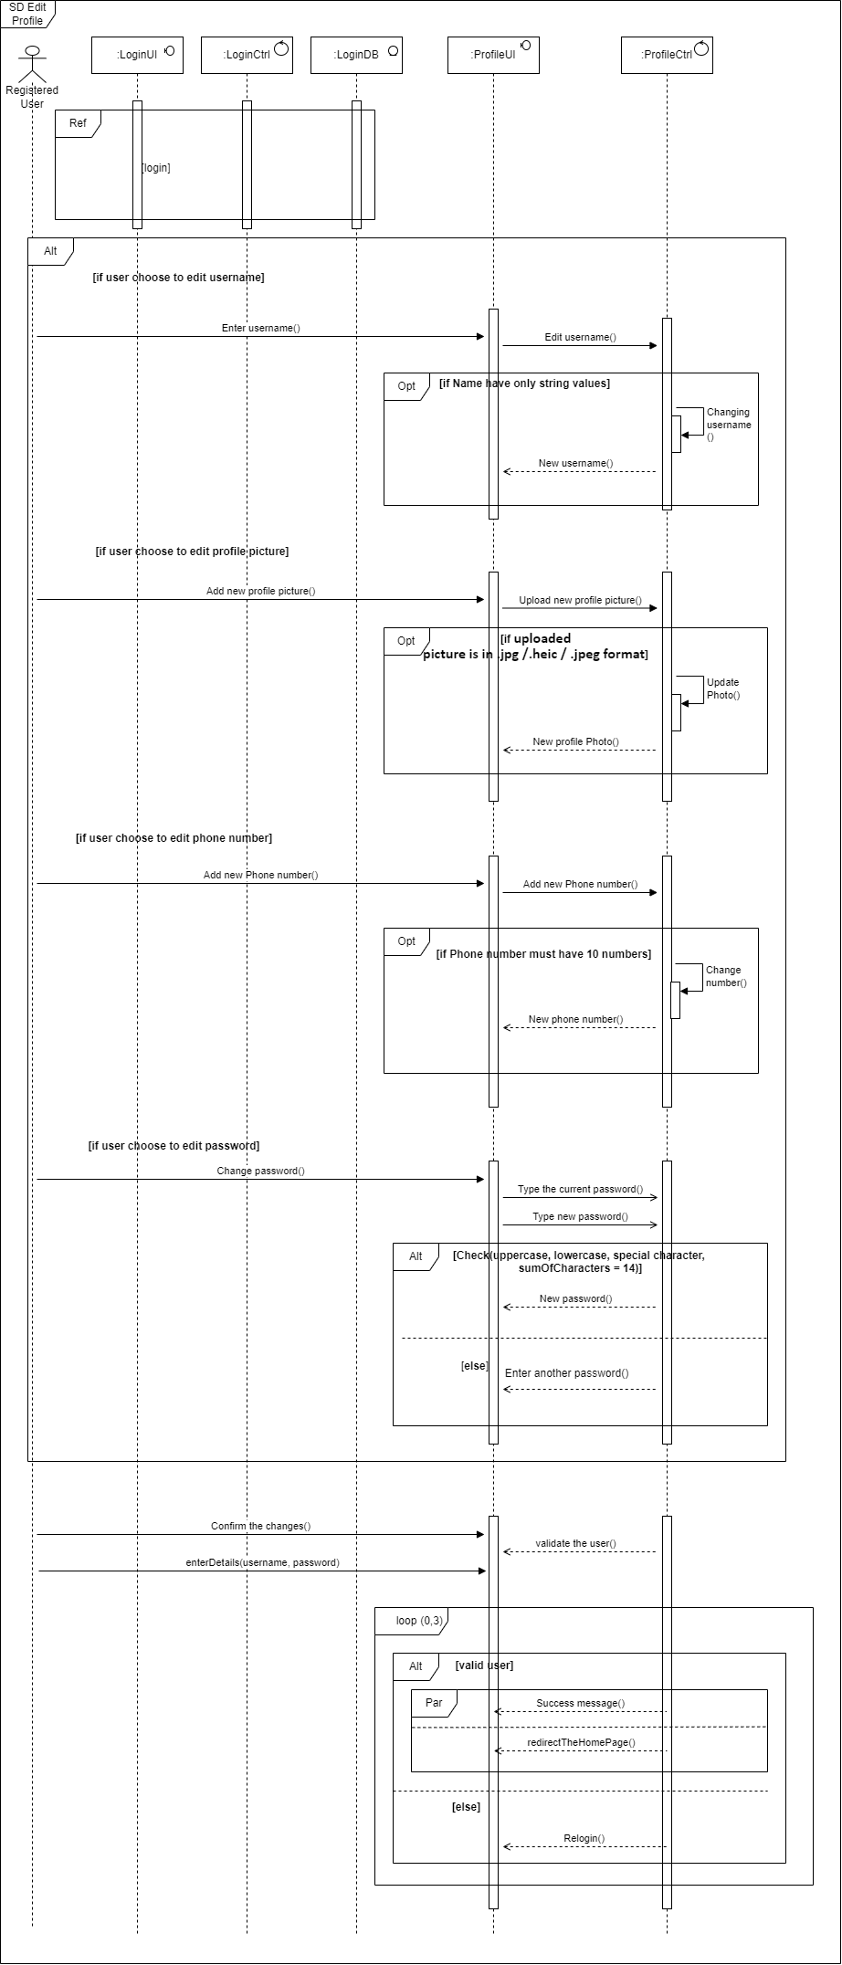

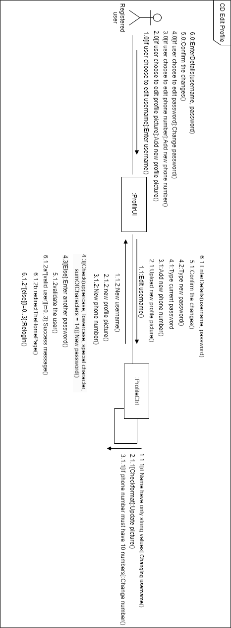

# IT22278012 – T. T. Thilakerathne

## Use Case Scenario

|  |  |  |
| --- | --- | --- |
| Use Case ID | 004. | |
| Use Case Name | Service Provider. | |
| Summary | Updating Vehicle’s Information to The System. | |
| Priority | 3 | |
| Precondition | * Logged in to the System with appropriate access rights. * Must have functioning with the Vehicle tracking system, driver database, and booking platforms. * Vehicles and drivers must meet safety and legal standers before operation. * System must be enable to coordination with drivers, customers, and the stakeholders. | |
| Postcondition | * All vehicles are properly accounted for, with any updates. * All customer bookings are processed, and trips are scheduled or completed as expected. * Effective coordination and ensuring customer satisfaction. * Check vehicles maintains. * Customer safety checking. | |
| Primary Actor | Admin | |
| Main Success Scenario | Step | Action |
|  | 1 | Log into the system with valid credentials and gains access to the necessary functionalities. |
|  | 2 | System gives to access for log into system. |
|  | 3 | System verifies the username and password. |
|  | 4 | System gives to access for username and the password. |
|  | 5 | Checks the fleet status, updates vehicle information, and ensures all vehicles are operational and compliant. |
|  | 6 | System gives access to checking and updating |
|  | 7 | Verifies that all drivers are available, assigns shifts or trips, and updates driver schedules as needed. |

|  |  |  |
| --- | --- | --- |
|  | 8 | System gives to access to verify the drivers. |
|  | 9 | Receives incoming bookings from customers, assigns trips to drivers, and ensures schedules are communicated effectively. |
|  | 10 | Track the location of vehicles in real-time to monitor trip progress and ensure operational efficiency. |
|  | 11 | System access to open the tracker to tracking and moitoring to location |
|  | 12 | Connect the other stakeholders immediately. |
|  | 13 | System gives access to connect to the stake holders. |
|  | 14 | Generates reports on fleet operations, driver performance, and completed trips for analysis and record-keeping. |
|  | 15 | System gives access to generate the reports and the operations. |
|  | 16 | Ensures all trips are completed, drivers have returned, and any necessary follow-up tasks are addressed. |
|  | 17 | logs out of the system, ensuring that all data is saved, and the system is secure. |
| Extensions | Step | Branching Action |
|  | 1a | The system notifies entered login details valid or invalid. |
|  | 1b | invalid details, the system will send an error massage and ask re- enter correct details. |
|  | 1c | The system terminates after the three unsuccessful attempts. |
|  | 1d | The system displays the “forget password” to recover the password. |
|  | 5a | The system notified the tracking issue on vehicles. |
|  | 5b | If find the issue and the other stakeholders. |

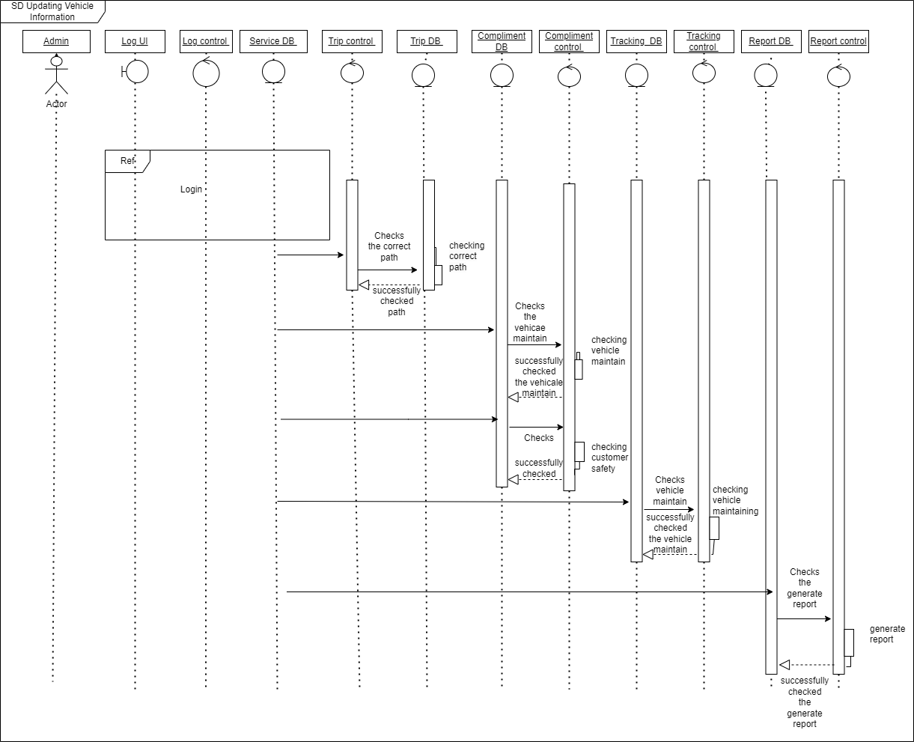

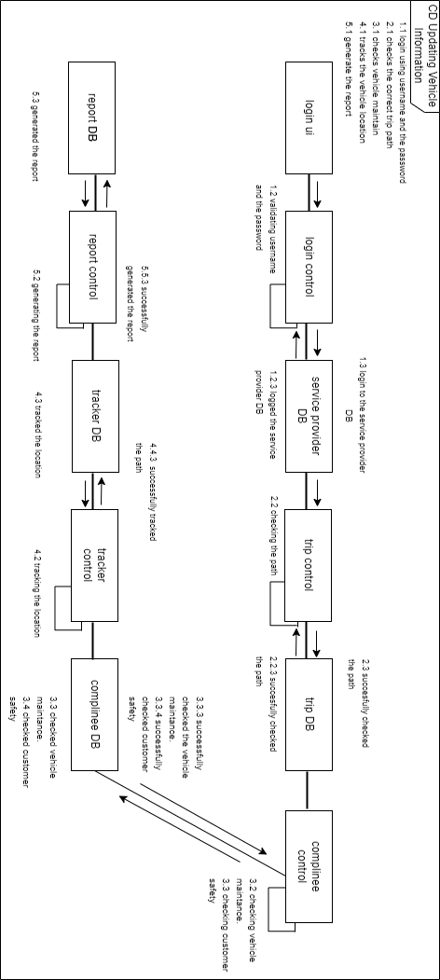

# IT22548146 – R. J. M. P. M. Bandara

## Use Case Scenario

|  |  |
| --- | --- |
| Use Case ID | 004 |
| Use Case Name | Maintaining Website |
| Summary | Developer Maintains the Website |
| Priority | 4 |
| Precondition | Developer logs into website using username and the password. |
| Postcondition | Exception Errors were handled. |
| Deals Discounts were updated. |
| Malicious activities were avoided. |
| Primary Actor | Developer |
| Main Success Scenario | Developer logs in to the system using username and password. |
| System validates and gives access to the user to log in to the system. |
| Developer Debugging simple errors. |
| System gives permission to debug errors. |
| Developer publishes new Deals and Discounts on the website. |
| The system displays the Deals and Discounts on the website. |
| Developer checks and resolve malicious activities on the website. |
| System gives permission to solve malicious activities. |
| Extension | {1.a) System notifies error Developer entered  password was wrong |
| (1.b) System rearranges the login interface. |
| (2.a) System shows error message please  include semicolons and characters. |
| (2.b) System rearranged sign up interface. |
| (3.a) System shows error of developer tries  multiple attempts on the password. |
| (3.b) system rearranged login interface. |

