Title off the project:
Online Medication And Prescription Tracker
Submitted by:
Aman Nagar,
Team-B.
Under the Guidance of:
Vinay Prashanth.

1. Project Overview

MedLink is a sophisticated digital health solution tailored to streamline the complexities of medical prescription management and treatment adherence. By providing a secure, cloud-based interface, the platform Bridges the gap between clinicians and patients, allowing for more precise healthcare coordination.
Key functionalities include real-time tracking of medication schedules, digital storage of clinical documentation, and automated alert systems. These tools work in tandem to ensure that patients receive their treatments correctly and on time, every time.
By transitioning away from physical, paper-based records, the platform significantly mitigates the risks associated with human error, missed doses, and the loss of critical medical data, thereby raising the standard of patient safety.

2. Problem Identification

The current healthcare landscape suffers from several systemic inefficiencies that MedLink seeks to rectify:
- Medication Non-Adherence: Patients frequently fail to complete medical courses due to simple human forgetfulness.
- Fragility of Physical Records: Traditional paper prescriptions are easily lost, damaged, or misinterpreted.
- Complex Medication Regimens: Patients with chronic conditions often find it difficult to manage multiple, overlapping treatment schedules.
- Decentralized Data: A lack of a unified health record makes it difficult for doctors to review a patient's historical medical data quickly.
These issues often lead to delayed recovery or worsening of medical conditions, especially for senior citizens who rely heavily on long-term treatments.

3. Proposed Solution

MedLink proposes a centralized platform that facilitates the seamless generation of digital prescriptions by doctors and easy access for patients. The system is equipped with an automated notification engine that alerts users about upcoming doses, refill requirements, and course endings.
A standout feature is the Medicine Validation module. This allows patients to cross-verify their medicine by uploading images of the medication packaging. The system validates the medicine against the digital prescription, significantly reducing the possibility of consuming incorrect or expired drugs.

4. Objectives

- To digitize clinical prescriptions into a secure and immutable electronic format.
- To enhance treatment compliance through an intelligent and personalized reminder system.
- To reduce therapeutic errors and complications resulting from skipped or incorrect doses.
- To provide an accessible, long-term historical log of all medications for future clinical reference.
- To improve communication and transparency between medical practitioners and their patients.

5. Scope of Requirements

1. Active Tracking: Continuous monitoring of prescribed medicine intake status.
2. Digital Ledger: Secure cloud storage for the lifecycle management of medical prescriptions.
3. Intake Confirmation: A user-interactive system to log every dose taken.
4. Smart Alerts: Automated reminders for pending doses and low-stock refills.
5. Visual Verification: Advanced image-based validation for medication accuracy.

6. Target Users

The platform is designed to cater to three distinct yet interconnected user groups:
- Patients: Individuals who need an intuitive tool to manage their daily medications and health progress.
- Doctors: Medical professionals who require a streamlined platform for issuing prescriptions and monitoring patient adherence.
- Admin: System administrators responsible for managing user roles, ensuring data security, and maintaining overall platform integrity.

7. Technology Stack

- Frontend: React.js for creating a highly responsive and dynamic user interface.
- Backend: Java-based Spring Boot for building a robust and high-scalability server logic.
- Architecture: RESTful Web Services to handle seamless communication between the client and server.
- Persistence: MongoDB providing a high-performance NoSQL database solution for medical records.
- Security: Spring Security coupled with JWT (JSON Web Tokens) for role-based access control.
- Dev Tools: VS Code for coding, Postman for API validation, and Git for version management.

8. Expected Outcome

The successful implementation of MedLink will result in a reliable, efficient, and user-centric platform that significantly improves the quality of chronic care management. Patients will experience higher adherence rates, which directly translates to better health outcomes.
For the healthcare industry, this system offers a roadmap toward a safer, paperless future where medical data is structured, easily accessible, and protected by modern encryption standards.

9. Challenges Faced

- Data Security: Implementing robust encryption and role-based access to safeguard private health information.
- Notification Latency: Ensuring that critical medication alerts are delivered to the user without any technical delays.
- System Scalability: Designing the backend to handle a vast number of concurrent users and medical records.
- User Accessibility: Simplifying the user interface so that non-technical and elderly users can navigate the platform comfortably.
- Verification Logic: Optimizing the validation engine to accurately identify medications through varied image qualities.

11. Future Enhancements

- AI Integration: Implementing AI for analyzing potential side effects and drug-to-drug interactions.
- Pharmacy Collaboration: Real-time integration with retail pharmacies for automated drug ordering and delivery.
- Cross-Platform Support: Launching dedicated iOS and Android mobile applications.
- Telemetry Sync: Syncing health data from smartwatches and other wearable medical devices.
- Telehealth Support: Integrating video consultation features directly into the MedLink dashboard.
- Calendar Integration
Appointment scheduling synchronized with external calendars using iCal standards
- AI-powered health chatbot to provide real-time medical guidance, medication reminders, and personalized patient support within the MedLink application.

12. Conclusion

MedLink represents a transformative shift in the way we approach medication management. By combining the power of modern web technologies with a deep focus on patient safety, the platform addresses the most critical pain points in therapeutic adherence today.
This project not only ensures that patients stay on track with their medical regimens but also empowers healthcare providers with the insights needed for improved coordination and better clinical decisions. We believe MedLink will set a new benchmark for accessible and safe digital healthcare solutions.

Registration and Login Page
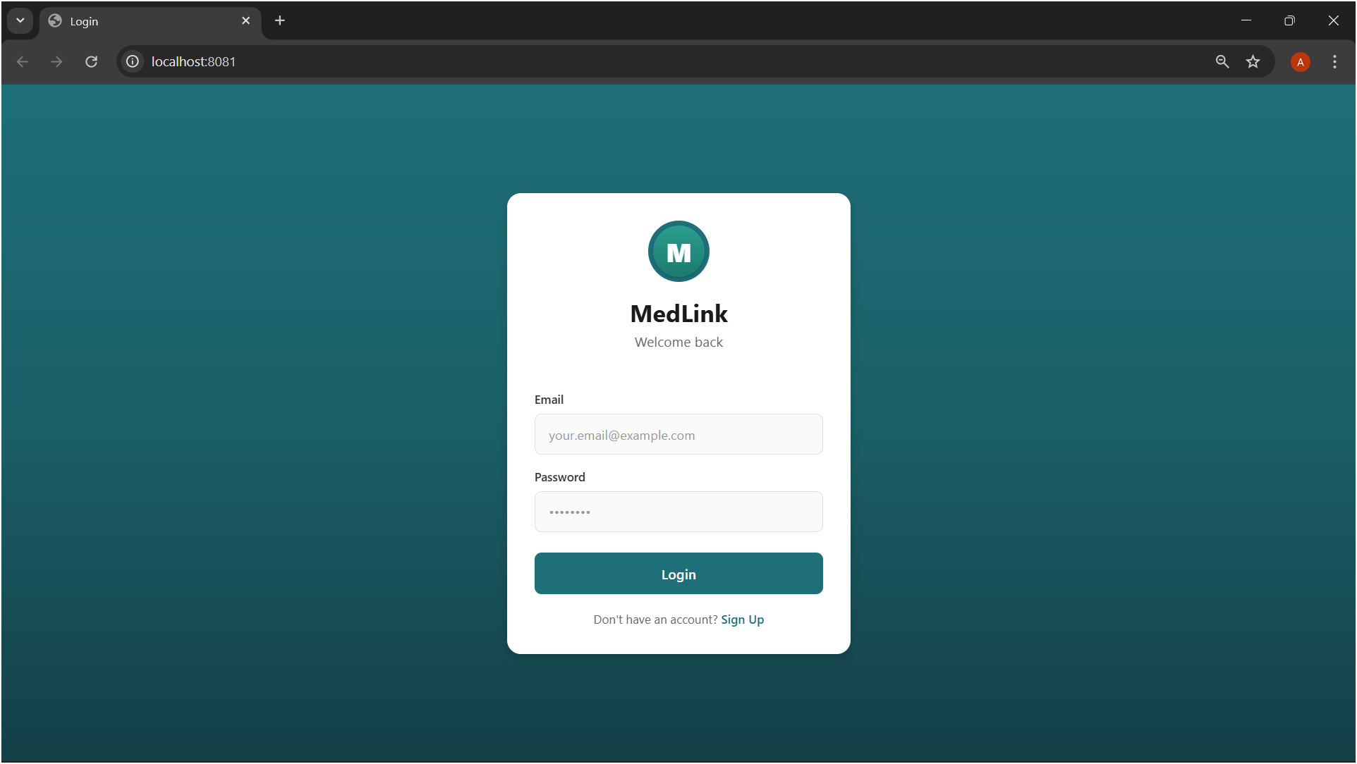
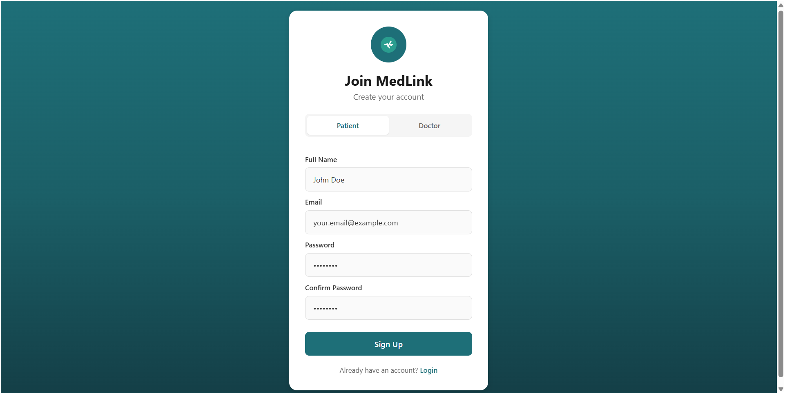
Patient Dashboard
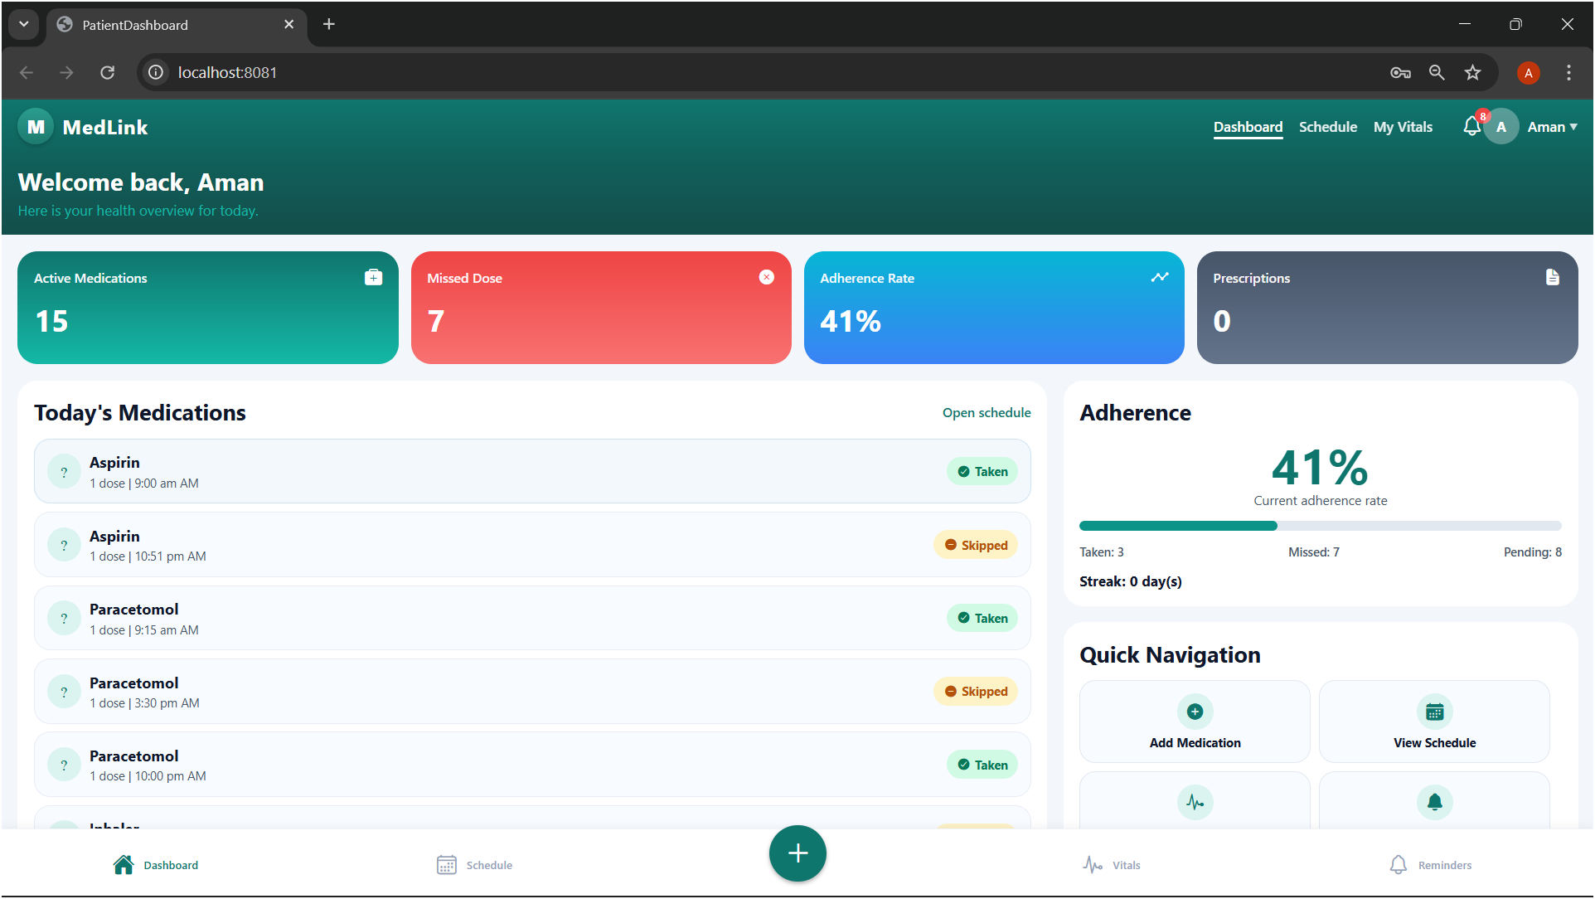
Daily Scheduling Page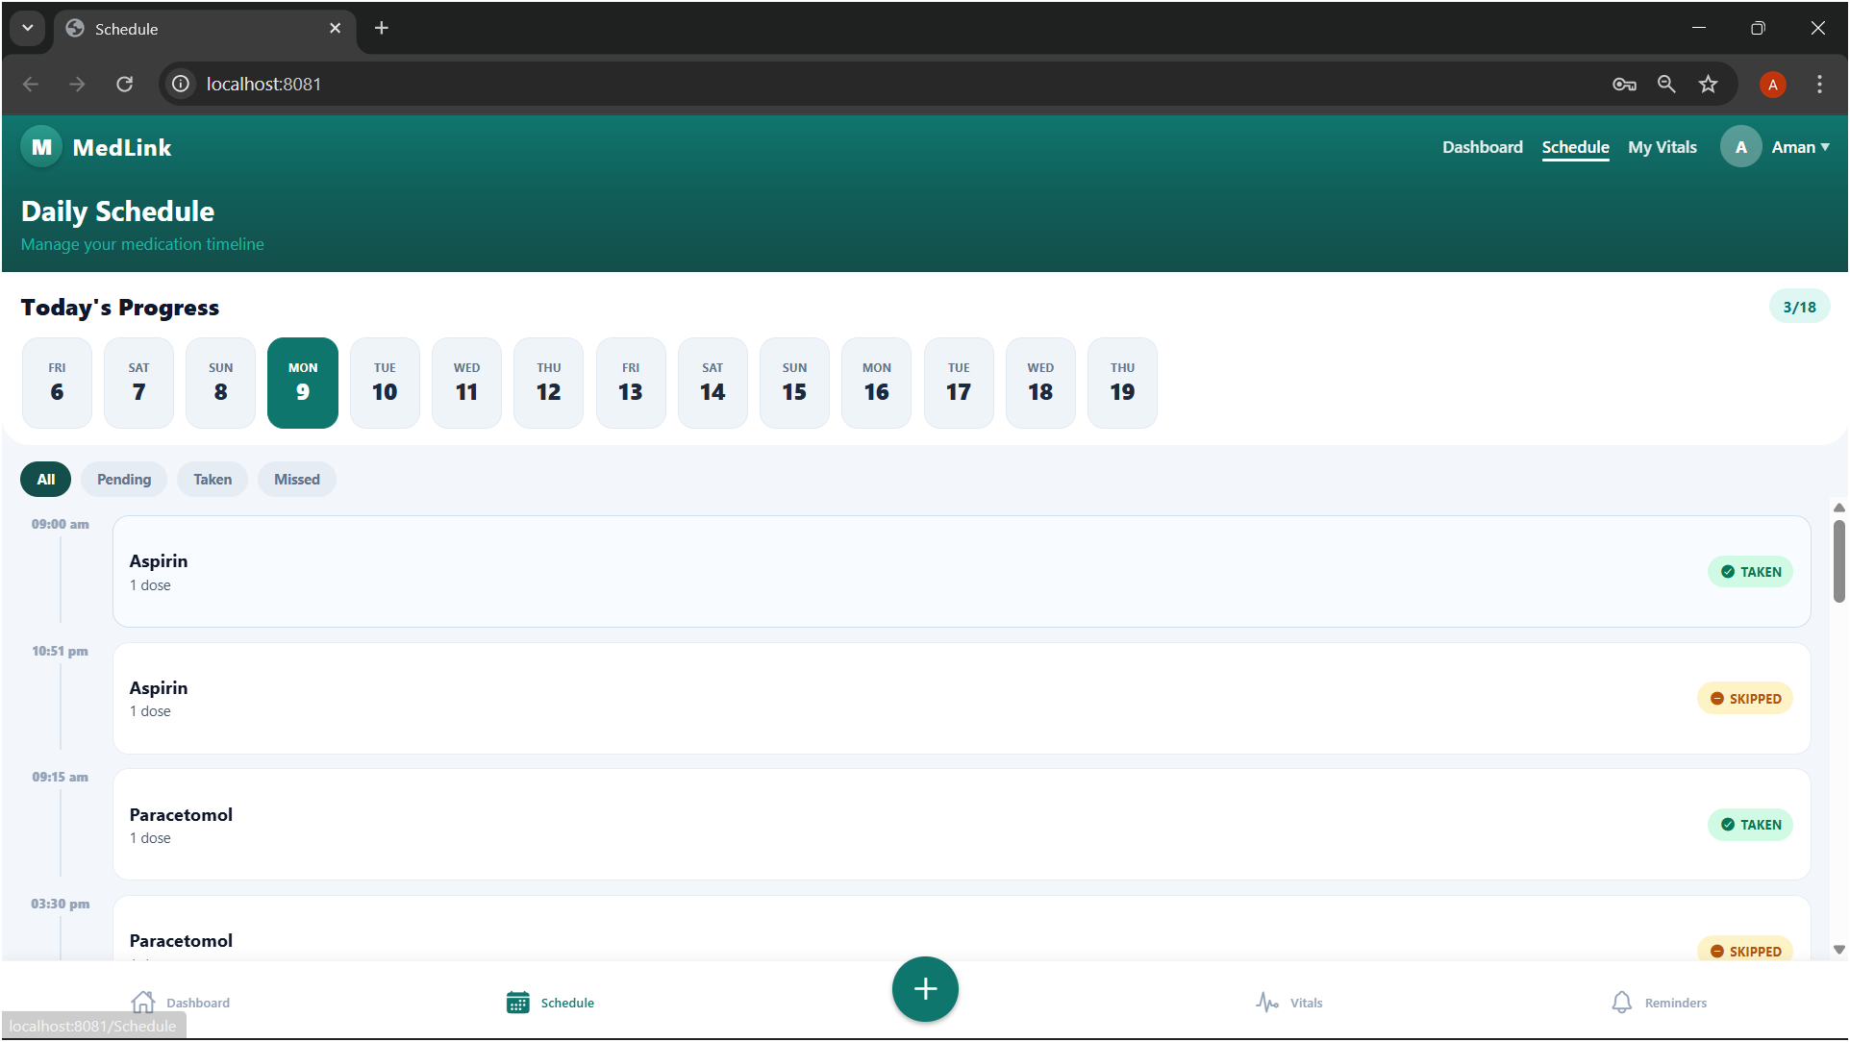
Add Medication Page
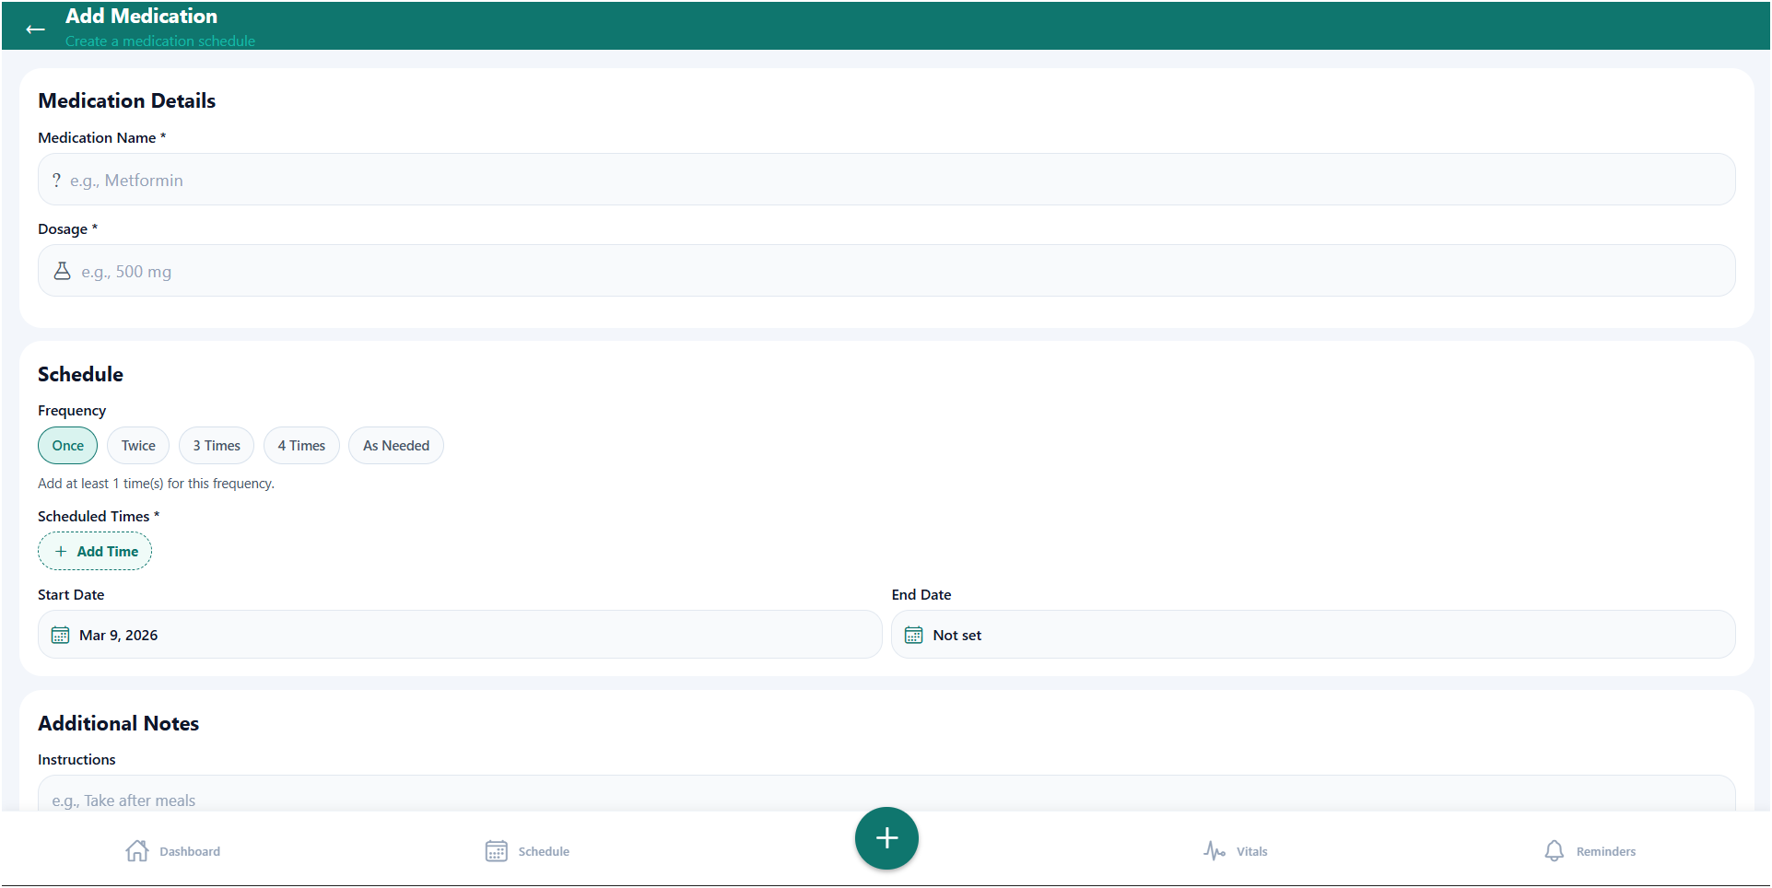
Reminder 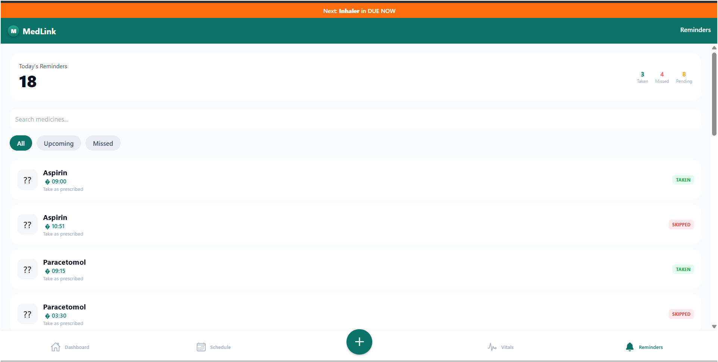
Doctor Dashboard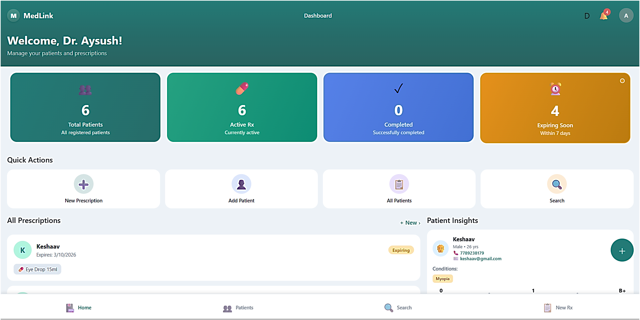
Add Prescription Page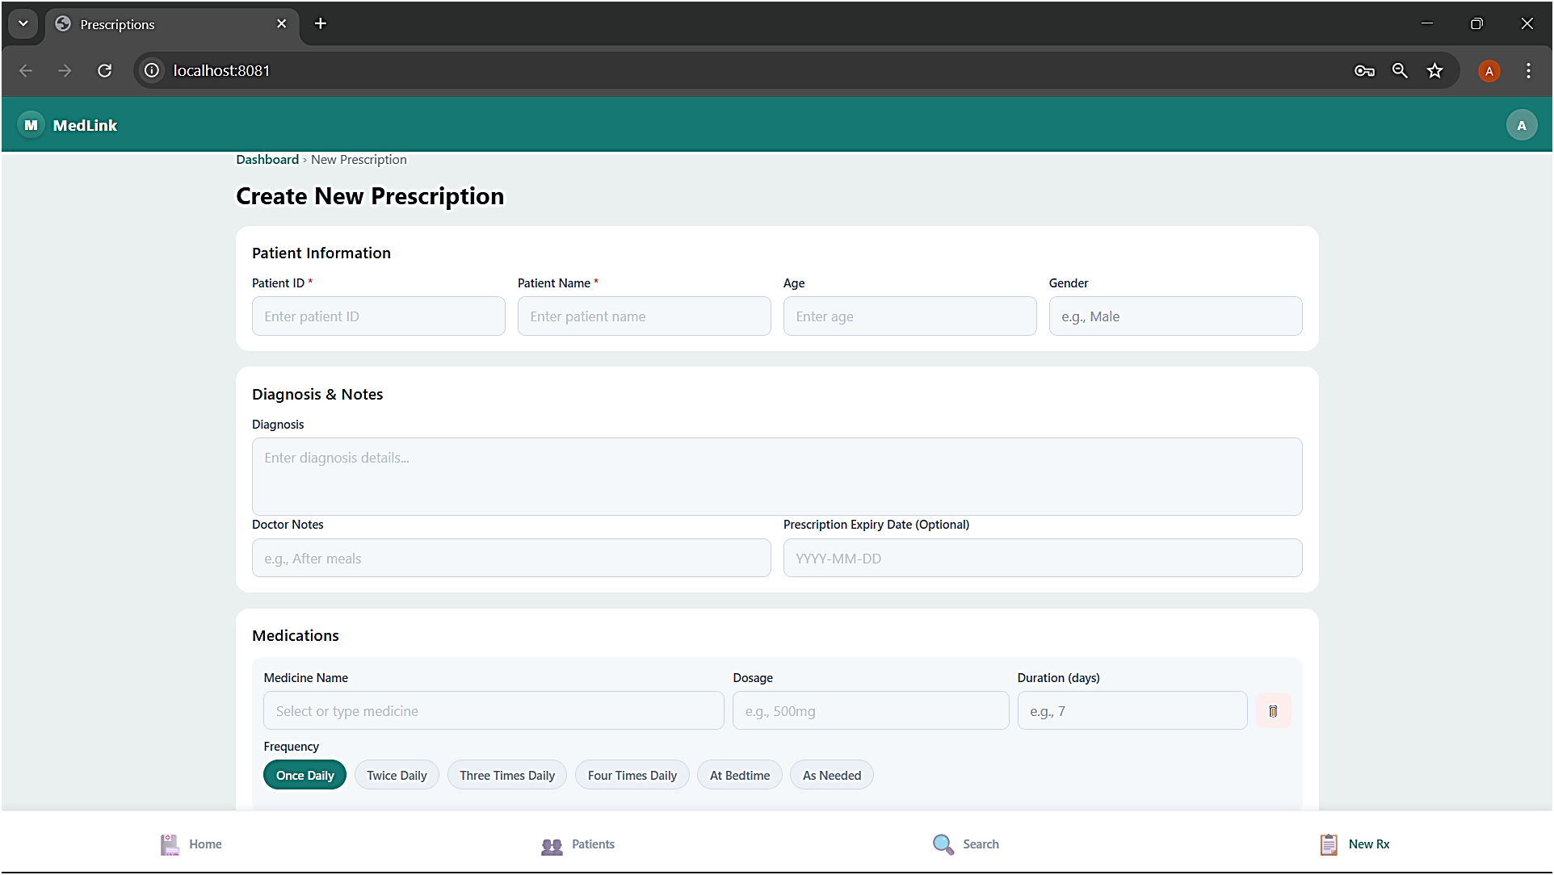
Add and View Patient 