Online Medication &
Prescription Tracker
Project Documentation

Field | Details
Project Name | Online Medication & Prescription Tracker
Submitted By | SHALINI CR
Team Name | Team-B Medlink
Guided by | Vinay Prashant
Organization | Infosys Springboard 6.0
Tech Stack | React Native, Java Spring Boot, MongoDB
Date | Mar 2026

Table of Contents

1. Introduction 3
1.1 What Problem Does It Solve? 3
1.2 What Does This App Do? 3
1.3 Who Will Use This App? 3
2. Project Requirements 4
2.1 Functional Requirements 4
2.2 Non-Functional Requirements 4
3. System Design 5
3.1 System Architecture 5
3.2 Tech Stack Used 5
3.3 Database Design 6
4. Features Explained 7
4.1 User Registration and Login 7
4.2 Add and Manage Medications 7
4.3 Prescription Upload and History 7
4.4 Medication Reminders 7
4.5 Refill Alerts 7
5. API Endpoints 8
5.1 Auth Routes 8
5.2 Medication Routes 8
5.3 Prescription Routes 8
6. Application Pages (UI Overview) 9
7. Testing 15
7.1 Types of Testing Done 15
7.2 Sample Test Cases 15
8. Future Improvements 16
9. Conclusion 17
References 17

1. Introduction
This project is a web-based application that helps users track their medications and prescriptions in one place. Instead of keeping paper prescriptions or forgetting to take medicines, users can manage everything digitally through a simple and easy-to-use website.

1.1 What Problem Does It Solve?
- People often forget to take their medicines on time
- Tracking multiple prescriptions from different doctors is confusing
- Refill reminders are needed so medicines do not run out
- There is no easy way to check if two medicines can be taken together

1.2 What Does This App Do?
- Lets users add and manage their medications
- Sends reminders when it is time to take medicine
- Keeps a history of all prescriptions
- Alerts when a refill is needed
- Shows basic drug interaction warnings

1.3 Who Will Use This App?
User | What They Do
Patient | Tracks their own medicines and gets reminders
Doctor | Views the patient medication history

2. Project Requirements

2.1 Functional Requirements
These are the main features the application must have:

User Management:
- User can register with name, email, and password
- User can log in and log out securely
- User can update their profile details

Medication Management:
- User can add a new medication with name, dosage, and frequency
- User can edit or delete a medication
- User can view all current and past medications
- System shows a warning if two medicines may interact

Prescription Management:
- User can upload or manually enter a prescription
- System stores the doctor name, date, and medicine details
- User can view prescription history
- User can mark a prescription as active or expired

Reminders & Notifications:
- User gets a notification when it is time to take medicine
- User gets an alert 3 days before a refill is needed
- User can choose to receive reminders by email notification

2.2 Non-Functional Requirements
Requirement | Description
Performance | Pages should load within 3 seconds
Security | Passwords must be stored encrypted, not as plain text
Usability | The app should be simple enough for any age group to use
Availability | The app should work 24/7 without frequent downtime
Compatibility | Should work on both mobile and desktop browsers

3. System Design

3.1 System Architecture

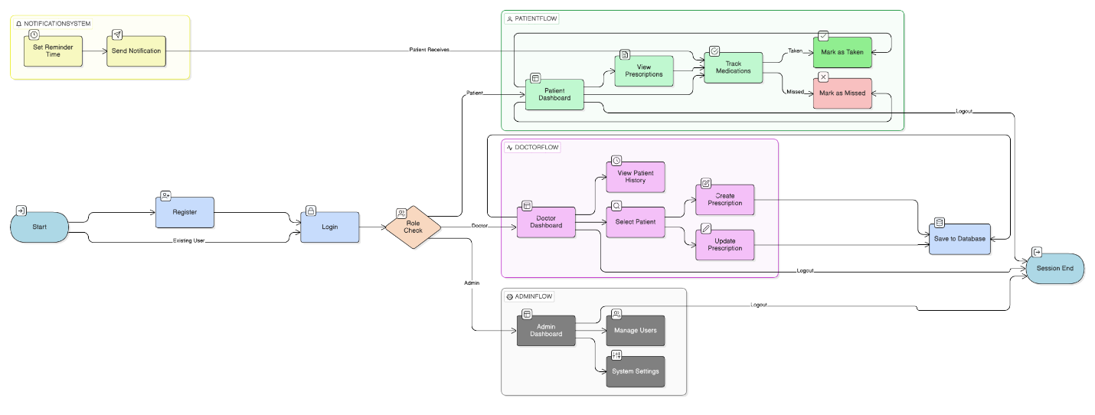

3.2 Tech Stack Used
Part | Technology Used
Frontend | React Native
Backend | Java Spring Boot
Database | MongoDB
Authentication | JWT (JSON Web Token)
Email Notifications | EmailJS
Hosting | Vercel (frontend), Render (backend)
Version Control | Git and GitHub

3.3 Database Design
Below are the main data collections (tables) used in MongoDB:

Users Collection:
Field | Type & Purpose
_id | Auto-generated unique ID
name | String — Full name of the user
email | String — Login email (must be unique)
password | String — Stored as a hashed value (bcrypt)
role | String — patient / doctor
createdAt | Date — When the account was created

Medications Collection:
Field | Type & Purpose
_id | Auto-generated unique ID
userId | Reference to the user who owns this record
name | String — Medication name (e.g., Paracetamol)
dosage | String — Amount per dose (e.g., 500mg)
frequency | String — How often (e.g., twice daily)
startDate | Date — When to start taking
endDate | Date — When to stop (if applicable)
status | String — active / completed / paused

Prescriptions Collection:
Field | Type & Purpose
_id | Auto-generated unique ID
userId | Reference to the patient
doctorName | String — Name of the prescribing doctor
issuedDate | Date — Date the prescription was issued
medications | Array — List of medicines in this prescription
notes | String — Doctor notes or instructions
status | String — active / expired / cancelled

4. Features Explained

4.1 User Registration and Login
New users can create an account by entering their name, email, and password. The password is encrypted before saving so it is never stored as plain text. On login, a JWT token is created and stored in the browser to keep the user logged in.

4.2 Add and Manage Medications
After logging in, the user can add medications they are currently taking. They enter the medicine name, dosage, and how often they take it. They can also edit or remove any medicine from their list.

Steps to add a medication:
- Click on 'Add Medication' button
- Fill in medicine name, dosage, start date, and frequency
- Click Save — the medicine appears on the dashboard

4.3 Prescription Upload and History
Users can add prescriptions manually by filling out a form with the doctor name, date, and medicines included. All past prescriptions are stored and can be viewed anytime under 'Prescription History'.

4.4 Medication Reminders
The system can send an email reminder to the user when it is time to take their medicine. The user sets the time when adding the medication. A background scheduler (using node-cron) checks every hour and sends reminders as needed.

4.5 Refill Alerts
If the user has set the number of pills they have, the system will automatically calculate when they will run out. An alert email is sent 3 days before the estimated end date so the user can request a refill in time.

5. API Endpoints
These are the main REST API routes used in this project. All routes that need login require a valid JWT token in the request header.

5.1 Auth Routes
Method + Route | What It Does
POST /api/auth/register | Create a new user account
POST /api/auth/login | Log in and receive a JWT token
POST /api/auth/logout | Logout the current user

5.2 Medication Routes
Method + Route | What It Does
GET /api/medications | Get all medications for the logged-in user
POST /api/medications | Add a new medication
PUT /api/medications/:id | Update a medication by its ID
DELETE /api/medications/:id | Delete a medication by its ID

5.3 Prescription Routes
Method + Route | What It Does
GET /api/prescriptions | Get all prescriptions for the logged-in user
POST /api/prescriptions | Add a new prescription
GET /api/prescriptions/:id | View one prescription by its ID
DELETE /api/prescriptions/:id | Delete a prescription by its ID

6. Application Pages (UI Overview)
Page Name | What It Contains
Login / Register Page | Form to create account or sign in
Dashboard | Summary of active medications, upcoming reminders, and alerts
Medications Page | List of all medications with options to add, edit, or delete
Prescriptions Page | List of all prescriptions with full details and history
Add Medication Form | Form to enter medicine name, dose, frequency, and schedule
Add Prescription Form | Form to enter prescription from doctor including medicines
Profile Page | View and update user personal details

Registration and Login Page

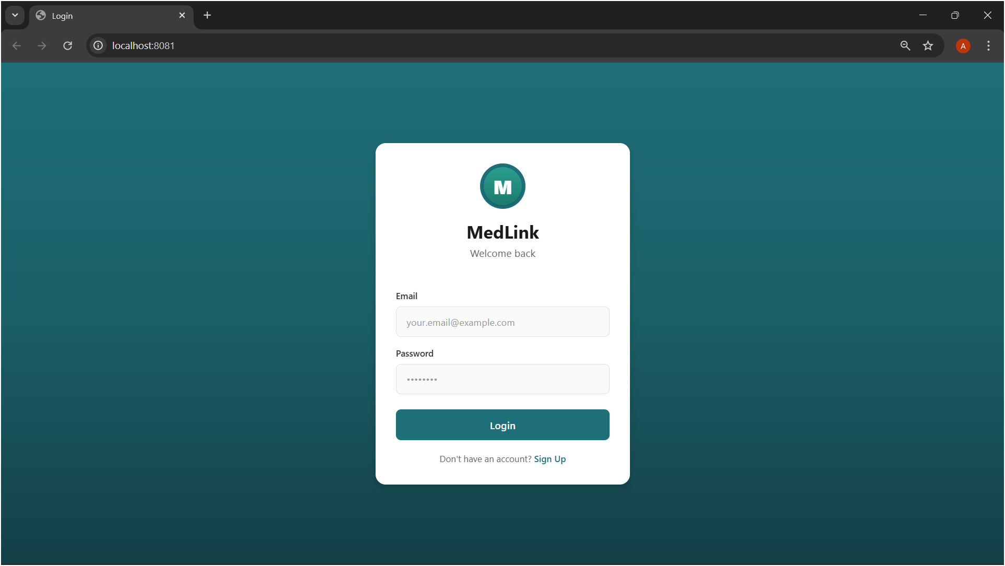
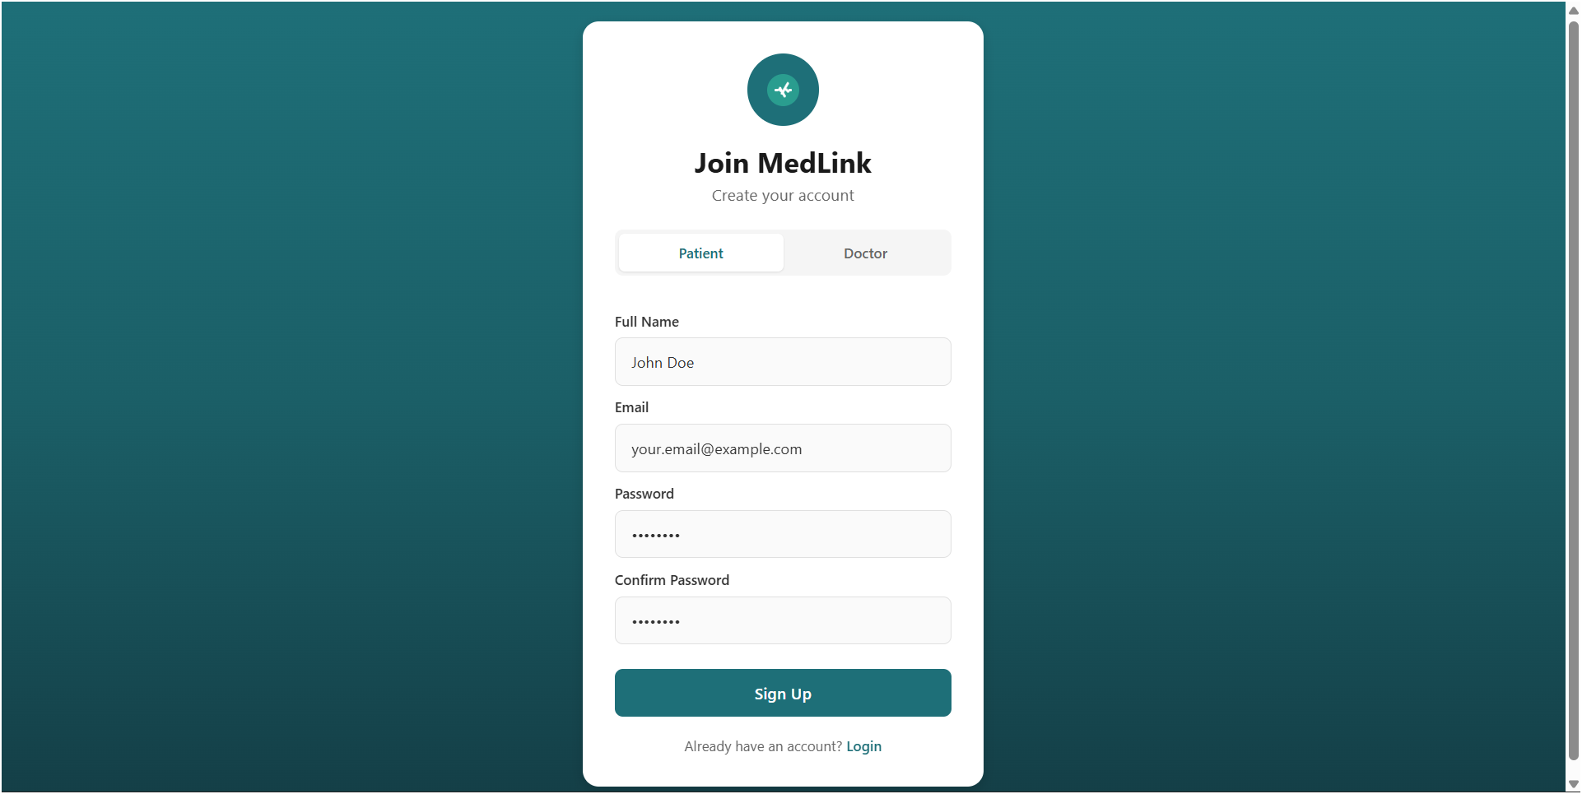

Patient Dashboard

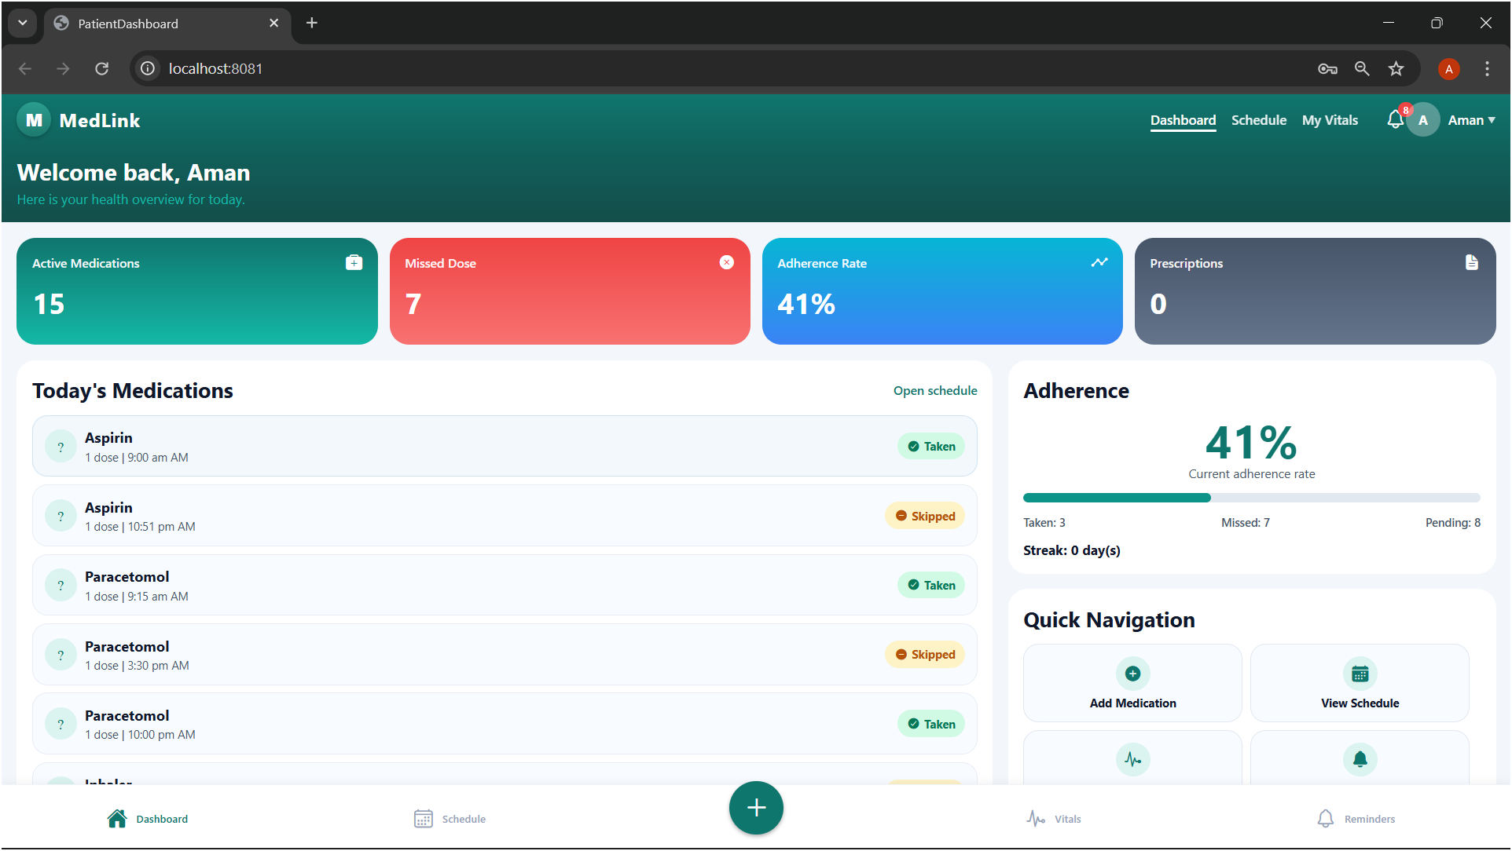
Daily Scheduling Page
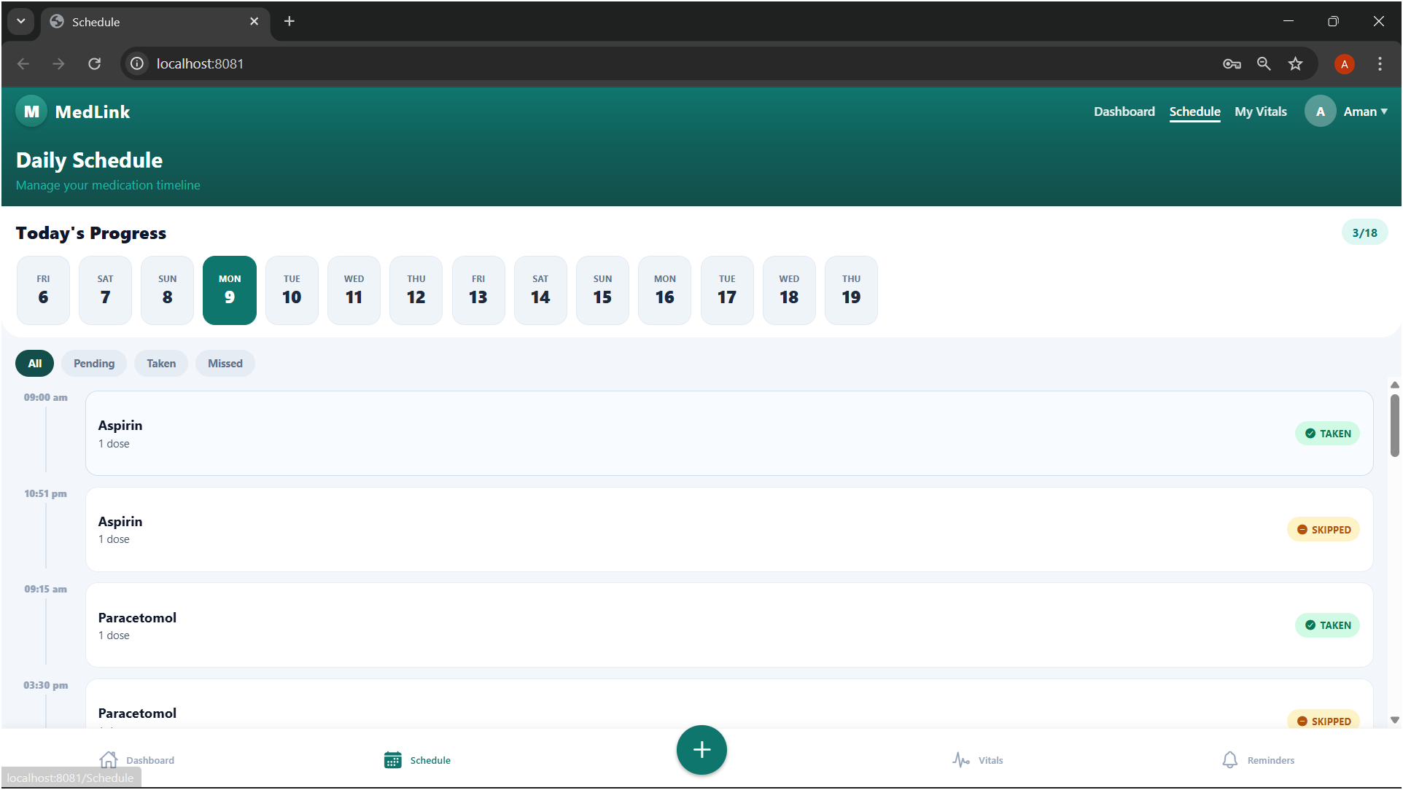
Add Medication Page

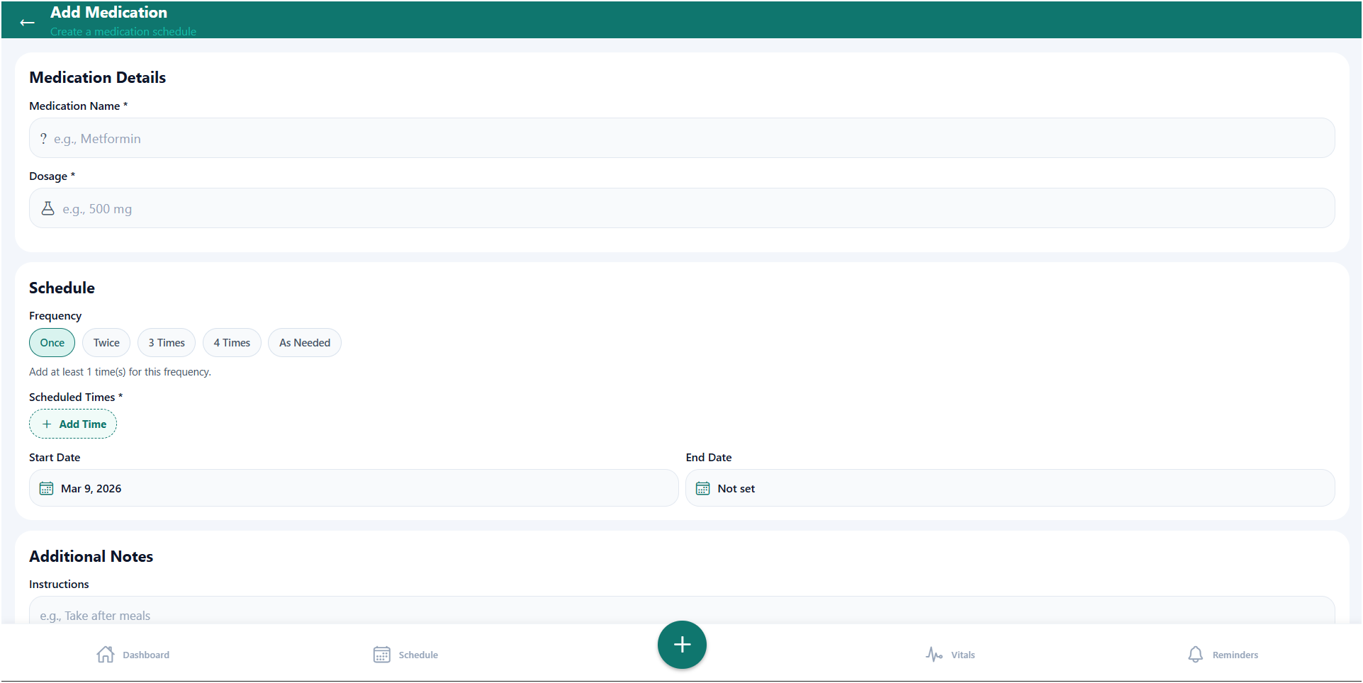

Reminder
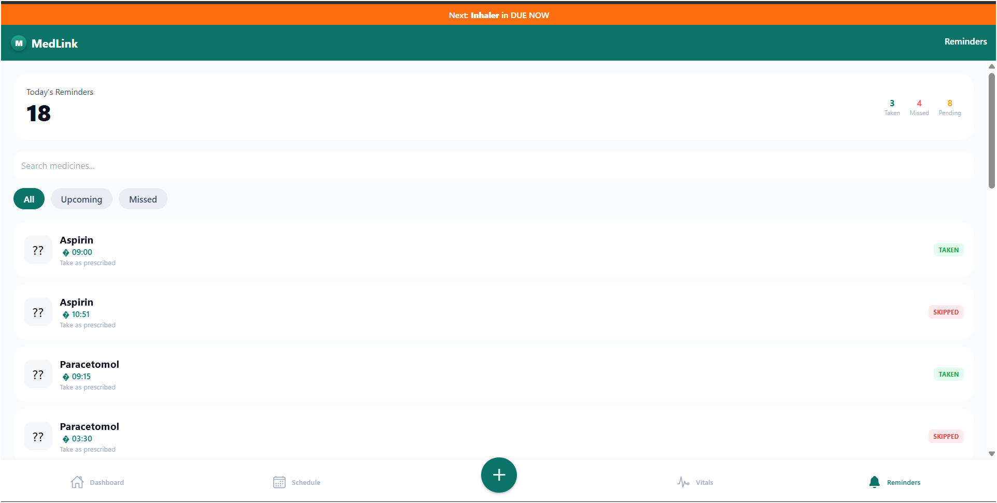
Doctor Dashboard
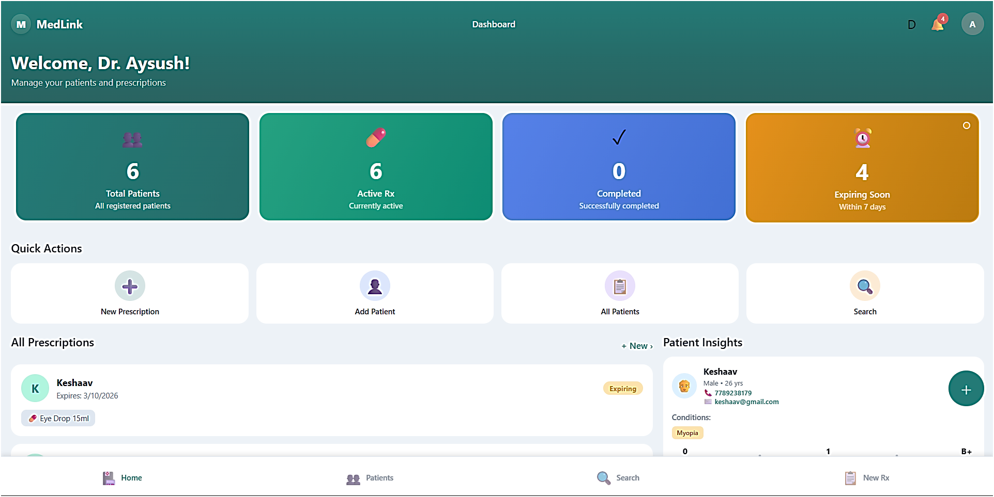

Add Prescription Page

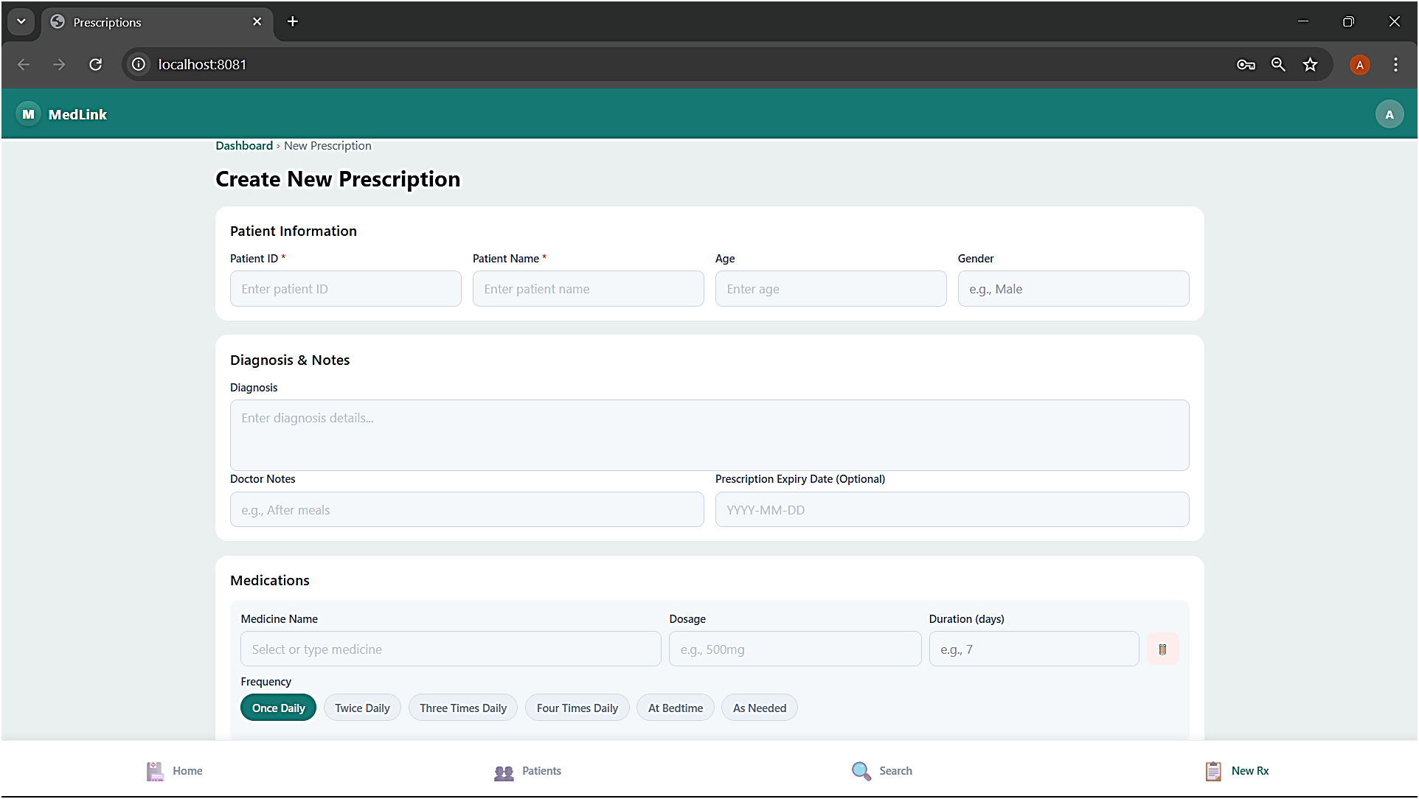

Add and View Patient
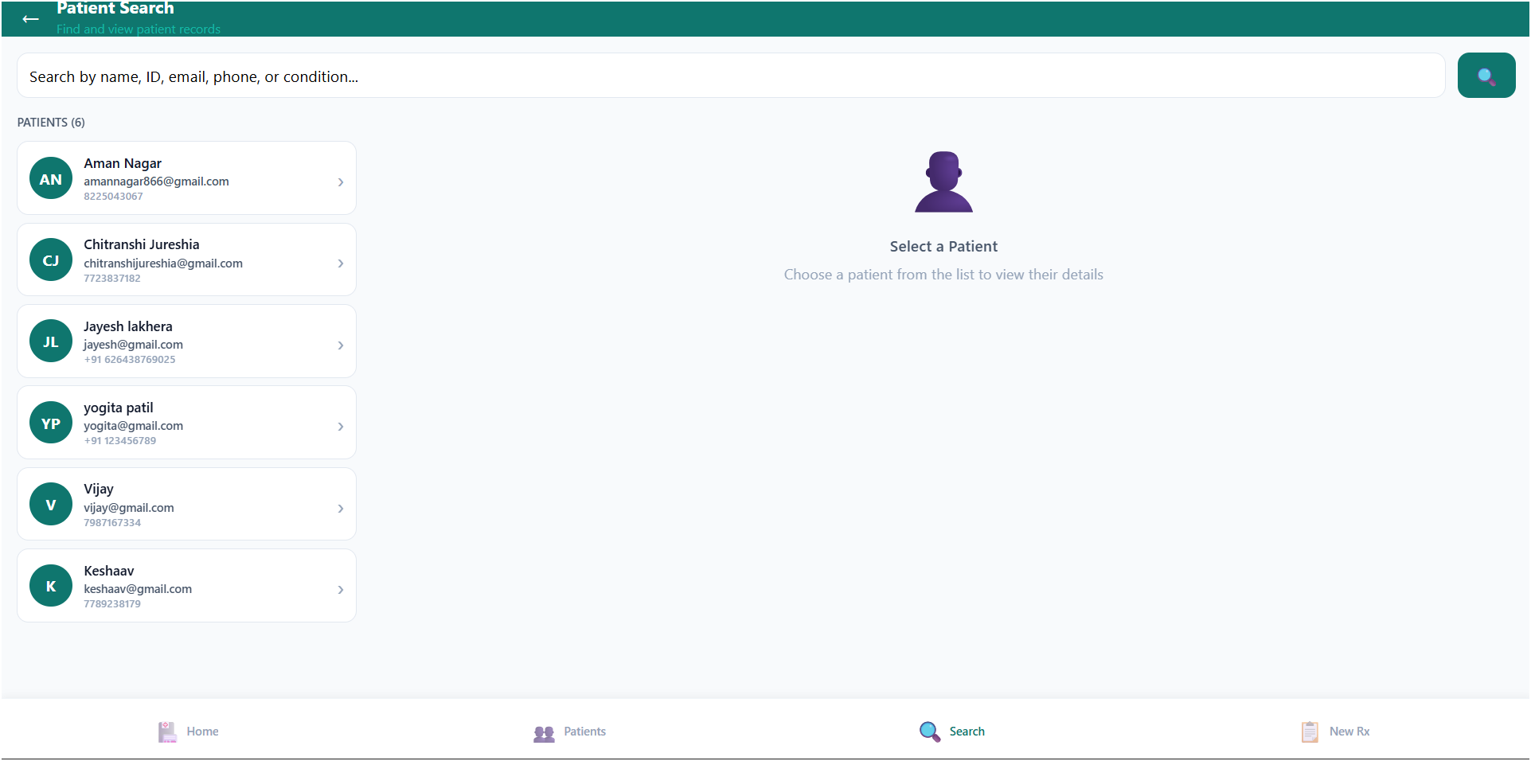

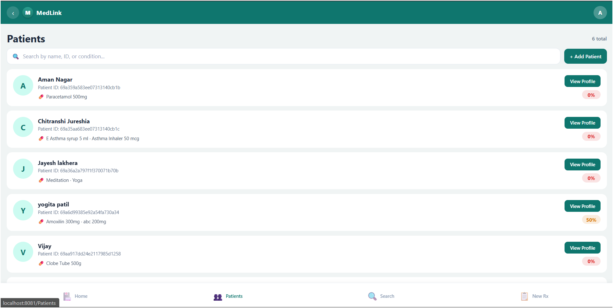

7. Testing

7.1 Types of Testing Done
Test Type | What Was Tested
Manual Testing | Opened each page in browser and tested all buttons and forms
API Testing | tested all API routes with different inputs
Login Testing | Checked that wrong passwords are rejected and correct ones work
Form Validation | Verified that empty fields show error messages
Reminder Testing | Checked that email reminders are sent at the correct time

7.2 Sample Test Cases
Test Case | Expected Result
Register with valid details | Account is created and user is redirected to dashboard
Login with wrong password | Error message: Invalid credentials
Add medication without name | Form shows: Medicine name is required
Add medication with all fields | Medication is saved and appears on the list
Delete a medication | Medication is removed from the list immediately
Request refill when stock is low | Alert notification is triggered successfully

8. Future Improvements
These are features that can be added in the future to make the app better:

- Add a mobile app version using React Native
- Connect to a real drug interaction database like OpenFDA
- Allow doctors to directly send e-prescriptions to the system
- Add a barcode scanner to auto-fill medicine details from the packaging
- Multi-language support for regional users
- Integrate with pharmacy websites for direct refill ordering
- Add a health report export feature (PDF download)

9. Conclusion
This project was built to solve a real-world problem that many people face — managing medications and prescriptions. Through this project, I was able to apply the web development skills I have learned and also pick up many new ones including API design, database management, and basic application security.

The application successfully meets the core requirements of the project: users can register, manage their medications, view their prescriptions, and receive timely reminders. While there is still room for improvement, this project serves as a solid foundation that can be extended with more features in the future.

References
- React.js Official Documentation — reactjs.org
- Java Spring Boot Documentation — docs.spring.io/spring-boot/
- MongoDB Documentation — mongodb.com
- JWT (JSON Web Tokens) — jwt.io
- Bcrypt Password Hashing — npmjs.com/package/bcrypt
- Node-cron Scheduler — npmjs.com/package/node-cron

--- End of Document ---

