Title of the project:
Online Medication And Prescription Tracker
Submitted by:
Shaik. Shaikun Rani ,
Team-B.
Under the Guidance of:
Vinay Prashanth.
1. Project Overview
The MedLink system can be further improved and expanded by adding advanced features to enhance its functionality and user experience.
In the future, the system can include doctor consultation features, allowing users to connect with healthcare professionals online for advice and prescription updates. Integration with pharmacy services can also be added, enabling users to order medicines directly through the application.
Another enhancement could be the implementation of AI-based recommendations, which can provide personalized medication reminders and health suggestions based on user history and conditions.
The system can also be extended to include multi-user access, allowing family members or caregivers to manage medications for others, especially elderly patients.
Adding wearable device integration (such as smartwatches) can help in monitoring health parameters and sending real-time alerts.

2. Problem Identification
In today’s healthcare system, managing medications and prescriptions manually creates several challenges for patients. Many people forget to take medicines on time, which can lead to serious health issues.
Physical prescriptions are often lost or damaged, making it difficult to maintain proper medical records. Managing multiple medications with different timings and dosages becomes confusing, especially for elderly patients.
There is also no proper system to track medication history or ensure that medicines are taken correctly. This increases the chances of medication errors such as missed doses or incorrect usage.
Additionally, medical information is not easily accessible when needed, as it is stored in physical form.
These problems highlight the need for a digital solution like MedLink, which can simplify medication management, provide reminders, and securely store prescriptions in one place.

3. Proposed Solution.
The proposed system, MedLink, is a web-based application developed to provide an effective solution for managing medications and prescriptions digitally. It replaces traditional manual methods with a smart and automated system that improves accuracy, accessibility, and efficiency.
MedLink allows users to store all their medication details and prescriptions in a centralized digital platform. Users can easily add information such as medicine name, dosage, timing, and duration. The system also enables users to upload and securely store prescriptions, reducing the risk of losing important medical documents.
One of the key features of MedLink is the reminder system, which sends timely notifications to users to ensure they take their medicines as prescribed. This helps in improving medication adherence and avoiding health complications caused by missed doses.
The system also maintains a complete history of medications, which can be accessed anytime for reference. Being a cloud-based application, MedLink allows users to access their data from anywhere using any device.
Additionally, the system ensures data security and privacy by implementing proper authentication and secure storage mechanisms.
4. Objectives
The main objective of MedLink is to develop a smart and efficient digital platform for managing medications and prescriptions. The system aims to replace traditional manual methods with an organized and user-friendly solution that improves healthcare management.
MedLink is designed to help users maintain accurate records of their medicines and prescriptions in a centralized system. It enables users to store, update, and access their medical information anytime and from anywhere.
Another important objective of the system is to ensure timely medication intake by providing reminders and notifications. This helps users follow their prescribed schedules properly and reduces the chances of missed doses or incorrect usage.
The system also focuses on reducing medication errors by clearly organizing details such as dosage, timing, and duration. Additionally, it aims to improve patient safety and health outcomes by promoting better medication adherence.

5. Scope of Requirements
The scope of MedLink is to provide a comprehensive digital solution for managing medications and prescriptions efficiently. The system is designed to simplify healthcare management by offering a centralized platform where users can store, access, and track their medical information.
MedLink allows users to manage their daily medication schedules by adding details such as medicine name, dosage, timing, and duration. It also provides the facility to upload and store prescriptions in digital format, ensuring that important medical records are not lost and can be accessed anytime.
The system includes a reminder feature that notifies users about their medication timings, helping them maintain proper adherence to prescribed treatments. Additionally, MedLink maintains a history of medications, which can be useful for future reference and medical consultations.
From a requirements perspective, the system includes both functional and non-functional aspects. Functionally, it supports user registration, login, medication management, prescription upload, reminders, and history tracking. Non-functionally, the system ensures security, reliability, performance, and ease of use.
6. Target Users
The MedLink system is designed to serve a wide range of users who need an efficient way to manage medications and prescriptions. The primary target users are patients who require regular medication and need a reliable system to track their medicine schedules and medical records.
Elderly people are one of the major target groups, as they often take multiple medications and may find it difficult to remember timings and dosages. MedLink helps them by providing reminders and easy access to their prescriptions.
Caregivers and family members are also important users of the system. They can use MedLink to monitor and manage the medication schedules of their dependents, ensuring proper care and timely intake of medicines.
Doctors and healthcare professionals can benefit from the system by reviewing patient medication history and prescriptions, which helps in providing better treatment and avoiding medication errors.
Additionally, individuals with chronic diseases who require long-term medication can use MedLink to maintain accurate records and follow their treatment plans effectively.
7. Technology Stack
The development of MedLink involves a combination of modern technologies to ensure a smooth, efficient, and scalable system. The technology stack is divided into frontend, backend, database, and additional tools.
For the frontend, technologies like HTML, CSS, and JavaScript are used to design an interactive and user-friendly interface. Frameworks such as React.js (or similar) can be used to enhance the responsiveness and overall user experience.
For the backend, Java is used as the core programming language, along with frameworks like Spring Boot to handle business logic, API development, and server-side operations. This ensures the system is robust and capable of handling multiple users.
The database used is MySQL (or any relational database), which stores user details, medication records, and prescription data in an organized manner.
For cloud storage, services like AWS S3 or similar platforms can be used to store prescription files securely and allow easy access from anywhere.
8. Expected Outcome
The expected outcome of MedLink is to provide a reliable and efficient digital platform that simplifies the management of medications and prescriptions. The system is designed to help users maintain accurate medical records and follow their medication schedules without difficulty.
By using MedLink, users will be able to store all their prescriptions and medication details in one centralized location, reducing the chances of losing important medical information. The reminder feature will ensure that users take their medicines on time, improving medication adherence and overall health outcomes.
The system will also help in minimizing medication errors by clearly organizing details such as dosage, timing, and duration. Users will have easy access to their medication history, which can be useful during medical consultations and follow-ups.
Additionally, MedLink will provide a secure and user-friendly environment where sensitive health data is protected. The accessibility of the system from anywhere will make it convenient for users to manage their healthcare effectively.
9. Challenges Faced
During the development of MedLink, several challenges were encountered while designing and implementing the system effectively.
One of the major challenges was integrating different technologies such as frontend, backend, and database to work seamlessly together. Ensuring smooth communication between these components required proper API design and testing.
Another challenge was implementing a reliable reminder and notification system. Making sure that users receive timely alerts without delays or failures was a critical task.
Data security and privacy was also a significant concern, as the system handles sensitive medical information. Proper authentication and secure storage mechanisms had to be implemented to protect user data.
Handling file uploads for prescription storage was another difficulty, especially ensuring that files are stored securely and can be accessed quickly when needed.

11. Future Enhancements
- The MedLink system can be further improved and expanded by adding advanced features to enhance its functionality and user experience.
- In the future, the system can include doctor consultation features, allowing users to connect with healthcare professionals online for advice and prescription updates. Integration with pharmacy services can also be added, enabling users to order medicines directly through the application.
- Another enhancement could be the implementation of AI-based recommendations, which can provide personalized medication reminders and health suggestions based on user history and conditions.
- The system can also be extended to include multi-user access, allowing family members or caregivers to manage medications for others, especially elderly patients.
- Adding wearable device integration (such as smartwatches) can help in monitoring health parameters and sending real-time alerts.
- Further improvements can include voice assistant support for easier interaction, especially for senior citizens, and multi-language support to make the application accessible to a wider audience.

12. Conclusion

MedLink represents a transformative shift in the way we approach medication management. By combining the power of modern web technologies with a deep focus on patient safety, the platform addresses the most critical pain points in therapeutic adherence today.
This project not only ensures that patients stay on track with their medical regimens but also empowers healthcare providers with the insights needed for improved coordination and better clinical decisions. We believe MedLink will set a new benchmark for accessible and safe digital healthcare solutions.

Registration and Login Page
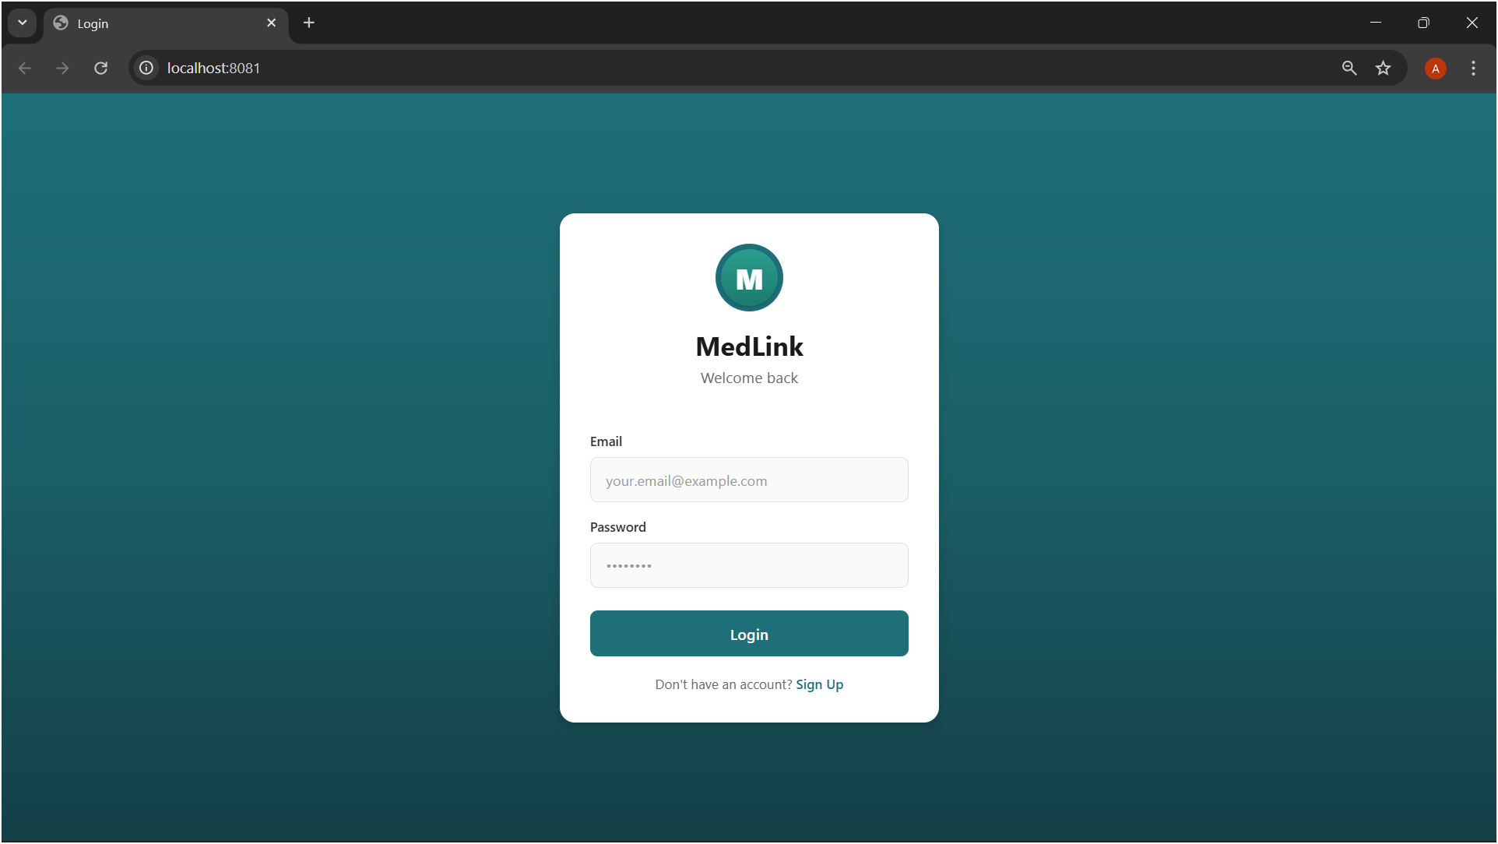
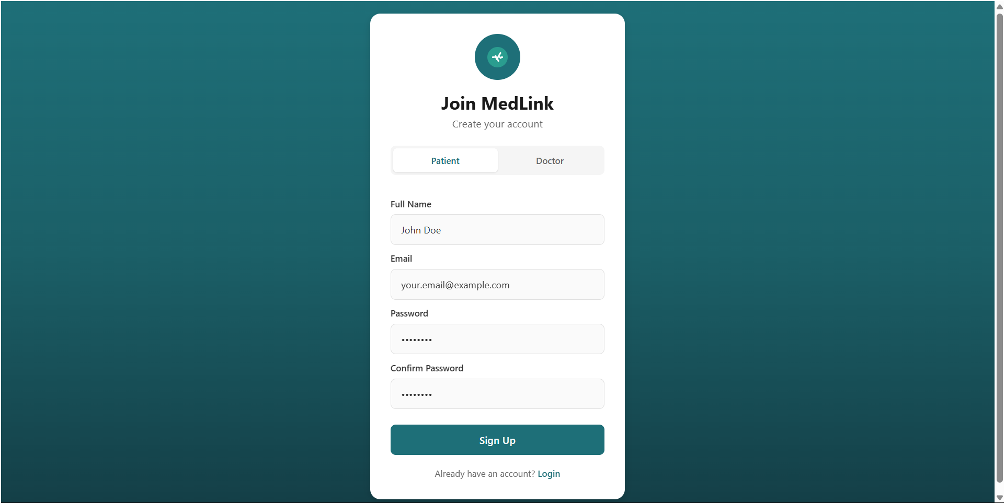
Patient Dashboard
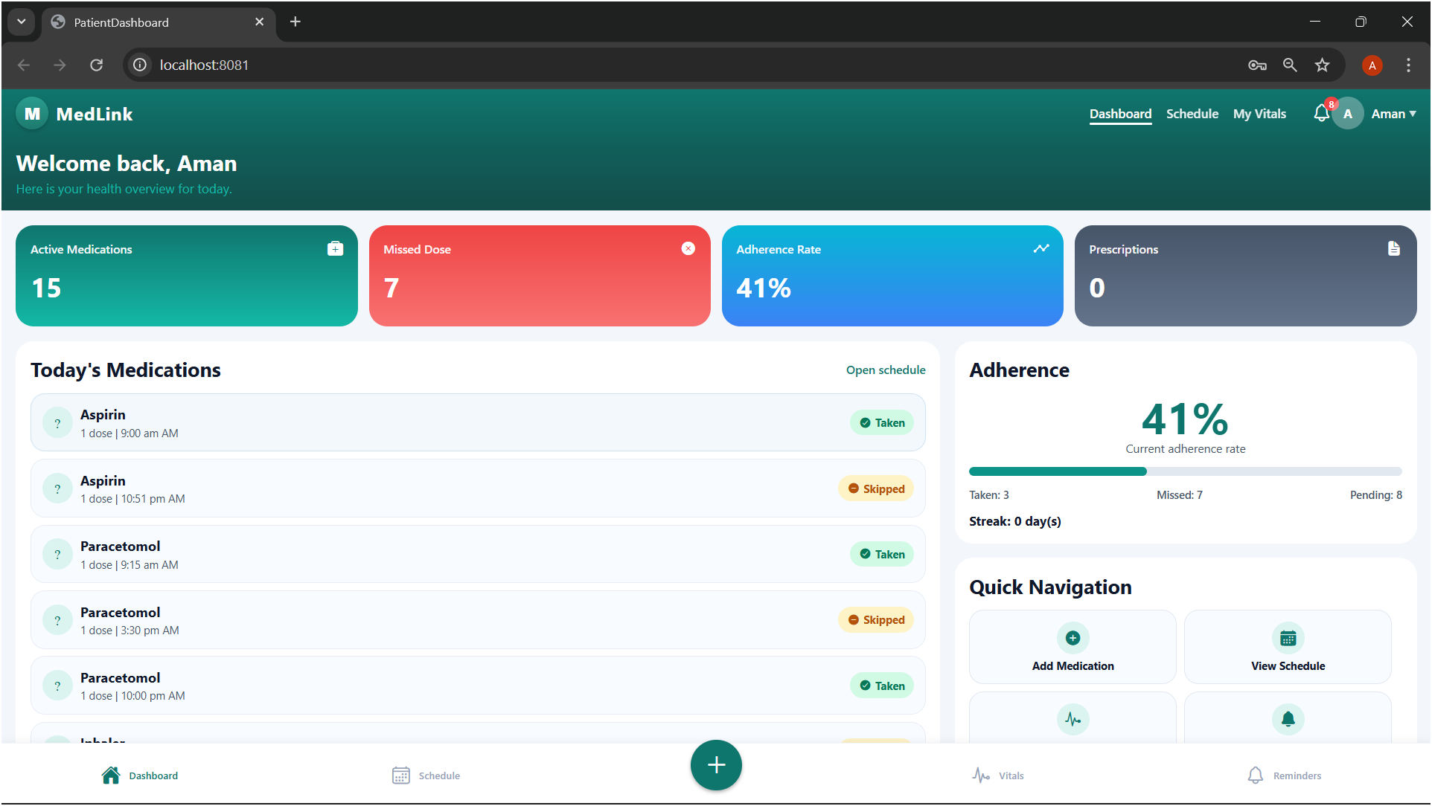
Daily Scheduling Page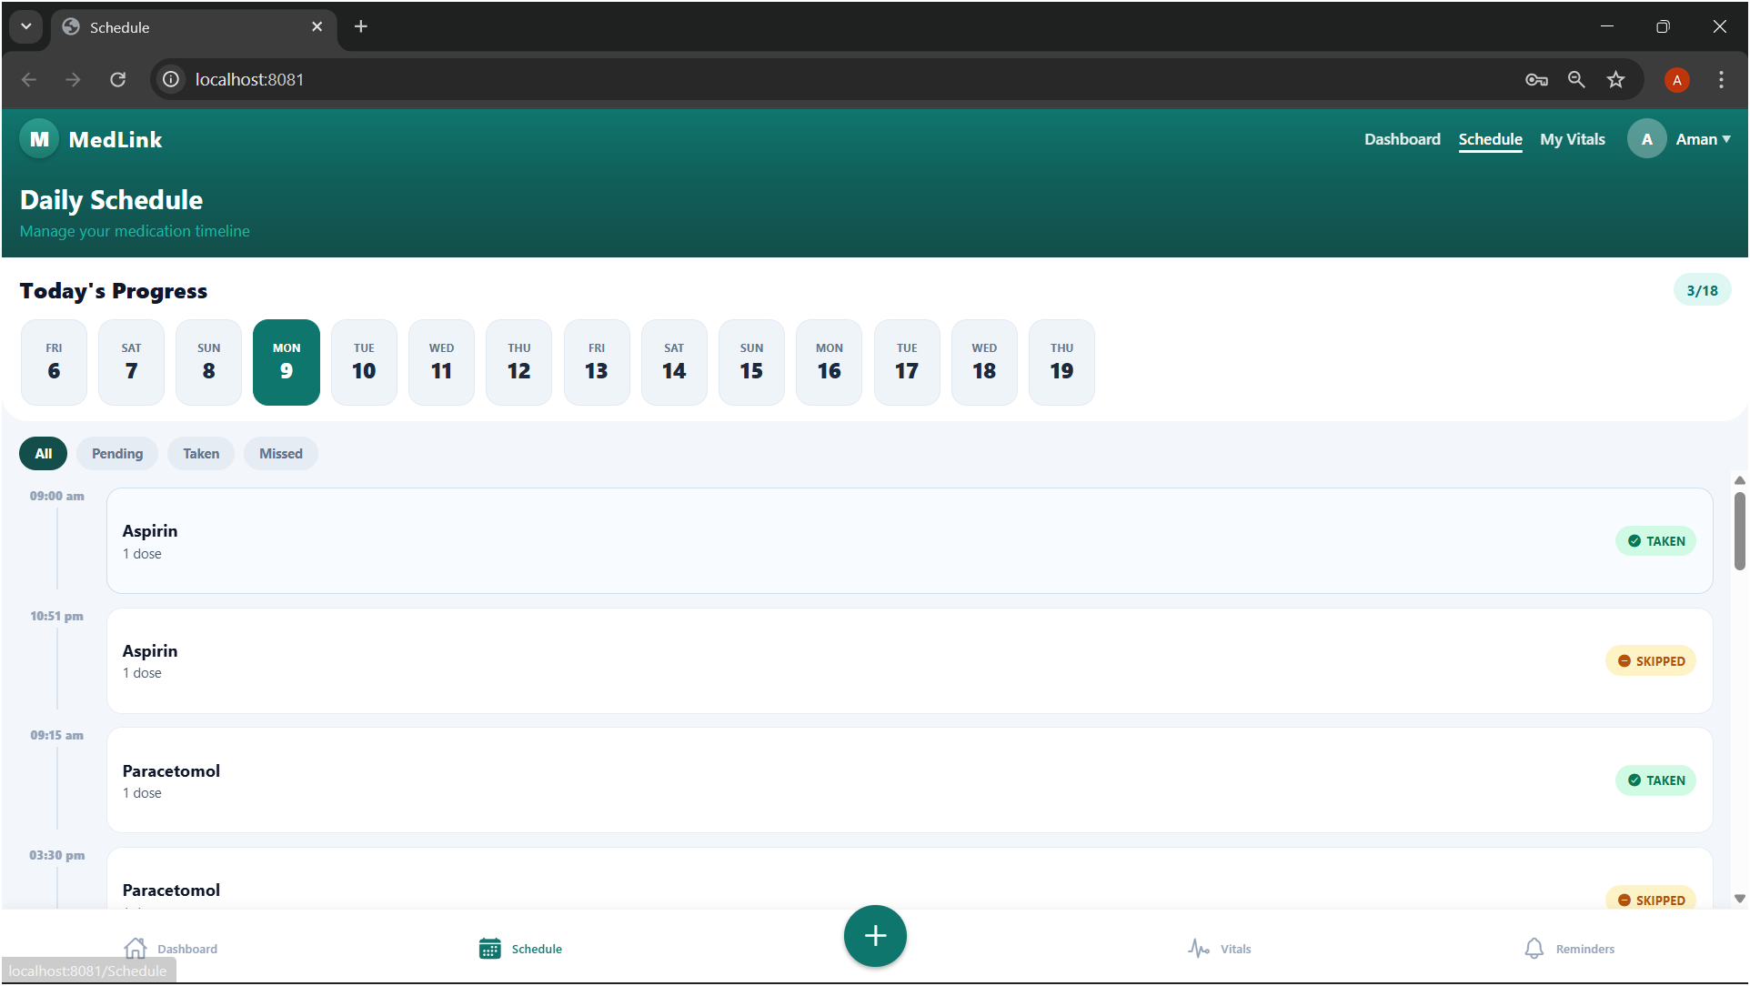
Add Medication Page
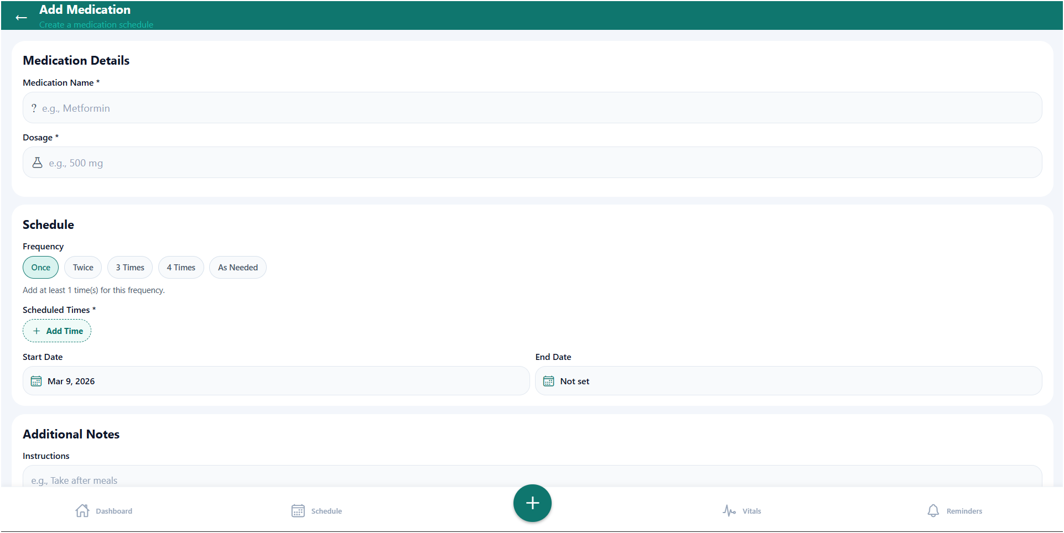
Reminder 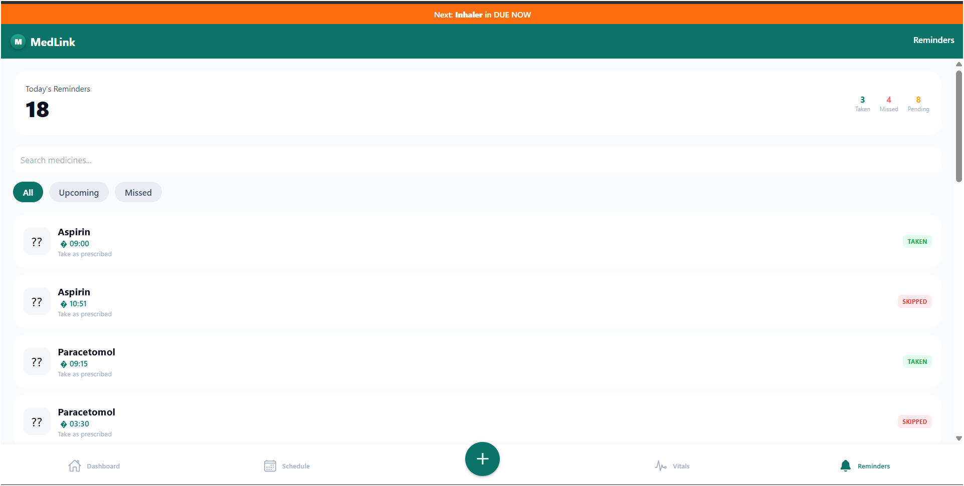
Doctor Dashboard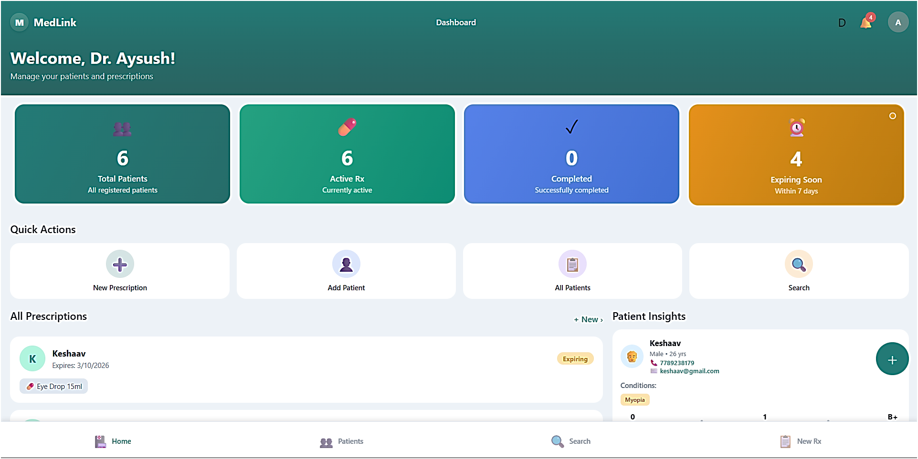
Add Prescription Page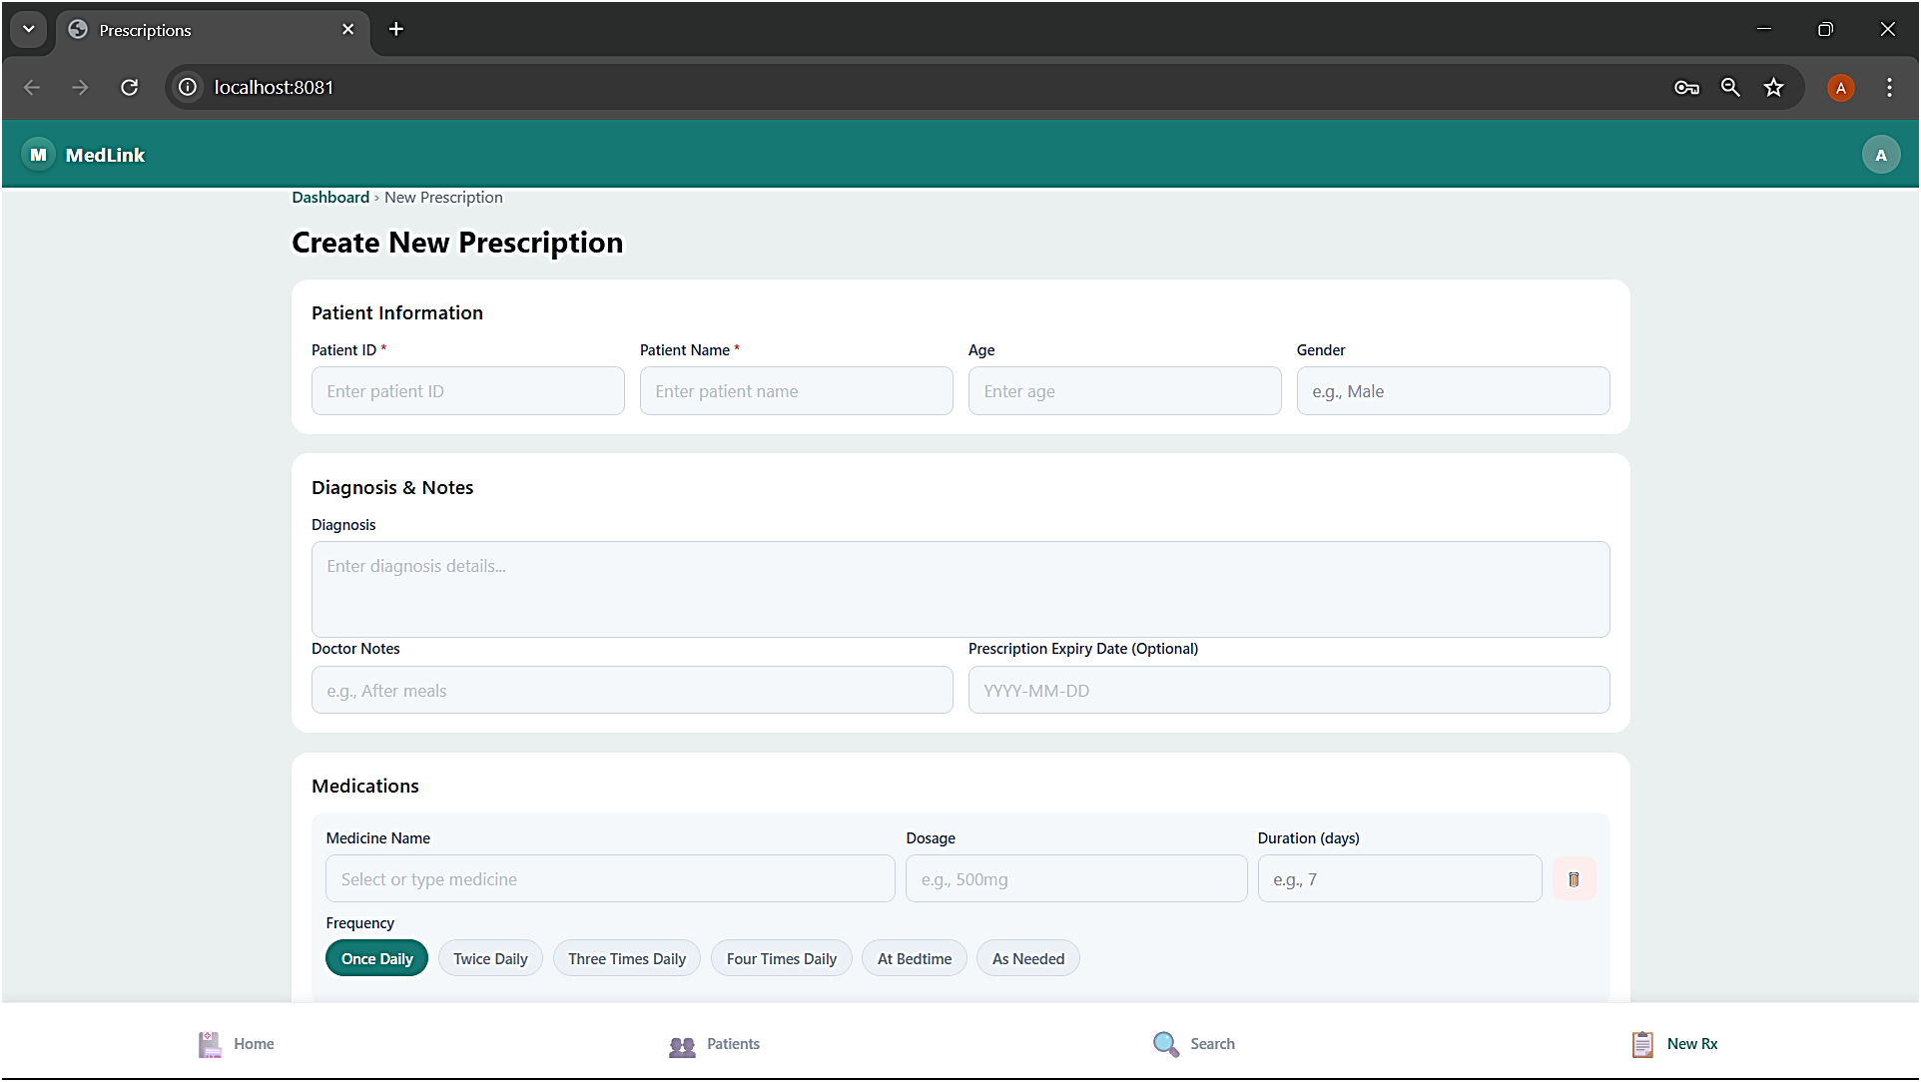
Add and View Patient 