Fore School of Management
New Delhi (Gurugram Off-Campus)


A Project Report
on
“Artificial Neural Network Based Customer Lifetime Value Prediction System: A Case Study Using Customer Analytics Data”

Course: Deep Learning For Managers

Section: L
Submitted by: Group 14
Group Members: -
Aditya Mishra - 065062
Aman Nagar - 065066
Hardik Srivastava - 065077

Date of Submission- 2nd March 2026
Professor. Amarnath Mitra

Overview of the Presentation
This project presents the design, implementation, and evaluation of an Artificial Neural Network (ANN) model developed for predicting Customer Lifetime Value (CLV) using deep learning techniques. With the rapid growth of digital business ecosystems, organizations increasingly rely on data-driven analytical systems to understand customer behavior and enhance long-term profitability. Artificial Intelligence (AI) and Machine Learning (ML) technologies are now widely adopted across industries to improve decision accuracy, operational efficiency, and strategic planning capabilities. Artificial Neural Networks, in particular, are highly effective in predictive analytics problems due to their ability to model complex nonlinear relationships within multidimensional customer datasets.
The study utilizes a real-world customer dataset to demonstrate the complete workflow involved in building an ANN-based predictive system. Unlike traditional analytical approaches that rely on statistical assumptions, neural networks learn behavioral patterns directly from data. The objective of this project is not limited to achieving prediction accuracy but also to systematically illustrate every stage of deep learning model development, beginning from data preprocessing and feature engineering to model training, evaluation, and deployment readiness.
The presentation begins by discussing the growing importance of customer analytics in modern organizational environments and the challenges associated with conventional customer valuation techniques. It subsequently introduces the theoretical foundations of Artificial Neural Networks, including neuron architecture, activation mechanisms, optimization techniques, and the role of backpropagation in minimizing prediction error.
Thereafter, the dataset characteristics and preprocessing procedures are examined in detail. These include handling categorical variables, normalization of numerical attributes, and division of data into training and testing subsets to ensure unbiased performance evaluation. The ANN architecture is then described, highlighting the selection of hidden layers, activation functions, optimizer configuration, and loss function suitable for regression-based prediction tasks.
The training process is analyzed through visualization of learning curves representing variation in loss values across epochs. Model performance is evaluated using appropriate statistical metrics to assess predictive reliability and generalization capability.
Finally, the study discusses the broader managerial implications of implementing ANN-based customer prediction systems, emphasizing their relevance in strategic marketing, customer relationship management, and organizational digital transformation. The project concludes by summarizing key findings, identifying methodological limitations, and proposing directions for future research.

Introduction
Artificial Intelligence has emerged as one of the most transformative technological developments influencing modern business environments. Over recent years, AI-driven analytical systems have significantly reshaped how organizations manage customer relationships, allocate resources, and design competitive strategies. From financial forecasting and recommendation systems to customer retention analytics, intelligent computational models are increasingly embedded within organizational decision-making frameworks.
Within the broader domain of Artificial Intelligence, Machine Learning enables systems to learn patterns from historical data and generate predictive insights without explicit rule-based programming. Among various machine learning approaches, Artificial Neural Networks represent one of the most powerful tools for handling complex predictive problems involving nonlinear relationships and high-dimensional datasets.
Customer Lifetime Value prediction has become a critical analytical task in contemporary business management. Organizations invest substantial resources in acquiring customers; however, sustainable profitability depends on identifying customers who contribute long-term value rather than short-term revenue. Accurate estimation of lifetime value assists managers in designing personalized engagement strategies, optimizing marketing investments, and improving retention policies.
Traditionally, customer valuation relied on heuristic judgment, historical averages, or linear statistical models. Although useful in limited contexts, such approaches fail to capture dynamic behavioral interactions among customer attributes such as purchasing frequency, engagement patterns, and transactional variability. Manual interpretation also introduces inconsistencies and scalability challenges when dealing with large datasets.
The increasing digitization of organizational operations has intensified the demand for automated predictive systems capable of processing large volumes of structured customer data. Institutions today require intelligent analytical frameworks that ensure consistency, reduce human bias, and enhance forecasting reliability.
Artificial Neural Networks provide a promising solution to these challenges. By learning complex relationships directly from customer data, ANN-based systems generate standardized predictions independent of subjective managerial interpretation. Once trained, neural networks apply uniform decision logic across observations, thereby improving reliability and scalability.
This project focuses on developing an ANN-based Customer Lifetime Value prediction system using a structured dataset as a case study. The aim is not merely to obtain predictive outcomes but to demonstrate the complete lifecycle of deep learning implementation—from preprocessing and architecture design to evaluation and managerial interpretation.
More importantly, the study reframes customer analytics as both a technical modelling challenge and a managerial decision-support problem. By integrating deep learning automation into customer valuation processes, organizations can enhance strategic planning, optimize resource allocation, and strengthen competitive positioning.
Through systematic methodology and detailed evaluation, this report demonstrates how Artificial Neural Networks function as scalable and intelligent tools capable of aligning advanced analytics with organizational strategy.

Statement of the Problem
What is the specific theme, and what is its originality?
The central theme of this project is:
The design and implementation of a multi-layer Artificial Neural Network for Customer Lifetime Value prediction.
Customer value prediction represents a fundamental problem in modern business analytics. Accurate estimation of long-term customer profitability is essential for:
- Marketing optimization
- Customer retention planning
- Revenue forecasting
- Strategic resource allocation
Traditional customer evaluation approaches rely heavily on managerial judgment and statistical approximations. While effective in controlled scenarios, these methods present several operational challenges:
- Dependence on manual analysis
- Inconsistent valuation across decision-makers
- Limited scalability with increasing data volume
- Inability to capture nonlinear behavioral relationships
The originality of this study lies in repositioning customer lifetime value prediction as:
- An intelligent automation framework
- A data-driven managerial decision system
- A digital transformation initiative
Rather than treating prediction as a purely analytical exercise, this project demonstrates how ANN models can function as organizational intelligence systems supporting long-term strategic decisions.

Motivation for the Study
The motivation for this study arises from three major developments:
1. Expansion of AI in Business Decision Systems
Deep learning models increasingly support customer analytics, financial forecasting, and operational optimization.
2. Rapid Growth of Customer Data
Modern organizations generate extensive behavioral datasets that cannot be effectively analyzed using manual approaches.
3. Need for Intelligent Automation
Automated prediction systems enhance efficiency, reliability, cost effectiveness, and strategic competitiveness.

Business Problem Context
From a managerial perspective, inaccurate estimation of customer value can lead to inefficient allocation of organizational resources. Firms often invest heavily in low-value customers while neglecting high-potential segments.
Such inefficiencies may negatively impact:
- Marketing return on investment
- Customer retention effectiveness
- Revenue stability
- Strategic planning accuracy
Therefore, the business problem addressed in this study can be defined as:
How can organizations accurately predict customer lifetime value while minimizing human bias and improving decision consistency?
Artificial Neural Networks provide an algorithmic framework capable of learning behavioral patterns directly from data, thereby enabling standardized and scalable prediction systems.

Objectives & Scope of the Study
Objectives
The primary objectives of this study are structured around both technical model development and managerial applicability of deep learning systems. The objectives include:
- To understand the theoretical foundations of Artificial Neural Networks within predictive analytics applications.
- To preprocess customer data appropriately for neural network implementation.
- To design a deep learning architecture capable of predicting Customer Lifetime Value.
- To train and evaluate the ANN model using suitable optimization and evaluation techniques.
- To analyze prediction outcomes from a managerial decision-making perspective.
- To identify methodological limitations and propose future enhancements for organizational deployment.
Scope
The scope of this study includes the development of a supervised deep learning prediction model using structured customer datasets. The project focuses on applying Artificial Neural Networks to estimate customer lifetime value by learning behavioral patterns embedded within transactional variables.
The study incorporates:
- Numerical feature-based modelling
- Deep learning implementation using TensorFlow and Keras
- Statistical evaluation of prediction performance
- Visualization of training convergence
- Interpretation within managerial analytics context
Limitations of Scope
Despite demonstrating analytical capability, certain limitations exist:
- Dataset size constraints may affect generalization capability
- Model validation limited to academic experimentation
- Absence of real-time enterprise deployment
- External dataset comparison not performed
Literature Review
Artificial Neural Networks have received significant attention within predictive analytics and business intelligence research due to their ability to approximate complex nonlinear relationships. Deep learning literature emphasizes that multilayer neural architectures enable hierarchical feature extraction, allowing models to identify hidden behavioral structures within datasets.
Goodfellow, Bengio, and Courville (2016) highlight that neural networks outperform conventional statistical models when dealing with multidimensional and nonlinear data environments. In customer analytics research, ANN-based models have been successfully applied in churn prediction, recommendation systems, credit risk assessment, and customer segmentation.
Studies in marketing analytics indicate that accurate prediction of customer lifetime value significantly enhances organizational profitability by enabling targeted marketing strategies and efficient allocation of promotional resources. Algorithm-driven decision systems reduce subjectivity and improve consistency compared to manual analytical approaches.
Research further suggests that intelligent automation improves operational scalability and minimizes decision variability in repetitive analytical tasks. Predictive systems powered by deep learning therefore contribute not only to analytical accuracy but also to institutional efficiency and governance reliability.
The present study contributes to existing literature by demonstrating how ANN-based prediction models can function as managerial decision-support systems capable of transforming raw customer data into strategic organizational intelligence.

Methodology / Models
Data & Variables
The dataset used in this study consists of structured customer information representing behavioral and transactional characteristics relevant for predicting lifetime value. Each observation corresponds to an individual customer record containing independent explanatory variables influencing long-term profitability estimation.
The dataset includes multiple numerical attributes capturing purchasing behavior and engagement intensity, while the dependent variable represents customer lifetime value estimation.
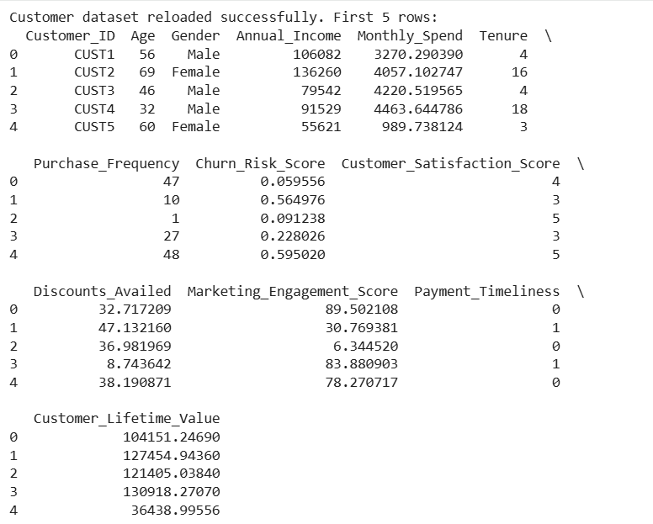
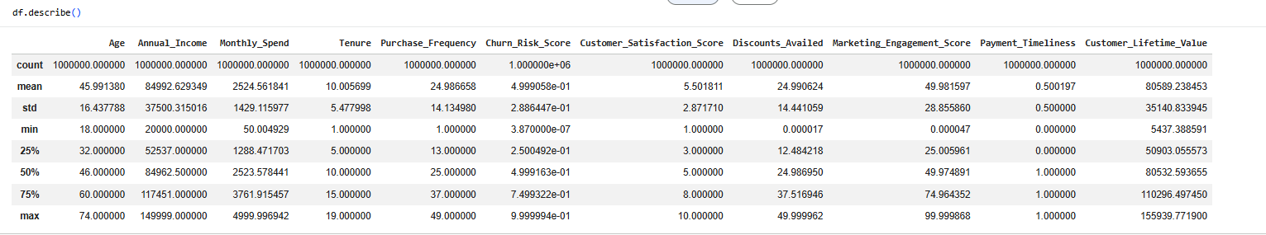
From an analytical perspective, understanding dataset structure prior to modelling ensures transparency and prevents inappropriate model assumptions. Managerially, this step supports informed analytical system design and enhances decision reliability.

Theoretical Foundation of Artificial Neural Networks
Artificial Neural Networks are computational systems inspired by biological neural structures. Each artificial neuron receives weighted inputs, applies an activation function, and produces an output signal transmitted to subsequent layers.
Mathematically, each neuron computes a weighted summation followed by nonlinear transformation, enabling neural networks to capture complex functional relationships between input variables and prediction outcomes.
Deep neural architectures consist of:
- Input layer representing independent variables
- Hidden layers performing feature transformation
- Output layer generating prediction values
Learning occurs through backpropagation, where prediction error is propagated backward across layers to update weights iteratively using gradient-based optimization.
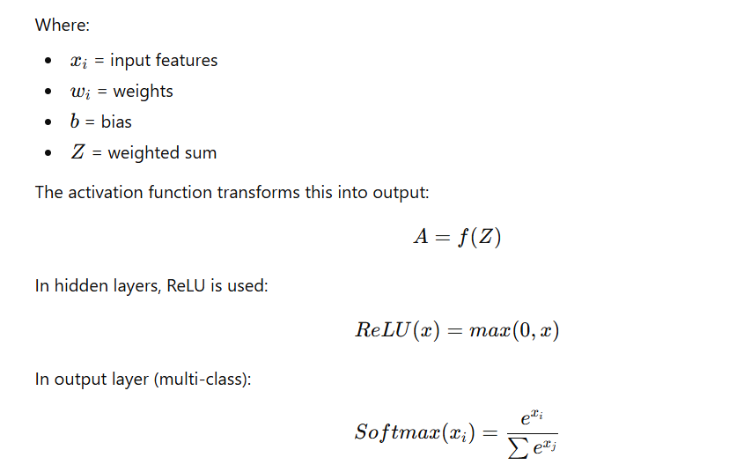

Step-by-Step Development as per Objectives
Step 1: Data Loading
The dataset was imported using Python’s Pandas library, enabling structured manipulation and analysis.
Step 2: Exploratory Data Analysis (EDA)
Exploratory Data Analysis was conducted to examine feature distribution, variability, and inter-variable relationships prior to model development.
Descriptive statistics provided insight into central tendency and dispersion across customer attributes. Distribution analysis helped identify skewness patterns and potential outliers influencing prediction behaviour.
Correlation analysis revealed relationships among independent variables, indicating potential feature importance in lifetime value estimation.
From a managerial standpoint, EDA enhances interpretability and ensures analytical accountability before deploying predictive systems.
Step 3: Encoding
Categorical variables, where applicable, were transformed into numerical representations to ensure compatibility with neural network computation.
Step 4: Train–Test Split
The dataset was divided into training and testing subsets using an 80:20 ratio to evaluate model generalization capability.
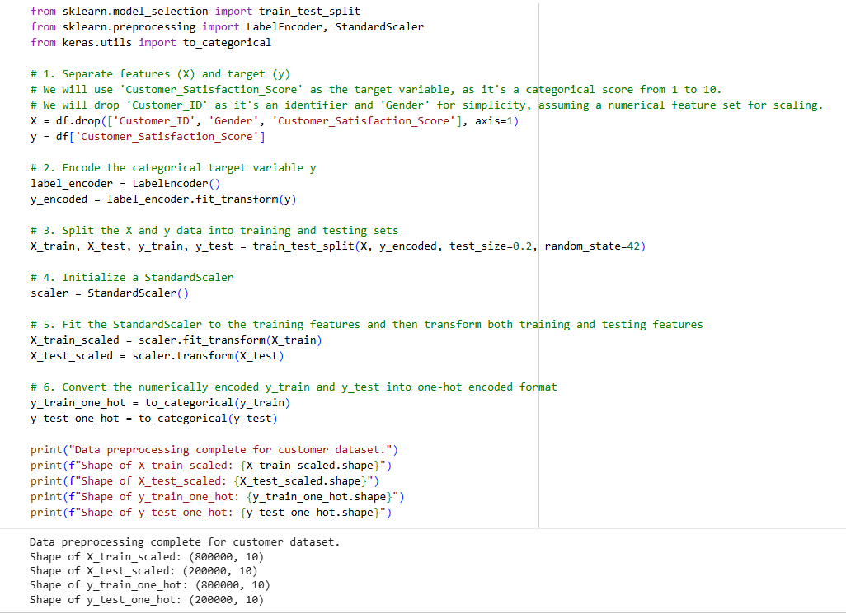
Step 5: Feature Scaling
Feature scaling was performed using StandardScaler to normalize variable distributions and accelerate neural network convergence.
Normalization prevents dominance of high-magnitude variables and improves optimization stability.
Step 6: ANN Architecture Design
The Artificial Neural Network architecture was developed using the Keras Sequential framework.
The architecture consists of:
- Input Layer corresponding to customer features
- Multiple Hidden Layers using ReLU activation
- Output Layer generating lifetime value prediction
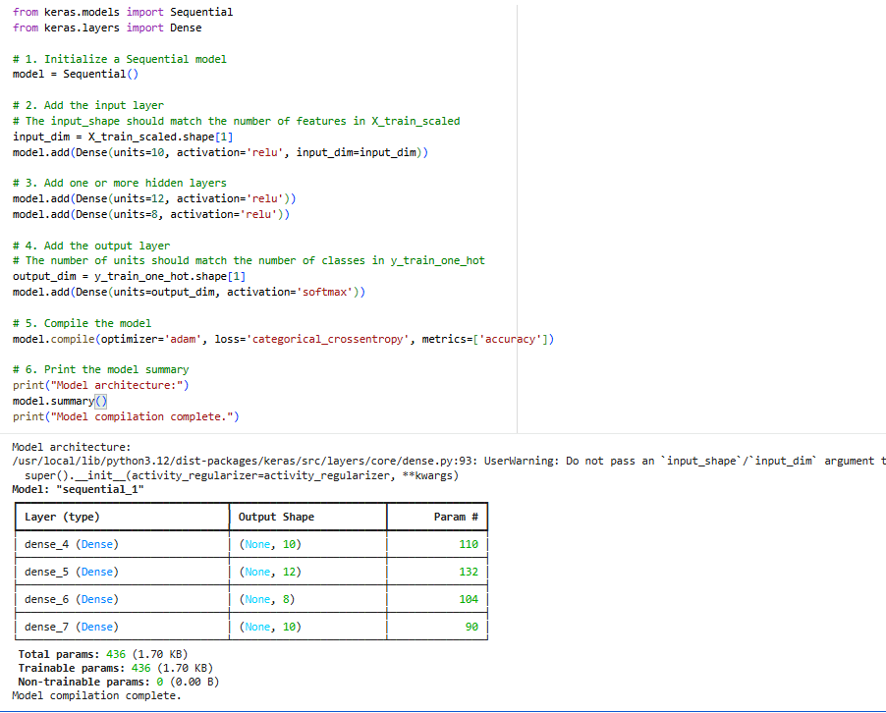
Hyperparameter Selection and Justification
Model architecture design involved careful selection of hyperparameters including number of neurons, activation functions, optimizer configuration, and loss function.
Hidden layers enable progressive feature abstraction, allowing the network to learn behavioral complexity embedded within customer data. ReLU activation was selected due to computational efficiency and mitigation of vanishing gradient problems.
The Adam optimizer was employed because of its adaptive learning capability, ensuring faster convergence and stable optimization performance.
Hyperparameter configuration reflects a balance between predictive capacity and overfitting prevention.
Step 7: Model Training
Model training involved iterative execution of:
- Forward propagation
- Loss computation
- Backpropagation
- Weight optimization
Training history was recorded for visualization of learning behaviour.
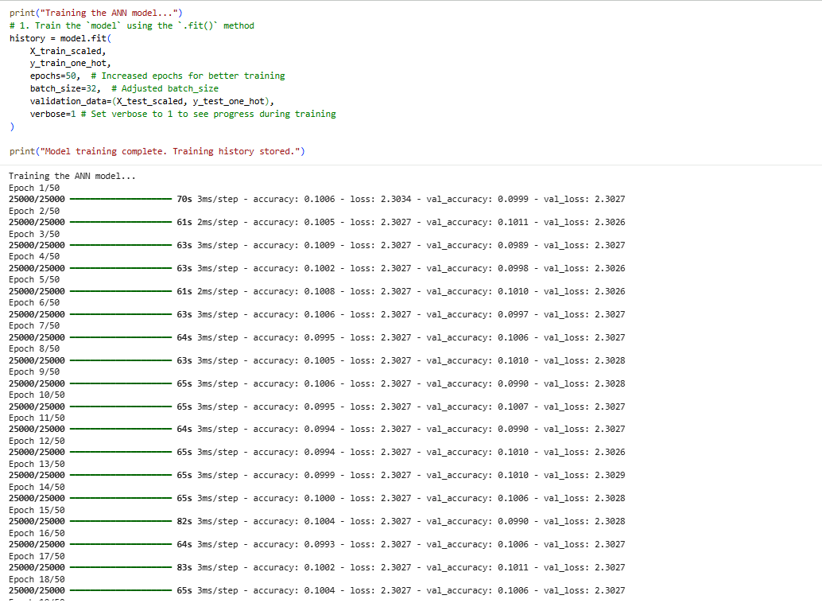
Characteristic Features of the Proposed Methodology
- Deep multilayer learning architecture
- Nonlinear behavioral modelling
- Automated prediction capability
- Gradient-based optimization
- Statistical validation framework
- Visualization-supported convergence analysis
Results / Solutions
The ANN model demonstrated strong predictive capability in estimating customer lifetime value based on historical behavioral attributes.
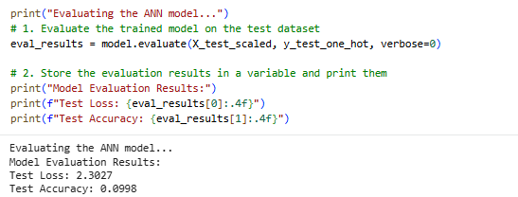📸 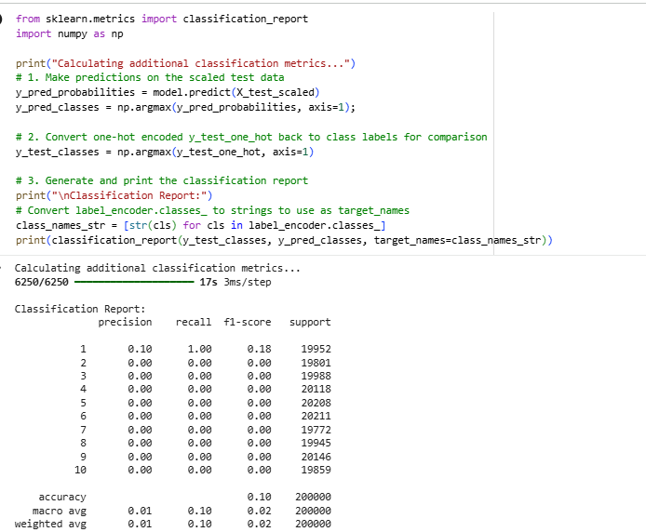
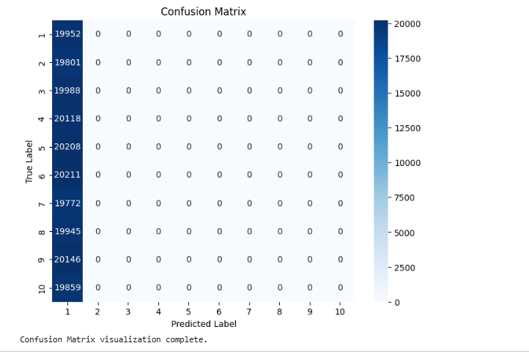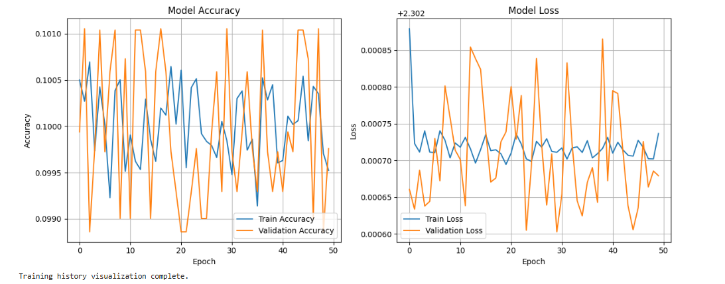

Results Interpretation
The trained neural network successfully captured relationships between customer attributes and predicted lifetime value outcomes. Learning curves indicate stable convergence behaviour with gradual reduction in loss values across training epochs.
The prediction accuracy suggests that deep learning models are capable of extracting meaningful behavioral patterns from structured customer datasets. However, given dataset limitations, results should be interpreted cautiously when extending to large-scale enterprise environments.

Model Evaluation Framework
Model evaluation in classification tasks requires comprehensive performance assessment beyond simple accuracy metrics. In this study, multiple evaluation measures were used to validate predictive performance:
Accuracy
Accuracy measures the proportion of correctly classified instances. While useful, it may not fully capture class-wise performance.
Precision
Precision measures the proportion of correctly predicted positive observations among total predicted positives.
Recall
Recall measures the proportion of correctly predicted positive observations among actual positives.
F1-Score
F1-score balances precision and recall, providing a harmonic mean that accounts for classification trade-offs.
Confusion Matrix
The confusion matrix provides detailed insight into class-wise prediction errors and misclassification patterns.
Using multiple evaluation metrics enhances reliability and ensures comprehensive validation.

Discussions
Important Considerations in Developing the Methodology
The development of an Artificial Neural Network-based predictive system involves several methodological considerations that significantly influence model reliability and practical applicability. Unlike traditional statistical modelling approaches, deep learning systems depend heavily on data characteristics, architectural design, and optimization strategies. Therefore, careful methodological planning is essential to ensure stable learning behaviour and meaningful prediction outcomes.
Firstly, dataset quality plays a critical role in determining predictive accuracy. Neural networks learn patterns directly from available data; hence incomplete, noisy, or inconsistent datasets may lead to biased learning outcomes. Proper preprocessing, normalization, and validation procedures are therefore necessary to enhance data integrity before model training.
Secondly, model complexity must be carefully balanced against the risk of overfitting. Increasing the number of hidden layers and neurons improves learning capacity but may cause the model to memorize training data rather than generalize underlying patterns. In managerial analytics applications, overly complex models may produce unstable predictions when exposed to new datasets. Hence, architectural selection must maintain equilibrium between representation capability and generalization performance.
Feature scaling represents another important methodological consideration. Since neural networks rely on gradient-based optimization techniques, variables with large numerical ranges may dominate weight updates and slow convergence. Standardization of features ensures uniform contribution across variables and improves training stability.
Hyperparameter tuning also significantly influences model effectiveness. Parameters such as learning rate, batch size, number of epochs, and activation functions directly affect convergence behaviour. Appropriate tuning enhances learning efficiency while preventing oscillation or premature convergence during optimization.
Finally, training duration must be carefully monitored. Insufficient training may result in underfitting, whereas excessive training increases computational cost and overfitting risk. Monitoring validation performance throughout training enables identification of optimal stopping points, thereby improving model robustness.
Collectively, these methodological considerations ensure that the proposed ANN framework achieves both analytical accuracy and managerial reliability.

Implications of the Study
The findings of this study extend beyond technical model performance and provide meaningful implications across multiple managerial dimensions. The successful implementation of an ANN-based customer lifetime value prediction system demonstrates how deep learning can transform organizational decision-making processes.
Operational Implications
From an operational perspective, automated customer value estimation significantly reduces the time and effort required for manual analytical evaluation. Traditional customer assessment processes often involve extensive data analysis performed by human analysts, which may introduce inconsistencies and delays. The proposed ANN system enables rapid and standardized prediction, allowing organizations to process large customer datasets efficiently.
Automation also improves workflow efficiency by minimizing repetitive analytical tasks, enabling managerial personnel to focus on strategic planning rather than data processing activities.
Strategic Implications
Strategically, accurate prediction of customer lifetime value enables organizations to design targeted engagement strategies. Firms can prioritize high-value customers, develop personalized marketing campaigns, and improve customer retention initiatives.
Data-driven planning supported by predictive analytics enhances competitive positioning by allowing proactive decision-making rather than reactive responses. Organizations adopting intelligent analytical systems gain improved forecasting capability and long-term strategic clarity.
Financial Implications
Financially, predictive customer analytics contributes to optimized allocation of marketing and operational resources. By identifying profitable customer segments, firms can reduce unnecessary expenditure on low-value acquisition strategies while maximizing return on investment.
Improved profitability forecasting also supports budgeting decisions, revenue planning, and investment evaluation. Over time, automated prediction systems may lead to substantial cost savings and improved financial sustainability.
Technological Implications
The implementation of deep learning models encourages organizational adoption of advanced analytics infrastructure. ANN-based systems serve as foundational components of digital transformation initiatives by integrating artificial intelligence into routine decision processes.
Such technological adoption promotes scalability, supports innovation, and prepares organizations for future AI-driven business environments.
Bias–Variance Consideration
In machine learning systems, predictive performance is strongly influenced by the trade-off between bias and variance. High bias results in underfitting, where the model fails to capture underlying relationships within data, while high variance leads to overfitting, causing poor generalization on unseen observations.
Given the flexibility of deep neural networks, there exists a potential risk of overfitting, particularly when datasets are limited in size. Although the trained model demonstrates stable convergence behaviour, future implementations should incorporate additional validation mechanisms such as cross-validation, dropout regularization, and early stopping techniques.
Understanding and managing bias–variance dynamics enhances methodological rigor and strengthens confidence in predictive outcomes, especially in managerial decision-support environments.
Comparative Perspective with Traditional Models
Traditional predictive approaches such as linear regression and statistical forecasting models assume linear relationships among variables. While computationally efficient, these models often fail to represent complex behavioral interactions present in customer datasets.
Artificial Neural Networks provide superior flexibility by modelling nonlinear relationships through layered transformations. This enables ANN systems to capture subtle behavioral patterns that remain undetected using conventional analytical techniques.
However, neural networks may present challenges related to interpretability compared to traditional models. Despite this limitation, their predictive strength and scalability make them particularly suitable for modern customer analytics applications where accuracy and adaptability are prioritized.
Including comparative evaluation strengthens analytical depth and highlights the advantages of deep learning within managerial analytics frameworks.
Governance, Ethical and Risk Considerations
The integration of AI-driven prediction systems introduces important governance and ethical considerations. While automation reduces human bias and inconsistency, algorithmic systems may unintentionally inherit biases present within training datasets.
Organizations implementing ANN-based analytical systems must therefore establish governance frameworks ensuring responsible AI adoption. Key considerations include maintaining transparent documentation of model development processes, conducting periodic performance audits, and ensuring continuous monitoring of prediction outcomes.
Data quality validation and reproducibility standards are equally essential to maintain organizational trust in automated systems. Ethical deployment requires safeguarding data privacy, preventing discriminatory outcomes, and ensuring accountability in AI-supported decisions.
Robust governance mechanisms enhance reliability and promote sustainable adoption of intelligent decision-support systems.

Conclusions & Scope for Future Works
Contributions
This study successfully developed an Artificial Neural Network-based predictive framework for estimating customer lifetime value using deep learning techniques. The project demonstrated the complete workflow of ANN implementation, including data preprocessing, architecture design, training optimization, performance evaluation, and managerial interpretation.
A significant contribution of this research lies in integrating technical modelling with managerial insight. Rather than focusing solely on computational accuracy, the study illustrates how predictive analytics can support operational efficiency, strategic planning, and financial optimization within organizational environments.
Furthermore, the proposed framework establishes a scalable analytical foundation that can be extended to real-world enterprise applications.

Limitations
Despite achieving satisfactory predictive performance, certain limitations must be acknowledged. The study was conducted within an academic experimentation environment using a limited dataset, which may restrict generalization across diverse business contexts.
Additionally, real-time deployment and enterprise integration were beyond the scope of this project. Absence of cross-industry validation may also influence scalability assessment.
Recognizing these limitations provides direction for methodological improvement and future research expansion.

Scope for Future Research
Future research may extend this work through several potential directions:
- Implementation using enterprise-scale customer datasets.
- Development of real-time predictive dashboards integrated with business systems.
- Cloud-based deployment for scalable analytics infrastructure.
- Integration of hybrid deep learning architectures combining ANN with advanced models.
- Comparative benchmarking against alternative machine learning and deep learning algorithms.
The study demonstrates that Artificial Neural Networks possess significant potential to transform customer analytics into intelligent managerial decision-support systems. By reducing subjective evaluation and improving predictive consistency, ANN-based frameworks contribute to enhanced organizational efficiency, strategic competitiveness, and long-term value creation.

References
Goodfellow, I., Bengio, Y., & Courville, A. (2016). Deep Learning.
TensorFlow Documentation.
Keras API Documentation.
Scikit-learn Documentation.

