TapSearch

Technology Used : In this search API I have used Java Maven + HTML + Glassfish Server+ Java 8

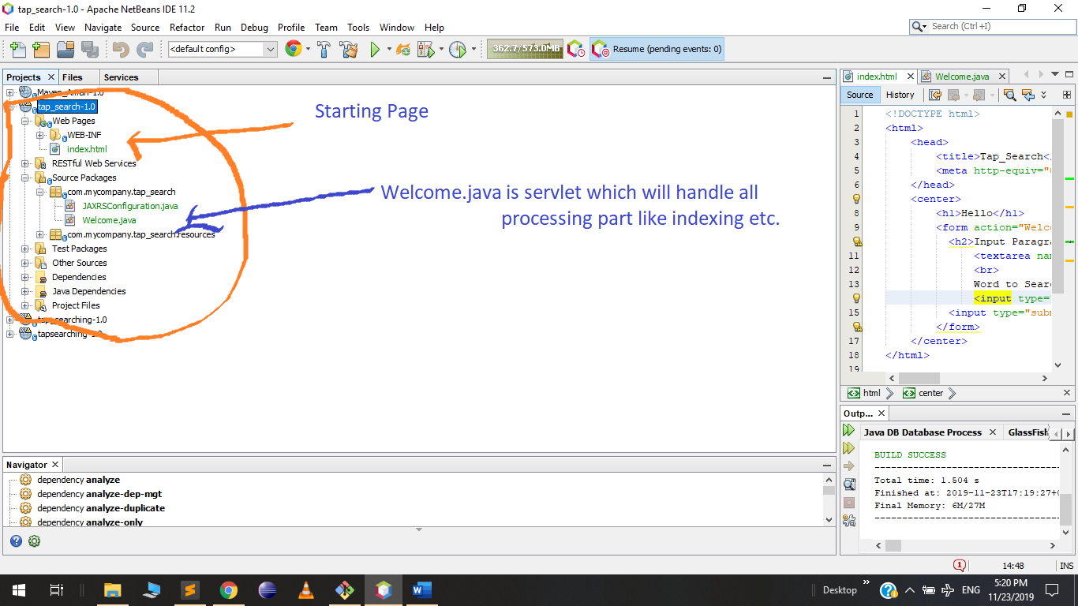

There are two important file:

1 : index.html

Here user inputs the data. This is how it looks like.

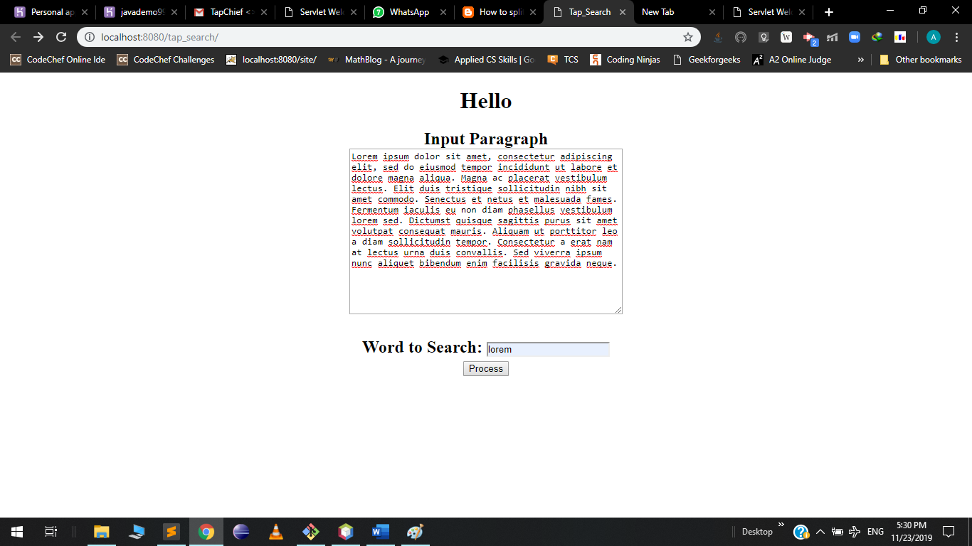

2: Welcome.java –

After giving the input , data is send out for processing which is handle by Welcome.java at the backend and display matched paragraph to the user as a result . Sample Screenshot

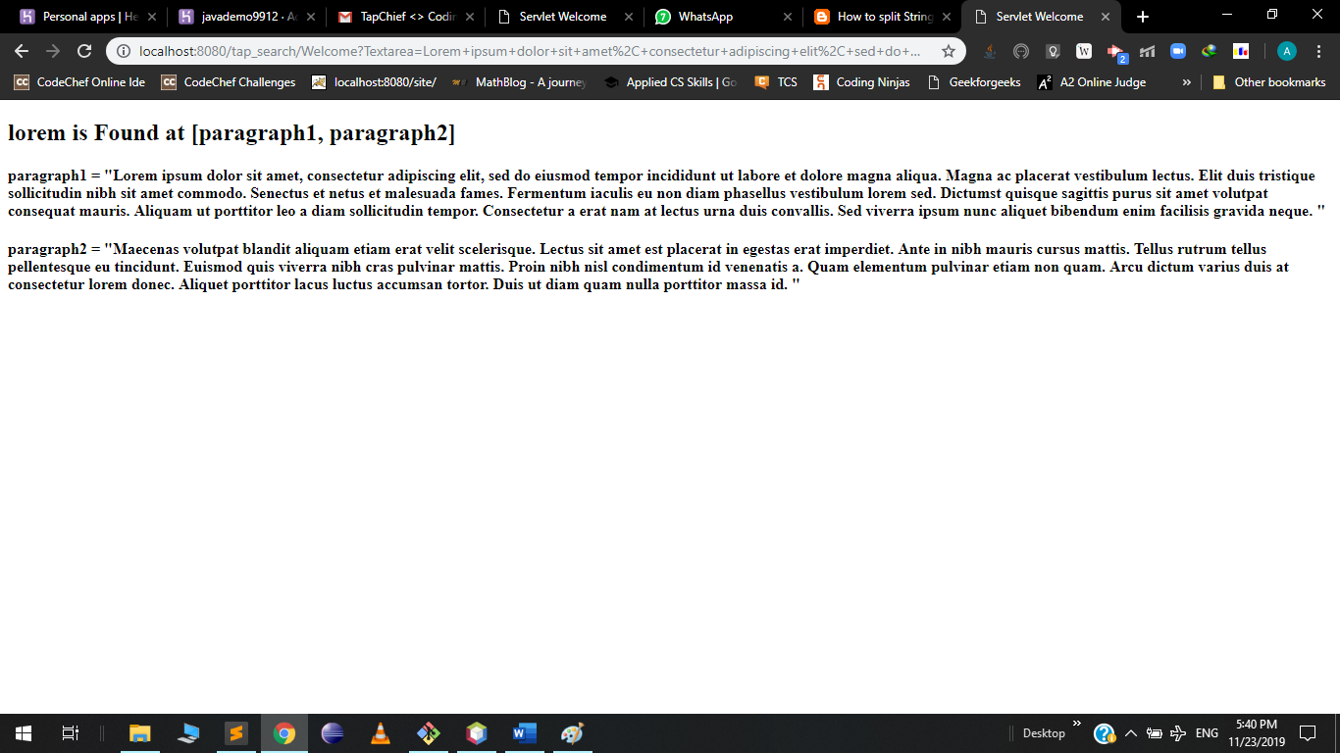

How to Use it :

There are two fields in index.html. In first field input paragraphs and In the second field input the word you want to search.

Thank You