GameMatch AI
Video Game Recommendation System

Submitted By:
Aman Negi
Roll Number: 33
Organization: JTP Project Round 2026
Technology Stack: FastAPI • React • PostgreSQL • Docker
Submission Date: (8th July 2026)
INDEX

- Project Overview
- System Architecture
- Technology Stack
- Project Structure
- ETL Pipeline
- Database Design
- API Design
- Recommendation Engine
- Match Score Calculation
- Frontend Architecture
- Docker Architecture
- Future Scope
- Data Source
- Conclusion

1. Project Overview
1.1 Introduction
GameMatch AI is a full-stack web application that provides personalized video game recommendations based on a user's preferences. Instead of displaying a generic list of popular games, the application analyzes multiple factors such as genres, platforms, gameplay tags, digital stores, minimum rating, release year, and maximum playtime to recommend games that best match the user's interests.
The project follows a complete software engineering workflow, beginning with data collection from the RAWG Video Games Database API through an ETL (Extract, Transform, Load) pipeline. The collected data is cleaned, transformed, and stored in a normalized PostgreSQL database. During runtime, the FastAPI backend retrieves data from the database, applies a custom weighted recommendation algorithm, and returns personalized recommendations to the React frontend.
In addition to implementing a recommendation system, the project demonstrates the integration of modern software engineering technologies and practices, including RESTful API development, relational database design, frontend development using React, Docker-based containerization, and version control with Git.

1.2 Project Objectives
The primary objectives of GameMatch AI are:
- Develop a personalized video game recommendation system based on user preferences.
- Design and implement a complete ETL pipeline for collecting and preparing game data.
- Store structured game data in a normalized PostgreSQL database.
- Develop RESTful APIs using FastAPI for communication between the frontend and backend.
- Build a responsive and user-friendly interface using React.
- Deploy the complete application using Docker and Docker Compose.
- Demonstrate the integration of data engineering, backend development, database management, frontend development, and containerization in a single full-stack application.

1.3 Project Features
The application provides the following features:
- Personalized game recommendations using a weighted scoring algorithm.
- Filtering based on genres, platforms, gameplay tags, stores, rating, release year, and playtime.
- Transparent recommendation scores with matched preference information.
- A normalized PostgreSQL database containing approximately 11,960 video games.
- Fast recommendation generation without requiring external API calls during runtime.
- Responsive and intuitive user interface built with React.
- Containerized deployment using Docker for easy setup and portability.
2. System Architecture
GameMatch AI follows a layered architecture where each component has a specific responsibility. The application consists of an ETL pipeline, a PostgreSQL database, a FastAPI backend, and a React frontend.
The ETL pipeline collects game data from the RAWG Video Games Database API, processes the data, and stores it in a PostgreSQL database. During application runtime, the FastAPI backend retrieves the required data from the database, processes the user's preferences using the recommendation engine, and returns the results to the React frontend. The frontend then displays the recommended games to the user.
The overall system architecture is illustrated below.
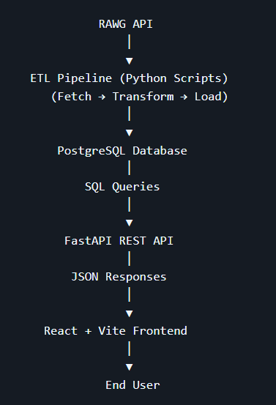

System Workflow
- Game information is collected from the RAWG Video Games Database API through the ETL pipeline.
- The extracted data is transformed and loaded into the PostgreSQL database.
- The user selects preferences through the React frontend.
- The frontend sends the selected preferences to the FastAPI backend.
- The backend retrieves the required data from PostgreSQL and executes the recommendation algorithm.
- The backend returns the ranked recommendations as JSON.
- The React frontend displays the recommended games along with their details and match scores.

3. Technology Stack
GameMatch AI was developed using the following technologies. Each technology was selected based on the requirements of the project.
Technology | Purpose
Python | Used for backend development and implementing the ETL pipeline.
FastAPI | Used to build REST APIs that handle communication between the frontend and the database.
React | Used to develop the user interface and display personalized game recommendations.
Vite | Used as the frontend build tool for React development.
Tailwind CSS | Used for styling the user interface and creating a responsive layout.
PostgreSQL | Used to store game data, genres, platforms, tags, stores, and screenshots in a relational database.
RAWG Video Games Database API | Used as the source of game data during the ETL process.
Docker | Used to containerize the frontend, backend, and database services.
Docker Compose | Used to manage and run all Docker containers with a single command.
Axios | Used by the React frontend to send HTTP requests to the FastAPI backend.
Git | Used for version control during project development.
GitHub | Used to host the project repository and documentation.
Visual Studio Code | Used as the primary development environment for writing and managing the project code.

4. Project Structure
The project is organized into separate backend, frontend, and database modules to maintain a clean and modular architecture. Each directory is responsible for a specific part of the application.
GameMatchAI/
│
├── backend/
│ ├── app/
│ ├── database/
│ ├── scripts/
│ ├── data/
│ └── Dockerfile
│
├── frontend/
│ ├── src/
│ ├── public/
│ └── Dockerfile
│
├── database/
│ └── gamematchai.sql
│
├── images/
│
├── docker-compose.yml
├── README.md
├── INSTALL.md
└── USAGE.md

Directory / File | Description
backend/app/api/ | Contains the FastAPI API endpoints responsible for handling HTTP requests and returning responses to the frontend.
backend/app/models/ | Defines the Pydantic schemas used to validate incoming requests and structure API responses.
backend/app/services/ | Contains the application's business logic. game_service.py retrieves game data, while recommendation_service.py implements the weighted recommendation algorithm.
backend/database/ | Contains the PostgreSQL connection configuration, database schema, and connection testing files.
backend/scripts/ | Contains the ETL pipeline scripts used to extract, transform, and load game data into PostgreSQL.
frontend/src/components/ | Contains reusable React components such as filters, sliders, recommendation cards, and other user interface elements.
frontend/src/pages/ | Contains the main application page (Home.jsx) that combines all frontend components.
frontend/src/api/ | Handles communication between the React frontend and the FastAPI backend using Axios.
database/ | Stores the PostgreSQL database dump (gamematchai.sql) used to initialize the database automatically.
docker-compose.yml | Defines and manages the PostgreSQL, FastAPI, and React containers using Docker Compose.
README.md | Contains the complete project overview, architecture, implementation details, and technical documentation.
INSTALL.md | Provides step-by-step instructions for installing and setting up the project.
USAGE.md | Explains how to start the application and use its features.

5. ETL Pipeline
The GameMatch AI application uses an ETL (Extract, Transform, Load) pipeline to collect, prepare, and store game data before it is used by the recommendation engine. Instead of requesting data from the RAWG API every time a user searches for recommendations, the application retrieves the data once, processes it, and stores it in a local PostgreSQL database.
This approach improves application performance, reduces dependency on external APIs during runtime, and provides faster recommendation results.
ETL Workflow
RAWG API
│
▼
fetch_games.py (Extract)
│
▼
transform_games.py (Transform)
│
▼
load_games.py (Load)
│
▼
PostgreSQL Database

File | Purpose
fetch_games.py | Retrieves game information from the RAWG Video Games Database API and stores the raw response as JSON files.
transform_games.py | Extracts the required fields, handles missing values, removes duplicate metadata, organizes relationships, and prepares the data for PostgreSQL.
load_games.py | Loads the transformed data into PostgreSQL while maintaining the relationships between tables.
run_etl.py | Executes the complete ETL pipeline by running the Extract, Transform, and Load stages in sequence.

Data Preparation
During the transformation stage, the raw API response is prepared before being loaded into the database. The following operations are performed:
- Extracts only the fields required by the application.
- Handles missing values, such as unavailable ESRB ratings.
- Removes duplicate genres, platforms, tags, and stores.
- Converts nested JSON objects into a normalized relational structure.
- Creates many-to-many relationship tables.
- Generates unique identifiers for screenshots before storing them.
Benefits of the ETL Pipeline
- Stores all game data locally in PostgreSQL.
- Eliminates dependency on the RAWG API during normal application usage.
- Improves recommendation speed by querying the local database.
- Makes it easy to refresh the database by running the ETL pipeline again when new game data is required.

6. Database Design
GameMatch AI uses PostgreSQL as its relational database to store and manage video game information. The database is designed using normalization principles to reduce data redundancy and maintain relationships between different entities.
Instead of storing all information in a single table, related data such as genres, platforms, tags, stores, and screenshots are stored in separate tables and connected through many-to-many relationship tables. This structure improves data consistency and simplifies database maintenance.
Database Overview
The PostgreSQL database contains 11,960 video games collected through the ETL pipeline from the RAWG Video Games Database API.
The database stores:
- Game information
- Genres
- Platforms
- Gameplay tags
- Digital stores
- Screenshots
- Relationship data between games and their metadata

Database Tables
Table | Purpose
games | Stores basic information about each game, including its name, release date, rating, Metacritic score, playtime, ESRB rating, and cover image.
genres | Stores all unique game genres.
platforms | Stores all supported gaming platforms.
tags | Stores gameplay tags associated with games.
stores | Stores digital game stores and their URLs.
screenshots | Stores screenshots associated with each game.
game_genres | Maps games to one or more genres.
game_platforms | Maps games to their supported platforms.
game_tags | Maps games to gameplay tags.
game_stores | Maps games to the stores where they are available.

Database Design Highlights
- Uses a normalized relational database structure.
- Reduces duplicate data by separating metadata into individual tables.
- Uses many-to-many relationship tables to connect games with genres, platforms, tags, and stores.
- Maintains referential integrity using primary and foreign keys.
- Supports efficient SQL queries required by the recommendation engine.

7. API Design
The backend of GameMatch AI is developed using FastAPI and exposes RESTful APIs that enable communication between the React frontend and the PostgreSQL database. These APIs allow the frontend to retrieve game-related data and generate personalized recommendations based on the user's selected preferences.
Available API Endpoints
Method | Endpoint | Description
GET | /games | Retrieves the list of available games from the database.
GET | /genres | Returns all available game genres.
GET | /platforms | Returns all supported gaming platforms.
GET | /tags | Returns all available gameplay tags.
GET | /stores | Returns all available digital game stores.
POST | /recommend | Generates personalized game recommendations based on the user's selected preferences.
API Workflow
React Frontend
│
HTTP Request (Axios)
│
▼
FastAPI API Endpoint
│
▼
Service Layer
│
▼
PostgreSQL Database
│
▼
JSON Response
│
▼
React Frontend
Request Validation
FastAPI uses Pydantic schemas to validate incoming requests before they reach the recommendation engine. This ensures that the required data is received in the correct format and reduces the possibility of invalid inputs.
The recommendation request includes:
- Genres
- Platforms
- Tags
- Minimum Rating
- Release Year
- Maximum Playtime
- Preferred Stores
API Response
The recommendation API returns a list of games in JSON format. Each recommendation includes:
- Game ID
- Game Name
- Cover Image
- Release Year
- Rating
- Genres
- Platforms
- Tags
- Stores
- Recommendation Match Score
- Matched Preferences
Benefits of the API Design
- Provides a clear separation between the frontend and backend.
- Uses RESTful APIs for communication.
- Returns data in JSON format for easy processing by the React frontend.
- Uses Pydantic schemas to ensure consistent request validation and response formatting.

8. Recommendation Engine
The recommendation engine is the core component of GameMatch AI. It generates personalized game recommendations by comparing the user's selected preferences with the game data stored in the PostgreSQL database.
Instead of using a machine learning model, the application uses a custom weighted scoring algorithm. Each user preference contributes a predefined number of points to the final recommendation score, making the recommendation process transparent and easy to understand.
Recommendation Workflow
User Preferences
│
▼
Apply Hard Filters
(Rating • Release Year • Playtime)
│
▼
Retrieve Candidate Games
from PostgreSQL
│
▼
Load Game Metadata
(Genres • Platforms • Tags • Stores)
│
▼
Calculate Match Score
│
▼
Sort by Match Score
(Higher Rating if Tie)
│
▼
Return Top 20 Games

Recommendation Process
The recommendation process consists of the following steps:
- Candidate Filtering
  - Games are filtered using the selected minimum rating, release year, and maximum playtime.
  - This reduces the number of games that need to be evaluated.
- Metadata Retrieval
  - The genres, platforms, tags, and stores for the remaining games are retrieved from the database.
- Match Score Calculation
  - Each candidate game is compared with the user's selected preferences.
  - A weighted score out of 100 is calculated.
- Ranking
  - Games are sorted according to their recommendation score.
  - If two games have the same score, the game with the higher user rating is ranked first.
- Recommendation Results
  - The application returns the top 20 highest-ranked games along with their recommendation scores and matched preferences.
Scoring Criteria

Criteria | Weight
Genre | 35
Platform | 25
Tags | 20
Rating | 5
Release Year | 5
Playtime | 3
Store | 7
Maximum Recommendation Score = 100
Why a Weighted Recommendation Algorithm?
A weighted scoring approach was selected because it is simple, transparent, and easy to explain. Each recommendation score is calculated using predefined weights, allowing users to understand why a game was recommended. The algorithm can also be easily adjusted in the future by modifying the scoring weights without changing the overall system design.
9. Match Score Calculation
Each candidate game is assigned a Recommendation Match Score out of 100 points. The score is calculated by comparing the game's attributes with the user's selected preferences. Each criterion contributes a predefined number of points based on its assigned weight.
Scoring Criteria
Criteria | Maximum Score | Description
Genre | 35 | Awarded proportionally based on the number of matched genres.
Platform | 25 | Awarded proportionally based on the number of matched platforms.
Tags | 20 | Awarded proportionally based on the number of matched tags.
Rating | 5 | Awarded if the game's rating meets or exceeds the user's minimum rating.
Release Year | 5 | Awarded if the game was released in or after the selected year.
Playtime | 3 | Awarded if the game's playtime is within the selected maximum playtime.
Store | 7 | Awarded if the game is available on one of the selected stores.
Maximum Recommendation Score = 100

Example
Suppose the user selects the following preferences:
- Genres: Action, RPG, Adventure, Shooter
- Platforms: PC, PlayStation 5
- Tags: Open World, Multiplayer, Fantasy, Story Rich
- Minimum Rating: 4
- Release Year: 2020
- Maximum Playtime: 40 Hours
- Preferred Store: Steam
A candidate game has the following attributes:
- Genres: Action, RPG, Puzzle
- Platforms: PC, Xbox
- Tags: Open World, Fantasy, Survival, Multiplayer
- Rating: 4.5
- Release Year: 2022
- Playtime: 30 Hours
- Available Stores: Steam, Epic Games
Match Score Breakdown

Criteria | Explanation | Calculation | Score
Genre | The user selected 4 genres, and the game matches 2 of them (Action and RPG). | (2 ÷ 4) × 35 | 17.5
Platform | The user selected 2 platforms, and the game matches 1 (PC). | (1 ÷ 2) × 25 | 12.5
Tags | The user selected 4 tags, and the game matches 2 (Open World and Fantasy). | (2 ÷ 4) × 20 | 10
Rating | The game's rating (4.5) meets the user's minimum rating (4). | Full Score | 5
Release Year | The game was released in 2022, which satisfies the selected year (2020). | Full Score | 5
Playtime | The game's playtime (30 hours) is within the selected maximum (40 hours). | Full Score | 3
Store | The game is available on the selected store (Steam). | Full Score | 7

Final Recommendation Score
17.5 + 12.5 + 10 + 5 + 5 + 3 + 7 = 60
The calculated score is rounded to the nearest whole number before being displayed as the Recommendation Match Score.

10. Frontend Architecture
The frontend of GameMatch AI is developed using React and follows a component-based architecture. Each component is responsible for a specific part of the user interface, making the application easier to maintain and extend.
The frontend allows users to select their preferences, sends the selected data to the FastAPI backend, and displays personalized game recommendations returned by the recommendation engine.
Frontend Workflow
User Opens Application
│
▼
Home Page
│
▼
Select Preferences
(Genres, Platforms, Tags,
Rating, Release Year,
Playtime, Stores)
│
▼
Click "Find My Next Game"
│
▼
Axios sends request
to FastAPI Backend
│
▼
Backend processes
recommendation request
│
▼
Recommendation data
returned as JSON
│
▼
RecommendationList
displays Game Cards

Frontend Components
Component | Purpose
Home.jsx | Main page that combines all frontend components.
Header.jsx | Displays the application title and introductory section.
HeroCarousel.jsx | Displays featured game images on the home page.
FilterPanel.jsx | Organizes all user preference filters.
GenreFilter.jsx | Allows users to select preferred game genres.
PlatformFilter.jsx | Allows users to choose gaming platforms.
TagFilter.jsx | Allows users to select gameplay tags.
StoreFilter.jsx | Allows users to choose preferred digital stores.
RatingSlider.jsx | Sets the minimum game rating.
ReleaseYearSlider.jsx | Selects the minimum release year.
PlaytimeSlider.jsx | Sets the maximum preferred playtime.
SearchButton.jsx | Sends the selected preferences to the backend.
RecommendationList.jsx | Displays the list of recommended games.
GameCard.jsx | Displays detailed information about each recommended game.
api.js | Handles communication with the FastAPI backend using Axios.

Frontend Features
- Interactive preference filters.
- Responsive user interface.
- Recommendation cards displaying detailed game information.
- Dynamic communication with the backend through REST APIs.
- Component-based design for better code organization and reusability.

11. Docker Architecture
GameMatch AI is containerized using Docker and Docker Compose. The application consists of three separate containers: one for the React frontend, one for the FastAPI backend, and one for the PostgreSQL database.
Using Docker ensures that the application runs in a consistent environment across different systems and simplifies the setup process by allowing all services to be started with a single command.
Docker Architecture
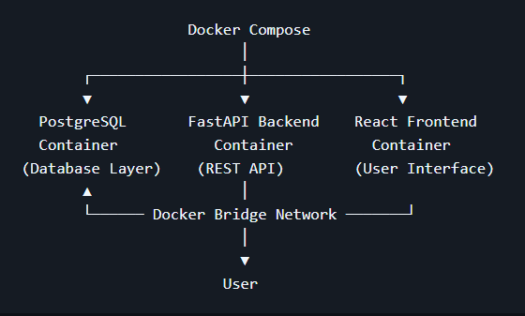

Docker Containers
Container | Purpose
PostgreSQL | Stores the game database and is automatically initialized using the provided SQL dump.
FastAPI Backend | Processes recommendation requests, communicates with PostgreSQL, and returns API responses.
React Frontend | Provides the user interface for selecting preferences and displaying recommendations.
Container Communication
The containers communicate through the Docker bridge network created by Docker Compose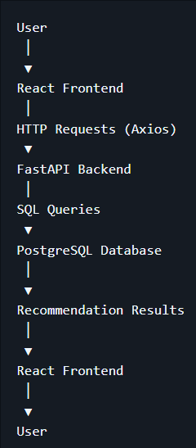
Docker Workflow
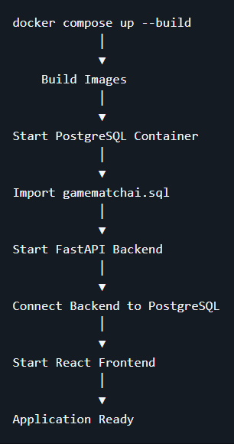

Advantages of Using Docker
- Runs the application in a consistent environment.
- Keeps the frontend, backend, and database isolated in separate containers.
- Simplifies project setup with a single docker compose up --build command.
- Reduces dependency and version conflicts across different operating systems.
- Makes the project easier to deploy and share.

12. Future Scope
Although GameMatch AI meets the current project requirements, there are several opportunities for future improvement:
- Machine Learning Integration – Enhance the recommendation engine using machine learning for more personalized recommendations.
- Similar Game Search – Allow users to search for a game and receive recommendations for similar games.
- Larger Game Database – Import more games from the RAWG API to increase the variety of recommendations.
- Store Links and Prices – Display direct links to digital stores along with game prices and discounts.
- Additional Game Information – Include trailers, screenshots, descriptions, developers, publishers, and system requirements.
- Improved UI/UX – Enhance the interface with better navigation, animations, themes, and interactive features.
- More Search Filters – Add filters such as ESRB rating, multiplayer support, developer, publisher, and supported languages.
- Performance Optimization – Improve database queries and recommendation performance as the dataset grows.

14. Data Source
GameMatch AI uses the RAWG Video Games Database API as the source of game data.
The ETL pipeline retrieves publicly available information such as game titles, genres, platforms, tags, stores, ratings, release dates, playtime, and screenshots. The extracted data is then transformed and stored in a local PostgreSQL database.
After the ETL process is completed, the application generates all recommendations using the local database without making external API calls during runtime.
Source: https://rawg.io/apidocs

13. Conclusion
GameMatch AI is a full-stack video game recommendation system that combines data engineering, backend development, database management, frontend development, and containerization into a single application.
The project uses an ETL pipeline to collect game data from the RAWG Video Games Database API, transforms and stores the data in a normalized PostgreSQL database, and generates personalized recommendations using a custom weighted scoring algorithm. The React frontend provides a simple and interactive interface through which users can select their preferences and view recommendation results.
The application is fully containerized using Docker, allowing the frontend, backend, and database to run together in a consistent environment with minimal setup.
This project provided practical experience in designing REST APIs with FastAPI, working with relational databases, implementing an ETL pipeline, building reusable React components, integrating multiple technologies, and managing the complete software development workflow from data collection to deployment.
The modular architecture also allows the project to be extended in the future by adding new recommendation techniques, additional filters, more game data, and enhanced user interface features.



