Garbage Collection:

Garbage collection in Java is a process that occurs automatically for memory management.

When Java programs run on the JVM, objects are created on the heap, which is a portion

of memory dedicated to the program. Eventually, some objects will no longer be needed.

The garbage collector finds these unused objects and deletes them to free up memory.

By default heap memory is 256 mb.

The finalize() method is invoked each time before the object is garbage collected.

This method can be used to perform cleanup processing.

This method is defined in Object class as:

protected void finalize() throws Throwable{}

The Garbage collector of JVM collects only those objects that are created by new keyword.

So if you have created any object without new, you can use finalize method to perform cleanup

processing (destroying remaining objects).

The gc() method is used to invoke the garbage collector to perform cleanup processing.

The gc() is found in System and Runtime classes.

Example : System.gc();

It’s important to note that Neither finalization nor garbage collection is guaranteed..

There are 2 types of Garbage Collection activity that usually happen in Java:

Minor or incremental Garbage Collection. Occurs in young generation

Major or Full Garbage Collection. Occurs in the Old generation.

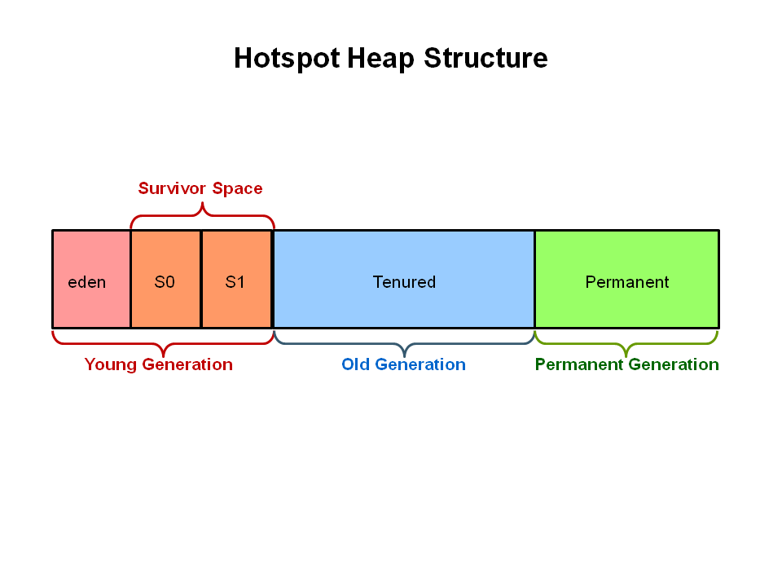

Any new objects are allocated to the eden space. When the eden space fills up,

a minor garbage collection is triggered.

Referenced objects are moved to the first survivor space.

Unreferenced objects are deleted when the eden space is cleared.

This cycle is repeated and this time if there are objects in survivor space, it will move to the next

survivor space. Once all surviving objects have been moved to S1, both S0 and eden are cleared. Again the cycle repeats but this time the survivor spaces switch. Referenced objects are moved to S0. Surviving objects are aged. Eden and S1 are cleared.

When aged objects reach a certain age threshold, they are promoted from young generation to old generation