***AGROVISION***

***A plant disease classifier***

Submitted for

Artificial Intelligence and Machine Learning CSET301

Submitted by:

E23CSEU1545 ANSHIKA AGRAWAL

E23CSEU1543 AMAN RAI

E23CSEU1536 VAIBHAV TIWARI

Submitted to:

DR. YAJNASENI DASH

School of Computer Science and Engineering

***Index***

|  |  |
| --- | --- |
| *Sr.No* | Content |
| *1.* | *Abstract* |
| *2.* | *Introduction* |
| *3.* | *Related Work* |
| *4.* | *Methodology* |
| *5.* | *Hardware/Software Required* |
| *6.* | *Experimental Results* |
| *7.* | *Conclusions* |
| *8.*  *9.* | *Future Scope*  *Github Link of project* |

1. ***Abstract***

Plant diseases can significantly impact agricultural productivity and food security. Early detection and accurate classification of these diseases are crucial for effective crop management. This project presents a deep learning-based approach for detecting plant diseases from leaf images using Convolutional Neural Networks (CNNs) built with the PyTorch framework. The model is trained on the PlantVillage dataset and is capable of classifying leaf images into 39 different disease categories. A user-friendly web interface is deployed using Flask to enable easy accessibility and testing of the model.

1. ***Introduction***

Agriculture is the backbone of many economies, particularly in developing countries, where a significant portion of the population relies on farming for livelihood. One of the major challenges faced by farmers is the timely and accurate identification of plant diseases, which, if left undetected, can lead to severe crop loss and reduced agricultural productivity. Traditionally, disease detection has relied on manual observation and expert knowledge, which can be time-consuming, inconsistent, and inaccessible in remote areas.

The rise of artificial intelligence and deep learning has provided new ways to automate and improve the accuracy of disease detection in plants. This project aims to provide a deep learning solution using CNNs to classify plant diseases efficiently and accurately.

1. ***Related Work***

Several researchers have utilized machine learning and deep learning techniques for plant disease detection. Traditional methods employed SVMs, KNN, and decision trees on handcrafted features. However, these methods lacked scalability and performance. Recent work has shown that CNNs outperform traditional approaches by automatically learning complex features directly from images. The PlantVillage dataset has been widely adopted in many similar projects for benchmarking purposes.

1. ***Methodology***

The proposed system uses the following steps:

1. **Dataset**: We used the publicly available PlantVillage dataset containing over 50,000 labeled leaf images across 39 disease categories.
2. **Preprocessing:** Images were resized and normalized for uniformity.
3. **Model Architecture**: A CNN model was implemented in PyTorch with multiple convolutional, ReLU, pooling, and fully connected layers.
4. **Training:** The model was trained on GPU using cross-entropy loss and Adam optimizer.
5. **Deployment:** A Flask web application was built for users to upload leaf images and get real-time predictions using the trained model.
6. **Testing:** Sample test images were used to evaluate the accuracy and reliability of the model.
7. ***Hardware/Software Required***

**Hardware -**

* GPU-enabled Machine (Optional but recommended)
* Minimum 8GB RAM
* i5/i7 Processor

**Software -**

* Python 3.8
* PyTorch
* Flask
* Jupyter Notebook
* Virtual Environment
* Required Python libraries (listed in requirements.txt)

1. ***Experimental Results***

* The model achieved high accuracy on the test dataset, demonstrating strong generalization capability.
* The classification was tested on multiple unseen leaf images, and results were consistent with labeled categories.
* The Flask app provides a smooth and user-friendly interface for model interaction.
* Sample output results confirmed that the model can correctly identify disease categories with high confidence.

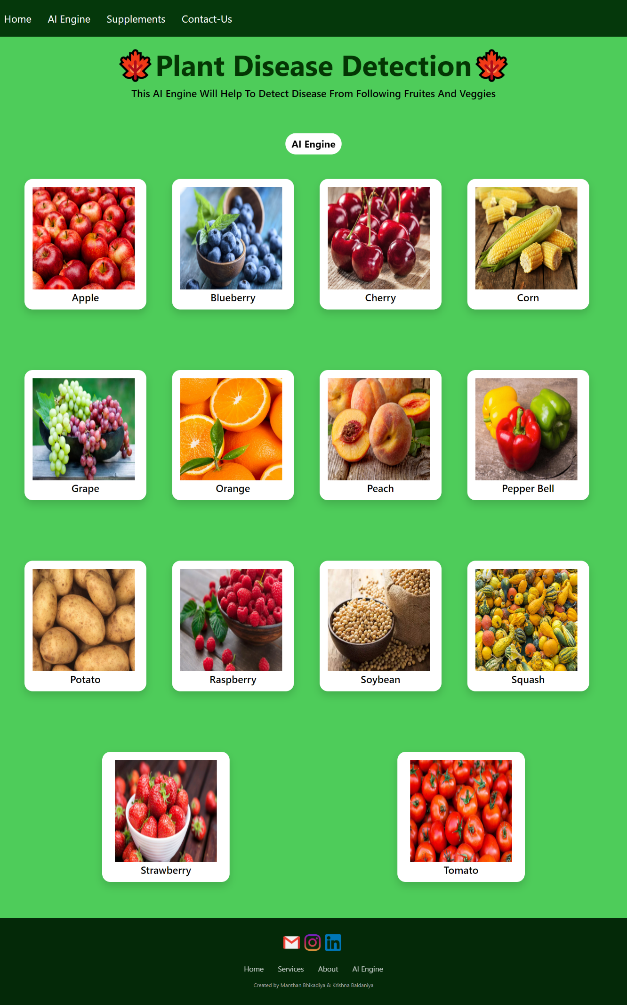

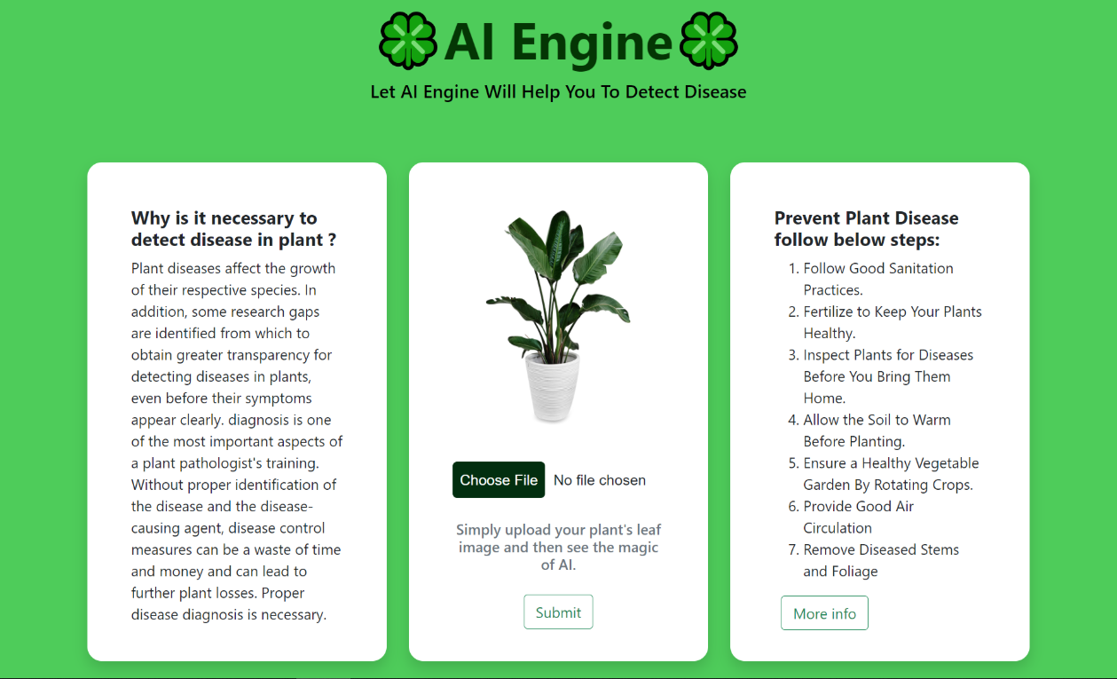

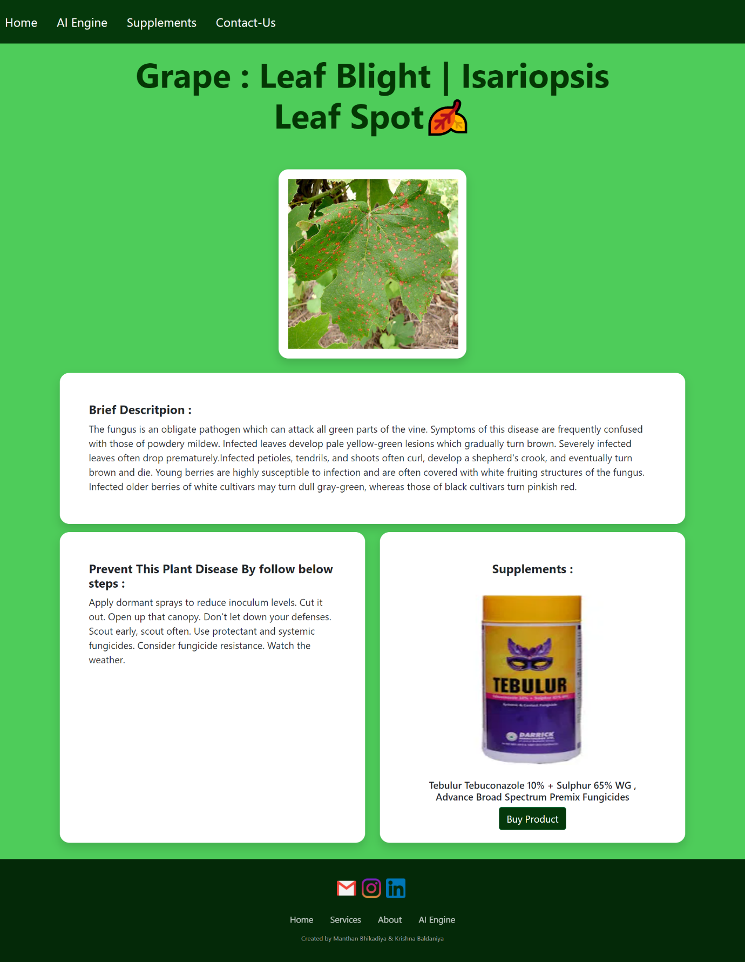

1. ***Conclusions***

This project effectively demonstrates the application of deep learning for plant disease detection using CNNs. The model, trained on the PlantVillage dataset, accurately classifies leaf images into 39 disease categories. With a simple Flask-based interface, the system is easy to use and accessible to farmers and researchers alike. It reduces dependency on manual disease identification and promotes early diagnosis. The open-source nature allows continuous improvements and collaboration. Overall, it bridges the gap between AI technology and practical agricultural solutions.

1. ***Future Scope***

* Improve the model accuracy by experimenting with more advanced architectures like ResNet, EfficientNet, etc.
* Enhance the user interface to be more interactive and mobile-friendly.
* Integrate with real-time mobile applications for field use.
* Include more plant species and disease categories.
* Add multilingual support for better accessibility to farmers in different regions.
* Develop an alert and treatment recommendation system based on disease predictions.

1. ***GitHub Link of Project***

<https://github.com/AmanRai-2702/plant_disease_detection_system.git>