**Preliminary Application for the Japanese Government (MEXT) Scholarship**

**Research Students 2026**

**Read the instructions carefully before proceeding to fill out the form:**

1. **Application submission is by email at [scholarship-india@nd.mofa.go.jp](mailto:scholarship-india@nd.mofa.go.jp) in MS Word format only (file size should not exceed 1 MB). Any other format or sending by other medium may lead to rejection of the application.**
2. **The application screening will be based on the information below and the Research Plan. If your Field of Study and/or Research Plan are blank, then your application will not be processed. This rule applies to Master’s Courses as well.**
3. **If your Research plan exceeds two pages, you may add another 1 or 2 pages.**
4. **The guidelines on the embassy’s webpage are for reference and information, until the first screening. Documents mentioned in the guidelines will be required only for shortlisted candidates who will be called for written tests and interviews. Therefore, please do not attach or insert any other documents mentioned in the guidelines in this preliminary application.**
5. **We expect you to be able to fill out the form to the best of your understanding. Avoid contacting the embassy unnecessarily for insignificant matters.**
6. **In principle, the university preference you furnished here must remain the same, and changes will not be allowed in future. Therefore, thorough research on Japanese Professors/Universities is advised before filling out the information. Please note that there is no need to contact the Japanese professors at this stage.**
7. **If the photograph is missing, the application will not be processed.**

|  |  |  |
| --- | --- | --- |
| Field of Study: | [Please refer to the field of study column in Embassy’s webpage and choose one from the 20 field of studies. If the field of study is not from the list, the application may get disqualified] | (insert a passport size photograph here. The file size should not exceed 20kb) |
| Course Applied | **Master**  (Choose one and delete the remaining) |
| Name | **AMAN RAJ** |
| Date of Birth (DD/MM/YYYY) | 10/11/2001 |
| Age (on April 1, 2026) | 24 YEAR 4 MONTH |
| Current Address (Do not omit city name.) | SANICHRA ASTHAN, BRAHMPURA, MUZAFFARPUR, BIHAR, PIN-842003 |
| Contact No. (write only one, if it is more than one, mention it as alternative no.): | +91-9973444173 |
| Email id (write only one): | AMANRAJKUMAR124@GMAIL.COM |

**Educational Qualification:**

|  |  |  |  |
| --- | --- | --- | --- |
|  | School/Board/College/University  along with name of the institution and place/city | Year of Passing | Percentage only* |
| 10th Grade | INDRAPRASTHA INTERNATIONAL SCHOOL, C.B.S.E, MUZAFFARPUR | 2016 | 89.3 % |
| 12th Grade | N.K.S.M COLLEGE, B.S.E.B, MUZAFFARPUR | 2019 | 78 % |
| Bachelor Degree  (Please specify) | SHYAL LAL COLLEGE, UNIVERSITY OF DELHI | 2022 | 77.44 % |
| Master Degree  (Please Specify) |  |  |  |
| M.Phil./Ph.D. |  |  |  |
| Any other national exam like NET/GATE/GPAT etc  (Relevant certificate must be pasted at the end of this form and keep in mind the size of the whole document) |  |  |  |

*\*Those who have CGPA score must convert grade into percentage according to the respective university’s formula/guidelines.*

*\* if you are currently pursuing a course, then write marks until your last semester/year.*

**Employment Record (please begin with your current job and add rows if required)**

|  |  |  |  |
| --- | --- | --- | --- |
| Name and location of the organization | Period of  Employment | Position | Type of work |
| NEURAPSES TECHNOLOGIES | 23 AUGUST 2022 - CURRENT | SOFTWARE ENGINEER | FULL-TIME, FULL STACK DEVELOPMENT |
|  |  |  |  |
|  |  |  |  |

* *Only mention full time job/s, Research Assistant/Internships etc. will not be counted as employment record*

Please mention if you have qualified any of the following along with the respective score and year of qualifying:

1) TOFEL/ IELTS

2) GRE

List of Award/Certificate/Medal, if any (give specific details)

1. State level award:
2. National level award
3. International level award

|  |
| --- |
| **Publication Details (in the given format):**   1. Research article/Review/book chapter, etc.:   Title:  Journal Name:  Authors (in the same order they appear in publication)  Year/Vol/Page  DOI no. (or direct link to webpage) (mandatory):  Impact factor, if any (only Clarivate Analytics impact factor):  Publisher: |
| Master Thesis details:  Title:  Area of research:  Supervisor name:  Abstract:  Name of publication out of master thesis, if any: |

専攻分野及び研究計画

Field of Study and Research Plan

Name (in alphabet)

(氏名(ｱﾙﾌｧﾍﾞｯﾄ)) _______RAJ______________, __________AMAN_______________ _____________________

(Surname) (Given name) (Middle name)

Nationality

（国 籍）__________INDIAN____________________________________________________________________

≪Guide for Creating a Field of Study and Research Plan Sheet/作成要領≫

(1) As this sheet is one of the most important references for selection and university placement, outline your field of study and specify your research theme and plan in line with the following items 1 and 2. If plagiarism or fraud is discovered after selection, the selection will be cancelled retroactively.

本様式は選考及び大学配置の重要な参考となるので、下記の項目1 及び2 に沿って専攻分野の概要及び研究計画の詳細を具体的 に記入すること。なお、採用後に不正、盗用等が判明した場合は遡って採用を取り消す。

(2) This sheet must be typewritten or written in block letters. If possible, please write in Japanese.

記入はタイプ又は楷書によるものとする。相当の日本語能力を有する者は日本語により記入すること。

(3) This sheet must be created within two pages. Additional materials may be attached if necessary. Both a single-side and dual-side printing will be acceptable.

本様式は２ページ以内で作成すること。ただし必要な場合は別紙を付してもよい。印刷は片面印刷、両面印刷のどちらも可。

1. Past and present field of study（これまでの専攻分野）

I studied Physical Sciences with Computer Science at the University of Delhi, Shyam Lal College, where I gained a foundation in programming, algorithms, and system design. After graduation, I enrolled in a professional MERN stack course at Webskitter Academy to deepen my skills in full stack web development.

Currently, I am working as a Software Engineer at Neurapses Technologies, where I develop full-stack applications and APIs, Alongside my job, I have been indepently studying about Blockchain and AI technologies, focusing on their applications in building transparent and efficient governance systems -an are where I now aim to explore further graduate research.

2. Research theme and plan in Japan（渡日後の研究テーマ及び研究計画）

Describe articulately the research theme and plan you wish to carry out in Japan. Specify particularly the ultimate goal(s) of your research in Japan.（日本において希望する研究テーマ及び研究計画を明確に記入すること。特に研究の最終目標を具体的に記入すること。）

**(1) Research theme（研究テーマ）**

**Designing AI-Powered Governance Tools for Transparent Public Welfare: A Blockchain-Based Solution for India and Japan**

1. **Research plan（研究計画）**

This Research aim to create a smart digital platform that uses Artificial Intelligence (AI) and Blockchain to improve transparency, speed, and accountability in public welfare schemes. The system will help track the distribution of health benefits, disaster relief, educational funds and social program, ensuring that aid reaches to the right people.

* **Research Background and Purpose**

India and Japan both run several government welfare schemes in health insurance, disaster aid, education funding, to subsidies for the poor but both countries face challenges:

* **India** struggles with fund leakage, middlemen, delays, and fake benificiaries.
* **Japan** faces issues in maintaining public trust, disaster aid, and ensuring quick responses due to complex government processes.

With Growing populations and increasing demand for welfare support, governments need better tools for manage and monitor these schemes.

This research proposes a digital solutions using **AI for real-time data insights and Blockchain for transparency and immutability.** The platform will help governments monitor who gets what, when and where with full tracebility and fraud prevention. This will trust in governance, reduce waste and allow smarter policy decisions.

* **Research Plan and Methodology**
* **Year 1 : System Design and Sector Study**

Month 1-3: Research Phase

* Analyze existing welfare systems in India and Japan (e.g-Japan’Kokumin Kenko Hoken, Ayushman Bharat, PM-Kisan).
* Identify pain points in fund distributions, verification, and handling citizen complaints.
* Study global models like Estonia’s e-governance and Ukraine’s Diia app.

Month 4-6: Architecture Planning

* Choose Blockchainn Framework (Hyperleadger, Ethereum, or Polygon)
* Define components: Smart Contracts, AI models, User Interfaces
* Plan separate modules for Health, Disaster Relief, Education, and Social Aid

Month 7-12: Prototype Design

* Use MERN stack to build the intial version of the platform.
* Develop an AI-based system to detect irregularities, identify duplicate claims, and predicting resource needs
* Design smart contract to auto trigger fund releases and alerts
* **Year 2 : System Design and Sector Study**

Month 13-16: Research Phase

* **Health Module** : Track claims, hospital visits, and approvals using blockchain.
* **Relief Module** : Use AI to detect fraud in disaster relief fund and identify high-risk zones using geospatial data.
* **Education & Fund Module** : Track Scholarship payments and predict dropouts using AI

Month 17-20: Simulations and Feedback

* Run case simmulations using dummy data.
* Collect feedback from professors, local agencies, and community orgs.

Month 21-24: Documentation and Thesis

* Finalize research results.
* Publish findings and propose implementation plan for pilot in select districts.

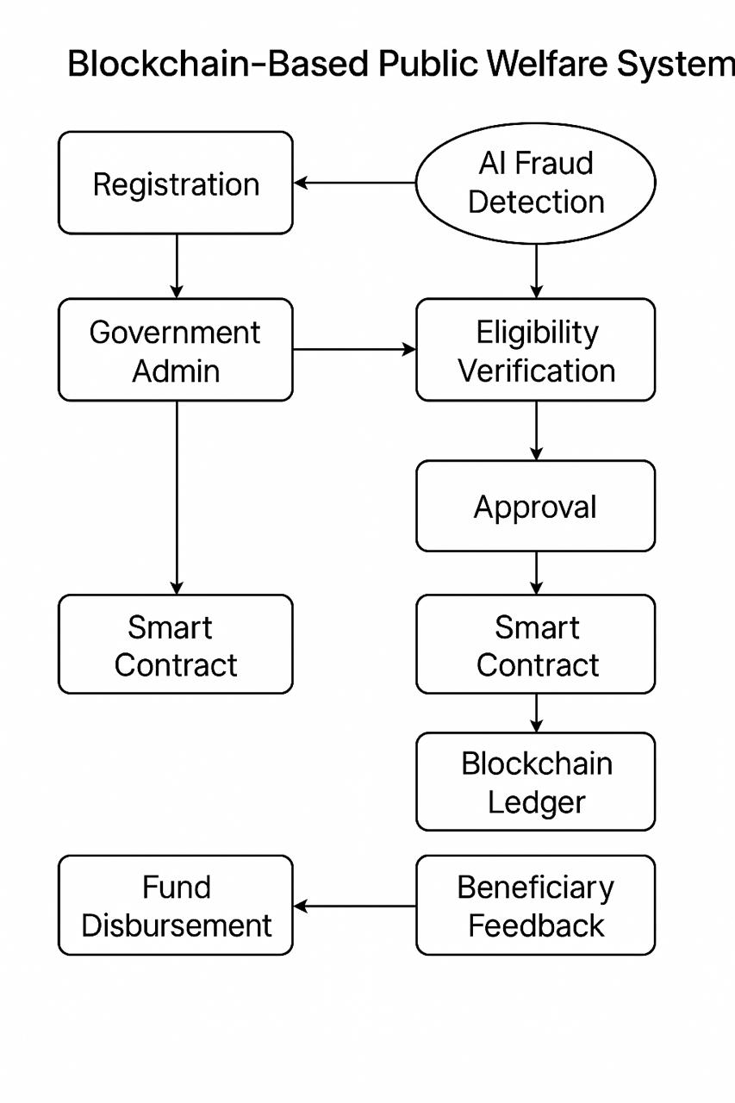

* **Expected Outcomes And Applications**
* A Multi-sector, Modular AI + Blockchain platform for public welfare.
* Real-time dahboards for government officers and citizens.
* Improved transparency in fund distributions.
* Early detections of fraud and misuse.
* Data-driven planning for better governance policies.
* **Use Cases**
* In **Japan**, it could boost public trust in disaster aid and automate many manual steps in claim processing.
* In **India**, this could stop ghost beneficiaries, reduce delays, and improve rural service delivery.
* **Why I Want to Study in Japan**

Japan is leader in digital governance and social innovation, with rich experience in disaster management and public health. Studying in Japan will give me access to real-world problems and working systems, so I can understand both strengths and limitations of current approaches.

Japan also value precision, long-term planning, and citizen-focused design -things I want to learn and apply to future governance solutions in India. The Strong academic environment and openness to innovation make japan the perfect place to pursue this research.

* **Future Goals**

After completing this research, I plan to work with government departments, think tanks, and digital policy groups to build real tools for national welfare platforms in India and Japan. I also want to continue researching how technology can strengthen democracy , reduce inequality, and make public services more transparent and fair.

Ultimately, I hope to contribute to build the next generation of digital infrastructure for governance driven by ethics, inclusivity and innovation.

**Placement Preference Application Form (Preliminary Application Form)**

|  |  |  |  |
| --- | --- | --- | --- |
| Preference | Name of University | Name of Graduate School | Name of Professor |
| First choice |  |  |  |
| Second choice |  |  |  |
| Third choice |  |  |  |