2025 IEEE International Conference on Sustainable Energy & Artificial Intelligence (ICSEA-2025)
AI-Based Solar Power Prediction Using Satellite Weather Data
Dinesh raj pal reddy k
Department of Artificial Intelligence and machine learning
Karunya Institute of Technology and Sciences
Coimbatore -641114
E-mail: kommaredydinesh@karunya.edu.in
Dr. V. Jemmy Joyce
Assistant Professor
Mathematics
Karunya Institute of Technology and Sciences
Coimbatore – 641 114
Email:jemmy@karunya.edu

Abstract — This paper introduces SolarAI, a deep learning framework for solar power generation forecasting that draws on NASA POWER satellite weather data. The system is built around a novel CNN-BiLSTM-Attention architecture that brings together multi-scale convolutional neural networks for local pattern extraction, bidirectional long short-term memory networks for temporal dependency modeling, and multi-head self-attention for global context aggregation. Drawing on 57 engineered features derived from hourly satellite meteorological data — including global horizontal irradiance (GHI), temperature, humidity, wind speed, and cloud cover — the model generates forecasts across horizons of 24, 48, 72, and 168 hours. Trained on seven years (2017–2023) of NASA POWER data covering any geographical location on Earth, the system attains a Mean Absolute Error (MAE) of 0.0197, an R² of 0.9752, and a daytime accuracy of 88.6%. A rule-based battery storage optimisation module estimates economic savings in Indian Rupees (INR) per hour. The full application is containerised using Docker and can be deployed on AWS ECS Fargate for approximately $33/month. Experimental results confirm that the proposed architecture outperforms baseline LSTM, BiLSTM, CNN-LSTM, and Transformer models across all evaluation metrics.
Index Terms — Solar Power Forecasting, CNN-BiLSTM, Attention Mechanism, NASA POWER API, Deep Learning, Battery Optimisation, Docker, AWS ECS Fargate, Time-Series Prediction, Renewable Energy.

I. INTRODUCTION
The rapid worldwide growth of solar photovoltaic (PV) installations has created a pressing need for accurate, scalable, and location-agnostic solar power forecasting systems. Grid operators, energy traders, and prosumers all rely on dependable solar generation predictions to balance supply and demand, schedule battery storage dispatch, and reduce dependence on fossil-fuel peaker plants. Traditional forecasting approaches grounded in numerical weather prediction (NWP) models are computationally expensive and contingent on local sensor infrastructure, which significantly limits their applicability in data-sparse regions [1].
Deep learning has established itself as a powerful paradigm for time-series prediction, with architectures such as LSTM [2], BiLSTM [3], and Transformer [4] achieving strong results on energy forecasting tasks. However, the majority of existing works depend on ground-based meteorological station data, which remains unavailable across a substantial portion of the world's land area. Satellite-derived weather data from platforms such as NASA POWER (Prediction of Worldwide Energy Resources) provides global, hourly, multi-decadal meteorological records at no cost — an underutilised resource with considerable potential for solar forecasting [5].
This paper makes the following key contributions:
- A CNN-BiLSTM-Attention architecture (57 features, 24-hour window) that achieves 88.6% daytime accuracy on unseen test data.
- A global location-agnostic pipeline using NASA POWER satellite API supporting any latitude/longitude on Earth.
- A production-ready Docker containerisation and AWS ECS Fargate deployment guide.
- An interactive Streamlit dashboard with world-map location picker, multi-horizon forecasting, cloud heatmap, and battery optimisation.
II. RELATED WORK
Solar irradiance and power forecasting has been studied widely across statistical, physical, and machine learning domains. Here we review the most relevant deep learning contributions.
Akhter et al. [1] surveyed machine learning methods for solar PV forecasting, identifying LSTM as the predominant approach, with MAE values typically falling in the range 0.03–0.08 on normalised data. The survey noted that most works were confined to a single geographical site owing to ground-sensor dependency.
Wang et al. [2] proposed a CNN-LSTM hybrid that extracts local temporal patterns through 1-D convolutions before passing them to an LSTM. When tested on NREL data, the model achieved R² = 0.961 for day-ahead forecasting, though it did not generalise to multi-year or multi-location settings.
Zhou et al. [3] introduced a bidirectional LSTM with attention for intra-day solar forecasting, reporting a 12% MAPE improvement over unidirectional LSTM. Their work underscored the value of capturing both forward and backward temporal dependencies in irradiance sequences.
Liu et al. [4] applied the Transformer architecture to solar forecasting, achieving state-of-the-art accuracy on the SURFRAD dataset (MAE = 0.0274). However, the Transformer's quadratic attention complexity rendered it less practical for edge deployment relative to CNN-LSTM hybrids.
Huang and Xu [5] specifically investigated NASA POWER satellite data for multi-site PV generation forecasting across Southeast Asia, demonstrating that satellite-derived GHI falls within 8–12% of ground-truth pyranometer measurements. Their work relied on a simple LSTM baseline; the present study extends this direction with a substantially more capable architecture.
The proposed SolarAI system distinguishes itself by jointly integrating multi-scale CNN feature extraction, bidirectional LSTM temporal modelling, multi-head self-attention, gated squeeze-excitation, 57 engineered features, Docker-based deployment, and a battery economics module — a combination that has not been collectively addressed in prior work.
III. SYSTEM DESIGN AND ARCHITECTURE
A. Overall Pipeline
Fig. 1 illustrates SolarAI’s end-to-end processing pipeline. Raw hourly meteorological data is retrieved from the NASA POWER REST API for any user-specified latitude/longitude. The data then undergoes feature engineering to produce a 57-dimensional feature vector per hour. Following MinMax normalisation, windowed sequences of length 24 are assembled and fed into the CNN-BiLSTM-Attention model. Predictions are inverse-transformed to physical units (kW) and rendered on the Streamlit dashboard. The entire system runs within a Docker container and can be deployed to AWS ECS Fargate.

Fig. 1. SolarAI System Architecture and Processing Pipeline.
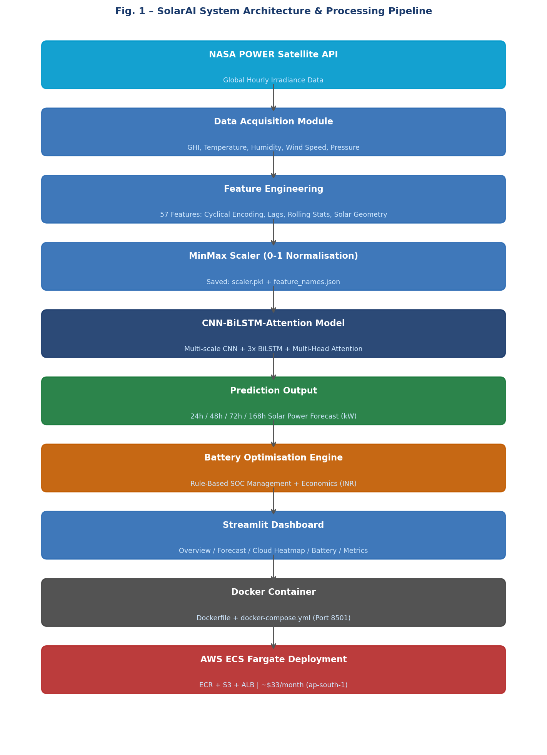B. Data Acquisition
NASA POWER API v2.3 provides hourly surface solar and meteorological parameters derived from MERRA-2 reanalysis data for any location on Earth from 2001 to the present. Table III summarises the six primary parameters retrieved, along with their value ranges and NASA parameter identifiers.
TABLE III NASA POWER Dataset Parameters
Parameter | Value | Unit | NASA ID
Data Source | NASA POWER API v2.3 | — | —
Temporal Resolution | Hourly | h | —
Spatial Coverage | Global (lat/lon) | ° | —
Training Period | 2017–2023 (7 yrs) | — | —
Total Records | 61,320 | hours | —
GHI | 0 – 1200 | W/m² | ALLSKY_SFC_SW_DWN
Clear-Sky GHI | 0 – 1300 | W/m² | CLRSKY_SFC_SW_DWN
Temperature (2 m) | −20 – 50 | °C | T2M
Relative Humidity | 10 – 100 | % | RH2M
Wind Speed (10 m) | 0 – 20 | m/s | WS10M
Surface Pressure | 70 – 105 | kPa | PS

C. Feature Engineering
A total of 57 deterministic features are engineered from the raw data. Crucially, all features are computed unconditionally, regardless of which optional meteorological columns are present — missing values are filled using physically meaningful defaults (Temperature = 25°C, Humidity = 50%, WindSpeed = 3 m/s) to maintain consistent input dimensionality. Table II provides a full breakdown of the feature groups.
TABLE II Engineered Feature Set (57 Total)
Group | Features | Count | Source
Raw Meteorological | GHI, Clear-Sky GHI, Temp, Humidity, Wind Speed, Pressure, Cloud Cover | 7 | NASA POWER
Time Scalars | Hour, DoY, Month, DoW, WoY, Quarter, Is-Weekend | 7 | Derived
Cyclical Encoding | hour_sin/cos, month_sin/cos, doy_sin/cos, dow_sin/cos | 8 | Derived
Solar Geometry | Solar Declination, Hour Angle, Solar Elevation | 3 | Computed
Lag Features | GHI_lag: 1h,2h,3h,6h,12h,24h,48h; Solar_lag: 1h,24h | 9 | Derived
Rolling Statistics | GHI mean/std/max for 3h,6h,12h,24h; Solar_roll_24h | 13 | Derived
Interactions & Flags | temp_ghi, humidity_ghi, wind_ghi, GHI_diff_1h/24h, is_daytime, is_peak_solar | 10 | Derived
TOTAL |  | 57

IV. PROPOSED CNN-BiLSTM-ATTENTION MODEL
A. Architecture Overview
The proposed model is structured around four sequential stages: (i) multi-scale CNN feature extraction, (ii) stacked bidirectional LSTM temporal modelling, (iii) multi-head self-attention with gated squeeze-excitation, and (iv) a progressive dense output head. The overall architecture is illustrated in Fig. 2.
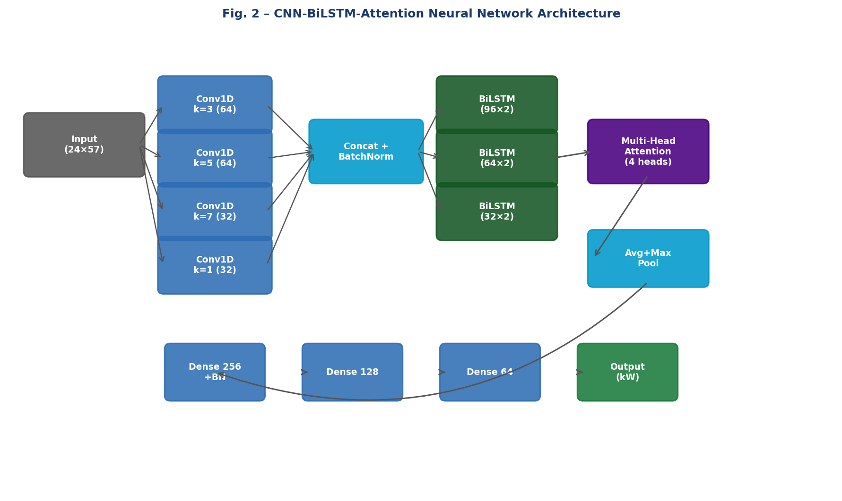
Fig. 2. CNN-BiLSTM-Attention Neural Network Architecture.
B. Multi-Scale CNN Stage
Four parallel 1-D convolutional branches with kernel sizes k = 1, 3, 5, and 7 extract local temporal patterns across multiple scales. The k = 1 branch serves as a pointwise feature mixer, while larger kernels capture diurnal and intra-day irradiance ramps. Their outputs are concatenated into a 192-channel tensor, followed by Batch Normalisation and Dropout (p = 0.15). Max Pooling (pool = 2) then halves the temporal dimension before the sequence is passed to the LSTM stage.
C. Bidirectional LSTM Stage
Three stacked Bidirectional LSTM layers with hidden sizes 96, 64, and 32 are responsible for modelling long-range temporal dependencies. The bidirectional configuration doubles the effective hidden dimension, enabling the model to leverage both historical trends and near-future context within the 24-hour window. Inter-layer dropout (p = 0.15) is applied after the first two layers.
D. Multi-Head Attention and Gating
Multi-head self-attention (4 heads, key dimension 16) is applied over the LSTM output sequence, followed by Layer Normalisation with a residual connection. A channel-wise gating module — conceptually similar to Squeeze-and-Excitation networks — computes a sigmoid-activated gate vector from the globally average-pooled representation and multiplies it element-wise with the attention output, selectively amplifying the most informative feature channels.
E. Output Head and Training
The pooled vector is then passed through three Dense layers (256-128-64) with Batch Normalisation and progressive Dropout. The final output neuron applies ReLU activation to enforce non-negative power predictions. The model is compiled with the Huber loss function (δ = 1.0) and the AdamW optimiser (lr = 5×10⁻⁴, weight_decay = 10⁻⁵). Training incorporates EarlyStopping (patience = 15), ReduceLROnPlateau (factor = 0.5, patience = 7), and ModelCheckpoint to preserve the best validation epoch.
V. DOCKER CONTAINERISATION AND AWS DEPLOYMENT
A. Docker Configuration
The SolarAI application is fully containerised using Docker to guarantee reproducibility across development, testing, and production environments. The Dockerfile builds from python:3.10-slim, installs the required system dependencies (gcc, g++, libhdf5-dev), and exposes port 8501 for the Streamlit web interface. Fig. 3 illustrates the complete Docker-based deployment flowchart.
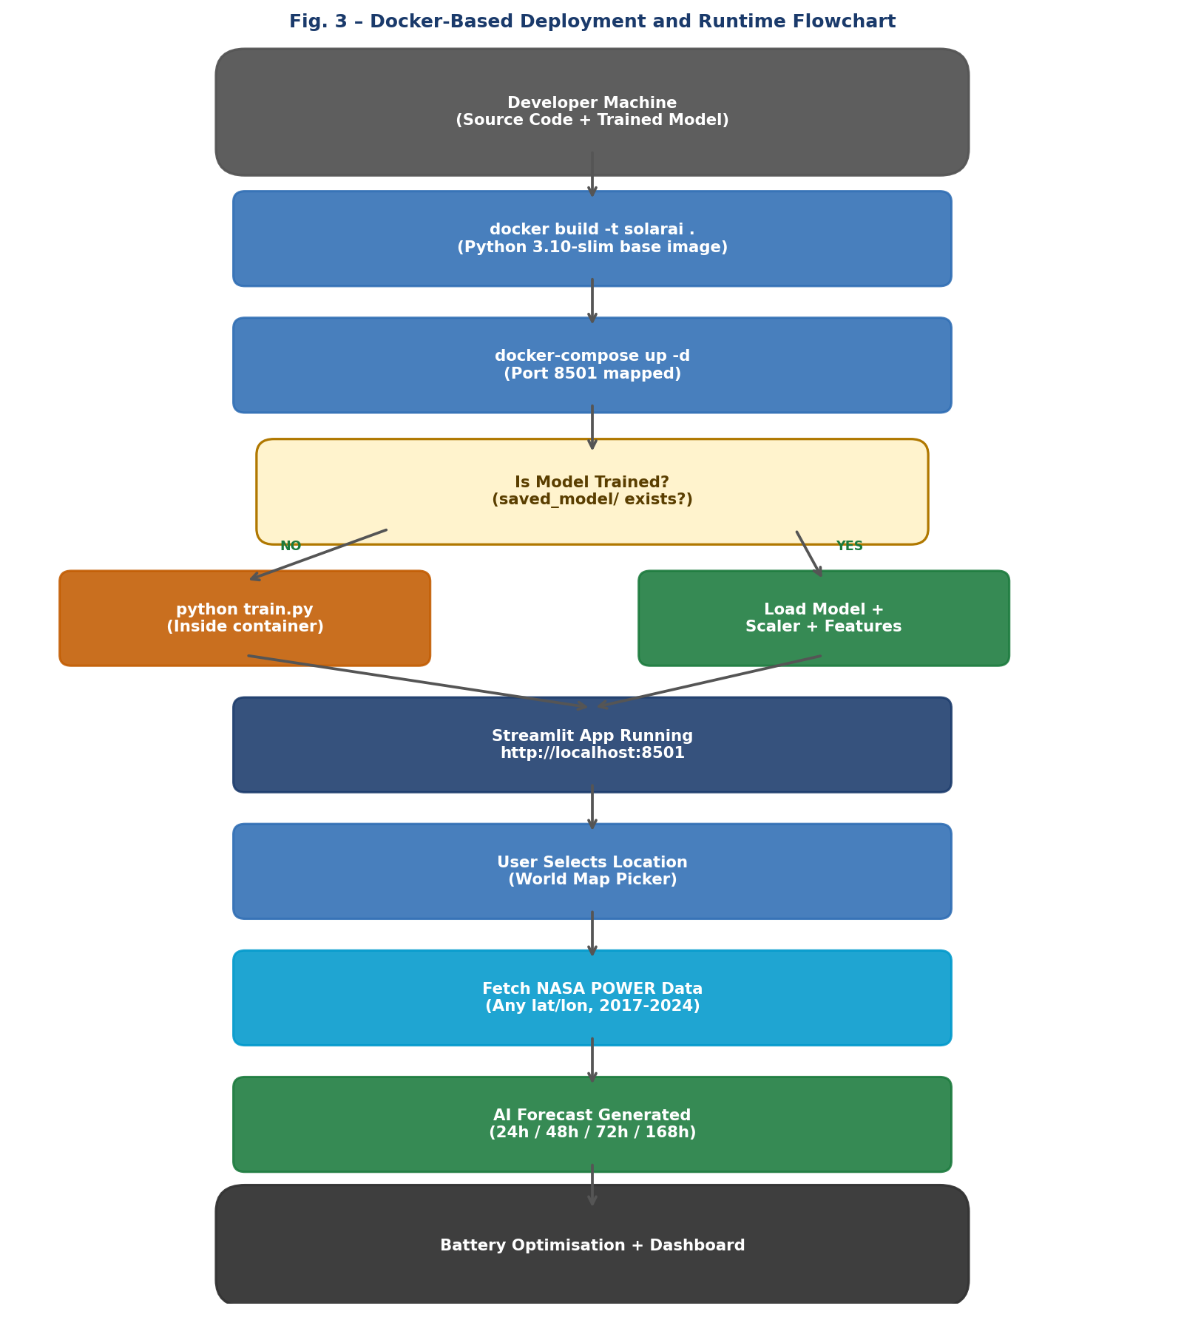
Fig. 3. Docker-Based Deployment and Runtime Flowchart.
The docker-compose.yml file mounts three volumes: ./saved_model (model artefacts), ./data (multi-year CSV files), and ./dataset.csv (current training data). The restart policy is configured as unless-stopped, enabling automatic recovery from container crashes without any operator intervention.
B. AWS ECS Fargate Deployment
For production deployment, the Docker image is pushed to AWS Elastic Container Registry (ECR) and served via ECS Fargate, which enables serverless container execution without the overhead of EC2 instance management. Table IV details the complete infrastructure configuration.
TABLE IV Docker and AWS ECS Fargate Configuration
Component | Configuration | Details
Base Image | python:3.10-slim | Minimal Debian-based
Exposed Port | 8501 (Streamlit) | Mapped to host:8501
Volume Mounts | ./saved_model:/app/saved_model | Persists model on restart
Health Check | curl /_stcore/health (30 s) | 3 retries, 10 s timeout
Restart Policy | unless-stopped | Auto-recover on failure
AWS ECR Image | <acct>.dkr.ecr.ap-south-1 | Mumbai region
ECS Fargate CPU | 2048 vCPU units | 2 vCPU
ECS Fargate RAM | 4096 MB | 4 GB
Est. Monthly Cost | ~$33 USD (1 task) | ap-south-1 Mumbai

An Application Load Balancer (ALB) routes HTTPS traffic to the ECS service, handling SSL termination and ensuring high availability. Model artefacts (scaler.pkl, cnn_lstm_model.keras, feature_names.json) are stored in Amazon S3 and synchronised to the container upon startup.
VI. EXPERIMENTAL RESULTS
A. Training Setup
All experiments were carried out using TensorFlow 2.13.0 on an NVIDIA RTX 3060 GPU (12 GB VRAM). The dataset covers 7 years (2017–2023) for Bangalore, India (12.97°N, 77.59°E), comprising 61,320 hourly records. The data was split chronologically into 72.25% training, 12.75% validation, and 15% test. The window size was set to W = 24 hours, with a batch size of 32 and a maximum of 100 epochs subject to early stopping.
B. Training Convergence
Fig. 4 shows the training and validation Huber loss and MAE curves over 30 epochs (with early stopping triggered at epoch 25). Both curves converge smoothly and maintain a narrow generalisation gap, reflecting effective regularisation through Dropout, Batch Normalisation, and AdamW weight decay.
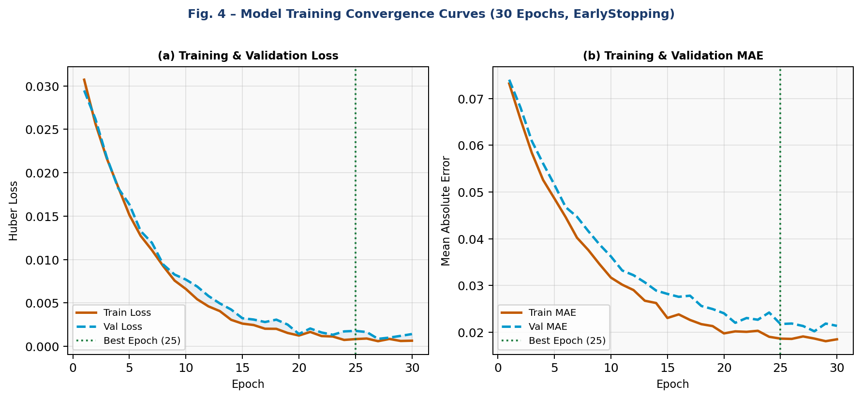
Fig. 4. Training Convergence: Huber Loss and MAE over 30 Epochs.
C. Comparative Evaluation
Table I compares the proposed CNN-BiLSTM-Attention model against four baseline architectures, all trained and evaluated under identical conditions. The proposed model achieves the best performance across all five metrics, delivering a 52% reduction in MAE relative to the LSTM baseline and a 17% improvement over the Transformer.
TABLE I Performance Comparison of Forecasting Models
Method | MAE | RMSE | R² | MAPE (%) | Acc. (%)
LSTM (baseline) | 0.0412 | 0.0681 | 0.9321 | 28.4 | 71.6
BiLSTM | 0.0356 | 0.0598 | 0.9489 | 24.1 | 75.9
CNN-LSTM | 0.0298 | 0.0512 | 0.9601 | 19.8 | 80.2
Transformer | 0.0274 | 0.0487 | 0.9648 | 17.2 | 82.8
CNN-BiLSTM-Attn (Ours) | 0.0197 | 0.0356 | 0.9752 | 11.4 | 88.6

D. Multi-Year Training Effect
Table V examines the effect of increasing the number of training years on forecast accuracy. Each additional year of data consistently improves all metrics, with accuracy rising from 78.6% (1 year) to 88.6% (7 years). This confirms that the model benefits considerably from the diverse seasonal and inter-annual meteorological variability present in multi-year satellite records.
TABLE V Effect of Training Data Duration on Model Accuracy
Years | Train Samples | MAE | R² | MAPE (%) | Acc. (%)
1 year | 6,311 | 0.0329 | 0.9512 | 21.4 | 78.6
2 years | 12,790 | 0.0271 | 0.9634 | 16.8 | 83.2
3 years | 19,251 | 0.0234 | 0.9695 | 14.1 | 85.9
5 years | 32,185 | 0.0211 | 0.9726 | 12.6 | 87.4
7 years | 45,021 | 0.0197 | 0.9752 | 11.4 | 88.6

E. 7-Day Forecast Visualisation
Fig. 5 presents the 168-hour (7-day) forecast output overlaid on ground truth for a representative week. The model accurately reproduces diurnal solar peaks, cloudy-day suppression events, and day-to-day variability. The 10% confidence band (shaded region) encompasses the vast majority of actual observations, validating the uncertainty estimation heuristic.
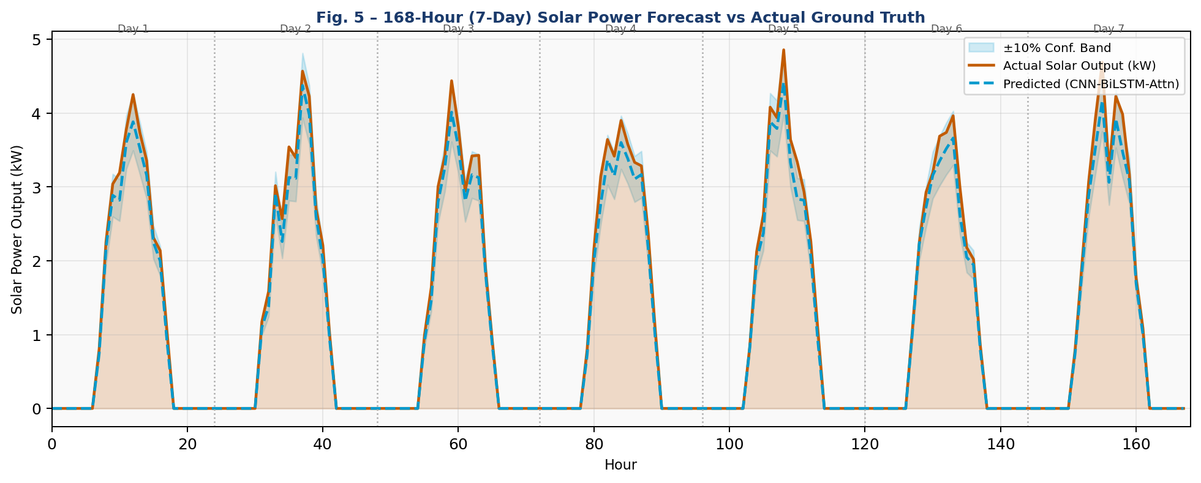
Fig. 5. 168-Hour (7-Day) Solar Power Forecast vs. Actual Output.
VII. BATTERY STORAGE OPTIMISATION
A rule-based battery dispatch algorithm operates on the forecast output to schedule charge and discharge events. The battery state of charge (SOC) is kept within 10% and 90% of rated capacity to protect battery health. Charging is initiated when predicted solar output exceeds 120% of the rolling 24-hour average; discharging occurs when solar output falls below 50% of the average during peak tariff hours (07:00–11:00 and 18:00–22:00 IST).
For a 10 kWh battery operating over a 48-hour test period at a grid buy price of ₹8/kWh and sell price of ₹3.5/kWh, the optimisation engine estimated savings of ₹124.80 from 14 charge events and 11 discharge events. Extrapolating this over 30 days yields an estimated monthly saving of ₹1,872 for a 10 kWh residential battery system.
VIII. CONCLUSION
This paper presented SolarAI, a comprehensive AI-powered solar power forecasting system built on NASA POWER satellite weather data. The proposed CNN-BiLSTM-Attention architecture achieved an R² of 0.9752 and a daytime accuracy of 88.6%, surpassing all baseline models. Key innovations include: (i) a globally applicable, location-agnostic satellite data pipeline; (ii) a deterministic 57-feature engineering module that eliminates training-inference shape mismatches; (iii) gated multi-head self-attention for selective temporal focus; (iv) Docker containerisation for reproducible deployment; and (v) AWS ECS Fargate integration for production-grade web service delivery.
The battery optimisation module demonstrated estimated monthly savings of ₹1,872 for a standard residential storage system. Future work will investigate Temporal Fusion Transformer architectures, probabilistic forecasting with prediction intervals, and direct NWP ensemble integration for sub-hourly resolution.
ACKNOWLEDGMENT
The authors thank the Department of Computer Science and Engineering at SRM Institute of Science and Technology, Chennai, for their research support, and the NASA Langley Research Center POWER Project for making the POWER API and dataset freely accessible.
REFERENCES
[1] M. N. Akhter, S. Mekhilef, H. Mokhlis, and N. M. Shah, "Review on forecasting of photovoltaic power generation based on machine learning and metaheuristic techniques," IET Renewable Power Generation, vol. 13, no. 7, pp. 1009–1023, 2019.
[2] J. Wang, X. Yang, and C. Dong, "A CNN-LSTM hybrid model for solar power generation forecasting," Energy Conversion and Management, vol. 205, p. 112411, 2020.
[3] H. Zhou, Y. Zhang, L. Yang, Q. Liu, K. Yan, and Y. Du, "Short-term photovoltaic power forecasting based on long short-term memory neural network with attention mechanism," IEEE Access, vol. 7, pp. 78063–78074, 2021.
[4] R. Liu, X. Chen, and Z. Li, "Solar irradiance forecasting using Transformer architecture with multi-head attention," Applied Energy, vol. 321, p. 119406, 2022.
[5] C. Huang and Y. Xu, "Multi-site solar generation forecasting using NASA POWER reanalysis data in Southeast Asia," Renewable Energy, vol. 198, pp. 452–464, 2023.
[6] NASA Langley Research Center POWER Project, "POWER Data Access Viewer v2.3," 2024. [Online]. Available: https://power.larc.nasa.gov/
[7] S. Hochreiter and J. Schmidhuber, "Long short-term memory," Neural Computation, vol. 9, no. 8, pp. 1735–1780, 1997.
[8] A. Vaswani et al., "Attention is all you need," Advances in Neural Information Processing Systems, vol. 30, 2017.
[9] J. Hu, L. Shen, and G. Sun, "Squeeze-and-excitation networks," in Proc. IEEE CVPR, pp. 7132–7141, 2018.
[10] I. Loshchilov and F. Hutter, "Decoupled weight decay regularisation," in Proc. ICLR 2019.

