Technical Documentation: Preprocessing Methodology
This document outlines the multi-stage preprocessing pipeline developed for the self-supervised lettuce disease segmentation system. Each step is designed to transform the raw RGB input into specialised representations that enhance the model's ability to localise and segment diseased regions accurately.

1. Original RGB Input
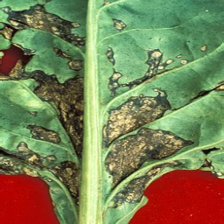
Description: The raw input image resized to 256x256 pixels.
Significance in Image Processing: Serves as the baseline visual representation, containing all spectral information available from the sensor.
Significance in Disease Region Capturing: Provides the primary context for the lesion, though raw images often suffer from lighting variations and low contrast in diseased spots.

2. Contrast Limited Adaptive Histogram Equalization (CLAHE)
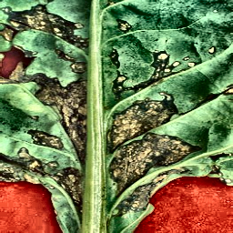
Description: The image after applying CLAHE in the LAB color space (L-channel).
Significance in Image Processing: Enhances local contrast by redistributing pixel intensities within small tiles, preventing over-amplification of noise while making details pop.
Significance in Disease Region Capturing: Critical for identifying "halo" effects or subtle color gradients at the edges of bacterial spots that might be washed out in standard RGB.

3. Excess Green Index (ExG)
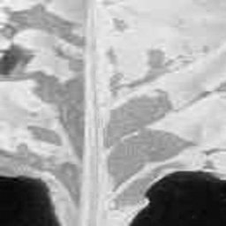
Description: A vegetation index map calculated as 2G - R - B.
Significance in Image Processing: Highlights chlorophyll-rich regions by emphasizing the green channel relative to red and blue.
Significance in Disease Region Capturing: Specifically useful for background subtraction and identifying necrotic (dead) tissue, which typically shows a sharp drop in ExG values compared to healthy green leaves.

4. Edge Detection (Sobel Gradient)
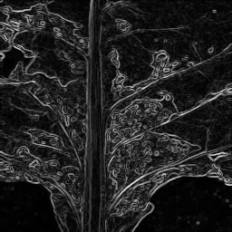
Description: A magnitude map of horizontal and vertical gradients.
Significance in Image Processing: Captures high-frequency spatial information, highlighting boundaries and texture transitions.
Significance in Disease Region Capturing: Diseased regions often have distinct, irregular boundaries. The edge map helps the model focus on these structural discontinuities during segmentation.

5. Felzenszwalb Superpixel Segmentation
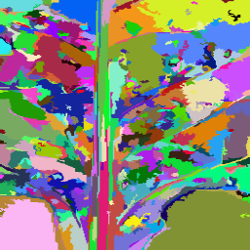
Description: A graph-based segmentation that groups pixels into homogeneous regions.
Significance in Image Processing: Reduces the complexity of the image from thousands of pixels to a few hundred "superpixels" that preserve boundary information.
Significance in Disease Region Capturing: Ensures that entire lesion areas are treated as cohesive units rather than isolated pixels, facilitating more consistent region-based localisation.

6. Watershed Segmentation
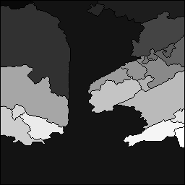
Description: A region-growing segmentation based on the distance transform and image gradients.
Significance in Image Processing: Treats the image as a topographic surface where boundaries are "ridges" between "catchment basins".
Significance in Disease Region Capturing: Excellent for separating overlapping leaves and localizing individual infection centers (foci) within a larger leaf area.

Conclusion
By stacking these 14 representations (RGB, CLAHE, Felz, Watershed, etc.), the system provides the neural network with a "multi-modal" view of the same leaf. This methodology significantly reduces the reliance on manual annotations by providing unsupervised structural and spectral priors that guide the anomaly localisation and pseudo-mask generation stages.

