Stage 2: Healthy-Only Representation Learning
Technical Deep Dive into Self-Supervised Feature Extraction and Statistical Modeling

1. Executive Summary
Stage 2 of the Lettuce Disease Segmentation pipeline focuses on learning a robust 'normality' model using self-supervised representations. By analysing only healthy lettuce leaves, the system builds a statistical 'Healthy Bank' that defines the expected distribution of visual features. This approach allows for anomaly-based localisation in Stage 3, where any significant deviation from this learned normality is flagged as a potential disease region.

2. Architecture: DINOv2 & ViT-B/14
The backbone of this stage is DINOv2 (Self-DIstillation with NO labels), a foundation model trained by Meta AI. Unlike supervised models, DINOv2 learns features that are highly semantic and geometrically robust without needing manual annotations.
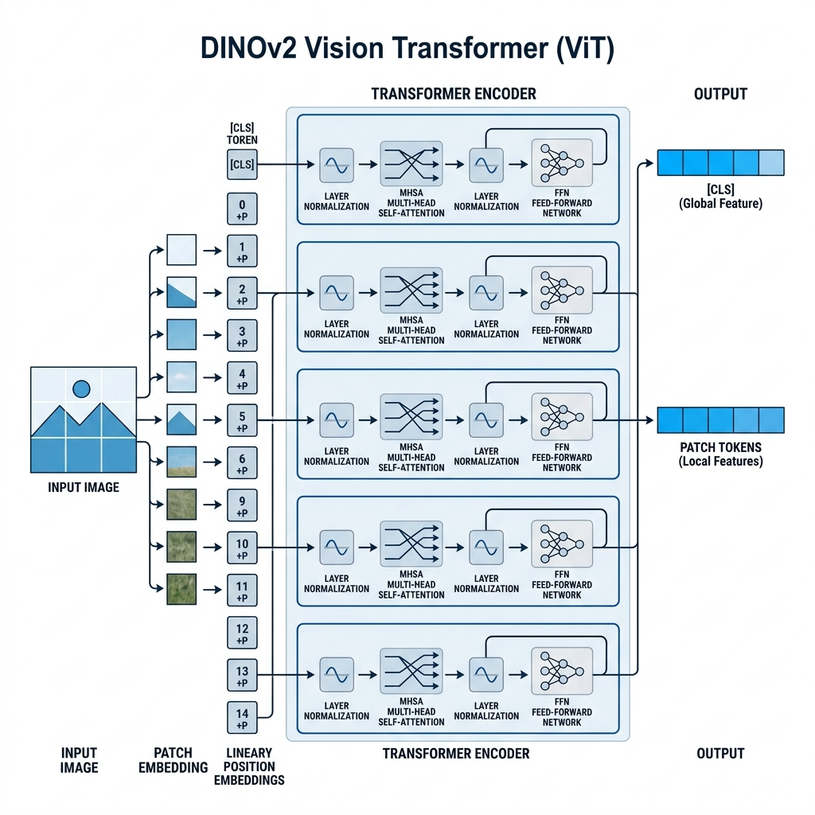
Figure 1: DINOv2 Vision Transformer Architecture showing patch-level feature extraction.

Why DINOv2?
1. All-Purpose Features: Performs exceptionally well on segmentation tasks out-of-the-box.
2. Patch Awareness: Provides dense, local features rather than just a global image embedding.
3. Invariance: Robust to changes in lighting and leaf orientation.

3. Data Pipeline and Tensor Shapes
Stage | Operation | Tensor Shape (B, C, H, W)
Input | MultiChannel Dataset (RGB Slice) | (B, 3, 256, 256)
Preprocessing | Resize to patch multiple (14px) | (B, 3, 252, 252)
Extraction | DINOv2 ViT-B/14 forward pass | (B, 768, 18, 18)
Reduction | Random Dimensionality Selection | (B, 128, 18, 18)
Modeling | Gaussian Parameter Estimation | (18*18, 128, 128)

4. Mathematical Methodology: PaDiM
We utilise Patch Distribution Modelling (PaDiM) to capture the statistical structure of healthy leaves. For every spatial patch position 'p' in the 18x18 grid, we model the distribution of features as a Multivariate Gaussian.
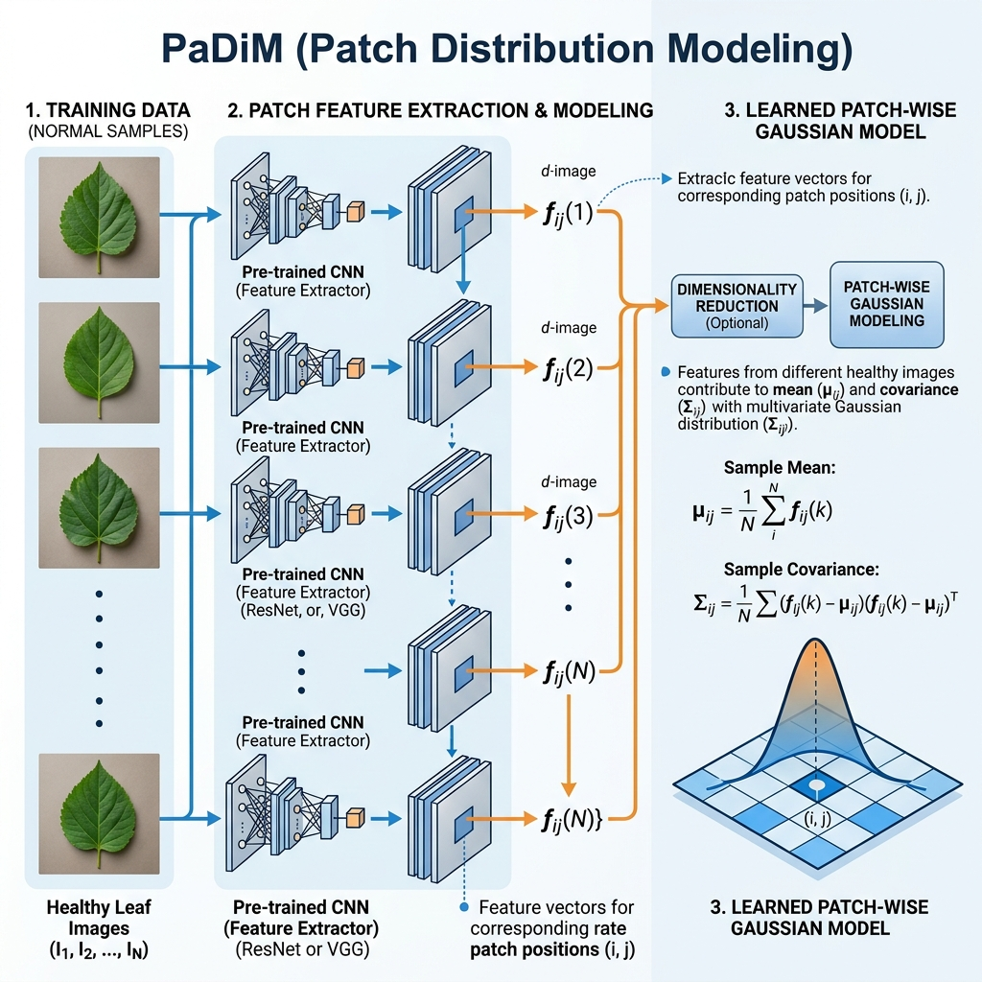
Figure 2: PaDiM Workflow - Multiple images contribute to a local Gaussian distribution per patch.

The Gaussian Distribution
For each patch position, we calculate the Sample Mean (μ) and Covariance Matrix (Σ):
μ_p = (1/N) * Σ(x_p,k)
Σ_p = (1/(N-1)) * Σ(x_p,k - μ_p)(x_p,k - μ_p)^T + εI
Where 'N' is the number of healthy images and 'εI' is a regularization term used to ensure the covariance matrix is invertible.

5. Visual Evidence: Healthy Features
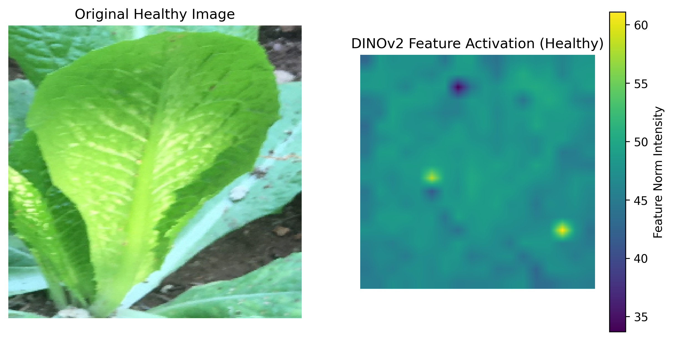
Figure 3: DINOv2 Activation Map showing high sensitivity to leaf structure and texture.
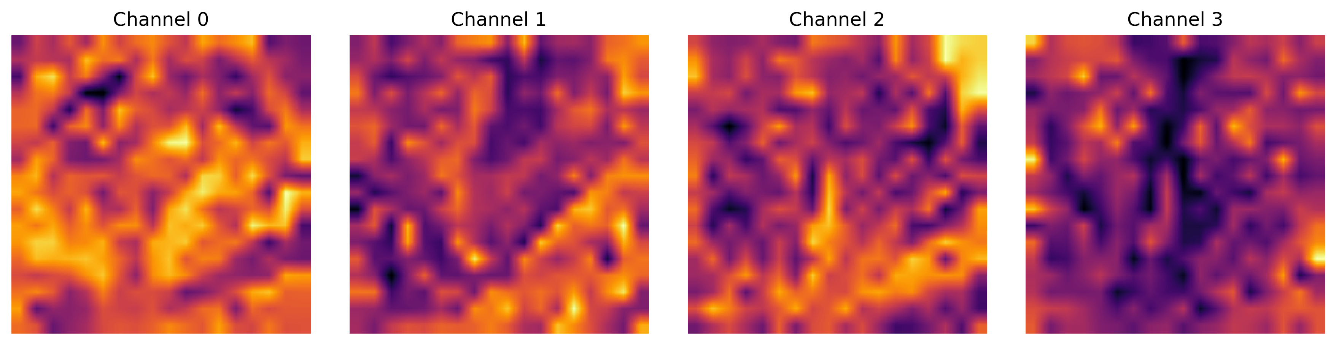
Figure 4: Individual feature channels highlighting different spatial and spectral properties of the leaf.

6. Conclusion
By the end of Stage 2, the system has constructed a high-dimensional statistical profile of healthy lettuce. The resulting 'Healthy Bank' (stored as .pkl and .npy files) acts as a reference library for all future anomaly detection tasks, providing a mathematically rigorous definition of 'normal leaf' against which diseased samples will be compared.

