Stage 4: Pseudo Mask Generation & Evidence Fusion
Synthesizing Self-Supervised Priors for Deep Segmentation Training

1. Workflow Overview
Stage 4 is the culmination of the self-supervised phase. It takes the statistical anomalies from Stage 3 and combines them with semantic class-awareness from a newly trained classifier head. This fusion process generates the dense pixel-level 'pseudo-labels' required to train a supervised segmenter.
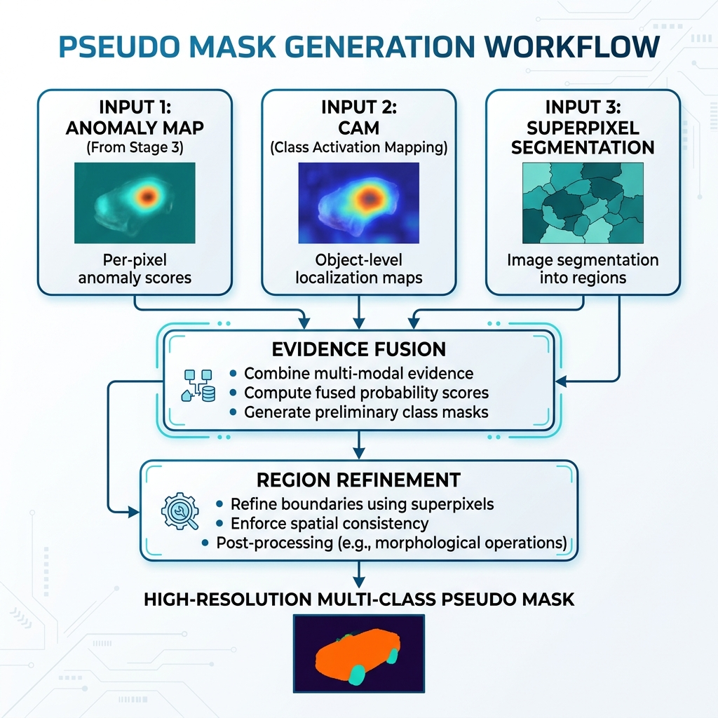
Figure 1: High-level workflow of the Pseudo Mask Generation process.

2. The CAM Mechanism
Class Activation Mapping (CAM) allows us to 'see' what a neural network is looking at when it makes a classification. By analyzing the weights of the final linear layer and applying them back to the dense feature maps of DINOv2, we can identify which spatial regions are most responsible for a specific disease classification.
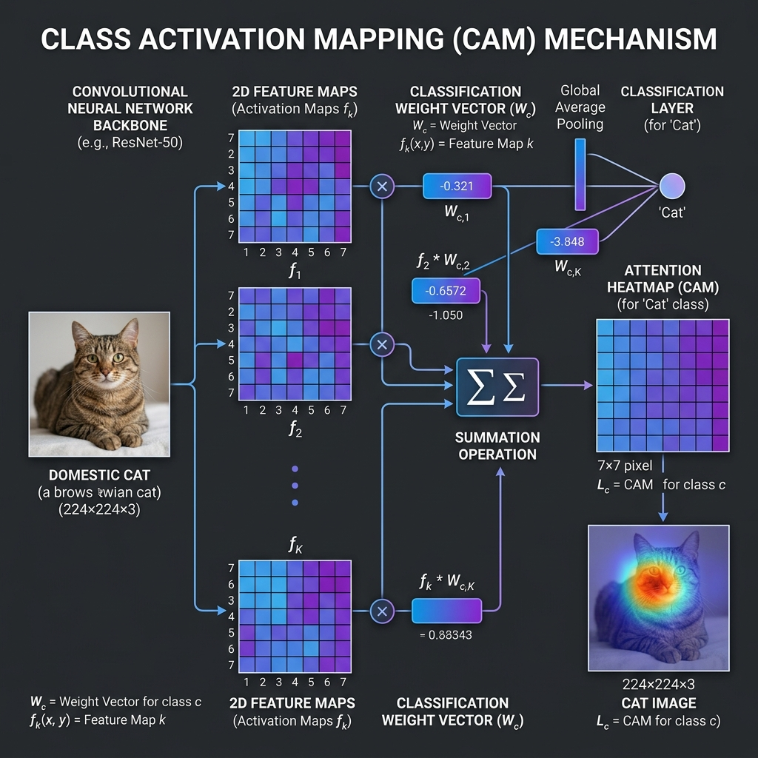
Figure 2: The mathematical mechanism of CAM - Weighting feature maps by classification logits.

Cross-Class Sensitivity Analysis
The following visualization shows how the same leaf is perceived through the 'lens' of different disease classes. The model correctly identifies the primary disease while showing low sensitivity for unrelated categories.
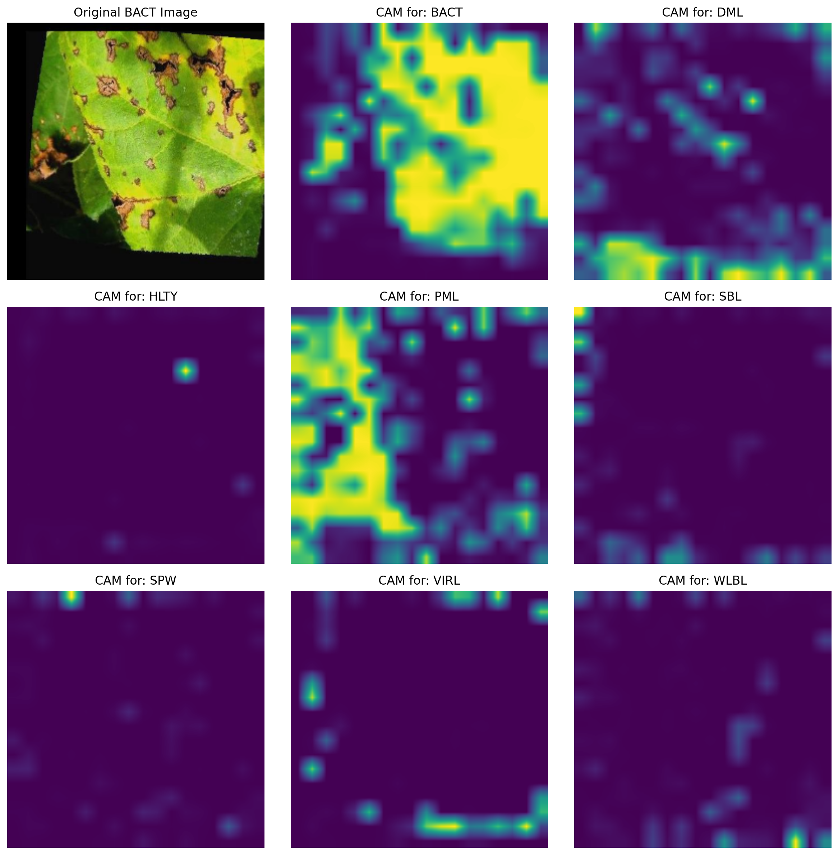
Figure 3: Multi-class CAM outputs for a single diseased leaf.

3. Evidence Fusion & Mathematics
The system fuses two types of information to create a robust localization map:
1. Statistical Anomaly (A): Deviation from the Healthy Bank (High spatial precision).
2. Semantic Attention (C): Class-aware CAM (High semantic specificity).
Final Evidence Map (E) = w_a * A + w_c * C
By default, we set w_a = 0.6 and w_c = 0.4. This weighting ensures that structural anomalies are prioritized while being refined by the semantic context of the specific disease.

4. Step-by-Step Mask Refinement
The 'raw' evidence maps are often noisy. To achieve clean, object-aware segmentation, we apply Superpixel Refinement using the Felzenszwalb segments generated in Stage 1.

Processing Class: HLTY
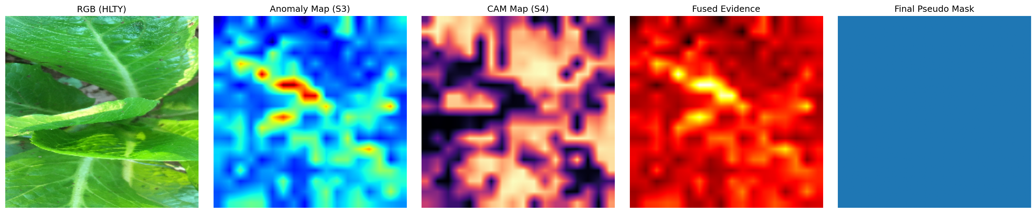
Visual Progression: RGB -> Anomaly -> CAM -> Fusion -> Final Mask (HLTY)

Processing Class: BACT
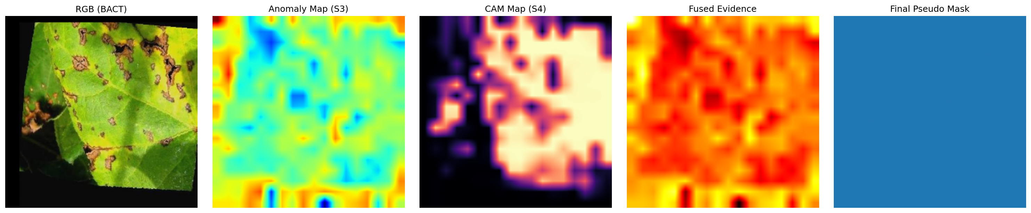
Visual Progression: RGB -> Anomaly -> CAM -> Fusion -> Final Mask (BACT)

Processing Class: DML
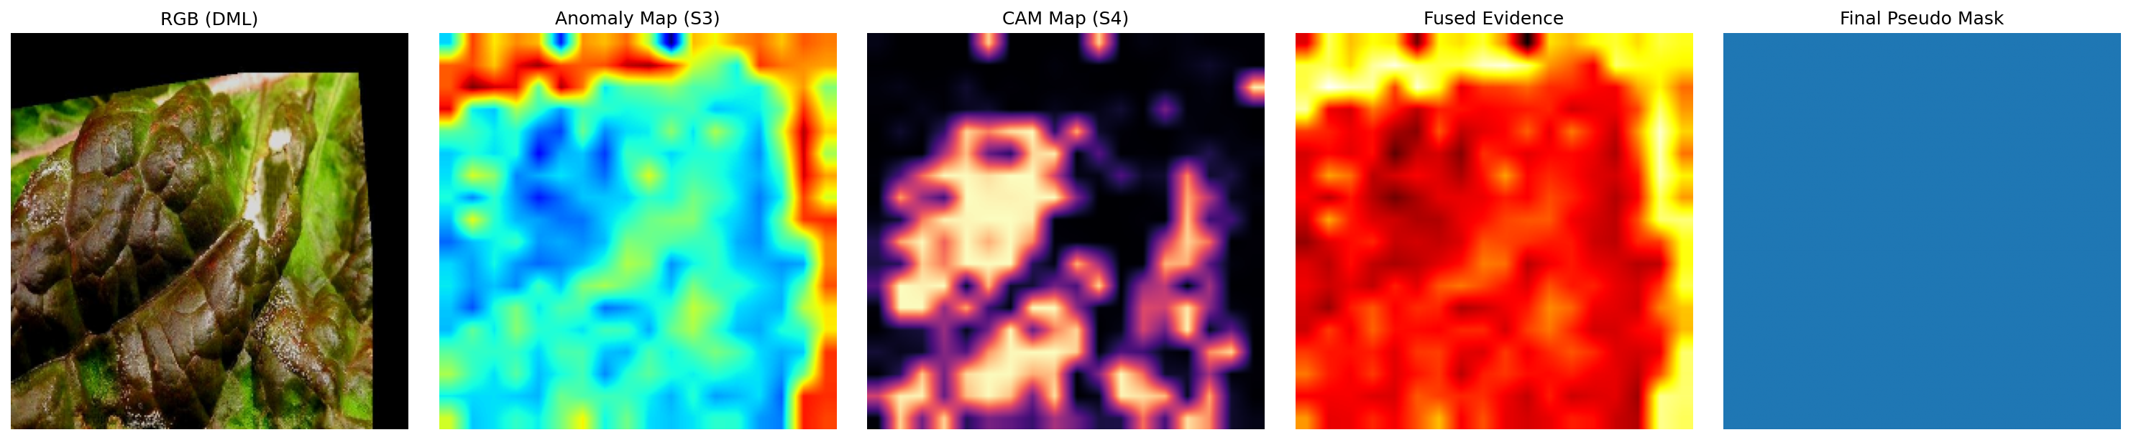
Visual Progression: RGB -> Anomaly -> CAM -> Fusion -> Final Mask (DML)

Processing Class: PML
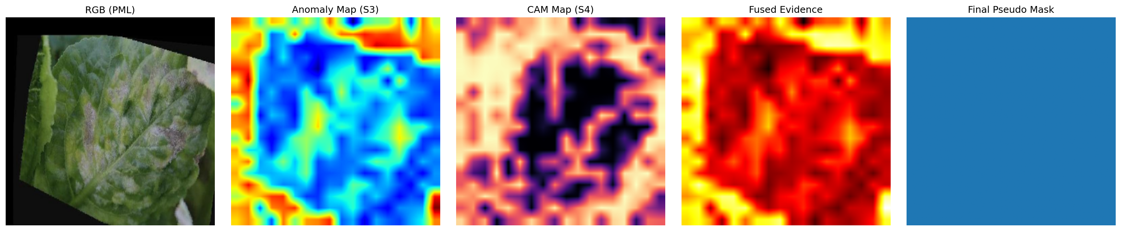
Visual Progression: RGB -> Anomaly -> CAM -> Fusion -> Final Mask (PML)

Processing Class: SBL
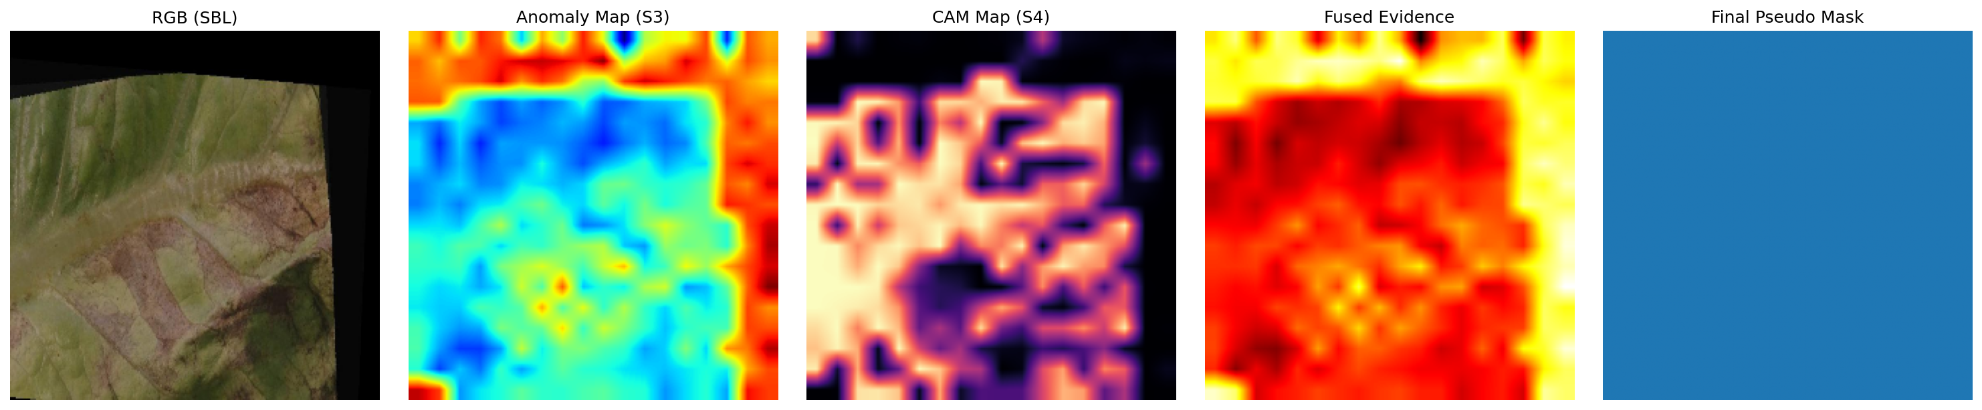
Visual Progression: RGB -> Anomaly -> CAM -> Fusion -> Final Mask (SBL)

Processing Class: SPW
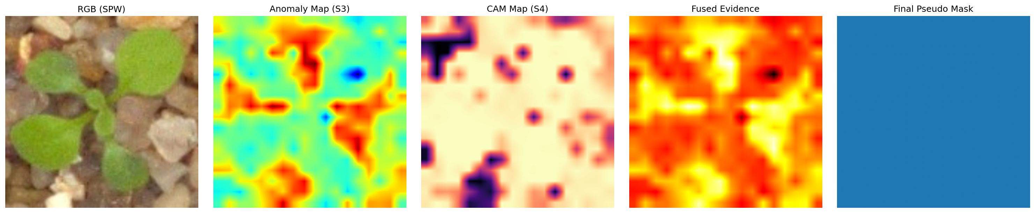
Visual Progression: RGB -> Anomaly -> CAM -> Fusion -> Final Mask (SPW)

Processing Class: VIRL
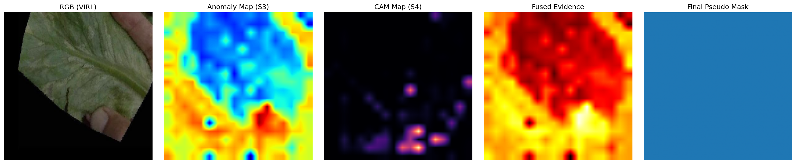
Visual Progression: RGB -> Anomaly -> CAM -> Fusion -> Final Mask (VIRL)

Processing Class: WLBL
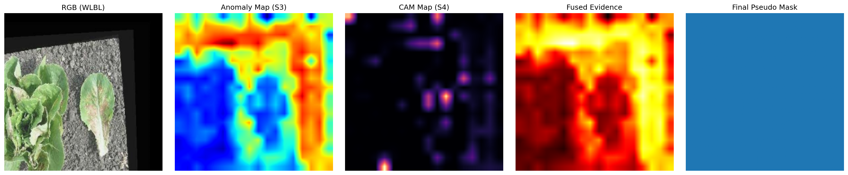
Visual Progression: RGB -> Anomaly -> CAM -> Fusion -> Final Mask (WLBL)

5. Conclusion
Stage 4 successfully generates a high-fidelity dataset of 14,000+ pseudo-labeled images. This dataset is now ready for Stage 6, where it will be used to train a state-of-the-art SegFormer model for robust, real-time lettuce disease segmentation.

