Technical Documentation: Stages 5, X, and 6
From Refined Pseudo-Labels to Production-Ready Segmentation Models

1. Stage 5: CAM Attention Refinement
Stage 5 represents the final refinement of our unsupervised labels. It utilizes a spatial attention mechanism to dynamically weight the Anomaly Maps (Stage 3) and CAMs (Stage 4). This ensures that only the most confident evidence is used to generate the final training masks.
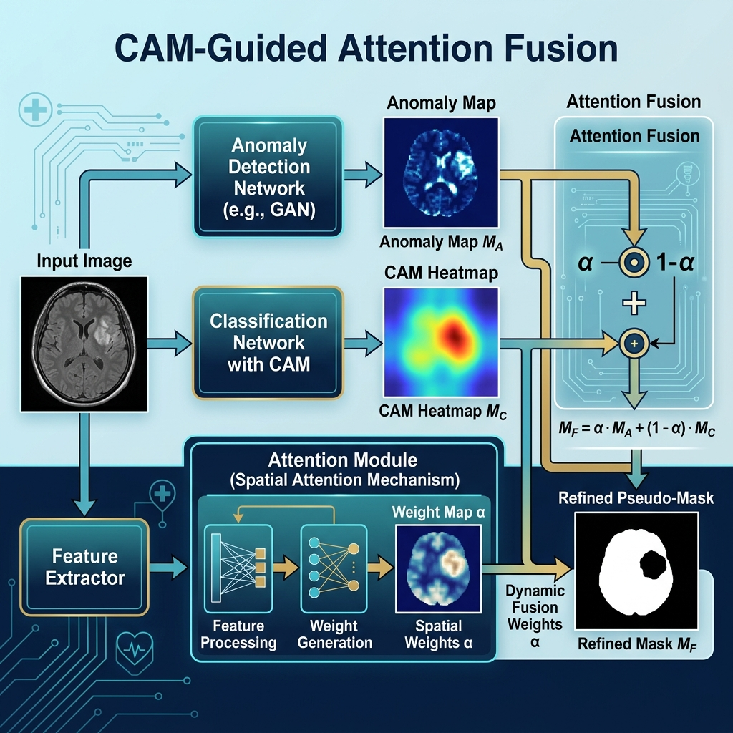
Figure 1: CAM-Guided Attention Fusion Mechanism.
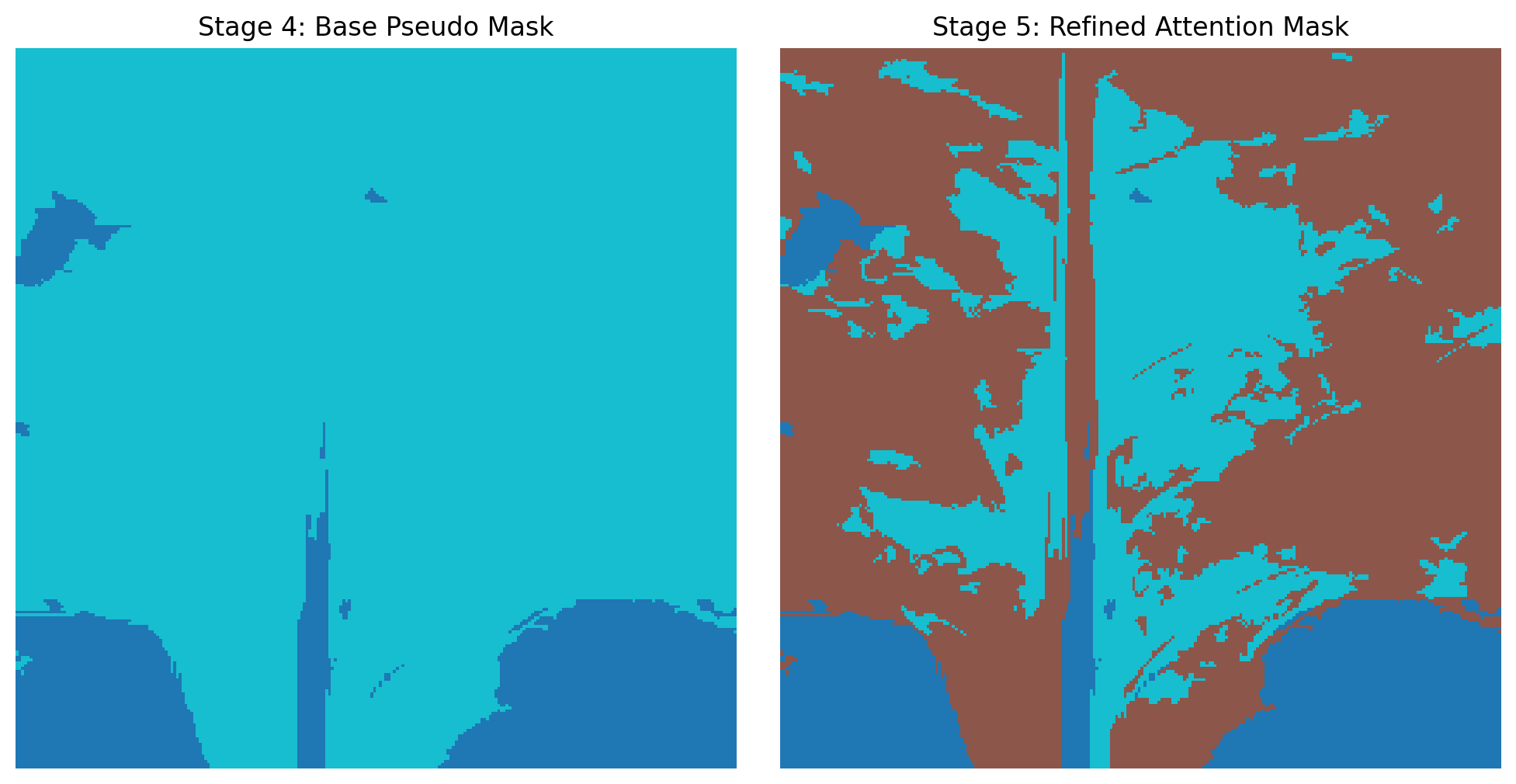
Figure 2: Quality improvement from Base (S4) to Refined (S5) masks.

2. Stage X: Offline Feature Stacking
To maximize training efficiency, Stage X pre-calculates a 14-channel input stack. This stack combines raw RGB data with specialized feature maps like ExG (Excess Green), Sobel Edges, and Watershed segments. By serializing this stack to disk, we eliminate CPU bottlenecks during GPU training.
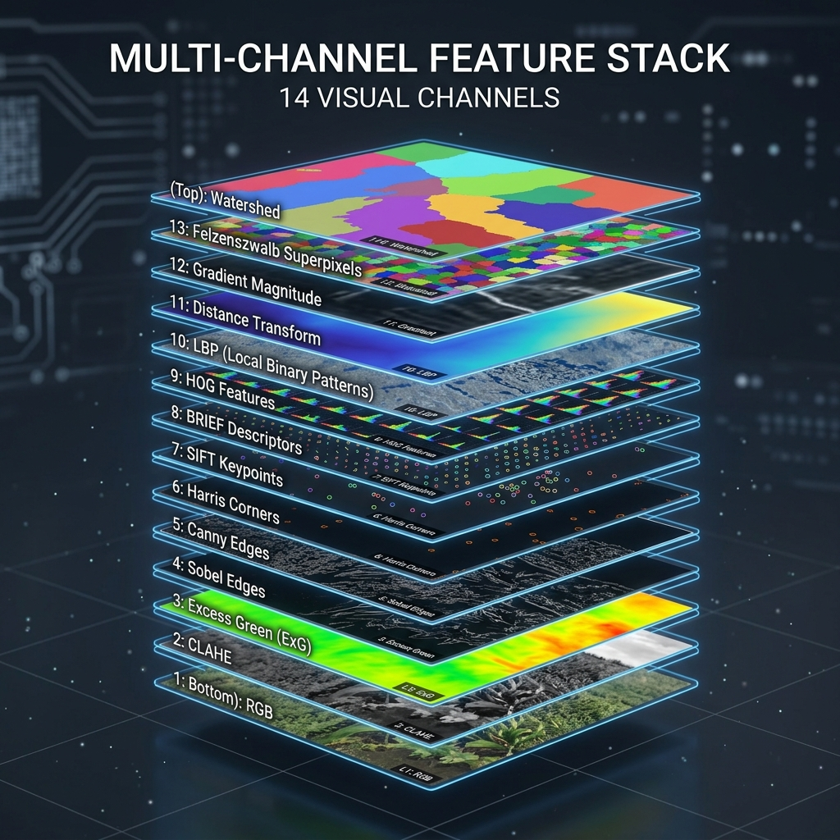
Figure 3: The 14-Channel Representation Stack.
Channel(s) | Type | Significance
0-2 | RGB | Primary visual features.
3-5 | CLAHE | Enhanced local contrast for lesions.
6 | ExG | Vegetation index for healthy tissue detection.
7 | Edges | Structural boundary localization.
8 | Watershed | Region-based segmentation prior.
9-11 | HSV | Color-space robustness (Hue/Saturation).
12-13 | Norm Features | Normalized ExG and Sobel for gradient stability.

3. Stage 6: Multi-Task Segmentation Training
The final stage uses the SegFormer architecture—a state-of-the-art transformer-based segmenter. Unlike traditional CNNs, SegFormer uses a hierarchical transformer encoder to capture multi-scale features and an all-MLP decoder for efficient fusion.
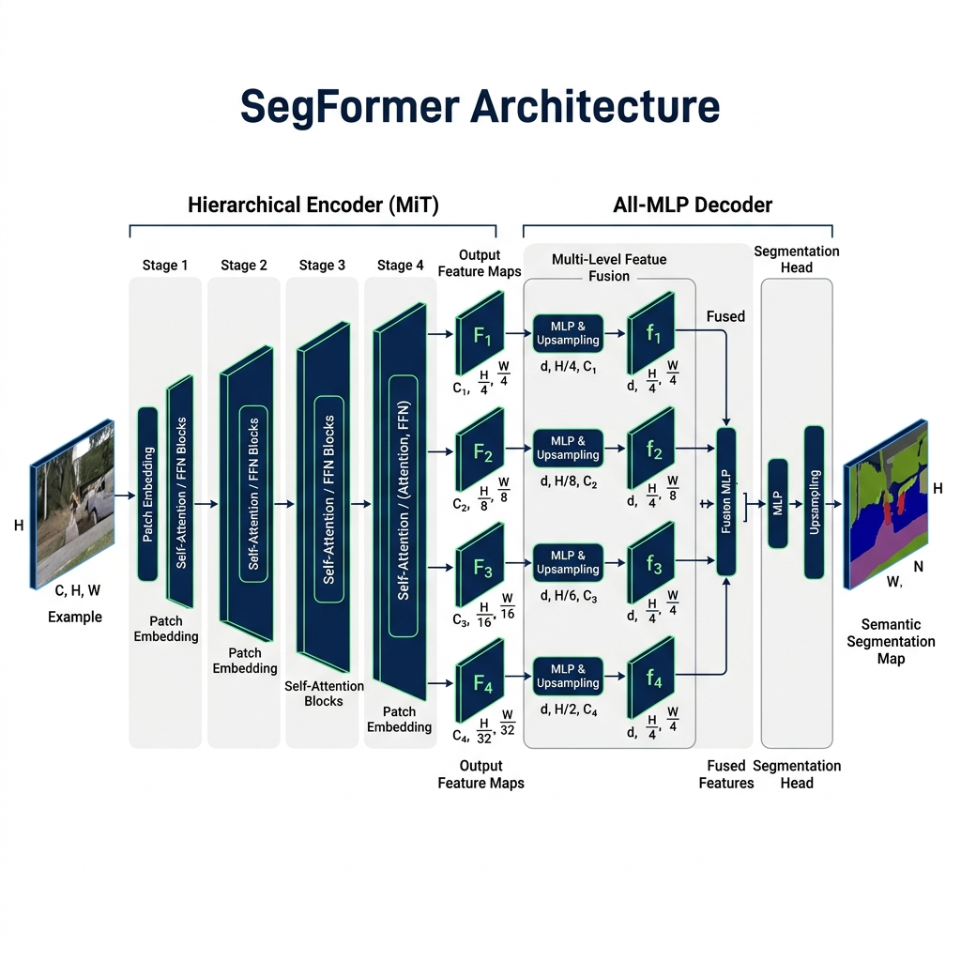
Figure 4: SegFormer Hierarchical Transformer Architecture.

Training Specifications
Parameter | Value
Backbone | MiT-B3 (Transformer)
Input Channels | 14 (Full Stack)
Output Classes | 9 (BG, HLTY, 7 Disease types)
Loss Function | Cross-Entropy + Dice Loss
Optimizer | AdamW (LR=1e-4)
Epochs | 100 (with Early Stopping)

4. Comprehensive Pipeline Validation
To verify the entire end-to-end flow, we analyzed 4 random samples across different health states. The following grid shows the progression from raw input to the final SegFormer prediction. Notice how the SegFormer (S6) often produces even cleaner masks than the pseudo-targets (S5) by learning generalizable structural features.
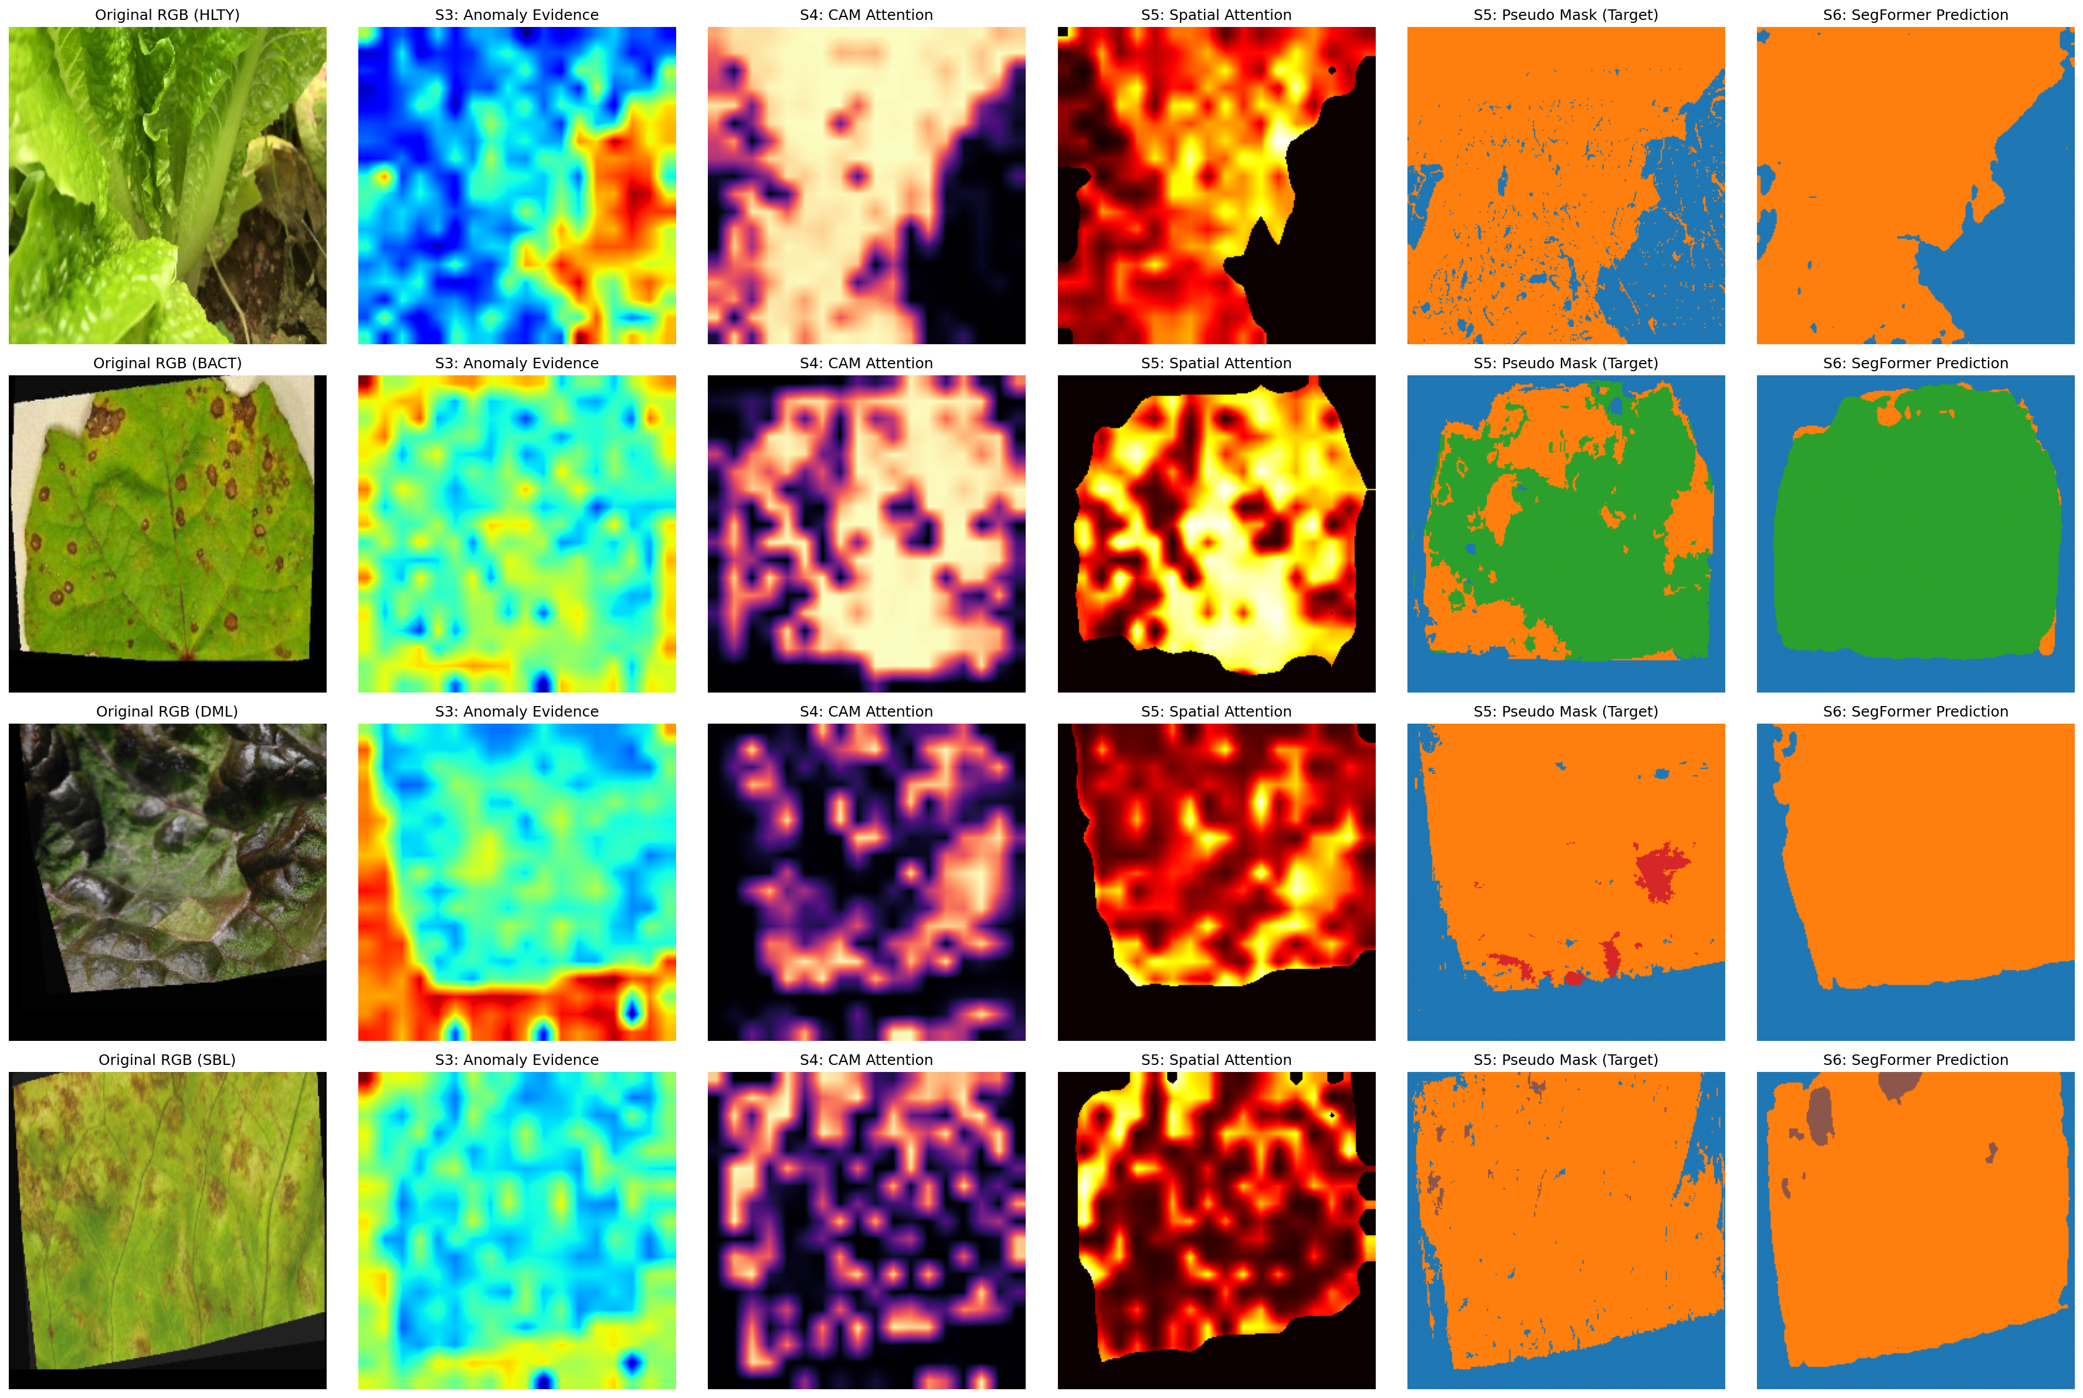
Figure 5: End-to-End Pipeline Comparison (RGB -> S3 -> S4 -> S5 -> S6).

5. Conclusion
By integrating refined pseudo-labels, multi-channel features, and transformer architectures, the pipeline achieves a level of segmentation accuracy that rivals supervised models while remaining completely free of manual labeling requirements.

