**TEAM NAME- Scarlettx_47**

***team members:- 1. Bhuvan Bhasker***

***2. Karan Verma***

***3. Santan Kumar Sharma***

Project_Name:- EnggMart

**Concept:**

We are providing an application for all the engineering student where they can sell or buy any type of material of their concerned .And also an individual profile to every student with a feature that they can share their views, ideas. It also contain chatting platform through which anyone can contact with anyone for any help.

**IDEA:**

* Idea is to make software platform like OLX sell for selling or buying anything of study concerned.
* NEWSFEED: On Newsfeed, anyone can share or read or review the post such as educational sites, job sites etc.
* STORE: In store section, we provide academic + competative books + notes and also many electronics equipment related to department.
* WORK/JOB: In this section, we provide platform for test like domain(department wise) + CRT (aptitude) test.
* And with the help of Job portal anyone can apply for job.
* CHAT: with this section, anyone can take help of any other by chatting with themselves.
* SELL: This section is heart of software, here, anyone can upload picture or image of product which they want to sell and from here, anyone can buy these product.
* PROFILE: It contain the information of every registered user information like Name, Mobile no., address, Resume.

**Features:**

* One platform for all engineering material.
* A complete digital platform for student to discuss share ideas, needs, problems & solution.
* This platform ensures optimum utilisation of engineering tools ,books & lab equipments etc.
* Proper evaluation of student through assessment.
* Arrangement of study material at reasonable price.

**Services:**

**Newsfeed:**

1. Post
2. Read
3. Review

**Store:**

1. Book (Academic + competitive)
2. Tools

**Work/job:**

1. Coding practice
2. CRT & aptitude practice
3. Apply for job

**Engg Library:**

1. Novels
2. Newspaper
3. Current affairs
4. Skill development/personality development videos

**Chat:**

1. Chatting through our platform
2. File sharing

**Sell on EnggMart:**

1. Old books
2. Handwritten notes
3. Engineering tools

**Profile:**

1. Name
2. College Name(year/semester/branch)
3. Address(current/permanent)
4. Upload resume

**Why us :**

* Here you can sell & buy engineering materials new or old one.
* Along with books we provide useful hand written notes, xerox books.
* There is no home delivery convenience in selling & buying platforms, that we do.
* Platform to enhance your soft skills.
* Updated news & novels available

**Business aspects :**

**Unique selling Proposition :**

**We**

**USE CASE Diagram:**

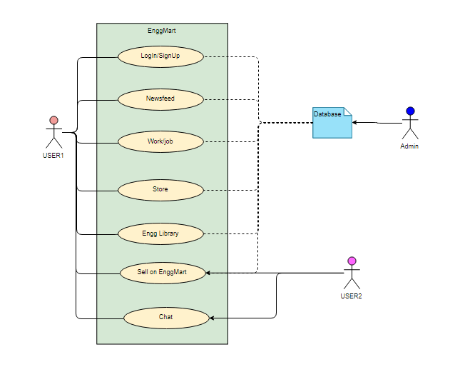

**Application Screenshot:**

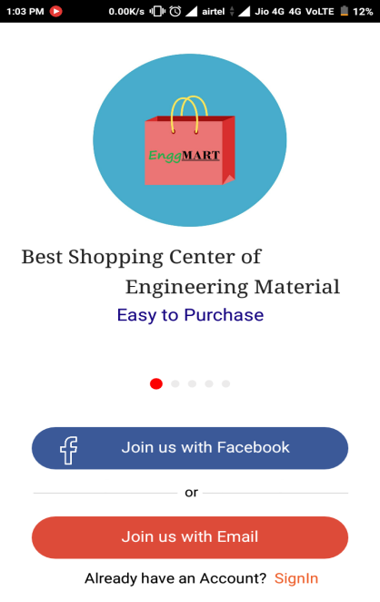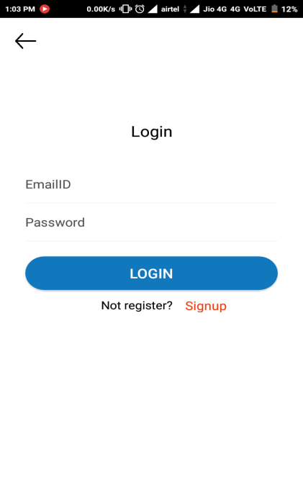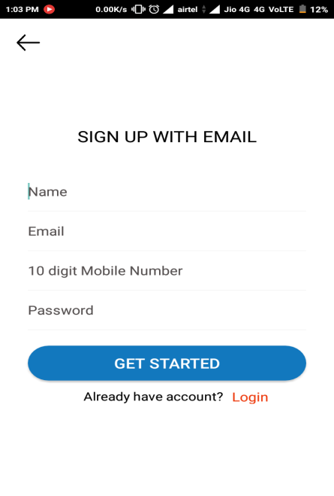

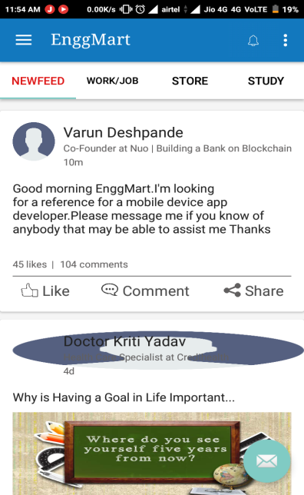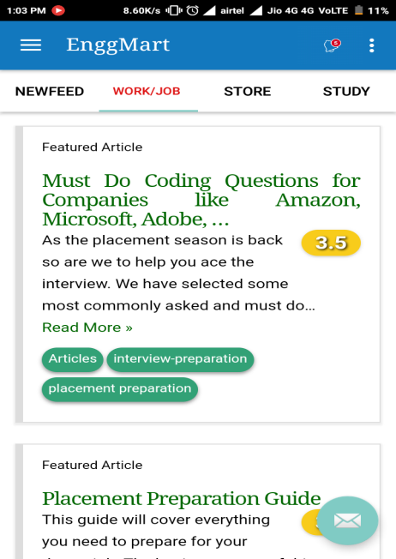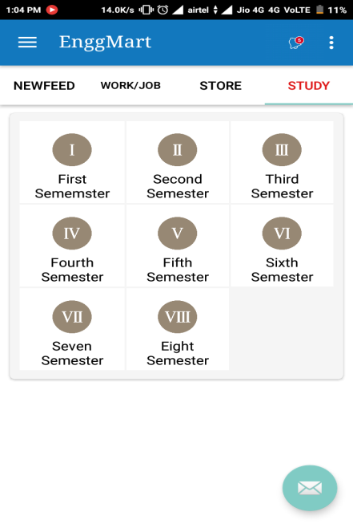

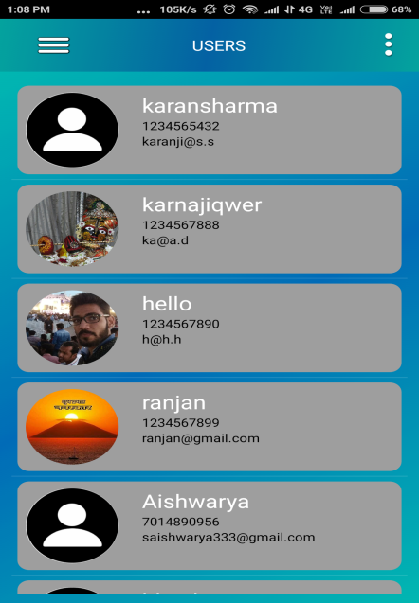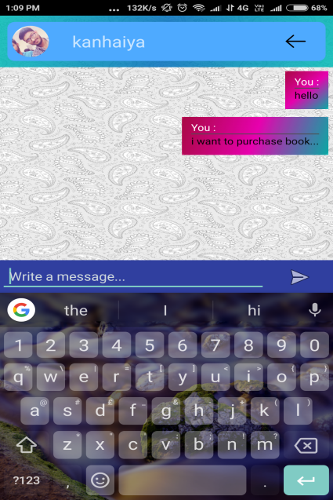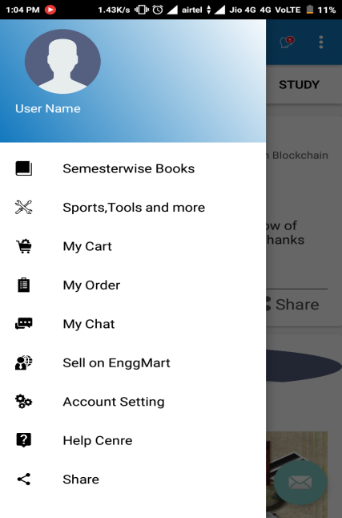

**Technology Used:**

* Java
* Xml
* Database(SQLite)