Development of Virtual lab :Round 3 -Lab Manual - Template (Worksheet)

|  |
| --- |
| **Name of Faculty:** Ajay Kumar Dhanopia  **Institute:** Swami Keshvanand Institute of Technology, Jaipur  **Email ID** (as submitted in the registration form)**:**ajaydhanopia123@gmail.com  **Discipline to which the Lab belongs:** Mechanical  **Name of the Lab:** Material Science & Testing (MST)  **Name of experiment:**(only one Experiment per worksheet)**:**To study the spring testing machine and Determine the design parameters for tension and compression helical spring  **Kindly Refer these documents before filling the worksheet**   1. **Coursework (MOOC ) on Pedagogy , Storyboard , Lab Manual :** [**http://bit.ly/Vlabs-MOOC**](http://bit.ly/Vlabs-MOOC) 2. **Additional Documentation booklet for reference.** [**http://vlabs.iitb.ac.in/vlabs-dev/document.php**](http://vlabs.iitb.ac.in/vlabs-dev/document.php) 3. **Sample Git Repository. :** |

**Round 2**

**1. Aim and Objective :-**

To study the spring testing machine and Determine the design parameters for tension and compression helical spring -

1. Max torque (t)
2. Max. shear stress (Fs)
3. Spring index (c)
4. Stiffness of spring (k)
5. Modulus of rigidity of spring material (G)

**2. Theory:-**

1) Stiffness of spring (k): -- Spring stiffness is defined as load that comes unit deflection.

k=w/δ

Where k = spring stiffness (kg/mm)

w = applied load

δ = deflection

The nature of load vs deflection curve decides whether the behaviour of spring is linear or non- linear. Mostly closed coiled helical spring have linear nature.

2) Spring index(c): --

c=D/d

Where D= mean distance of coil spring

d = spring wire distance

c = spring index

3) Max shear stress (Fs): --

Fs = 16.t/πd3 kg/mm2

4) Torque (t):--

t=w.r kg-mm

r=D/2 mm

5) Deflection (δ) :--

δ=64wr3n/Gdd3

δ=64w.(D/2)3n/Gdd3

δ=64wD3n/8Gdd3

δ=8wD3n/Gdd3

δ=8.wc3n/Gd4

δ=8wD3n/Gd4  mm

6).Modulus of Rigidity of spring (G): --

For Steel spring material (G) = 8297.43 kg/mm2

**COMPRESSION SPRING:--**

A **compression spring** is an open-coil **helical spring** that offers resistance to a compressive force applied axially. They are usually coiled at a constant diameter, though they can be coiled in other needed forms such as conical, concave (barrel), convex (hourglass), or various combinations of these. Compression springs are used compression springs are fabricated from round wire. Compression springs are used to keep components from meeting.

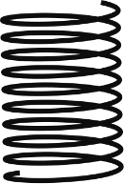

**TENSION SPRING:**

Tension springs resist the pulling force that is placed upon them and this creates a sling back effect when the force is removed, causing it to return to its original shape .This function makes them ideal for lifting heavy objects and assisting in the lifting or dispersing of certain loads. Tension springs usually have hooks on the ends to facilitate the function of being extended. Tension springs are mainly used to hold two components together.

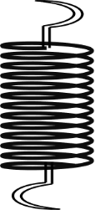

**SPRING TESTING MACHINE: --**

* It is used for determining the behaviour of spring while in compression or tension up to a max capacity if 300kg.
* The machine consists of a base unit inside which is housed a weighting system. The machine consist steel closed head and steel base. the hydraulic jack of 10tone capacity is fixed to base.
* A dial in front of a base unit is a load indicator which indicates the load being applied to a spring under test. The deformation undergone by spring can be observed from graduated scale on which a pointer move in case spring being tested under compression, it is to be placed between compression plates, and in case spring to be tested under tension it is located under upper tension book.
* Two vertical pillars are held by backer supported a beam whose position can be altered, if required. A pointer fixed on this beam slides over fixed scale.
* The motorized pumping unit, which is of plunger type housed in the base unit and is driven by a single phase 220v ac supply electric motor.
* The pumping unit is a separate unit connected to the jack by means of [pressure tube] the general construction of machine is robust and leak proof.
* The machine is fitted with a handle wheel control marked slow and fast, which enables the scale of application of load to be varied the machine is equipped with facilities for hand pumping in case of power failure.
* The helical spring testing machine is based on the hydraulic system.
* For helical steel spring material (G) = 8297.43kg/mm2

**DIAGRAM :--**

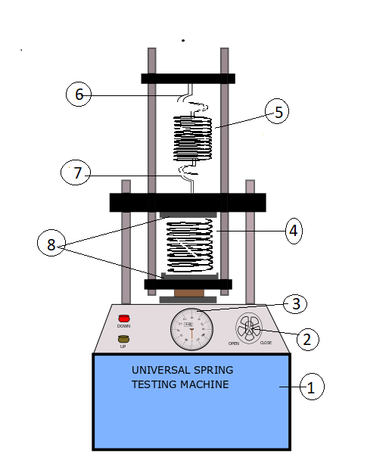

1. Base unit
2. Hand liver
3. Dial (load indicator)
4. Compression spring
5. Tension spring
6. Upper tension hook
7. Lower tension hook
8. Compression plates
9. **Procedure :-**

For tension test:

* 1. Step 1:

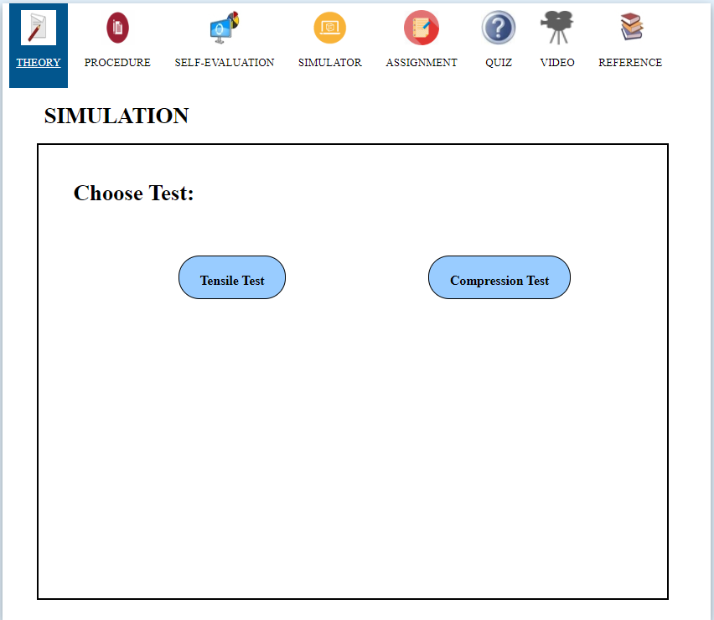

* 1. Step 2:

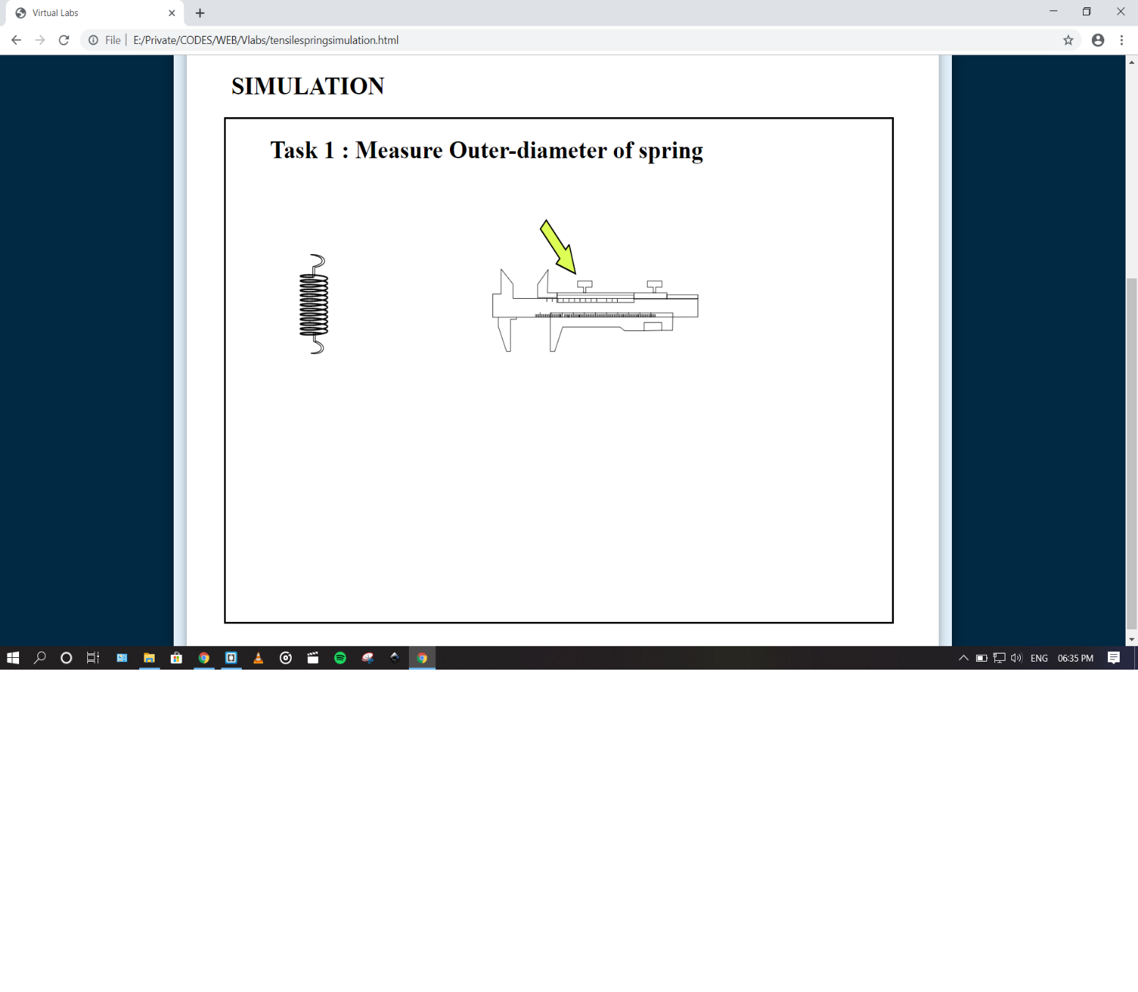

* 1. Step 3:

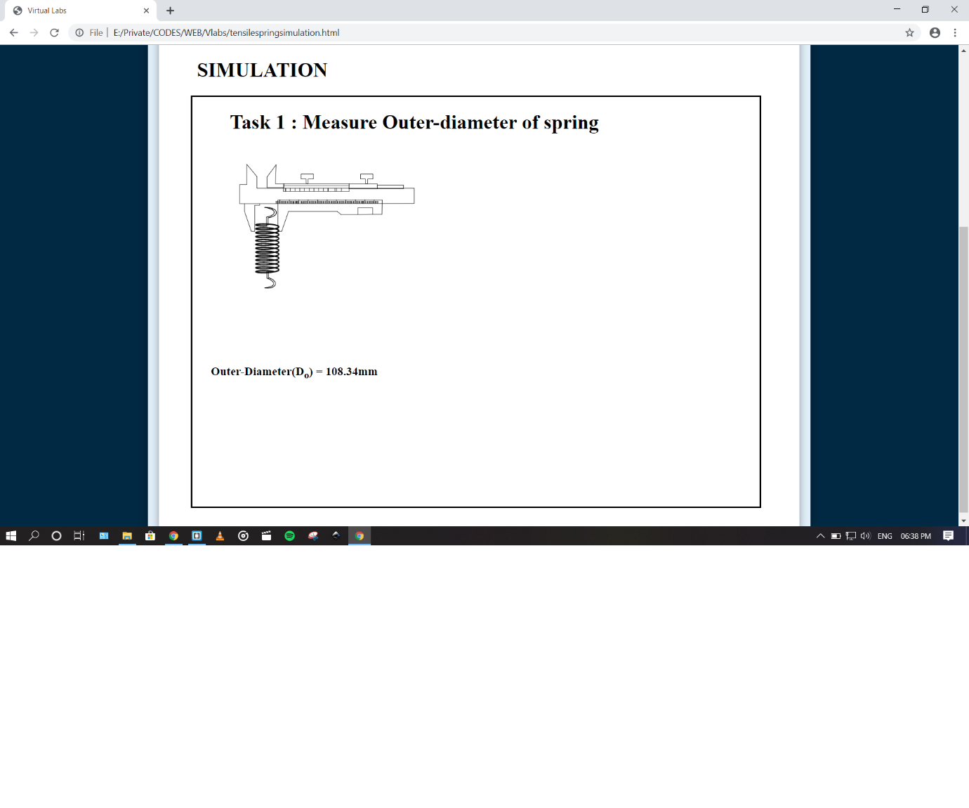

* 1. Step 4:

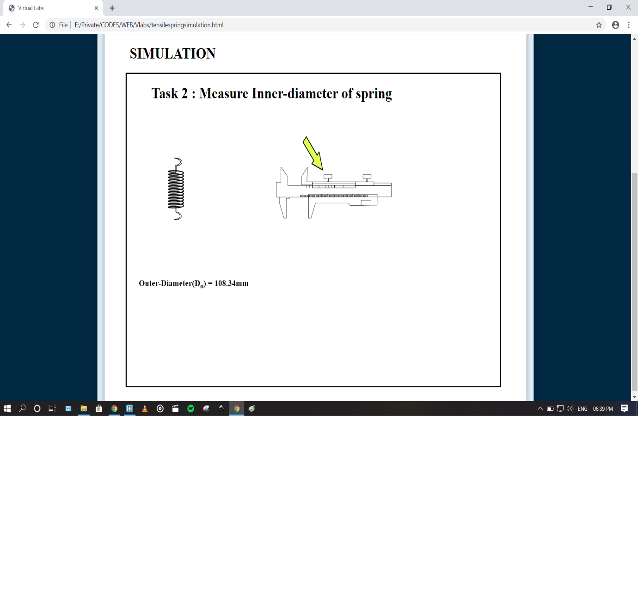

1. Step 5:

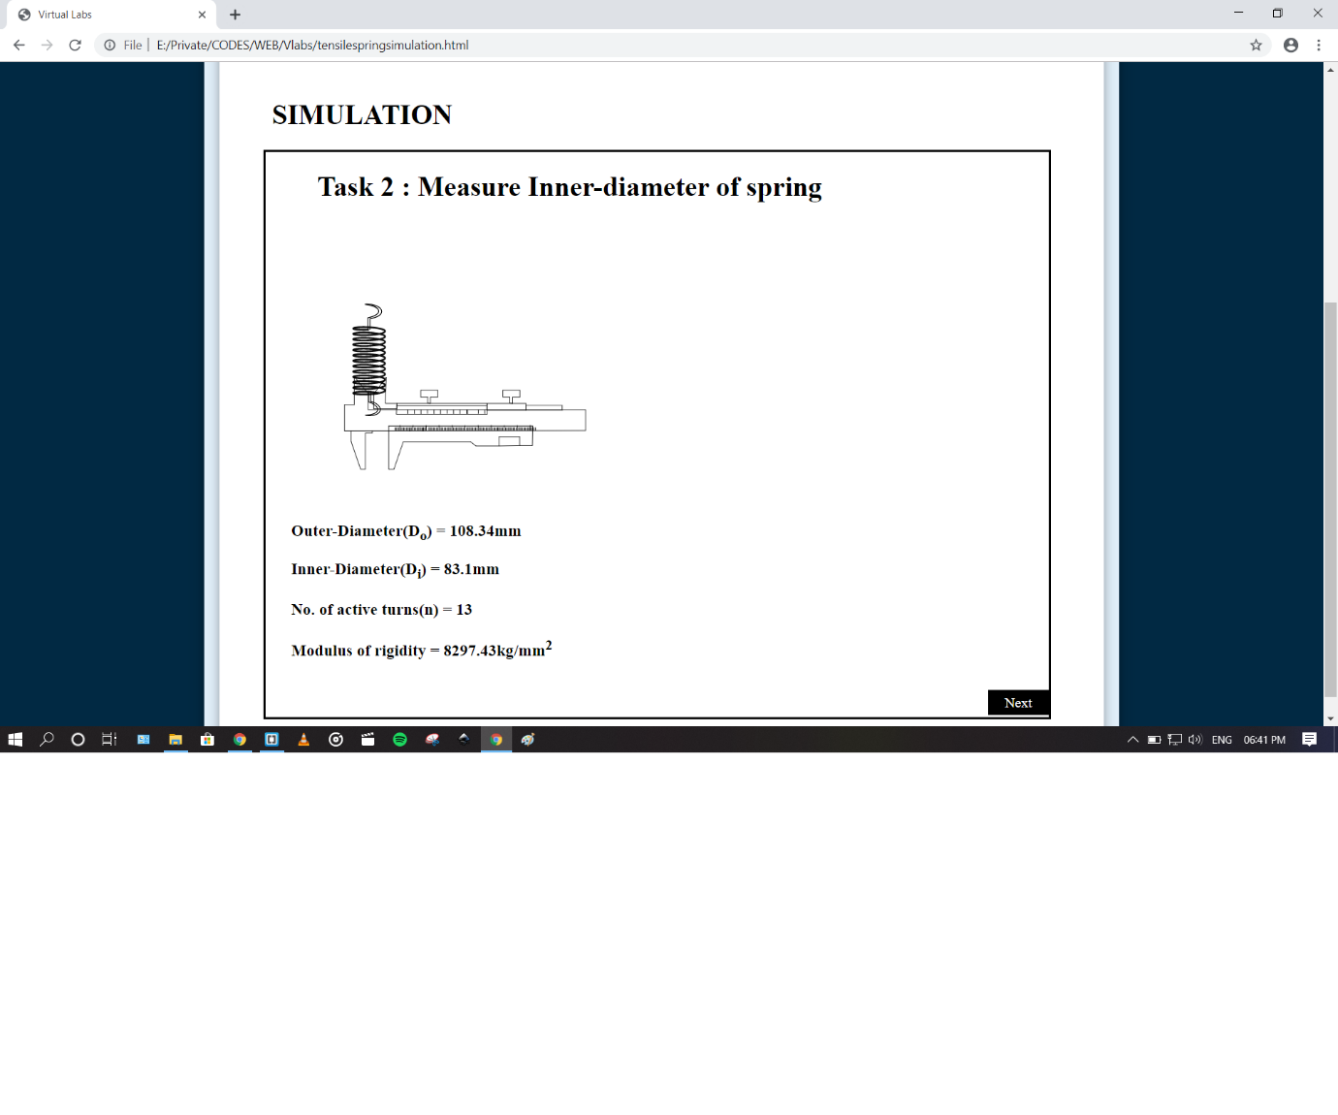

1. 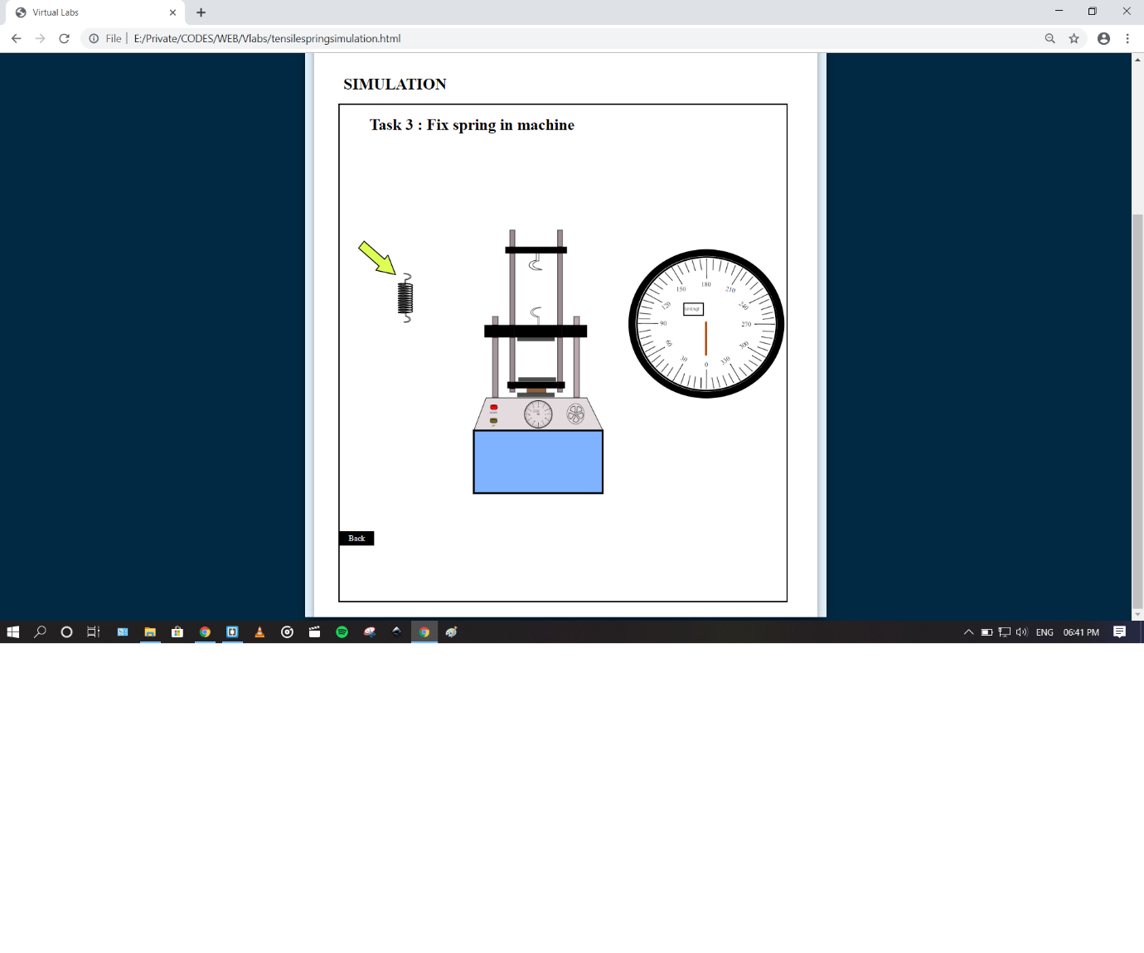Step 6:
2. 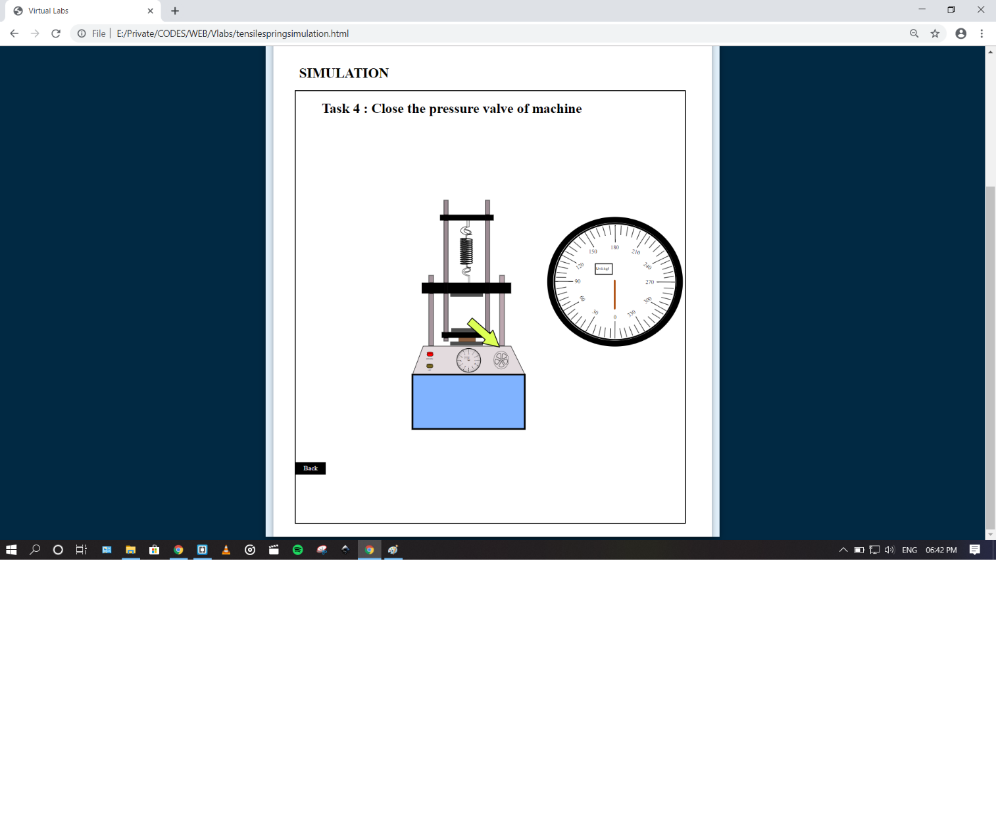Step 7:
3. Step 8:

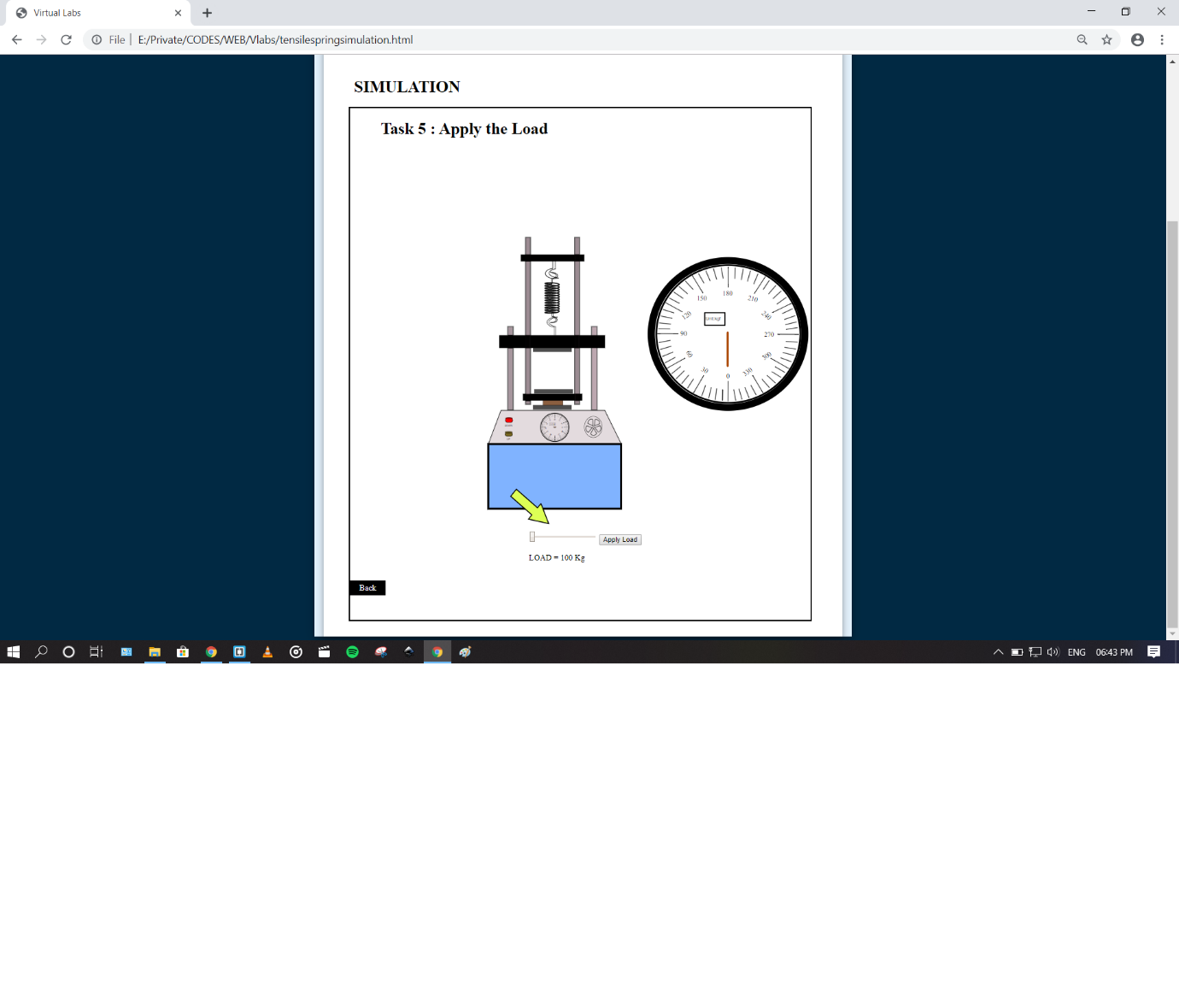

1. 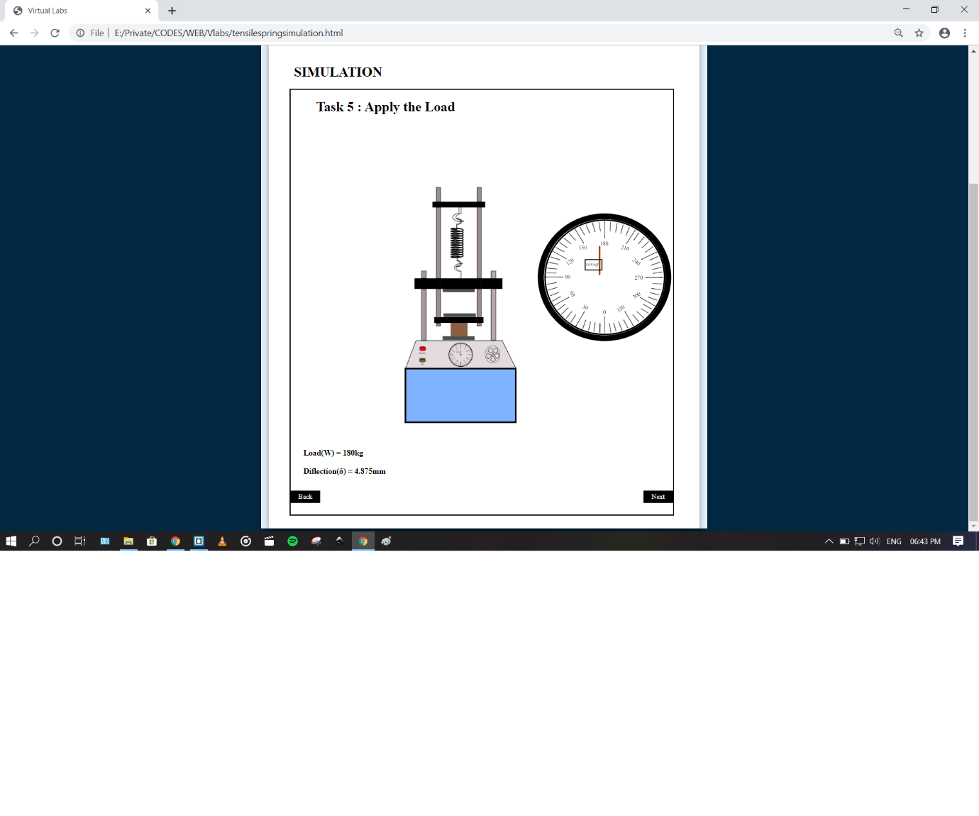Step 9:
2. 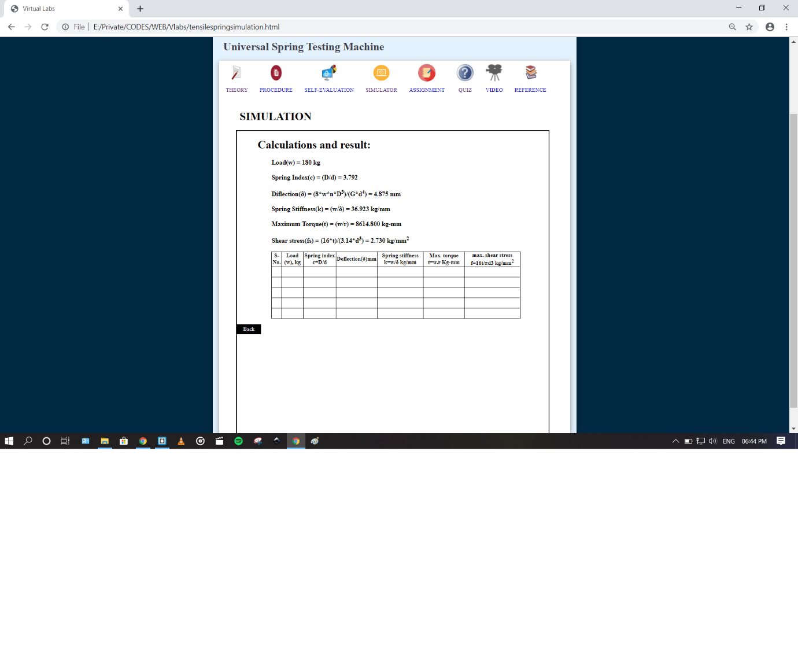Step :10

**4.Pre test Assessments**:-

1. **Which type of springs have only active coils?**

1. Helical compression springs
2. **Helical tension springs**
3. Both a. and b.
4. None of the above
5. **Solid length for helical compression springs having square and ground ends is given as _________.**
6. **(n + 2) d**
7. (n + 3) d
8. (n + 4) d
9. None of the above
10. Which law is used in the movement of a helical spring
11. Gravitational
12. Pascal’s Law
13. Newton’s Law
14. **Hooke’s Law**
15. Which of the following is an application of helical spring
16. Automatic door closers
17. Mattress springs
18. Car suspension
19. **All of the above**
20. Give the condition at which a spring obeys Hooke’s law
21. The extension of the spring should equal to the elastic limit
22. **The extension of the spring should be within the elastic limit**
23. The extension of the spring should be greater than the elastic limit
24. The extension of the spring should be less than the elastic limit

5. **Post test Assessments***:-*

1.If spring index=2.5, what can be concluded about stresses in the wire?

a**) They are high**b) They are negligible  
c) They are moderate  
d) Cannot be determined

2. Find the shear stress in the spring wire used to design a helical compression spring if a load of 1200N is applied on the spring. Spring index is 6, and wire diameter 7mm.

a) 452.2N/mm²  
b) **468.6N/mm²**c) 512.2N/mm²  
d) None of the listed

3. Find the mean coil diameter of a helical compression spring if a load of 1200N is applied on the spring. Spring index is 6, and wire diameter 7mm.

a) 7/6mm  
b) **42mm**c) 1200×6/7 mm  
d) None of the listed

4. Find the extension produced by a helical spring of spring constant 30N/m, when a mass of 500g is attached to its end?

1. 0.016 m
2. 1.6 m
3. **0.16 m**
4. None of these

5 .  Determine number of coils in a helical compression spring, if modulus of rigidity is 80 Gpa and spring stiffness is 50 N/ mm. Assume wire diameter and spring index as 8 mm and 5 respectively

1. 11.8 turns
2. **12.8 turns**
3. 13.3 turns
4. None of the above

**6. References:**

1. Design of Machine elements (by – V B Bhandari 3rd Ed.Tata McGraw-Hill, New Delhi).
2. Machine Design, Sharma and Agarwal, Kataraia and Sons, Delhi.
3. Mechanical Engg. Design, Shigley, Mischke, Budyans and Nisbett, Tata McGraw-Hill.
4. PSG Design Data Book, P.S.G. College of Technology, Coimbatore.