Modules need to install in your laptop.  
Following commands are:

* pip install tensorflow
* pip install keras
* pip install pillow
* pip install numpy
* pip install opencv-python
* pip install matplotlib
* pip install tk
* pip install pyinstaller

Window + R 🡪 type “cmd” 🡪 type command “pip install …….”.

Command to move from one file to another file. ex: -

**import os**

**os.system("main.py")**

Database🡪 diagonis.db  


Steps:

1. Create a file name as database_creation.py
2. Next file named as database_functional.py
3. Functions:

* Insert An tuple in Database:

def insert(id,name,Age,Result,Date):

pass

* Select Tuples from Database:

def select_all():

pass

def select_latest_id():

pass

* Sorting out by decending order:

def showfilter(two_d_list):

pass

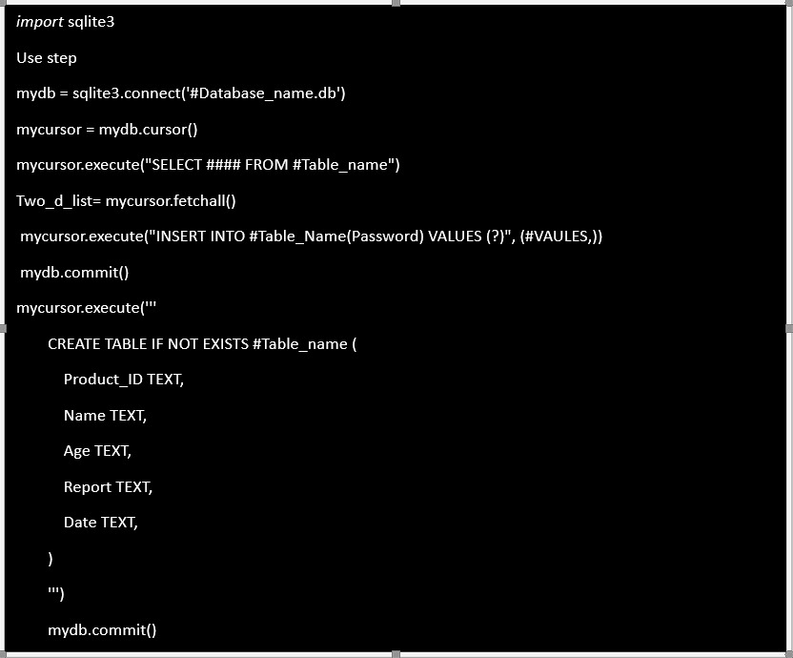

**BACKEND WORK**

Extract the features from dataset

Matching with the features.

Features.csv

BACKEND

Result

Python file

Partial Result

Modules needed:

Tensorflow: <https://www.tensorflow.org/tutorials>

Code help: <https://colab.research.google.com/github/tensorflow/docs/blob/master/site/en/tutorials/quickstart/beginner.ipynb#scrollTo=BPZ68wASog_I>

Dataset link:

<https://www.kaggle.com/datasets/paultimothymooney/chest-xray-pneumonia?resource=download>

Dataset code help:

<https://www.kaggle.com/code/amyjang/tensorflow-pneumonia-classification-on-x-rays>

Please follow these resources, if you really want to learn something.

It have taken my time to prepare this for you.