Date of Submission: 13/07/2024

Name: Aman Singhal

Institute: SRM Institute of Science and Technology Kattankulathur

Branch/Specialization: B-Tech AI

Register Number: RA2211047010132

Internal Mentor: Dr. Sumathy G

External Mentor: Dr. Vasudha Kumari (AI Software Solutions

Engineer, Intel)

**INTEL UNNATI PROJECT**

PROBLEM STATEMENT**: [** Vehicle Cut-in Detection ]

The objective of this project is to detect vehicle cut-in events using the Indian Driving Dataset (IDD). A vehicle cut-in event is when a vehicle abruptly moves into another lane, potentially leading to hazardous situations. The goal is to create a model that can accurately detect such events in real time, aiding in developing advanced driver assistance systems (ADAS) and autonomous driving technologies.

DATA PREPARATION:

The dataset used for this project is the Indian Driving Dataset (IDD), specifically its temporal subset. The IDD temporal dataset consists of temporally nearby frames (± 15 frames) from the IDD Segmentation and Detection Datasets. All images were resized to 512x512 pixels and split into training, validation, and test sets.

MODEL SELECTION:

A custom dataset class was created to handle the loading and processing of images and masks. The chosen model, Zloc-Estimator, consists of an LSTM followed by a series of fully connected layers with ReLU activations. The architecture includes an LSTM layer followed by fully connected layers with sizes of 306, 154, and 76 units, respectively, ending with a final output layer.

The training script was set up to train the model on the prepared dataset, including the necessary configurations such as learning rate, batch size, and number of epochs. The training process was conducted over 200 epochs, with specific mechanisms to monitor and save the best model based on the validation Mean Absolute Error (MAE).

Checkpoints were saved every 10 epochs to ensure progress could be resumed in case of interruptions.

EVALUATION:

The evaluation phase involved evaluating the trained model on the test set to assess its performance. Metrics such as accuracy, precision, recall, and F1-score were calculated to provide a comprehensive understanding of the model's effectiveness.

RESULT:

The Mean Absolute Error (MAE) is a measure of the average magnitude of errors in a set of predictions, without considering their direction. The MAE was calculated to be 2.2057.

The Root Mean Square Error (RMSE) is a measure of the differences between values predicted by a model and the values observed. The RMSE was calculated to be 3.4985.

Accuracy is calculated by taking the mean of the absolute percentage errors and subtracting it from 1. The accuracy was calculated to be 91.45%.

These results indicate the performance of the model on the given dataset. The relatively low MAE and RMSE values suggest that the model's predictions are close to the actual values, while the accuracy of over 91% indicates a high level of correctness in the predictions.

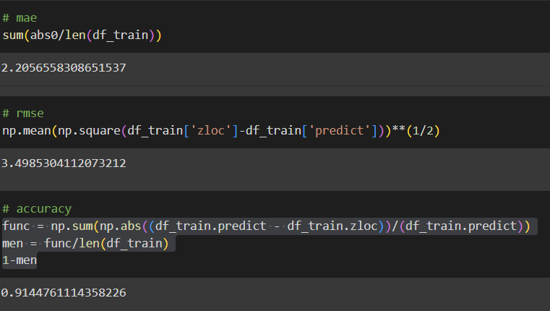

Future work includes further optimizing our model, expanding our dataset, and integrating the model into a real-time autonomous driving system to test its performance in live conditions.