

Lab : 01
Course Title: Cloud Computing
Course Code: SE-3202
Submitted By:
Aman Tariq
Roll No: 2023-SE-29
Semester: 6th Semester
Session: 2023–2027
Submitted To:
Engr. Fahad Nisar
(Lab Instructor)

The University of Azad Jammu and Kashmir, Muzaffarabad
Department of Software Engineering

LAB_TASK_01

Step 1: WSL Install command in Admin PowerShell

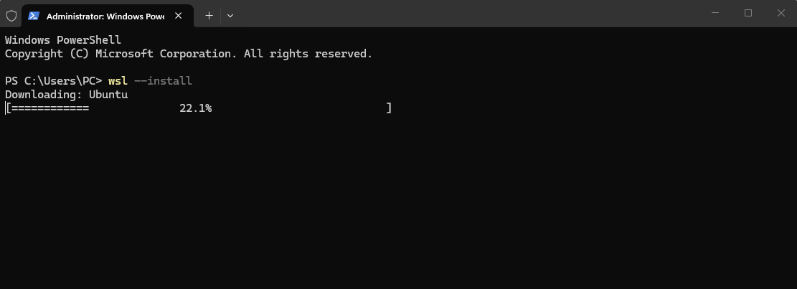
Figure 1: WSL Install command in Admin PowerShell

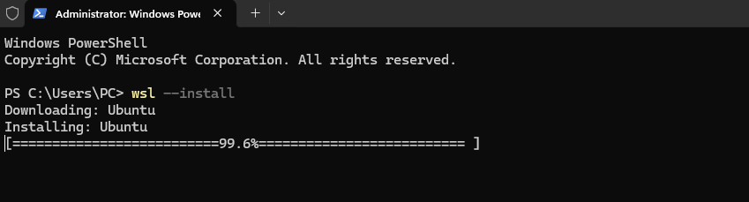

Step 2: Ubuntu successfully installed via WSL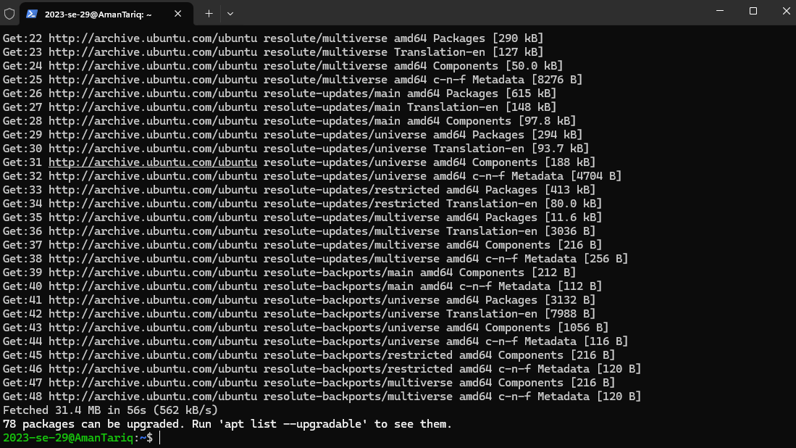
Figure 2: Ubuntu successfully installed via WSL.
.

Step 3: Creating the required Ubuntu user account.
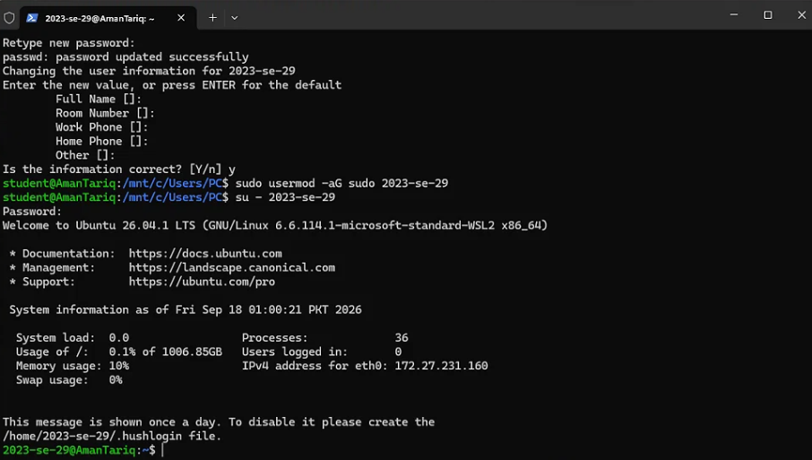
Figure 3: Creating the required Ubuntu user account.
Step 4: Verifying the Ubuntu username using whoami.
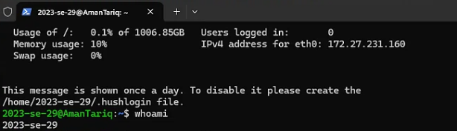
Figure 4: Verifying the Ubuntu username using whoami.
Step 5: Updating Ubuntu packages using sudo apt update.
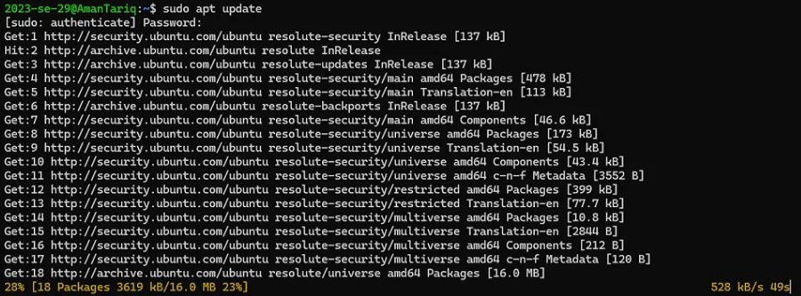
Figure 5: Updating Ubuntu packages using sudo apt update.

Step 6: Upgrading installed packages using sudo apt upgrade -y.
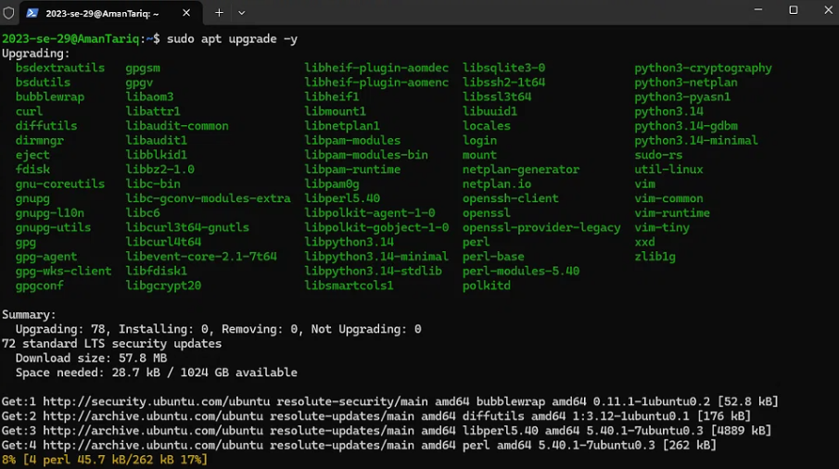
Figure 6: Upgrading installed packages using sudo apt upgrade -y.

Step 7: Final verification of the installation.
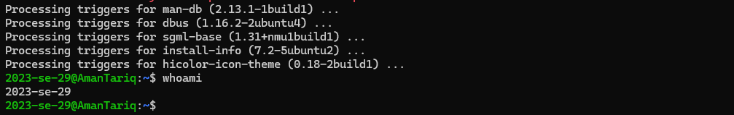
Figure 7: Final verification of the installation.

Thanks!

