

Lab : 02
Course Title: Cloud Computing
Course Code: SE-3202
Submitted By:
Aman Tariq
Roll No: 2023-SE-29
Semester: 6th Semester
Session: 2023–2027
Submitted To:
Engr. Fahad Nisar
(Lab Instructor)

The University of Azad Jammu and Kashmir, Muzaffarabad
Department of Software Engineering

LAB TASK 02 - SSH Key-Based Authentication

Step 1: SSH Server installed and running in WSL Ubuntu.
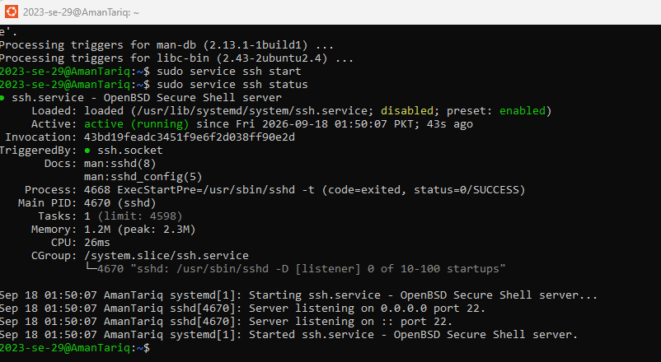
Figure 1: SSH Server installed and running in WSL Ubuntu.
Step 2: Generating SSH key pair using ssh-keygen in Windows PowerShell.
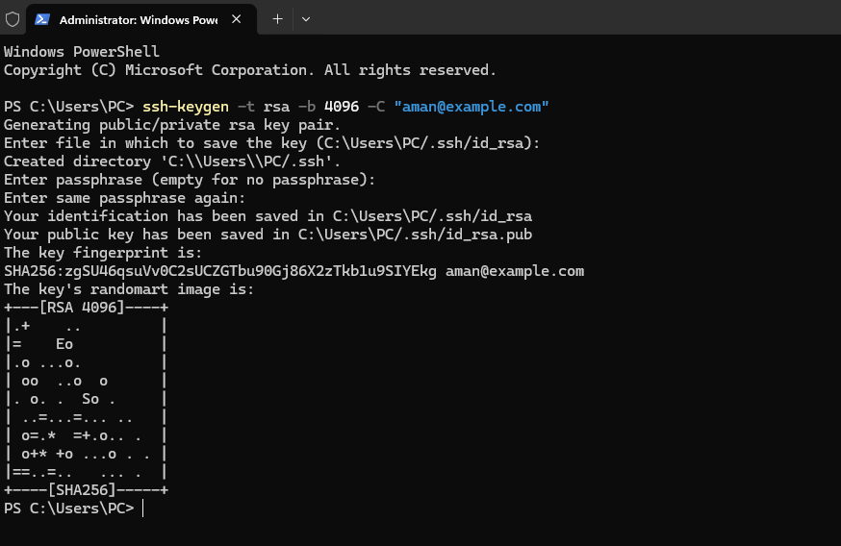
Figure 2: Generating SSH key pair using ssh-keygen in Windows PowerShell
Step 2.1: Viewing the generated public key (id_rsa.pub).
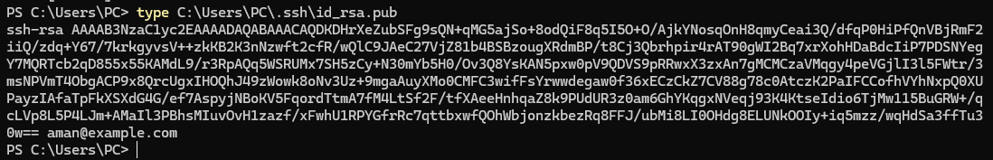
Figure 3: Viewing the generated public key (id_rsa.pub).
Step 3: Deploying the public key to WSL Ubuntu's authorized_keys.
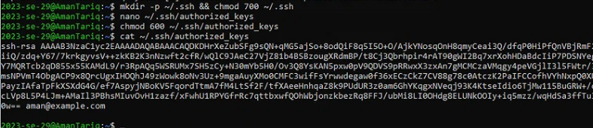
Figure 4: Deploying the public key to WSL Ubuntu's authorized_keys.
Step 4: Successful password-less SSH connection from Windows to WSL.
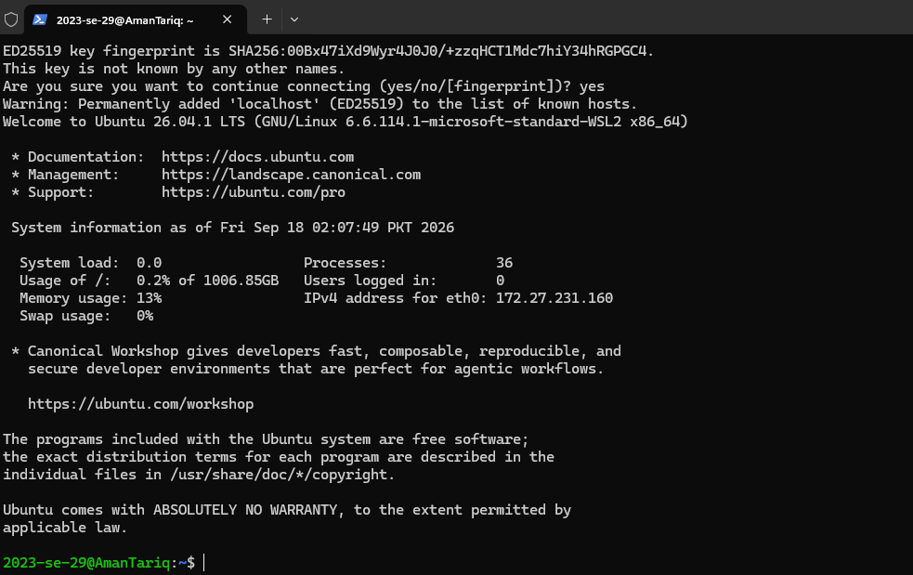
Figure 5: Successful password-less SSH connection from Windows to WSL.
Step 4.1: Verifying the connection and user identity.
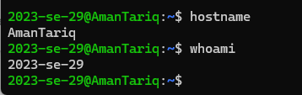
Figure 6: Verifying the connection and user identity.

Thanks!

