

Lab : 03
Course Title: Cloud Computing
Course Code: SE-3202
Submitted By:
Aman Tariq
Roll No: 2023-SE-29
Semester: 6th Semester
Session: 2023–2027
Submitted To:
Engr. Fahad Nisar
(Lab Instructor)

The University of Azad Jammu and Kashmir, Muzaffarabad
Department of Software Engineering

_LAB TASK 03 _
Securing SSH - Disabling Password Authentication and Root Login

Step 1: Confirming key-based login works before any configuration change.
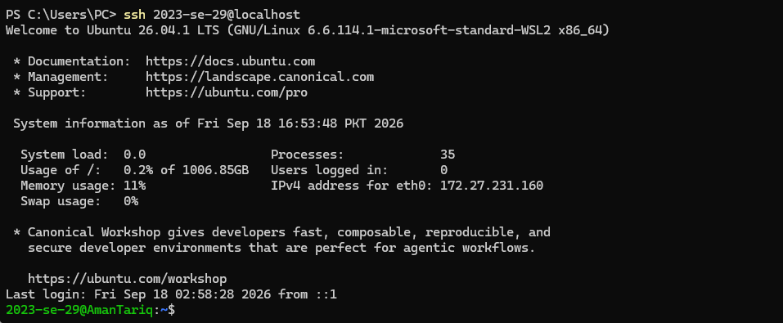
Figure 1: Confirming key-based login works before any configuration change.

Step 2: Editing the SSH server configuration.
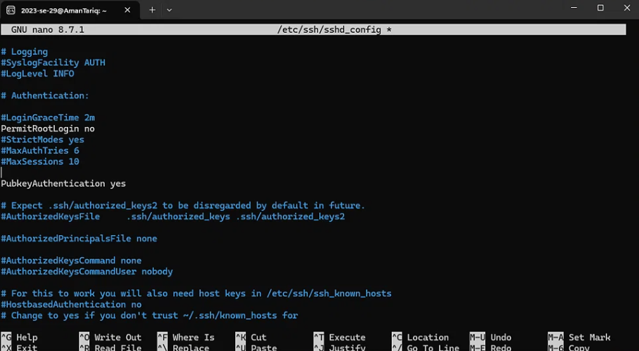
Figure 2: Editing the SSH server configuration.

Step 3: Restarting SSH service and verifying it is active (running).
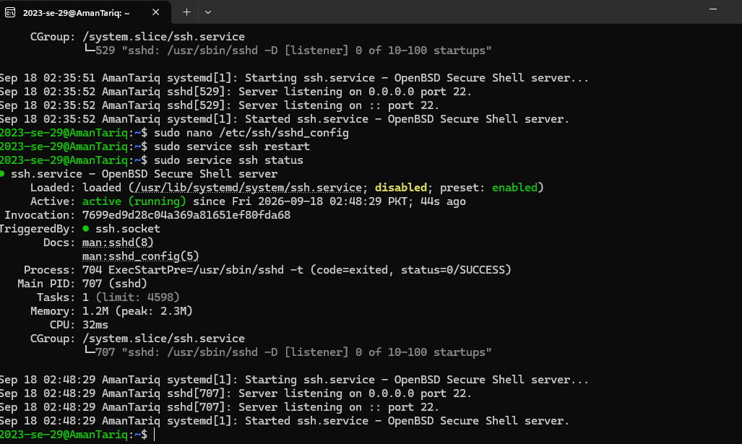
Figure 3: Restarting SSH service and verifying it is active (running).

Step 4: Testing key-based login still works after configuration change.
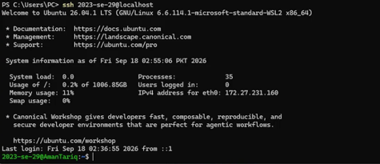
Figure 4: Testing key-based login still works after configuration change.
Step 4.1: Verifying password authentication is disabled.
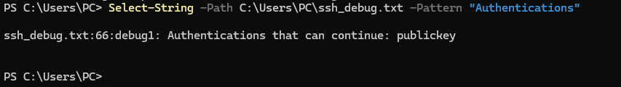
Figure 5: Verifying password authentication is disabled.
Thanks!

