

Lab : 04
Course Title: Cloud Computing
Course Code: SE-3202
Submitted By:
Aman Tariq
Roll No: 2023-SE-29
Semester: 6th Semester
Session: 2023–2027
Submitted To:
Engr. Fahad Nisar
(Lab Instructor)

The University of Azad Jammu and Kashmir, Muzaffarabad
Department of Software Engineering
LAB TASK 04 - Deploying a Static Website to a Free Hosting Platform

Step 1: Static website project working locally in browser.
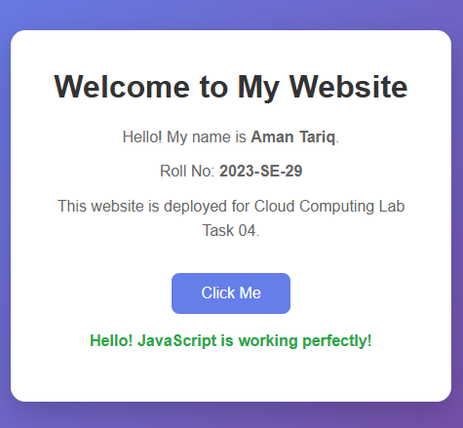
Figure 1: Static website project working locally in browser.
Step 2: Pushing the project to GitHub using Git commands.
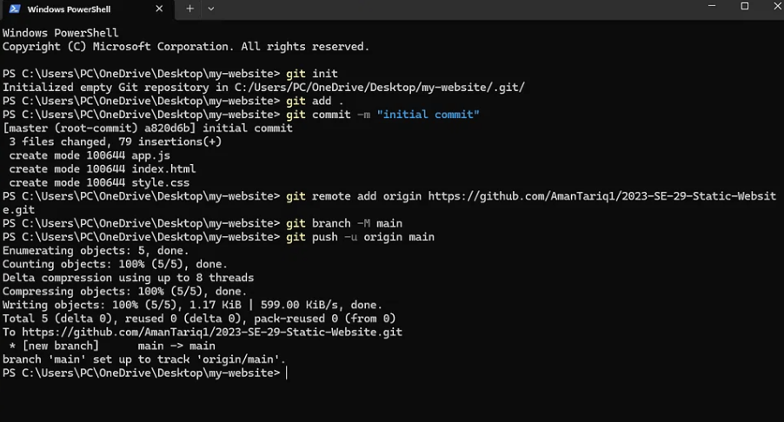
Figure 2: Pushing the project to GitHub using Git commands.
Step 2.1: GitHub repository with all project files.
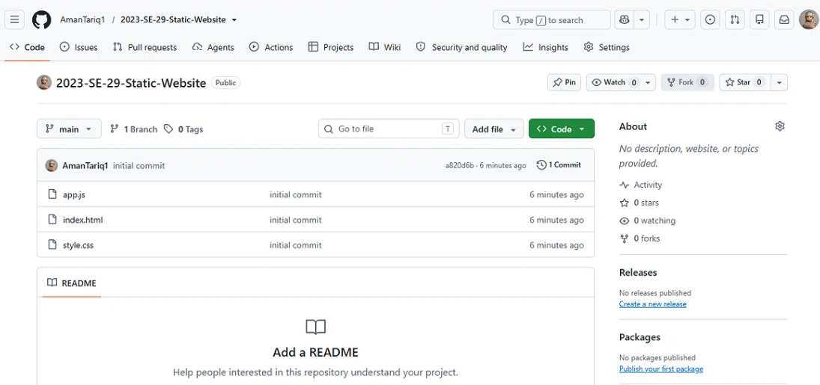
Figure 3: GitHub repository with all project files.
Step 3: Signing up on Netlify and connecting GitHub.
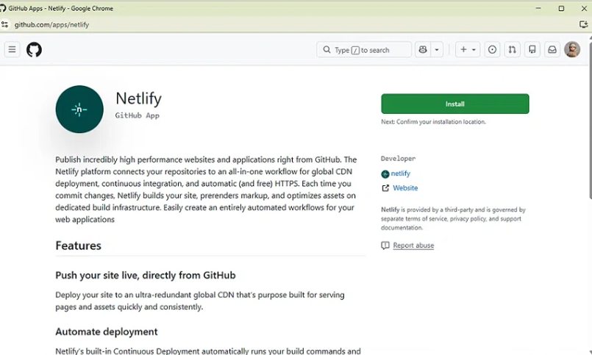
Figure 4: Signing up on Netlify and connecting GitHub.
Step 4: Connecting and deploying the project on Netlify.
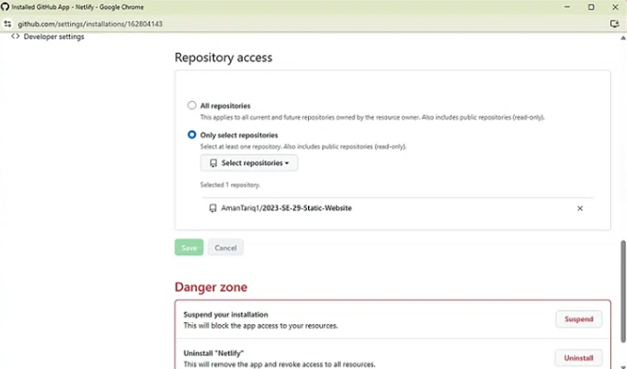
Figure 5: Connecting and deploying the project on Netlify.

Step 5: Live website accessible at public URL.
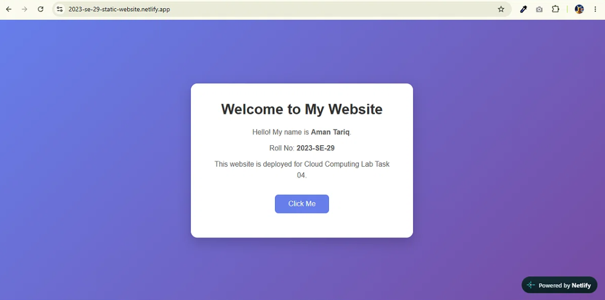
Figure 6: Live website accessible at public URL.

Step 5.1: Auto-deployment confirmed after making a change.

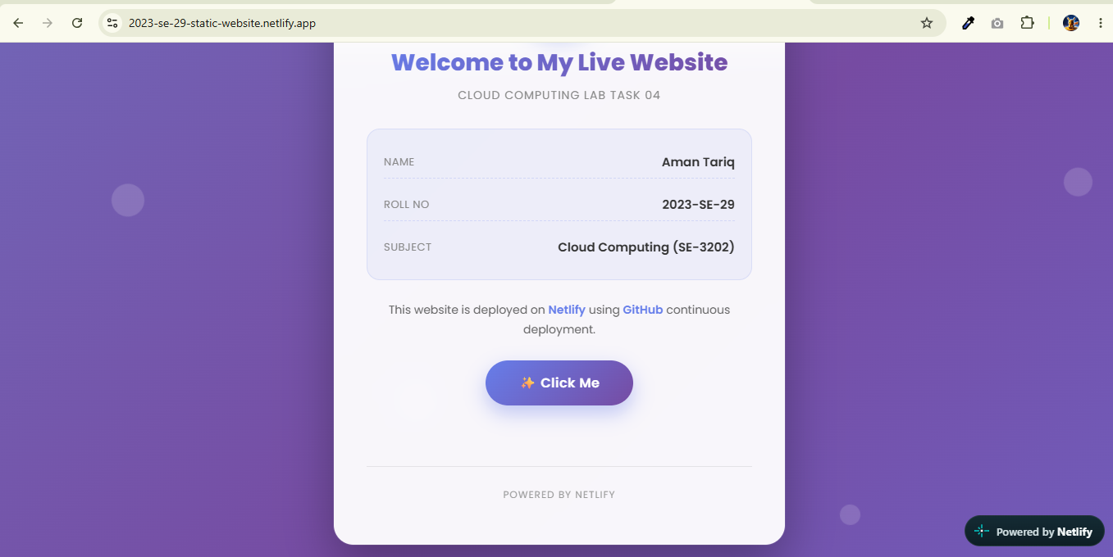
Figure 7: Auto-deployment confirmed after making a change.

Thanks!

