

Lab : 05
Course Title: Cloud Computing
Course Code: SE-3202
Submitted By:
Aman Tariq
Roll No: 2023-SE-29
Semester: 6th Semester
Session: 2023–2027
Submitted To:
Engr. Fahad Nisar
(Lab Instructor)

The University of Azad Jammu and Kashmir, Muzaffarabad
Department of Software Engineering
LAB TASK 05 - Deploying a Web App with a Backend Server

Step 1: Node.js installed, dependencies installed, and server running locally.
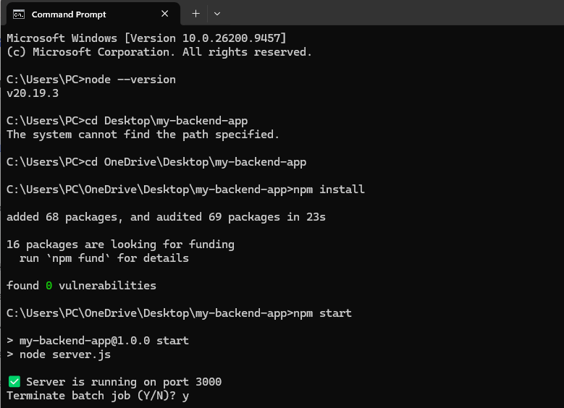
Figure 1: Node.js installed, dependencies installed, and server running locally.

Step 1.1: App working locally in browser.
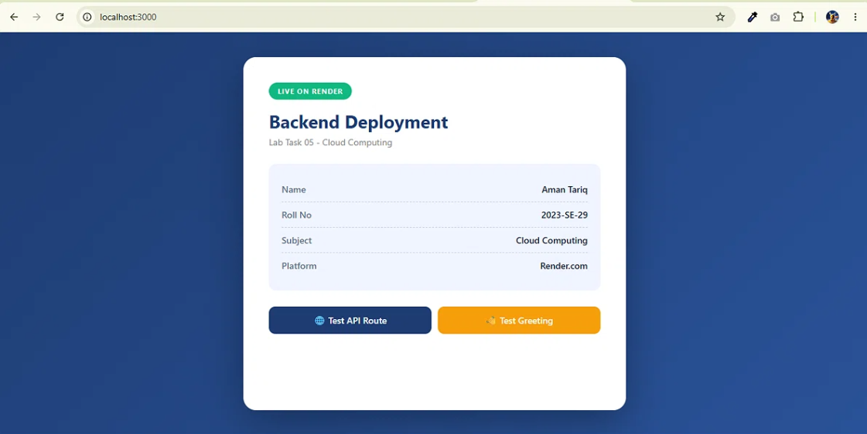
Figure 2: App working locally in browser.
Step 1.2: API route working locally.
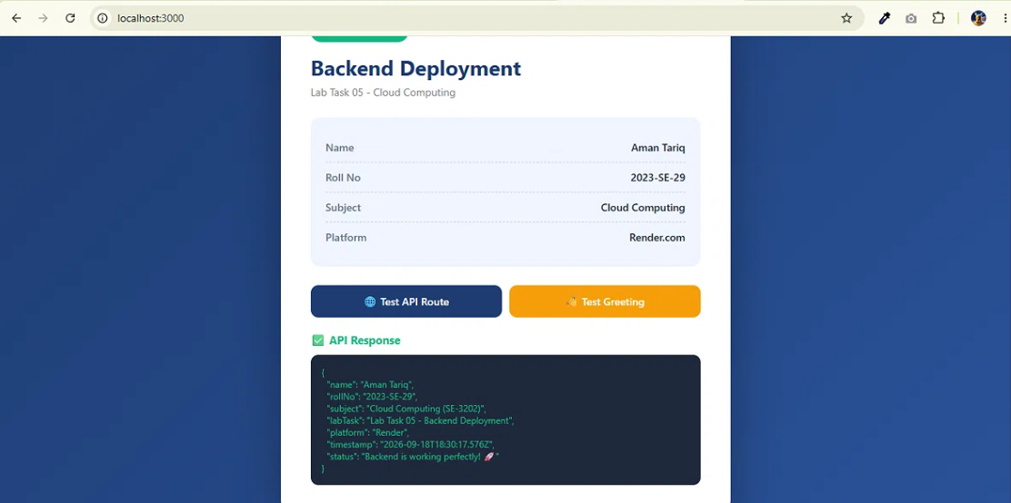
Figure 3: API route working locally.

Step 1.3: Greeting route working locally.
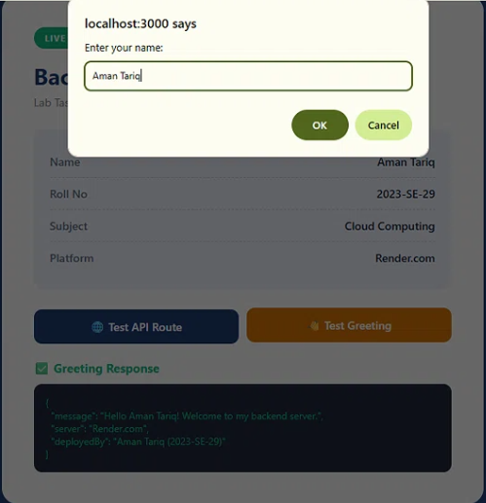
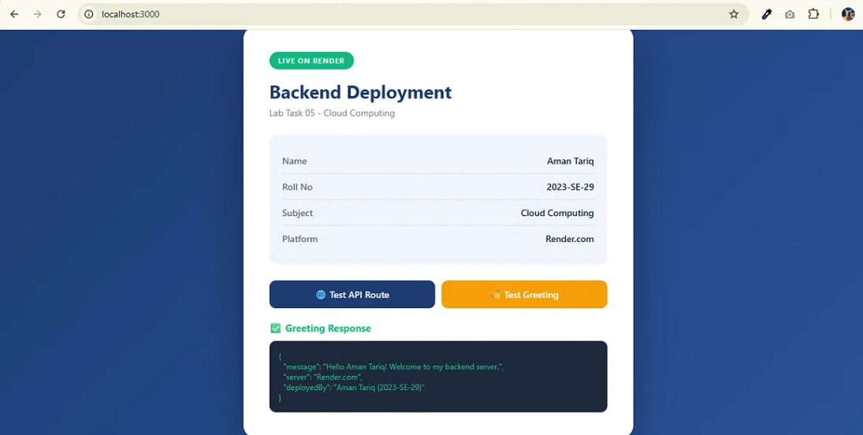
Figure 4: Greeting route working locally.

Step 2: Pushing project to GitHub.
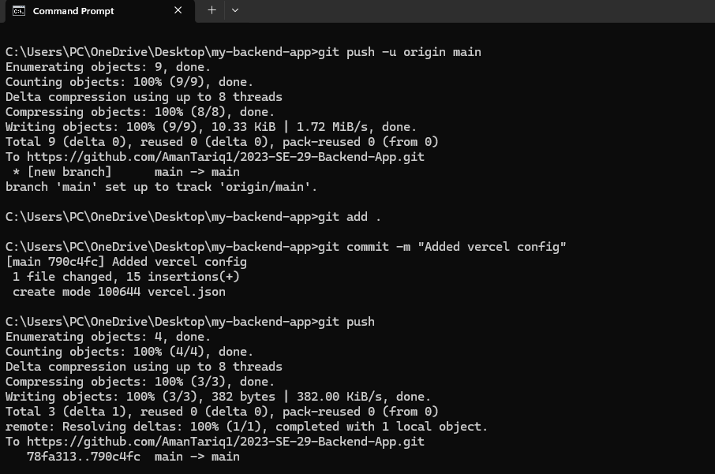
Figure 5: Pushing project to GitHub.

Step 2.1: GitHub repository with all project files.
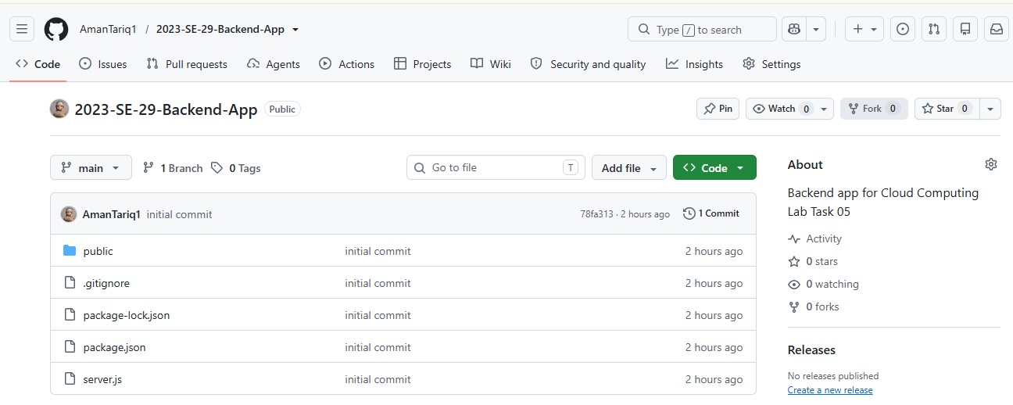
Figure 6: GitHub repository with all project files.

Step 3: Signing up on Vercel.
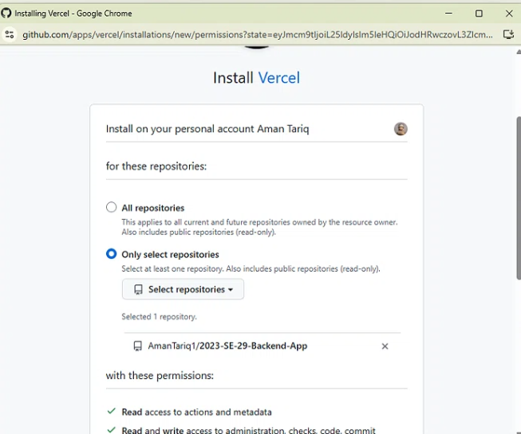
Figure 7: Signing up on Vercel and connecting GitHub

Step 4: Configuring project on Vercel.
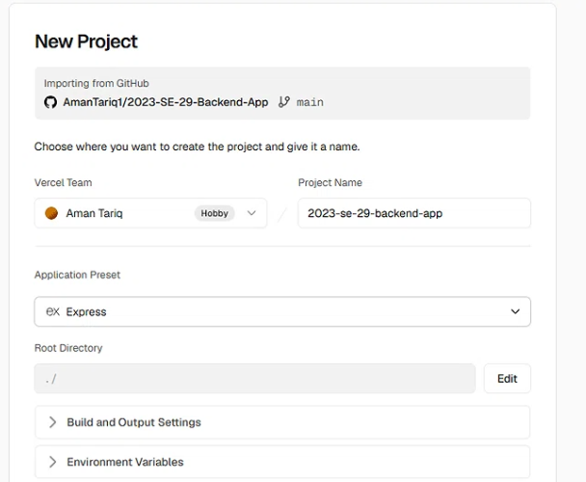
Figure 8: Configuring project on Vercel.

Step 4.1: Deployment complete on Vercel.
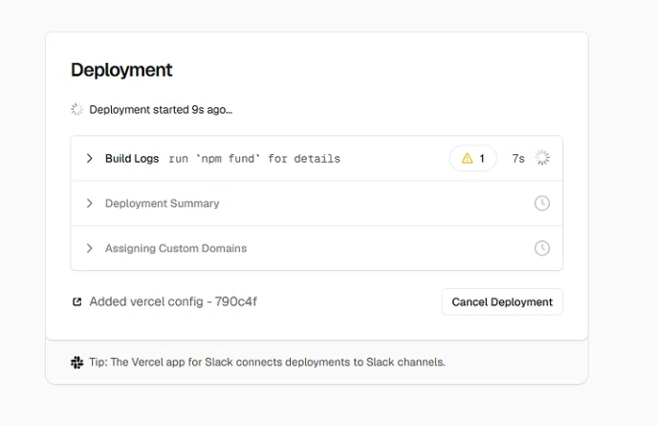
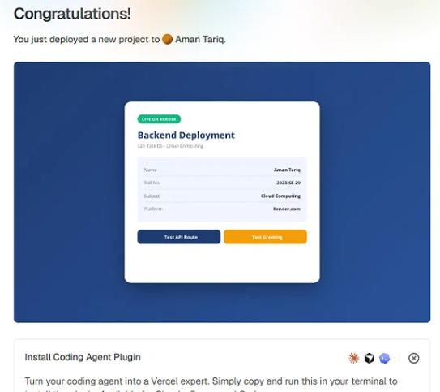
Figure 9: Deployment complete on Vercel.

Step 5: Live app accessible at public URL.
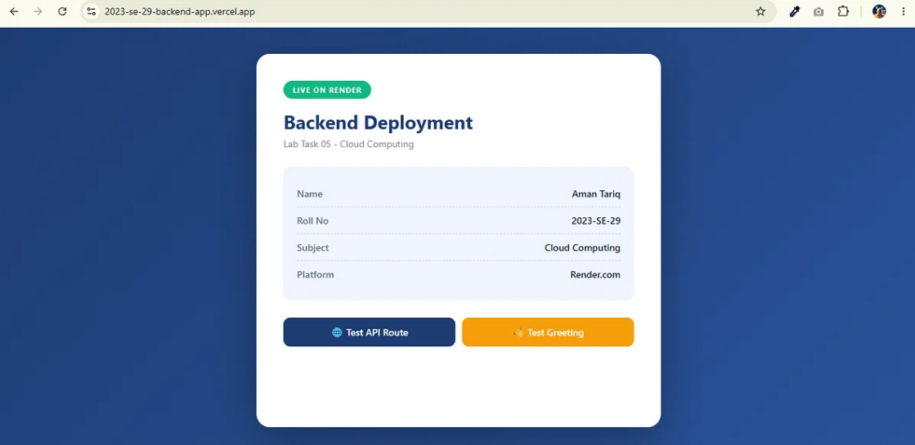
Figure 10: app accessible at public URL.

Thanks!

