

Lab : 06
Course Title: Cloud Computing
Course Code: SE-3202
Submitted By:
Aman Tariq
Roll No: 2023-SE-29
Semester: 6th Semester
Session: 2023–2027
Submitted To:
Engr. Fahad Nisar
(Lab Instructor)

The University of Azad Jammu and Kashmir, Muzaffarabad
Department of Software Engineering
LAB TASK 06 - Docker Fundamentals - Install, Run, and Explore Containers

Step 1: Docker Desktop installed
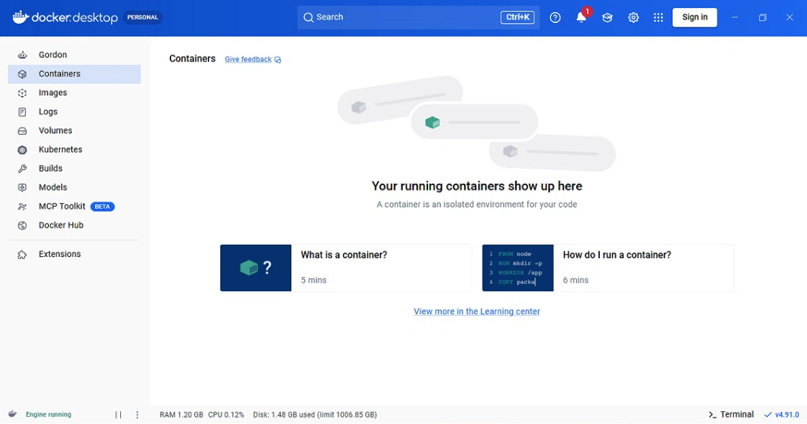
Figure 1: Docker Desktop installed and running.
Step 1.1: Docker version verified
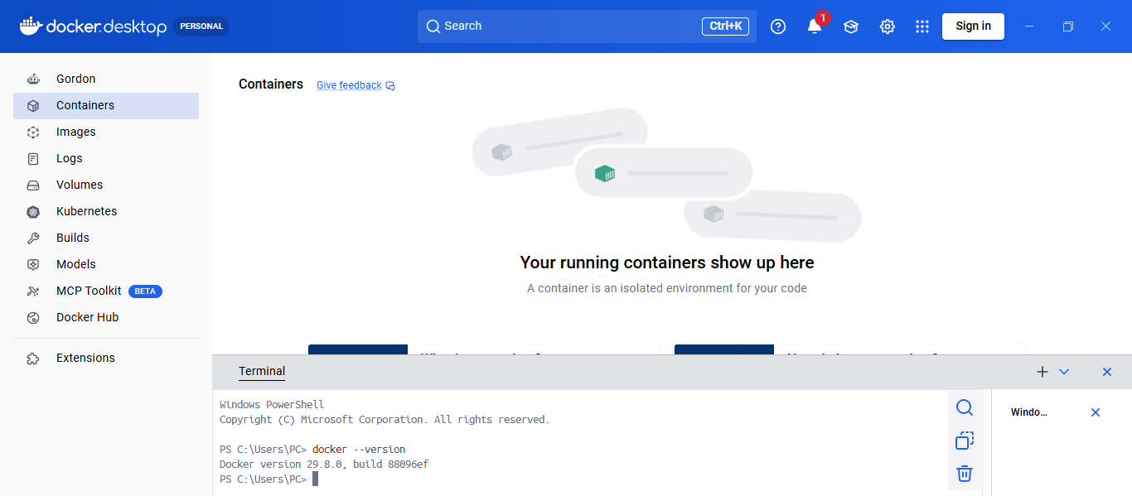
Figure 2: Docker version verified

Step 2: Hello World container
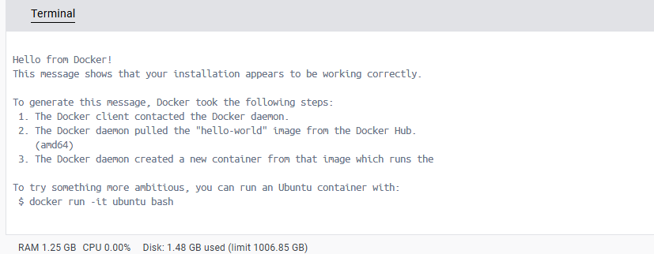
Figure 3: Hello World container

Step 3: Pulling LLM model
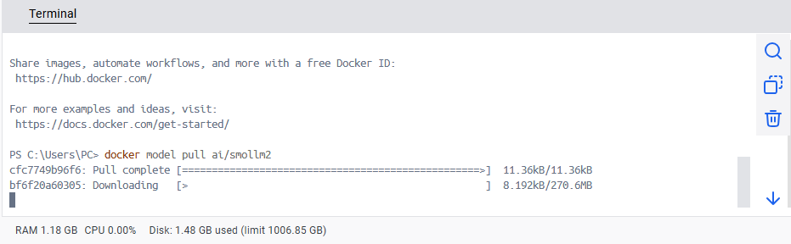
Figure 4: Pulling LLM model

Step 3.1: AI model response
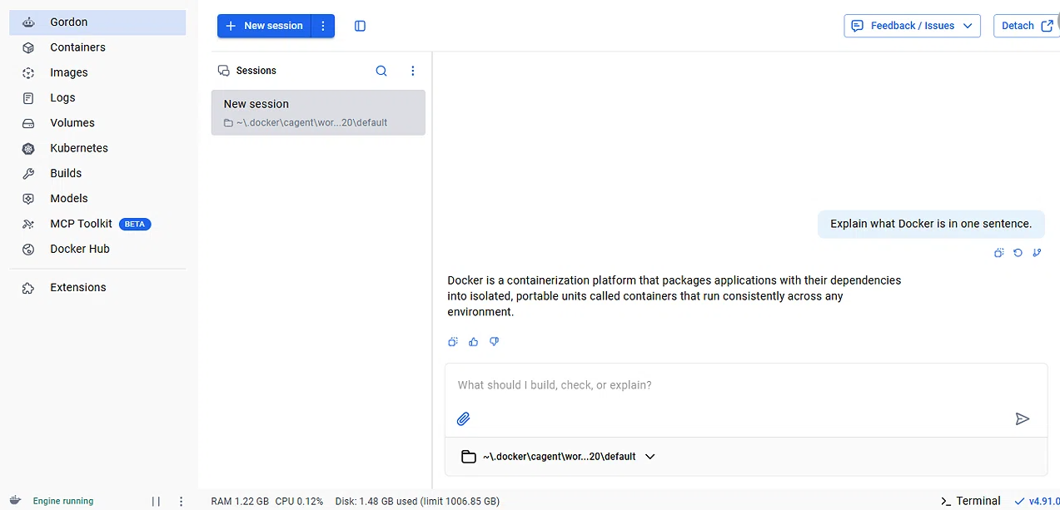
Figure 5: AI model response

Step 4: Listing images
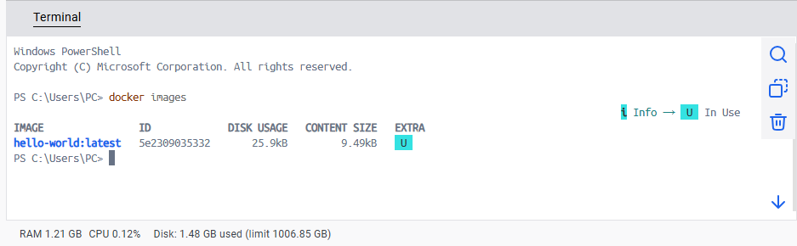
Figure 6: Listing images
Step 4.1: Listing AI models
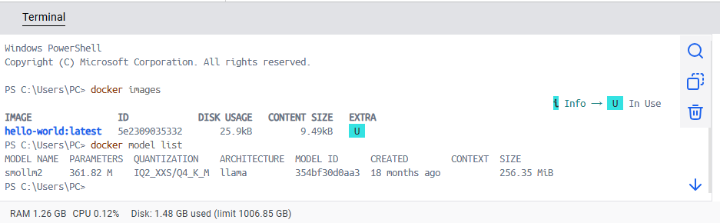
Figure 7: Listing AI models
Step 4.2: Listing running containers
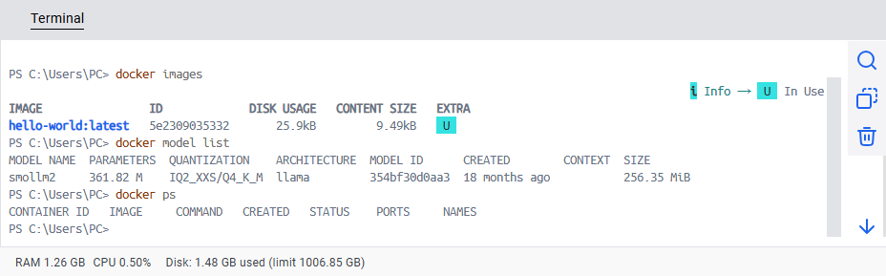
Figure 8: Listing running containers
Step 4.3: Listing all containers
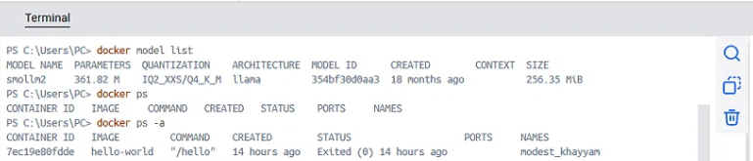
Figure 9: Listing all containers

Step 4.4: Viewing container logs
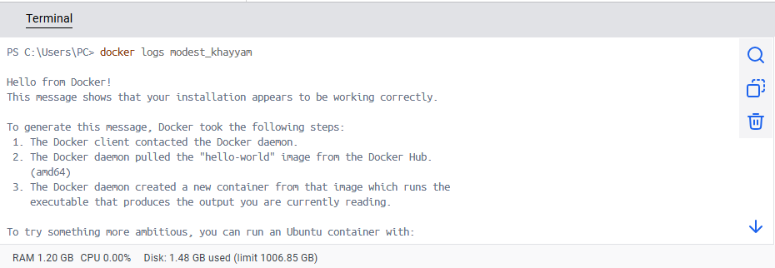
Figure 10: Viewing container logs
Step 5: Reflection
Docker Image vs Docker Container:
A Docker image is a read-only template that contains application code, libraries, and dependencies needed to run an application. A Docker container is a running instance of a Docker image — it is the live, executing environment created from that image. Multiple containers can be created from the same image.
Docker Container vs Virtual Machine:
One key difference I noticed is that Docker containers share the host operating system's kernel, making them lightweight and fast to start (in seconds), whereas a full virtual machine includes its own complete operating system, making it much heavier and slower to boot. Containers also use less disk space and RAM compared to VMs.

Thanks!

