

Lab : 07
Course Title: Cloud Computing
Course Code: SE-3202
Submitted By:
Aman Tariq
Roll No: 2023-SE-29
Semester: 6th Semester
Session: 2023–2027
Submitted To:
Engr. Fahad Nisar
(Lab Instructor)

The University of Azad Jammu and Kashmir, Muzaffarabad
Department of Software Engineering
LAB TASK 07 - Dockerfile - Build, Run, and Inspect a Custom Image

Step 1: Dockerfile created in project folder
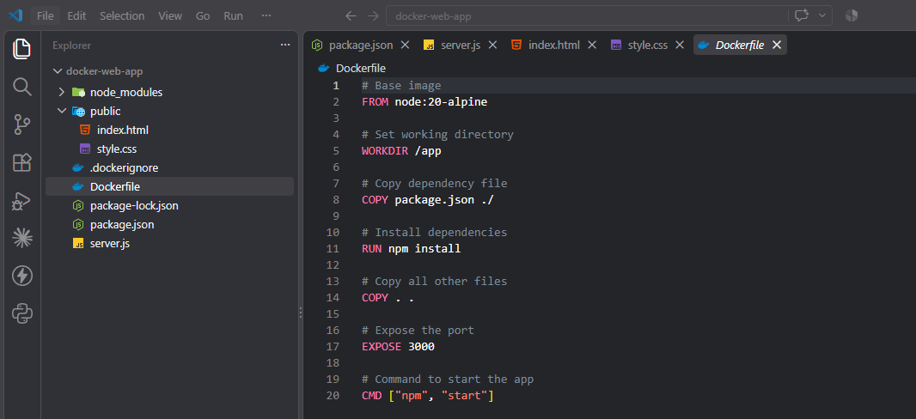
Figure 1: Dockerfile created in project folder
Step 2: App working locally before Docker
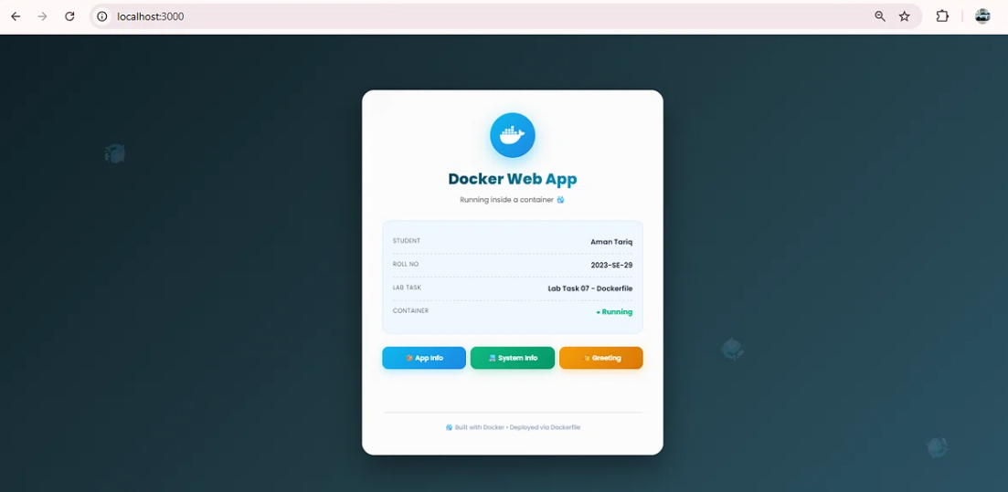
Figure 2: App working locally before Docker
Step 3: Docker image built successfully
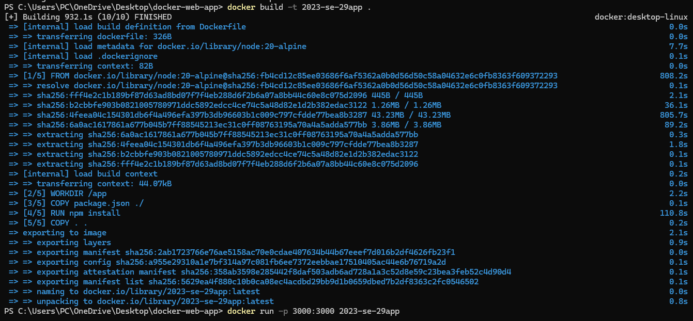
Figure 3: Docker image built successfully
Step 4: Container running successfully
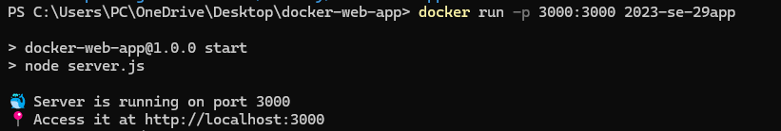
Figure 4: Container running successfully
Step 4.1: App accessible in browser via Docker
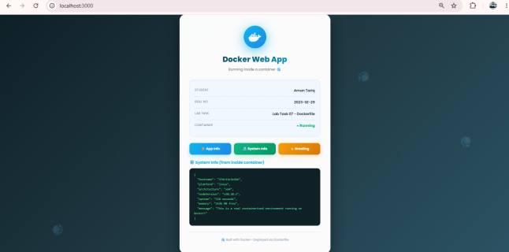
Figure 5: App accessible in browser via Docker
Step 4.2: App running inside Docker container
Figure 6: App running inside Docker container
Step 5: Listing images - 2023-se-29app visible
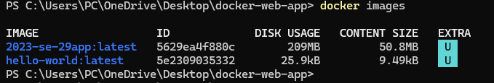
Figure 7: Listing images - 2023-se-29app visible
Step 5.1: Listing running containers
Figure 8: Listing running containers

Thanks!

