

Lab : 08
Course Title: Cloud Computing
Course Code: SE-3202
Submitted By:
Aman Tariq
Roll No: 2023-SE-29
Semester: 6th Semester
Session: 2023–2027
Submitted To:
Engr. Fahad Nisar
(Lab Instructor)

The University of Azad Jammu and Kashmir, Muzaffarabad
Department of Software Engineering
LAB TASK 08 - Multi-Container Apps with Docker Compose

Step 1: docker-compose.yml with web + redis
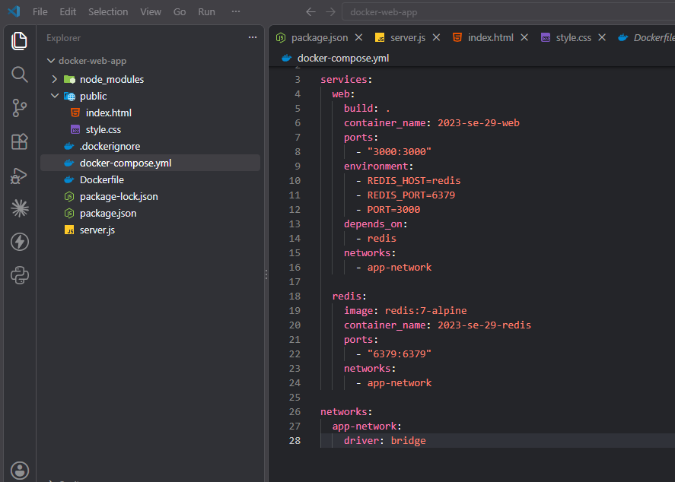
Figure 1: docker-compose.yml with web + redis
Step 2: Starting all services
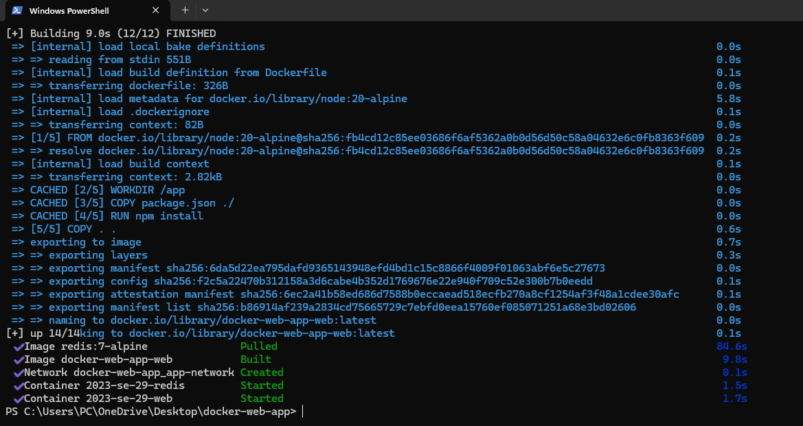
Figure 2: Starting all services
Step 3: Verifying both services running
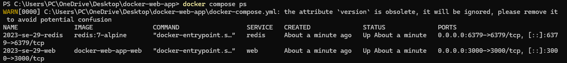
Figure 3: Verifying both services running
Step 3.1: App via Docker Compose
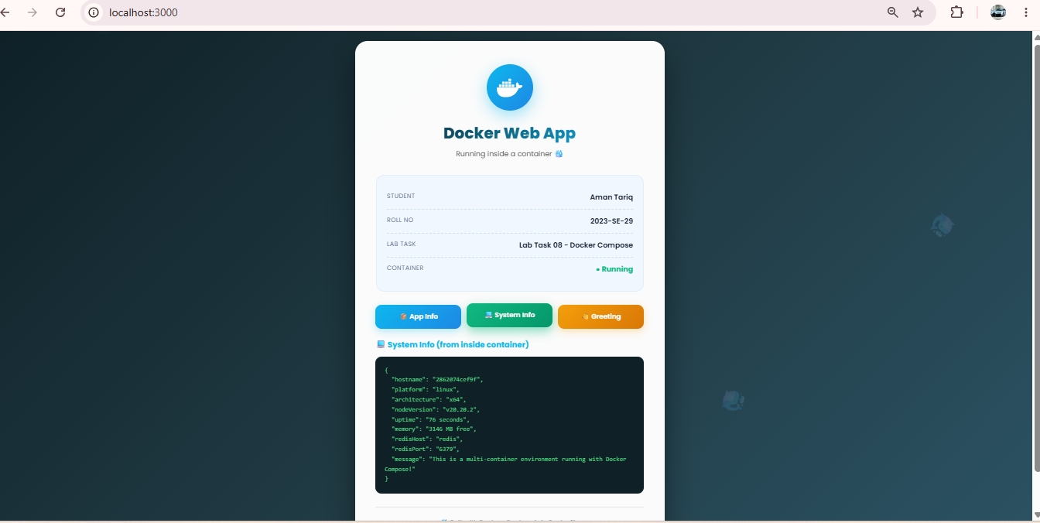
Figure 4: App via Docker Compose
Step 3.2: App showing both services + Redis
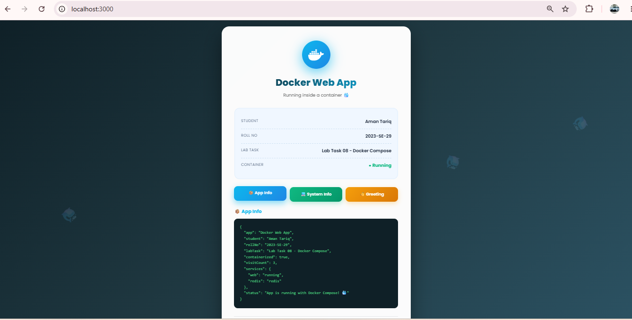
Figure 5: App showing both services + Redis
Step 4: Combined logs from all services
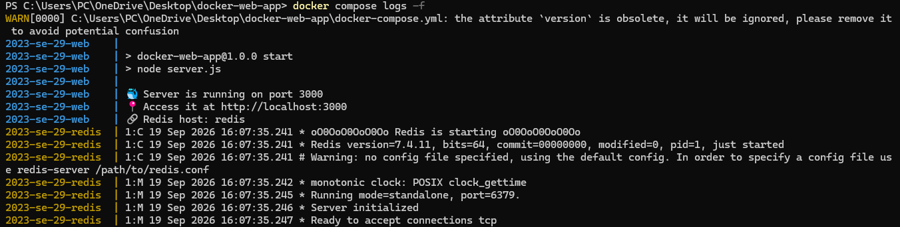
Figure 6: Combined logs from all services
Step 4.1: Stopping all services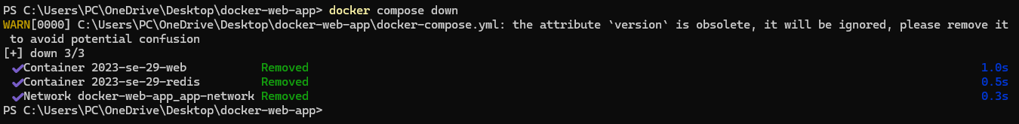
Figure 7: Stopping all services

Thanks!

