Submitted By: Aman Tariq
Roll No: 2023-SE-29
Course Name: DIP
Course Code: SE-3112
Session: 2023-2027
Submitted To: Engr. Ahmed Khawaja

OPEN ENDED LAB
-: DIP :-

Table of Contents
OPEN ENDED LAB 1
1. Introduction 3
2. Dataset Description 3
3. System Architecture 3
4. Data Loading and CSV Creation 4
5. Image Preprocessing 4
5.1 Image Resizing 4
5.2 Brightness and Contrast Adjustment 4
6. Hair and Noise Removal 4
7. Color Normalization 4
8. Lesion Segmentation 4
9. Segmentation Evaluation 5
10. Feature Extraction 6
10.1 Texture Features 6
10.2 Color Features 6
10.3 Shape Features 6
11. Dataset Labeling 6
12. Classification Models 6
12.1 Support Vector Machine (SVM) 6
12.2 K-Nearest Neighbors (KNN) 7
12.3 Logistic Regression 8
12.4 Decision Tree 8
13. Model Comparison 8
14. Results and Discussion 8
15. Conclusion 8
16. Future Work 9
17. Tools and Technologies 9
18. References 9

OEL: Skin Cancer Detection (PH2 Dataset)
OEL_LAB_REPORT

1. Introduction
Skin cancer, particularly melanoma, is one of the most dangerous forms of cancer if not detected early. Dermoscopic image analysis using Digital Image Processing (DIP) and Machine Learning (ML) plays a crucial role in assisting dermatologists with early diagnosis. This project presents a complete pipeline for skin lesion analysis using the PH2 dataset, covering image preprocessing, lesion segmentation, feature extraction, and classification.
The goal of this work is to automatically segment skin lesions, extract meaningful features, and classify lesions using different machine learning models.

2. Dataset Description
The PH2 dataset contains dermoscopic images categorized into benign and malignant cases. Each image folder includes:
- Original dermoscopic image (.bmp)
- Ground truth lesion mask (.bmp)
The dataset is stored on Google Drive and accessed through Google Colab.

3. System Architecture
The system follows these main stages:
- Data Loading and CSV Generation
- Image Preprocessing
- Hair and Noise Removal
- Color Normalization
- Lesion Segmentation
- Performance Evaluation
- Feature Extraction
- Classification Using ML Models

4. Data Loading and CSV Creation
Dermoscopic image paths are automatically extracted from dataset folders and stored in a CSV file. This allows structured access to image IDs and paths throughout the pipeline.
Output:
- dermoscopic_image_paths.csv

5. Image Preprocessing

5.1 Image Resizing
All images are resized to a uniform resolution (767 × 576) to ensure consistency during processing and feature extraction.

5.2 Brightness and Contrast Adjustment
Contrast and brightness are adjusted using linear transformation to enhance lesion visibility.

6. Hair and Noise Removal
Hairs and noise are removed using:
- Grayscale conversion
- Gaussian blur
- Adaptive thresholding
- Morphological closing
- Image inpainting
This step significantly improves segmentation accuracy.
Output Directory:
- noiseless_images/

7. Color Normalization
Color normalization is applied using the LAB color space and CLAHE (Contrast Limited Adaptive Histogram Equalization) on the L-channel. This reduces illumination variation across images.

8. Lesion Segmentation
Lesion segmentation is performed using:
- Grayscale conversion
- Otsu thresholding
- Morphological opening and dilation
- Contour detection
The largest contour is selected as the lesion region.
Generated Outputs:
- Binary lesion masks
- Masked lesion images

9. Segmentation Evaluation
The generated lesion masks are evaluated against ground truth masks using:
- Accuracy
- Sensitivity (Recall for lesion class)
- Specificity (Recall for background class)
- Confusion Matrix
This evaluation is performed pixel-wise across all images.
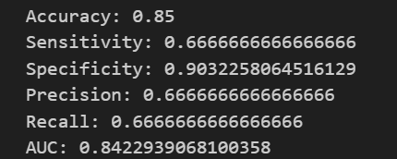
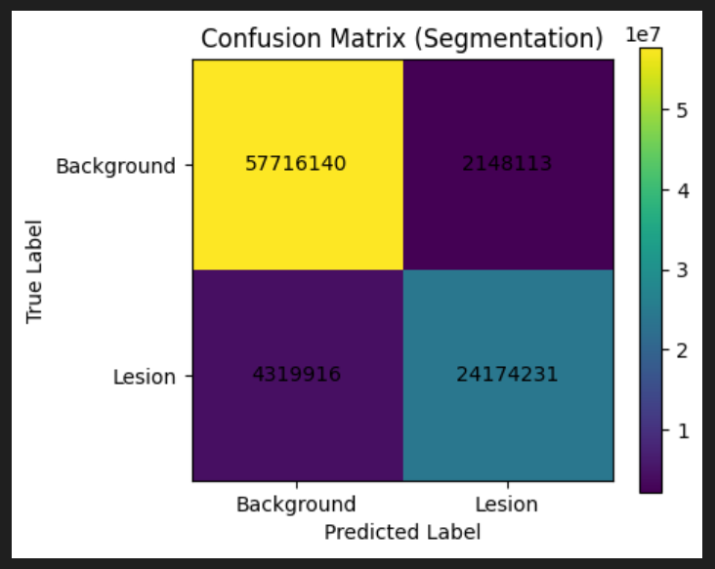

10. Feature Extraction
Three categories of features are extracted from masked lesion images:

10.1 Texture Features
- Gray Level Co-occurrence Matrix (GLCM)
- Contrast
- Dissimilarity
- Homogeneity
- Energy
- Correlation

10.2 Color Features
- Mean and standard deviation of LAB color channels

10.3 Shape Features
- Shannon entropy
- Lesion area
- Lesion perimeter
All features are combined into a single feature vector per image.
Output File:
- image_featuresss.csv

11. Dataset Labeling
Class labels are loaded from an Excel file and merged with extracted features using image IDs.
Final Dataset:
- image_features_with_levelss.csv

12. Classification Models
The following machine learning models are trained and evaluated:

12.1 Support Vector Machine (SVM)
- Linear kernel
- Evaluated using Accuracy, Sensitivity, Specificity, Precision, Recall, and AUC
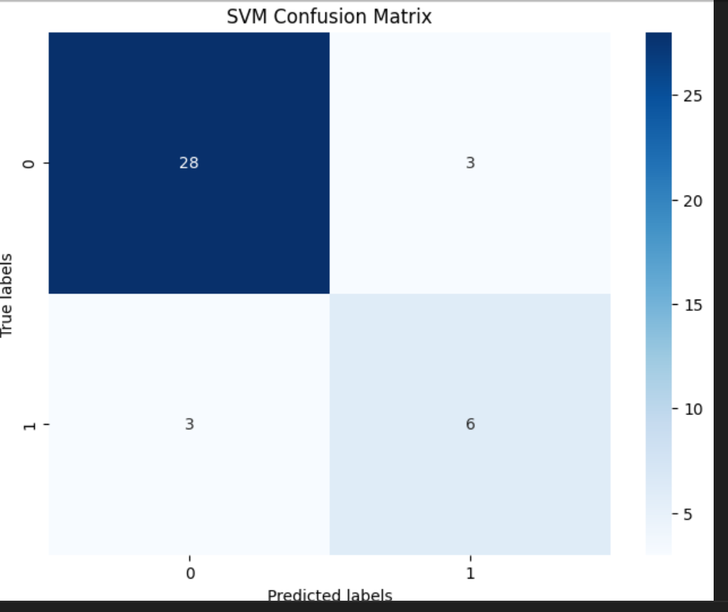

12.2 K-Nearest Neighbors (KNN)
- k = 5
- Evaluated using Accuracy, Sensitivity, Specificity, Precision, Recall

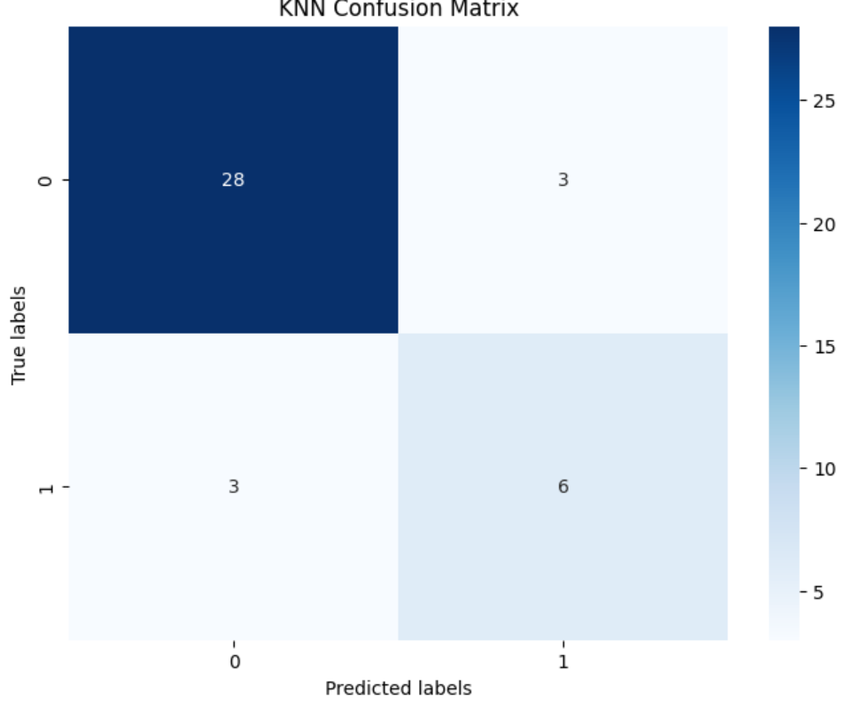

12.3 Logistic Regression
- Evaluated using Accuracy and ROC-AUC

12.4 Decision Tree
- Evaluated using Accuracy, Sensitivity, Specificity, Precision, Recall

13. Model Comparison
All models are compared using accuracy scores. A bar graph is plotted to visualize model performance and identify the best classifier.
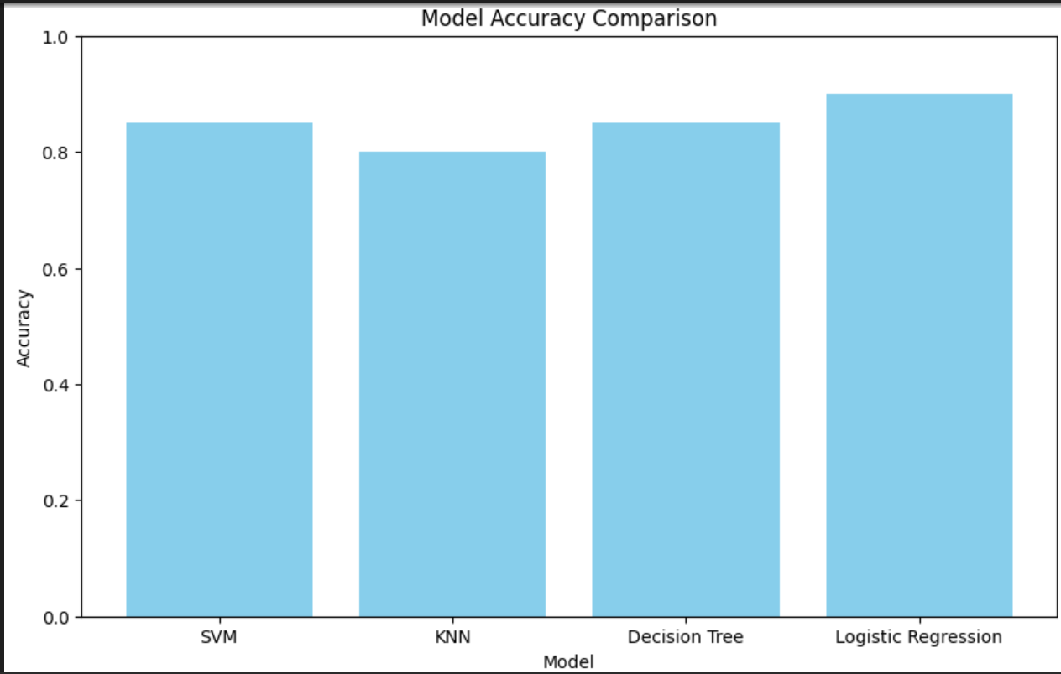

14. Results and Discussion
- Image preprocessing significantly improves segmentation quality
- Hair removal and color normalization enhance lesion boundaries
- Feature-based ML models successfully classify lesions
- SVM and Logistic Regression show strong performance

15. Conclusion
This project demonstrates a complete and effective pipeline for automated skin lesion analysis using DIP and ML techniques. The system successfully segments lesions, extracts meaningful features, and classifies skin lesions with good accuracy. Such systems can support dermatologists in early melanoma detection.

16. Future Work
- Use deep learning (CNNs) for end-to-end learning
- Improve segmentation using U-Net
- Apply feature selection techniques
- Extend dataset for better generalization

17. Tools and Technologies
- Python
- OpenCV
- Scikit-learn
- Scikit-image
- Google Colab
- PH2 Dataset

18. References
- PH2 Dataset – Dermoscopic Image Database
- OpenCV Documentation
- Scikit-learn Documentation
- Digital Image Processing – Gonzalez & Woods

THANKS!

