DIP_Lab_Task # 03-04
Submitted By: Aman Tariq
Roll No: 2023-SE-29
Course Name: DIP
Course Code: SE-3112
Session: 2023-2027
Submitted To: Engr. Ahmed Khawaja

Lab Task 3-4 (Histogram Equalization & Contrast Enhancement)
1. Introduction
Image enhancement is an important area of image processing that improves the visual quality of an image. Techniques such as histogram equalization, contrast stretching, and intensity transformations are used to enhance contrast and highlight important details.
In this lab, a colored image is taken as an input image. Different enhancement techniques including built-in histogram equalization, manual histogram equalization, contrast stretching, log transformation, and gamma correction are applied. The resulting output images show improved contrast and brightness for better visualization.
4. Methodology / Procedure
The following steps were performed in this lab:
Input Image Loading
- A colored image was loaded using OpenCV.
- The image was converted from BGR to RGB for correct visualization.
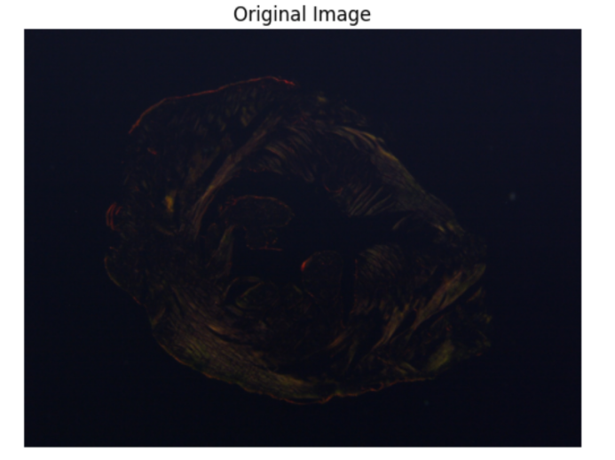
Histogram Equalization (Built-in Method)
- The image was converted into YCrCb color space.
- Histogram equalization was applied only on the Y (luminance) channel.
- The image was then converted back to RGB format.
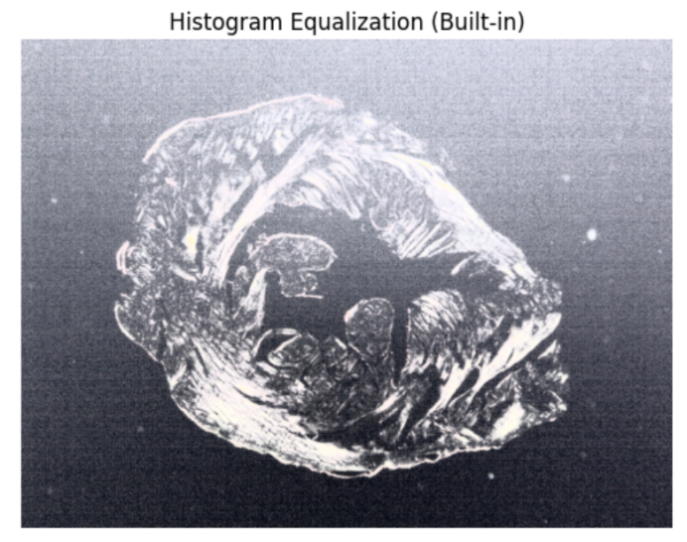
Histogram Equalization (Manual Method)
- The image was converted to grayscale.
- Histogram and cumulative distribution function (CDF) were calculated.
- Pixel values were remapped using the normalized CDF to enhance contrast.
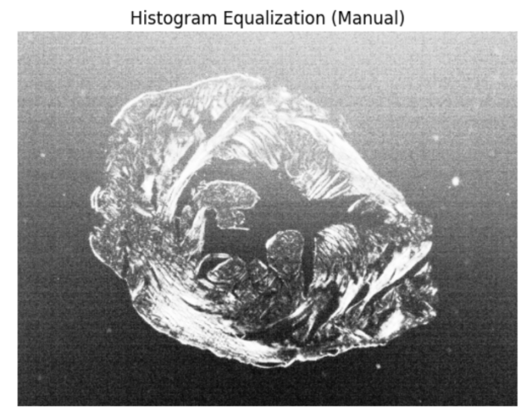
Histogram Comparison
- Histograms of the original image and the manually equalized image were plotted.
- This comparison shows the distribution of pixel intensities before and after equalization.

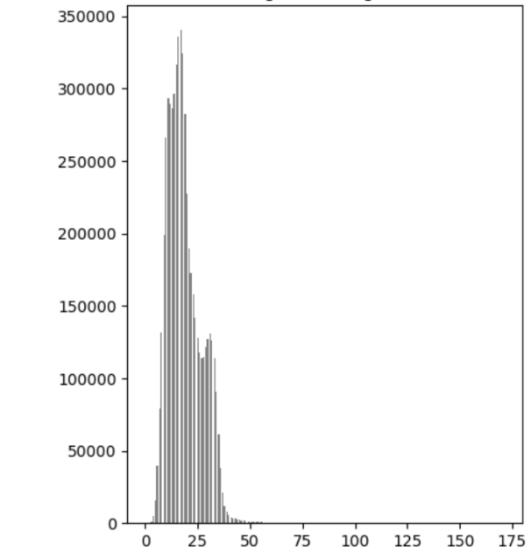
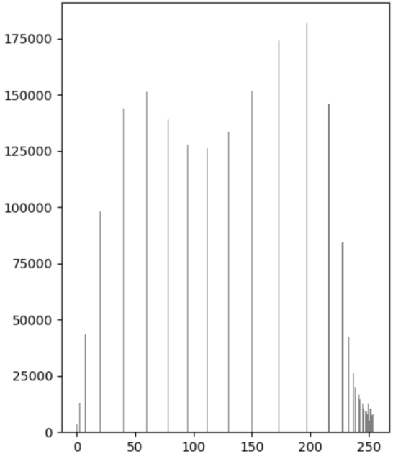
Contrast Stretching
- Minimum and maximum intensity values were calculated.
- Pixel values were stretched to the full intensity range (0–255) to improve contrast.
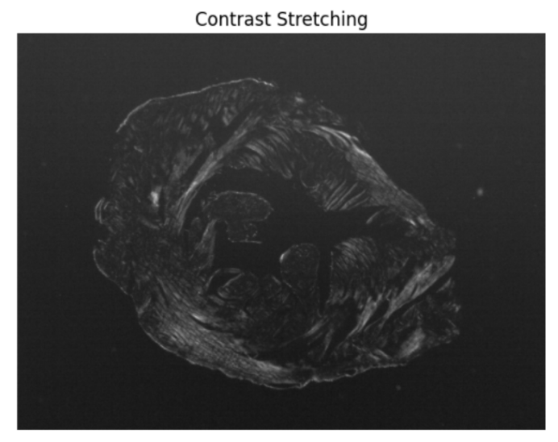
Log and Gamma Transformations
- Log transformation was applied to enhance darker regions of the image.
- Gamma transformation was applied to control brightness and contrast.
- These transformations help in emphasizing image details.
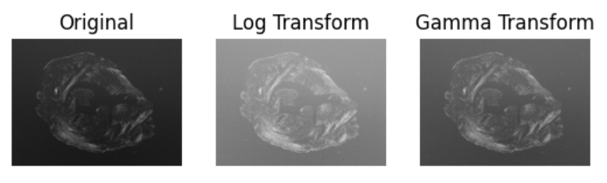
5. Results and Discussion
The original image showed limited contrast in some regions. Built-in and manual histogram equalization significantly improved the contrast by redistributing pixel intensity values. Histogram comparison clearly showed a more uniform distribution after equalization.
Contrast stretching enhanced the dynamic range of the image, while log and gamma transformations improved visibility of darker regions. These results demonstrate how different enhancement techniques affect image quality and visual appearance.
6. Conclusion
This lab successfully demonstrated various image enhancement techniques using OpenCV. Histogram equalization, contrast stretching, log transformation, and gamma correction were applied effectively to improve image contrast and brightness. These techniques are widely used in medical imaging, satellite imaging, and computer vision applications to enhance image details and visibility.
THE END

