DIP_Lab_Task # 05

Submitted By: Aman Tariq
Roll No: 2023-SE-29
Course Name: DIP
Course Code: SE-3112
Session: 2023-2027
Submitted To: Engr. Ahmed Khawaja

Lab Task 5
Title: Image Filtering using Mean, Median, Mode, and Gaussian Filters
1. Introduction
Image filtering is a fundamental technique in image processing used to reduce noise and improve image quality. Different filters are applied depending on the type of noise and the desired output.
In this lab, an image is taken as an input image and various spatial domain filters such as Mean, Median, Mode, and Gaussian filters are applied. The purpose of this lab is to analyze how each filter affects the image and to compare their results visually.
2. Objectives
- To load and display an image using Python
- To apply Mean, Median, Mode, and Gaussian filters
- To observe the effect of each filter on the image
- To compare filtered images with the original image
3. Tools and Libraries Used
- Python
- PIL (Python Imaging Library)
- NumPy
- Matplotlib
- SciPy
4. Methodology / Procedure
Input Image Loading
- The image (img5.jpg / image5(a).png) was loaded using the PIL library.
- The image was converted to grayscale for filtering operations.
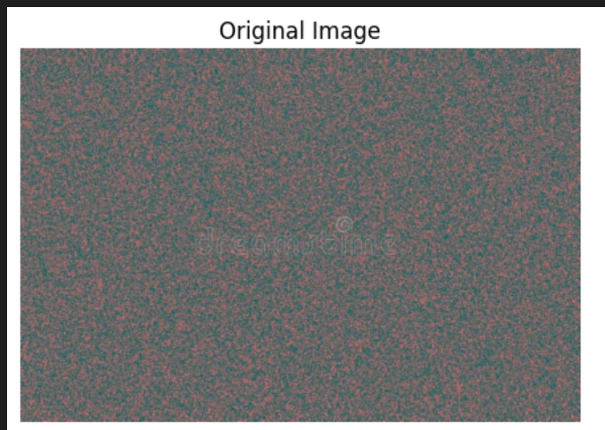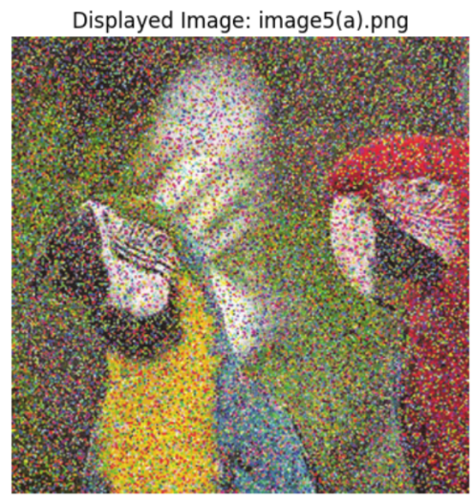
Mean Filter
- A mean filter was applied using a 3×3 kernel.
- This filter replaces each pixel with the average value of its neighboring pixels.
- It smooths the image but may blur edges.
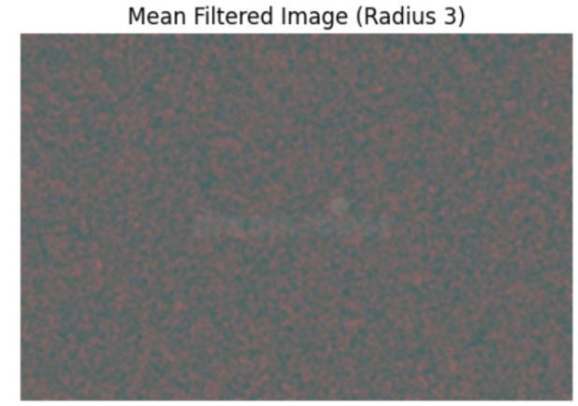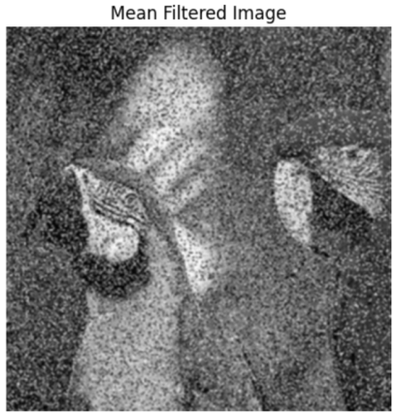
Median Filter
- A median filter of size 3×3 was applied.
- Each pixel was replaced by the median value of its neighborhood.
- This filter is effective in removing salt-and-pepper noise while preserving edges.
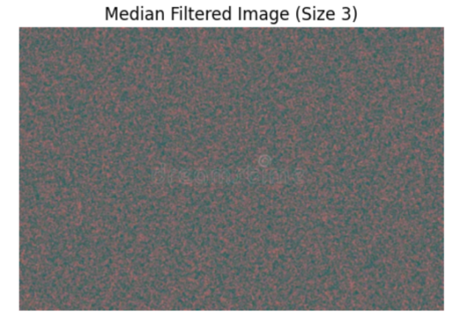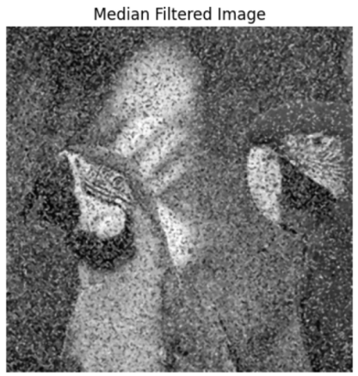
Mode Filter
- A mode filter was applied using a 3×3 neighborhood.
- Each pixel was replaced by the most frequently occurring value in its neighborhood.
- This filter works well for certain structured noise patterns.
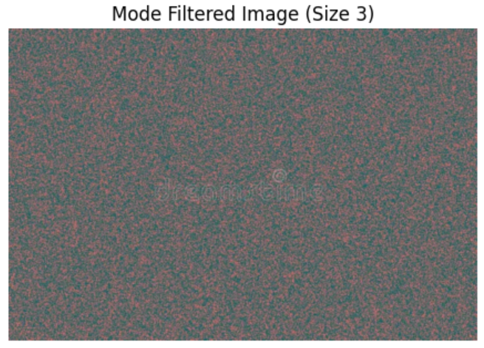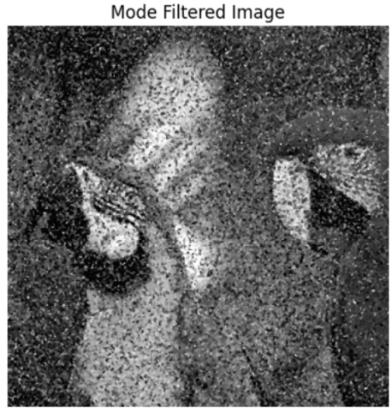
Gaussian Filter
- A Gaussian filter was applied using a Gaussian function with a selected sigma value.
- This filter smooths the image and reduces high-frequency noise.
- It produces a natural blur effect.
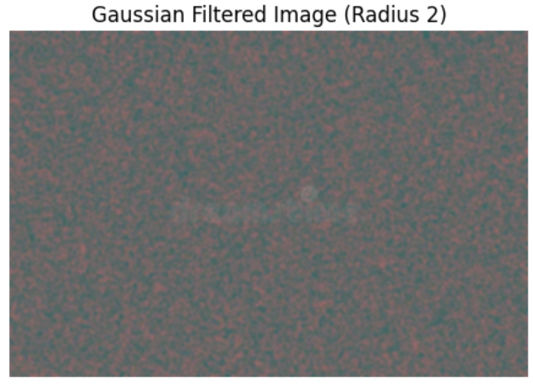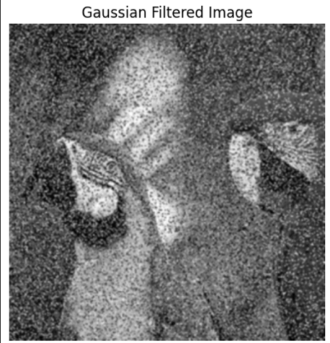

5. Results and Discussion
The original image contained noise and intensity variations. The mean filter reduced noise but caused noticeable blurring of edges. The median filter effectively removed salt-and-pepper noise while preserving edges better than the mean filter.
The mode filter produced moderate smoothing but was less effective than the median filter for noise removal. The Gaussian filter generated a smooth and visually pleasing image but reduced fine details depending on the sigma value.
Overall, each filter showed distinct behavior, highlighting the importance of selecting the appropriate filter based on the noise type and application.
6. Conclusion
This lab successfully demonstrated the application of various image filtering techniques. Mean, Median, Mode, and Gaussian filters were applied and compared. The median filter proved to be most effective for impulsive noise, while the Gaussian filter was suitable for general smoothing. This lab enhanced understanding of noise reduction techniques and their practical use in image processing systems.

THE END

