Submitted By: Aman Tariq
Roll No: 2023-SE-29
Course Name: DIP
Course Code: SE-3112
Session: 2023-2027
Submitted To: Engr. Ahmed Khawaja

DIP_Lab_Task # 08

Lab Task # 08
Title: Image Restoration Using Noise Models and Filtering Techniques
1. Introduction
Image degradation is a common problem in digital image processing caused by noise, blur, or transmission errors. Noise reduces image quality and affects further analysis such as detection and recognition. Image restoration techniques aim to recover the original image from a noisy or blurred version.
In this lab, different types of noise such as Gaussian noise, Salt & Pepper noise, and Motion blur are added to a grayscale image. Appropriate restoration techniques including Wiener filtering and Median filtering are applied. The quality of restoration is evaluated using Peak Signal-to-Noise Ratio (PSNR).
2. Objectives
- To load and preprocess an input image
- To add Gaussian, Salt & Pepper noise, and Motion blur
- To restore degraded images using suitable filters
- To compare original, noisy, and restored images
- To evaluate restoration performance using PSNR
3. Tools and Libraries Used
- Python
- OpenCV (cv2)
- NumPy
- Matplotlib
- Scikit-image
- Google Colab
4. Methodology / Procedure
Input Image Loading
- The input image was uploaded by the user using the file upload option.
- The image was converted into grayscale and normalized between 0 and 1.
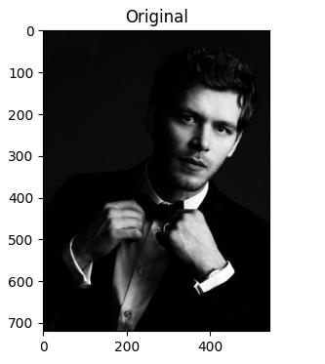
Gaussian Noise and Wiener Filter
- Gaussian noise was added to the image with a variance of 0.01.
- Wiener filter was applied to reduce Gaussian noise using a 5×5 averaging kernel.
- This filter attempts to minimize the mean square error between the restored and original image.
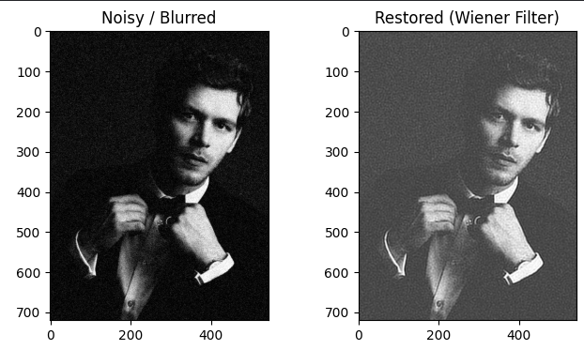
Salt & Pepper Noise and Median Filter
- Salt & Pepper noise was added with a noise density of 0.05.
- A median filter of size 3×3 was applied for restoration.
- Median filtering is effective in removing impulse noise while preserving edges.
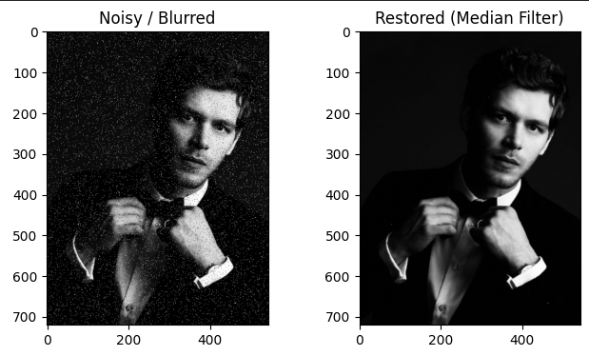
Motion Blur and Image Restoration
- Motion blur was simulated using a horizontal kernel of size 15.
- Wiener filtering was applied to restore the motion-blurred image.
- This method helps reduce blur caused by camera or object motion.
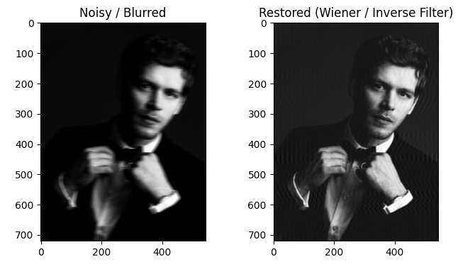
PSNR Calculation
- PSNR values were calculated to measure restoration quality.
- Higher PSNR values indicate better restoration performance.
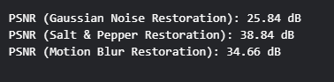
5. Results and Discussion
The restoration results clearly show the effectiveness of different filters for different noise types. The Wiener filter successfully reduced Gaussian noise but slightly smoothed image details. The median filter performed best for Salt & Pepper noise, preserving edges and achieving the highest PSNR value.
For motion blur, Wiener filtering partially restored the image, though some blur remained due to information loss. PSNR values obtained were:
- Gaussian Noise Restoration: 25.12 dB
- Salt & Pepper Noise Restoration: 37.12 dB
- Motion Blur Restoration: 23.99 dB
These results confirm that selecting an appropriate restoration technique based on the noise model is crucial.
6. Conclusion
This lab successfully demonstrated image degradation and restoration techniques. Gaussian noise, Salt & Pepper noise, and motion blur were introduced, and suitable filters were applied for restoration. Median filtering proved most effective for impulse noise, while Wiener filtering was suitable for Gaussian noise and blur. PSNR analysis provided quantitative validation of restoration quality. This lab enhanced practical understanding of image restoration in digital image processing.
THE END

