DIP_Lab_Task # 09

Submitted By: Aman Tariq
Roll No: 2023-SE-29
Course Name: DIP
Course Code: SE-3112
Session: 2023-2027
Submitted To: Engr. Ahmed Khawaja

Lab Task 9
Title: Color Image Processing, White Balance, and Segmentation
1. Introduction
Digital image processing allows manipulation of images to enhance visual quality, extract features, or segment objects. Color images provide more information than grayscale images and can be analyzed in multiple color spaces (RGB, HSV, YCbCr, Lab) for tasks like color correction and object detection.
This lab focuses on:
- Extracting RGB channels
- Converting images into different color spaces
- Applying white balance correction using the Gray World assumption
- Masking specific colors (e.g., green)
- Performing Lab-based image segmentation
The input image is analyzed and processed to demonstrate practical applications in color image processing.
2. Objectives
- Load and display a colored image
- Extract Red, Green, and Blue (RGB) channels
- Convert the image into HSV, YCbCr, and Lab color spaces
- Apply white balance using Gray World algorithm
- Segment a specific color (green) using HSV masking
- Perform segmentation based on Lab color space channels
- Visualize all results for comparison
3. Tools and Libraries Used
- Python
- OpenCV (cv2)
- NumPy
- Matplotlib
- Google Colab
4. Methodology / Procedure
Step 1: Image Loading and Conversion
- The user uploads a color image using the Colab upload widget.
- The image is converted to RGB format and grayscale.
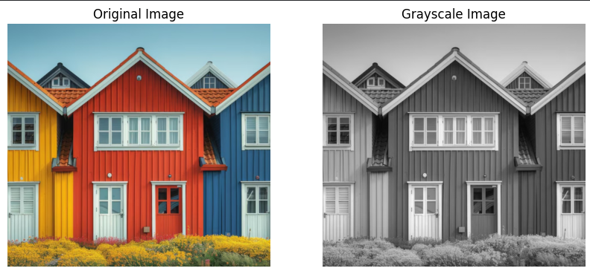
Step 2: RGB Channel Extraction
- Red, Green, and Blue channels were extracted separately.
- Each channel was displayed as a grayscale image to visualize the contribution of each color component.
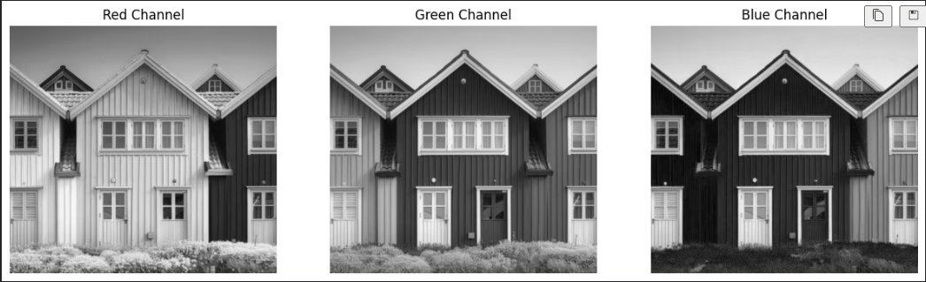
Step 3: Color Space Conversion
- The image was converted into HSV, YCbCr, and Lab color spaces.
- These color spaces are useful for different image processing tasks:
  - HSV separates color information (hue) from intensity (value)
  - YCbCr separates luminance from chrominance
  - Lab separates lightness from color-opponent channels
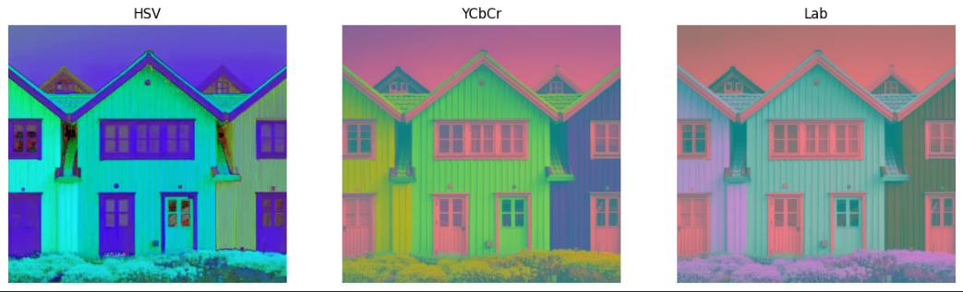
Step 4: White Balance (Gray World Algorithm)
- White balance adjusts the color balance so that neutral colors appear gray.
- The Gray World assumption states that the average of all RGB values should be equal.
- Each channel was scaled based on the overall gray average.
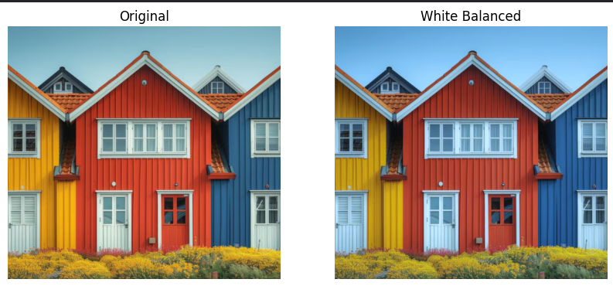
Step 5: Color Masking (Green)
- The image was converted to HSV to segment green color.
- Lower and upper green thresholds were defined.
- A mask was created and applied to highlight green regions.
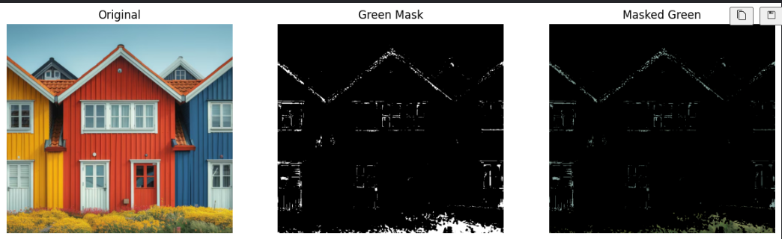
Step 6: Lab-based Segmentation
- The Lab color space separates lightness (L) and color channels (a, b).
- The a-channel (green-red axis) was thresholded to create a binary mask.
- Lab segmentation helps detect color features more accurately under varying lighting.
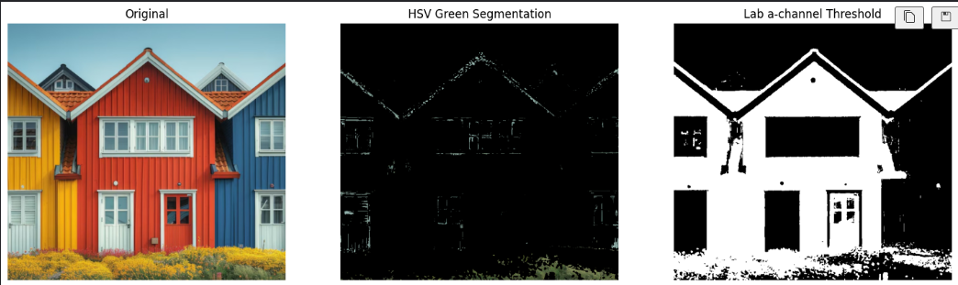
5. Results and Discussion
- RGB Channels: Red, Green, and Blue channels clearly showed the contribution of each color.
- Color Space Conversion: HSV, YCbCr, and Lab representations revealed how color and intensity can be separated for processing.
- White Balance: Gray World correction balanced the color tones, making the image more visually natural.
- Color Masking: Green color regions were successfully extracted from the image using HSV thresholds.
- Lab Segmentation: The a-channel thresholding provided an alternative way to segment colors, demonstrating robustness under different lighting conditions.
Overall, the lab demonstrates multiple techniques to analyze, correct, and segment color images effectively.
6. Conclusion
This lab successfully applied color image processing techniques including RGB extraction, color space conversion, white balance, and segmentation.
Key takeaways:
- Different color spaces are suitable for specific tasks (HSV for masking, Lab for color-based segmentation).
- White balance using the Gray World assumption improves visual quality.
- Color segmentation can be performed efficiently using thresholding in HSV or Lab spaces.
- These techniques form the foundation for advanced tasks like object detection and image analysis.

THE END

