DIP_Lab_Task # 10

Submitted By: Aman Tariq
Roll No: 2023-SE-29
Course Name: DIP
Course Code: SE-3112
Session: 2023-2027
Submitted To: Engr. Ahmed Khawaja

Lab Task 10
Title: JPEG-like DCT and Huffman Coding for Color Images
1. Introduction
Image compression reduces storage and transmission requirements while preserving visual quality. JPEG is a widely used method for compressing color images, which applies:
- Discrete Cosine Transform (DCT) to transform spatial data into frequency domain
- Quantization to reduce less important frequencies
- Huffman Coding for efficient entropy encoding
This lab demonstrates JPEG-like compression on a color image, highlighting:
- DCT and quantization artifacts
- Huffman coding for data compression
- Performance metrics including MSE, PSNR, compression ratio, and rate-distortion
2. Objectives
- Load a color image and convert it for processing
- Apply block-wise DCT and quantization
- Reconstruct the image using inverse DCT
- Encode quantized coefficients using Huffman coding
- Analyze compression performance using MSE, PSNR, and compression ratio
- Visualize compression artifacts using difference images
3. Tools and Libraries Used
- Python
- OpenCV (cv2)
- NumPy
- Matplotlib
- Google Colab
4. Methodology / Procedure
Step 1: Image Upload and Loading
- The user uploads a color image.
- The image is read into a floating-point array for numerical operations.
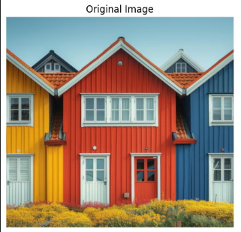
Step 2: Block-wise DCT and Quantization
- The image is split into 8×8 blocks (BLOCK = 8).
- DCT is applied to each block to convert spatial data to frequency domain.
- Quantization using a scaled JPEG matrix reduces high-frequency coefficients.
- Inverse DCT reconstructs the compressed image.
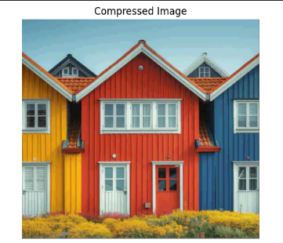
Step 3: Huffman Coding
- Huffman coding encodes quantized DCT coefficients efficiently.
- For demonstration, only the first channel (Red) is encoded.
- Symbols are assigned variable-length codes based on frequency.
- Compressed bitstream size is compared to original to compute compression ratio (CR).
Step 4: Performance Metrics
- Mean Squared Error (MSE): Measures average squared difference between original and reconstructed image.
- Peak Signal-to-Noise Ratio (PSNR): Evaluates reconstruction quality; higher PSNR indicates better quality.
- Compression Ratio (CR): Ratio of original bits to compressed bits.
- Rate-Distortion (RD): Efficiency of compression relative to distortion.
Step 5: Difference Image
- Absolute difference between original and reconstructed image is amplified for visibility.
- Highlights visible compression artifacts, mostly in high-frequency areas.
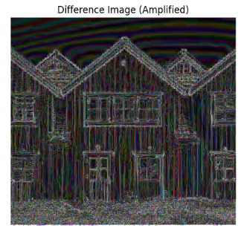
5. Results and Discussion
Metric | Value
Compression Ratio (CR) | 22.27
Mean Squared Error (MSE) | 48.29
PSNR | 31.29 dB
Rate Distortion (RD) | 157405.3

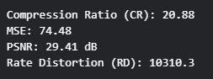
  - Visual Observation:
  - Compressed image closely resembles the original with some blocky artifacts visible in high-frequency regions.
  - Difference image shows where compression causes loss of detail.
- Interpretation:
  - High CR indicates substantial reduction in data size.
  - PSNR > 30 dB shows acceptable visual quality.
  - MSE is low, suggesting minor distortion.
- JPEG-like DCT with quantization and Huffman coding demonstrates typical compression trade-offs between file size and image fidelity.
6. Conclusion
- JPEG-like compression effectively reduces image size while maintaining visual quality.
- Block-wise DCT isolates image energy in low frequencies; quantization discards less perceptually important components.
- Huffman coding further reduces storage using frequency-based entropy coding.
- Difference images help visualize compression artifacts.
- Metrics like MSE, PSNR, CR, and RD quantify performance for evaluating compression methods.

THE END

