DIP_Lab_Task # 11

Submitted By: Aman Tariq
Roll No: 2023-SE-29
Course Name: DIP
Course Code: SE-3112
Session: 2023-2027
Submitted To: Engr. Ahmed Khawaja

Lab Task 11
Title: Morphological Image Processing
1. Introduction
Morphological operations are widely used in image processing for extracting structural features, removing noise, and analyzing shapes in binary or grayscale images. They work based on a structuring element that interacts with pixel neighborhoods.
Key operations include:
- Erosion & Dilation
- Opening & Closing
- Boundary Extraction
- Hole Filling
- Noise Removal
- Shape Detection
This lab demonstrates these techniques on grayscale or binary images.
2. Objectives
- Apply fundamental morphological operations to images
- Extract image boundaries and fill holes
- Remove noise using morphological techniques
- Detect simple geometric shapes using contour analysis
3. Tools and Libraries Used
- Python
- OpenCV (cv2)
- NumPy
- Matplotlib
- Google Colab
4. Methodology / Procedure
Step 1: Image Upload and Preprocessing
- User uploads a grayscale or binary image.
- Image is converted to binary using thresholding.
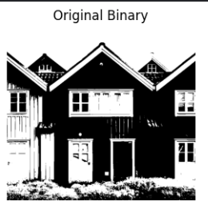
Step 2: Basic Morphology
- Erosion: Shrinks foreground pixels; removes small noise and detaches connected objects.
- Dilation: Expands foreground pixels; fills small holes and gaps.
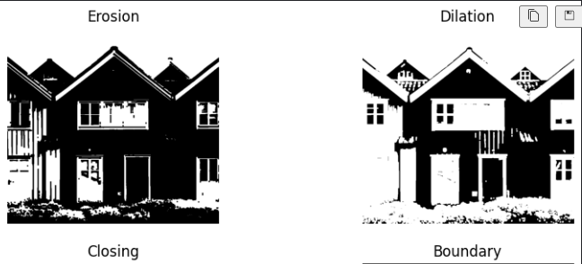
Step 3: Opening and Closing
- Opening (Erosion → Dilation): Removes small objects or noise.
- Closing (Dilation → Erosion): Fills small holes and gaps in objects.
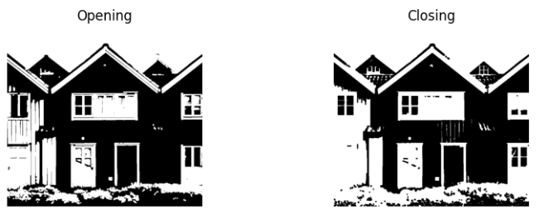
Step 4: Boundary Extraction
- Boundary = Original − Erosion
- Highlights object edges in the binary image.
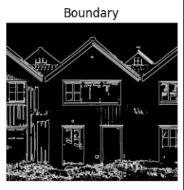
Step 5: Hole Filling Using Reconstruction
- Invert the binary image.
- Initialize marker image at the borders.
- Perform iterative dilation constrained by inverted image until convergence.
- Invert the result to get hole-filled image.
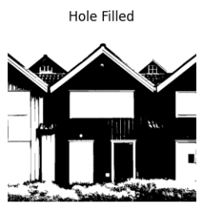
Step 6: Noise Removal Using Morphology
- Opening operation effectively removes small noise components without affecting larger structures.
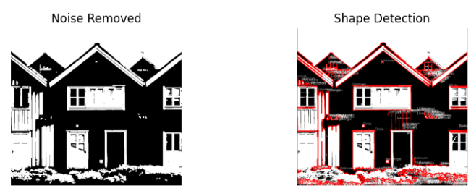
Step 7: Shape Detection
- Contours of objects are extracted using cv2.findContours.
- Approximated polygons determine object type:
  - Triangle: 3 vertices
  - Rectangle: 4 vertices
  - Circle: More than 6 vertices
- Shapes are drawn and labeled on the image.

5. Results
Operation | Observations
Original Binary | Input thresholded image showing foreground objects
Erosion | Objects shrunk; small noise removed
Dilation | Objects expanded; gaps filled
Opening | Noise removed; small objects eliminated
Closing | Holes and gaps in objects filled
Boundary | Clear edges of objects extracted
Hole Filling | Internal holes filled; objects become solid
Noise Removal | Remaining small noise eliminated
Shape Detection | Objects labeled as Triangle, Rectangle, or Circle based on contours
6. Conclusion
- Morphological operations are effective for preprocessing and structural analysis in images.
- Erosion & Dilation form the basis of advanced operations like Opening & Closing.
- Boundary extraction and hole filling provide useful image features for analysis.
- Contour-based shape detection can classify simple geometric shapes.
- These techniques are fundamental for object recognition, noise removal, and image segmentation tasks.

THE END

